
Description: | This document describes the production of the E-pickup device designed for the ESS LLRF control system
Title: | Critical Design Report for the E-pickup device
Authors: | Marcin Gosk, Dominik Rybka
Co Authors: | Jarosław Szewiński
Version: | 0.01
Date: | 20.04.2018

- Mechanical design description

Mechanical design is provided by ESS partner.

- Tests of the prototype

PEG partner has received from ESS assembled E-pickup prototype PCB in version 0.2, dated May 2017. Basic functionality tests were performed. The block diagram of the test system is presented on Figure 1, and the photo of system during the tests is presented on Figure 2.

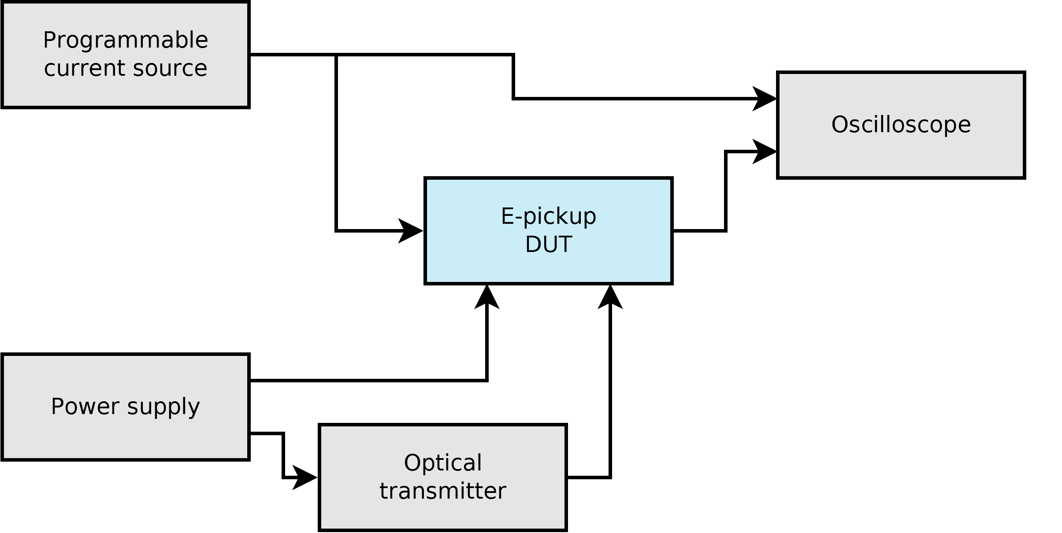
Figure 1. Test system layout

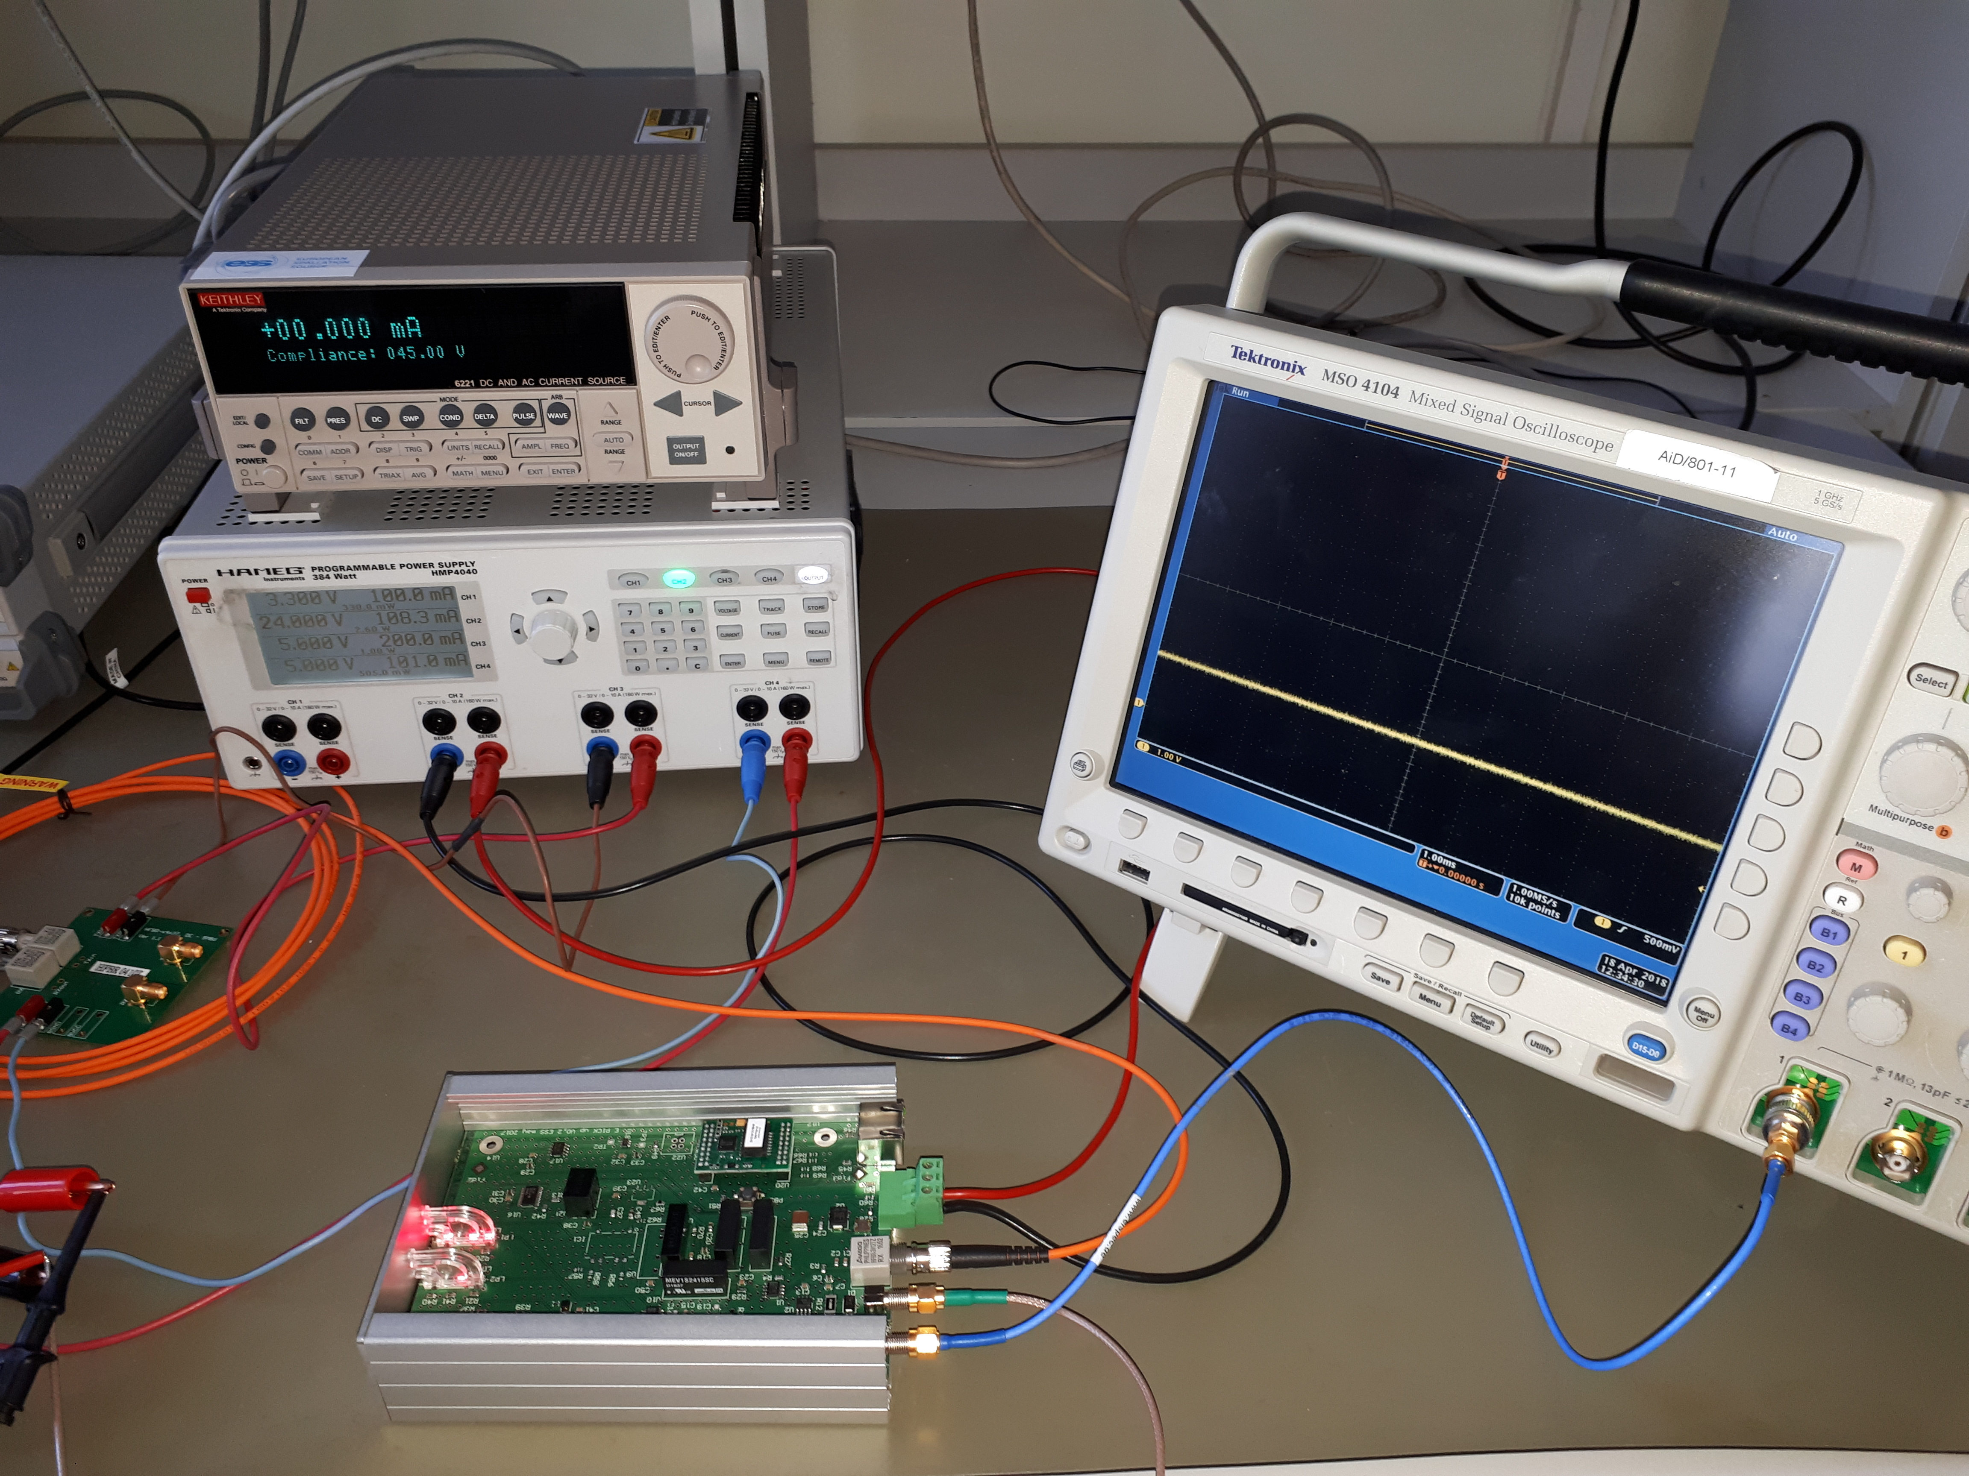
Figure 1. Test system setup

The testing procedure consisted of analysis of analog output signal from e-pickup device. As the input constant current signal of ±10mA and compliance around +45V (output from Keithley 6221 DC and AC current source) was used. The optical interlock signal was delivered from
HFBR-0410Z evaluation board. Analog output signal was measured utilizing oscilloscope Tektronix MSO 4104. In principle, the device is working correctly. Analog output is proportional to the input current. When input signal reaches approximately -4.7mA LED of the interlock=1 is on. Analog output signal is still proportional. When operating around these value of the current, one can observe situation of rapid both LEDs blinking indicating two states (interlock=0 and interlock=1). We suggest to include the hysteresis on LEDs comparators. We didn't notice any additional designing or manufacturing problems, one can only consider moving around 10 mostly passive components from bottom to top layer to help assembly of the boards.

Besides the functional tests, manufacturability of the device was checked. All components that are utilized in the design were available, without long lead times, in reasonable MOQ (minimum order quantity). The PCB is manufacturable in Euro Circuit company, that is able to produce printed circuit board with provided stackup.
Mechanical enclosure drawings were not provided, that's why its availability was not validated.

- Procurement, production and delivery planning

As soon as ESS partner provides PEG with final proven designs of the device, inluding schematics of the subsystem, layout of the PCB, GERBER production files of the PCB, pick and place file for automatic components placement, bill of materials and assembly drawings of the PCB and the mechanical enclosure, PEG partner will start the production procedure. This contains following steps:
- analysis of the changes made to the device schematics and PCB layout (if any) [0.5 month];
- verification of the production files, including GERBER production files of the PCB, pick and place file for automatic components placement, bill of materials and assembly drawings of the PCB [0.5 month];
- call for tender for PCB production and assembly [1 month];
- call for tender for mechanical enclosure manufacturing and delivery [1 month];
- production of elements in external companies [2 months];
- visual inspection of delivered elements of the device [0.25 month];
- DC electrical measurements of delivered PCBs [0.25 month];
- assembly of the devices [2 month];
- functional tests of devices [2 month];
- delivery to ESS partner [1 month].
In order to maximize production yield AOI (Automated optical inspection) will be included in terms of call for tender for PCB manufacturing.

- Description of planned tests and measurements including FAT

Following tests and measurements are forseen to be performed by PEG:
- on components delivered from external manufacturers:
  - visual inspection of delivered elements of the device:
    - PCB manufacturing defects;
    - components placement on PCB;
    - soldering quality check;
    - mechanical enclosure manufacturing defects.
  - DC electrical measurements of delivered PCBs:
    - PCB connection to power supply;
    - measurements of low voltages generated on device, when powered on;
- on assembled devices:
  - visual inspection of assembled devices.
- automated functional tests of devices connected to test setup:
  - Ethernet communication with XT-Pico;
  - complete tests of functions embedded in XT-Pico firmware;
  - analog output signal analysis.
Results of all completed tests and measurements will be contained in final manufacturing report.

