# SCHEDULE AIK 12.1

# Linac Warm Units (LWU) and other Specified Scope

# TO THE IN-KIND CONTRIBUTION (IKC) AGREEMENT SIGNED BETWEEN

# ESS and STFC (Daresbury Laboratory) on DATE

|  |  |  |
| --- | --- | --- |
| **Revision history table** | | |
| **Version** | **Comments** | **Sections amended** |
| *1* | *Version approved at IKRC in* | *N/A* |
| *2* | *Version to go to IKRC in April 2018* | *Various updates to dates, CBV and warranty/IP sections.* |
| *2.1* | *21 March 2018; JG* | *Accepted all changes and comments.*  *Modified table 3 (magnet delivery dates) per CR04*  *Tidied up table numbering* |

# Scope

This document describes the Scope of Work (SoW) required to complete the Partner’s contribution to the ESS programme. It is an integral part of the In-Kind Contribution Agreement and is agreed upon by all undersigning Parties. The SoW contains an appropriate level of detail so all parties clearly understand what work is required, the duration of the work involved, the deliverables and the conditions of acceptance.

The main deliverables in this SoW are of 71 Linac Warm Units (LWU) and 52 beam pipe modules / units. However this SoW includes the design, procurement and assembly of specified vacuum equipment, vacuum chambers, beam transport modules (LWU, beam pipes, Low and High Energy Differential Pumping units (LEDP and HEDP)) and their supporting structures, and the integration of Beam Position Monitors (BPM) and Beam Current Monitors (BCM) into beam transport modules. It does not include design or procurement of the magnets, BPMs, or any other diagnostic equipment. ESS shall provide magnets and BPMs to the Partner on contract loan for assembly and integration into the LWUs. Any other diagnostic equipment will be fitted into the LWUs by ESS in the ESS tunnel and therefore will not be part of the Partner’s responsibility. The Partner will be required to work closely with other ESS In-Kind Contribution (IKC) partners to ensure that the magnets, BPMs and BCMs can be easily assembled within the LWU.

With the exception of one prototype module, to be delivered early in 2016, all other units will be delivered from late 2016 to April 2020.

# Related documents

## Applicable Documents

The following documents and data are necessary to complete or support the execution of this SoW:

1. [IKA] In-Kind Contribution Agreement ESS ERIC and STFC
2. [REQ] ESS-0047024 Requirements: PBS Level 3 Vacuum, 08 Dec 2015, Rev. 1 State: Released
3. [EVH] ESS-0012894-97: ESS Vacuum Handbook, Parts 1-4, 19 Jan 2016, Rev. 1 State: Released
4. [PTF] ESS-0044808 Specification: Particle Test Facility, 08 Dec 2015, Rev. 1 State: Rel.
5. [GCF] ESS-0044809 Specification: Gauge Calibration Facility, 08 Dec 2015, Rev. 1 State: Rel.
6. [OGF] ESS-0044810 Specification: Outgassing Facility, 08 Dec 2015, Rev. 1 State: Rel.
7. [VIF] ESS-0044811 Specification: Vacuum Integration Facility, 08 Dec 2015, Rev. 1 State: Rel.
8. [SPN] ESS-0044812 Technical Specifications for the LWUs, 08 Dec 2015, Rev. 1 State: Rel.

## Reference documents

Unless specifically referenced elsewhere in this SoW, the following documents are for background and guidance only.

1. [CCP] ESS-0001879 Change Control Process, 9 Oct 2014, Rev. 1 State: Released
2. [CMP] ESS-0003688 Configuration Management Plan, 14 Oct 2013, Rev. 1 State: Released
3. [DRP] ESS-0008910 Design Review SOP, 27 Oct 2014, Rev. 1 State: Released
4. [LOG] ESS-0042559 (two documents) Guideline: & Shipping Instruction / Pre Advice – In Kind
5. [PQP] ESS-0037830 ESS template for Project Quality Plan, 22 Sep 2015, Rev. 1 State: Released
6. [RMP] ESS-0000263 ESS Process for Risk Management, 24 Nov 2014, Rev. 1 State: Released
7. [ISS] ESS-0017560 TS, AD, NSS and ICS Plan and Implementation Strategy for Hazardous Materials and Sustainability, 08 Feb 2016, Rev. 1 Released
8. [SAG] ESS-0012977 ESS Guideline for Survey and Alignment Fiducials
9. ASTeC Vacuum Specifications: ASTEC-VAC-QCD-SPC001-008
10. tdl-1224-meng-pog-002-v1.0 OBS
11. tdl-1224-meng-spec-004v1.0 - Mobile Cleanroom Spec
12. tdl-1224-meng-spec-005-v3.1. SoW Beam Transport Modules (ESS WP12, UK-A-6)
13. tdl-1224-meng-spec-006v1.7- WP12 Spec
14. tdl-1224-meng-spec-009v1.0 - WP12 Particle Count Procedure
15. tdl-1224-meng-ppl-001v1 – Outline Project Plan

# Terms and Definitions

|  |  |
| --- | --- |
| ASTeC | Accelerator Science and Technology Centre, UK |
| BCM | Beam Current Monitors |
| BPM | Beam Position Monitors |
| CAD | Computer-Aided Design |
| CDR | Critical Design Review |
| DAP Incoterms | Delivered at Place. ESS is responsible for any import clearance and applicable taxes. |
| ERIC | European Research Infrastructure Consortium |
| ESS | European Spallation Source |
| ETC | European Technology Centre (Daresbury, UK) |
| Facility element | This item corresponds to the product contribution of the Partner. It is an element of the ESS PBS and/or WBS |
| FAT | Factory Acceptance Test |
| HEBT-010LWU | Differential pumping LWU in High Energy Beam Transport section. Also know as HEDP. |
| ICC | International Chamber of Commerce (publisher of Incoterms**®** rules) |
| IKC | In-Kind Contribution |
| SPK-010LWU | Differential pumping LWU in Spoke section. Also know as LEDP. |
| LWU | Linac Warm Units |
| P&ID | Literally ‘Piping/Process and Installation/Instrumentation Diagram’ but P&ID may refer to any design description as a schematic representation for example for electrical circuit diagrams, logic diagrams, flow diagrams and. |
| PDR | Preliminary Design Review |
| PBS | Product Breakdown Structure |
| RAMI | Reliability, Availability, Maintainability, Inspectability |
| SAR | System Acceptance Review |
| SAT | Site Acceptance Test |
| SoW | Scope of Work |
| STEP | International standard for product data exchange (ISO 10303) |
| STFC | Science & Technology Facilities Council, UK |
| WBS | Work Breakdown Structure |
| WP | Work Package |
| WU | Work Unit |

# Project definition

## Deliverable Item Definition

### Deliverable Overview

#### Partner Deliverables

Start date: 01 January 2015

End date: 31 December 2020

The dates set out in table [1] represent the applicable Time Schedule referred to in Art.7.1.1 of the Agreement.

| **Nr** | **Deliverables** | **Final Delivery Deadline / Delivery MS** |
| --- | --- | --- |
| Pre-Stage 1 | | |
|  | ESS Vacuum Laboratory consisting of (see Chapter 2.1):   * [PTF] Particle Test Facility * [GCF] Gauge Calibration Facility * [OGF] Outgassing Facility * [VIF] Vacuum Integration Facility * technical data as specified in [PTF], [GCF], [OGF], [VIF] | 01 July 2015 |
| Stage 1 | | |
|  | Relevant Technical data package for PDR. See 4.4.2.1 | 2015 (Pre-PDR) |
|  | Qty 3 x Dummy Test Chambers | March 2016 |
|  | Qty 1 x 1st Prototype | June 2016 |
|  | Qty 1 x 2nd Prototype | August 2016 |
|  | Technical data package as specified for 1st CDR. See 4.4.2.2 | CDR, June 2016 |
|  | Technical data package as specified for 2st CDR. See 4.4.2.2 | CDR, July 2018 |
| Stage 2 | | |
|  | Qty 3 x Mobile Clean Rooms | July 2018 |
|  | Qty 57 x Beam Pipe Units | July 2019 |
|  | Qty 71 x LWUs | April 2020 |
|  | Qty 2 x Differential Pumping Systems | April 2020 |
|  | Qty 2 x Dipole Chambers | April 2020 |
|  | Technical data package as specified for SAR. See 4.4.3.2. | SAR, minus 5 weeks |
|  | Delivery of Final Report and documentation package for Supply. See 4.4.5 and 4.4.6 | 31 December 2020 |
| Stage 3 | | |
|  | Vacuum Technician Support during installation at STFC site. See 4.1.2.1.6 | 2018-2019, dates to be agreed |

Table 1- Partner Deliverables

This overall contribution is set to the ESS Cost Book value of 10,812 K€ (Euro).

Each of the delivery milestones are also part of the Earned Value tracking (Chapter 5.1).

The ESS element concepts have been developed by the ESS and its partners and have been incorporated into a baseline reference design.

#### ESS Deliverables – Contract Loan Items

The following is a list of items which shall be provided by ESS to STFC on contract loan. ESS will be responsible for sign off and approval of all contract loan items to ensure they meet specifications before they ship to STFC, including vacuum tests, leak tests and RGA scans. ESS will be responsible for ensuring all operational tests necessary are carried out by the contract loan item supplier before shipping, and that certificates of conformity are supplied. STFC may RGA scan, leak test, re-clean or process through the cleanrooms any items to ensure the ASTeC Vacuum Specifications standards and low particulate levels are met.

|  |  |
| --- | --- |
| **Item** | **QTY** |
| Button BPMs | 308 |
| Quadrupole Magnets | 139 |
| H&V Corrector magnets | 72 |
| Dipole Magnets | 2 |

Table 2- ESS Deliverables - Contract Loan Items

Magnets and BPM feedthroughs will be supplied as contract loan items to SFTC the following is a list of the items to be delivered to the STFC and the schedule as given by the supplier.

|  |  |
| --- | --- |
| **Magnet Type** | **Delivery at Daresbury** |
| **Q6,C6 x 5** | 12/09/2018 |
| **Q7, C6 X 6** | 17/10/2018 |
| **Q6,C6 X 6** | 15/11/2018 |
| **Q6,C6 X 6** | 18/12/2018 |
| **Q6,C6 X 6** | 18/01/2019 |
| **Q6,C6 X 6** | 21/02/2019 |
| **D1 X 2** | N/A ship to Lund |
| **Q8, C8 X 3** | N/A ship to Lund |
| **Q5,C5 X 6** | 10/07/2019 |
| **Q6,C6 X 6** | 27/04/2019 |
| **Q5,C5 X 7** | 15/08/2019 |
| **Q6,C6 X 6** | 20/04/2019 |
| **Q6,C6 X 7** | 03/06/2019 |

Table 3– Magnet delivery dates as of April 16

|  |  |  |  |  |
| --- | --- | --- | --- | --- |
| **Feedthrough type** | **Total Feedthroughs** | **Delivered in September 2016 - feedthroughs** | **Delivered in January 2017 - feedthroughs** | **Delivered in January 2018 - feedthroughs** |
| Big (100 mm chamber) | 360 | 52* | 308 | 0 |
| Small (57.1 mm chamber) | 68 | 0 | 0 | 68 |
| Total | 428 |  |  |  |

*This includes 11 pre made BPM blocks, each assembled with 4 welded feedthroughs

Table 4- BPM Feed through schedule.

### Description of Equipment Deliverables and Scope

#### Major Systems

Provided below is a description of the major systems to be delivered including:

* ESS Vacuum Laboratory
* High Energy & Low Energy Differential Pumping Systems: HEDP and LEDP
* beam transport modules: LWUs, including prototypes and dummy chambers; and Beam Pipe Modules,
* mobile installation cleanroom assemblies

##### ESS Vacuum Laboratory

The sub-facilities and systems for the ESS Vacuum Laboratory are described in Chapter 2.1, Specifications [PTF], [GCF], [OGF], and [VIF].

##### HEDP and LEDP

Two differential pumping sections are required by ESS, one at the high energy end and one at the low energy end of the accelerator, HEDP & LEDP respectively. These units consist of a LWU with the pumping systems capable of creating a pressure gradient of approximately 2 decades across them and will incorporate a fast acting valve to protect the adjoining modules. Both units shall incorporate an overpressure protection burst disc, nominally rated at 1.2 bar differential pressure, located between the connection to the cryomodule and the fast valve. This burst disc shall be sized to accommodate the maximum inflow of cryogens from the cryomodule in the event of failure of the cryogen containment boundary.

The LEDP system is required to have an inlet pressure 1x10-9 mbar, with an inlet to outlet pressure ratio 100:1. The HEDP system is required to have an outlet pressure 1x10-9mbar, with an inlet to outlet pressure ratio 100:1, over a slot length of 1635mm. The pumping capacity of both the LEDP and HEDP shall be capable of operating with inlet and outlet pressure of 1x10-8 mbar respectively.  Reference configuration is described in Chapter 2.1, Reference G. [SPN]

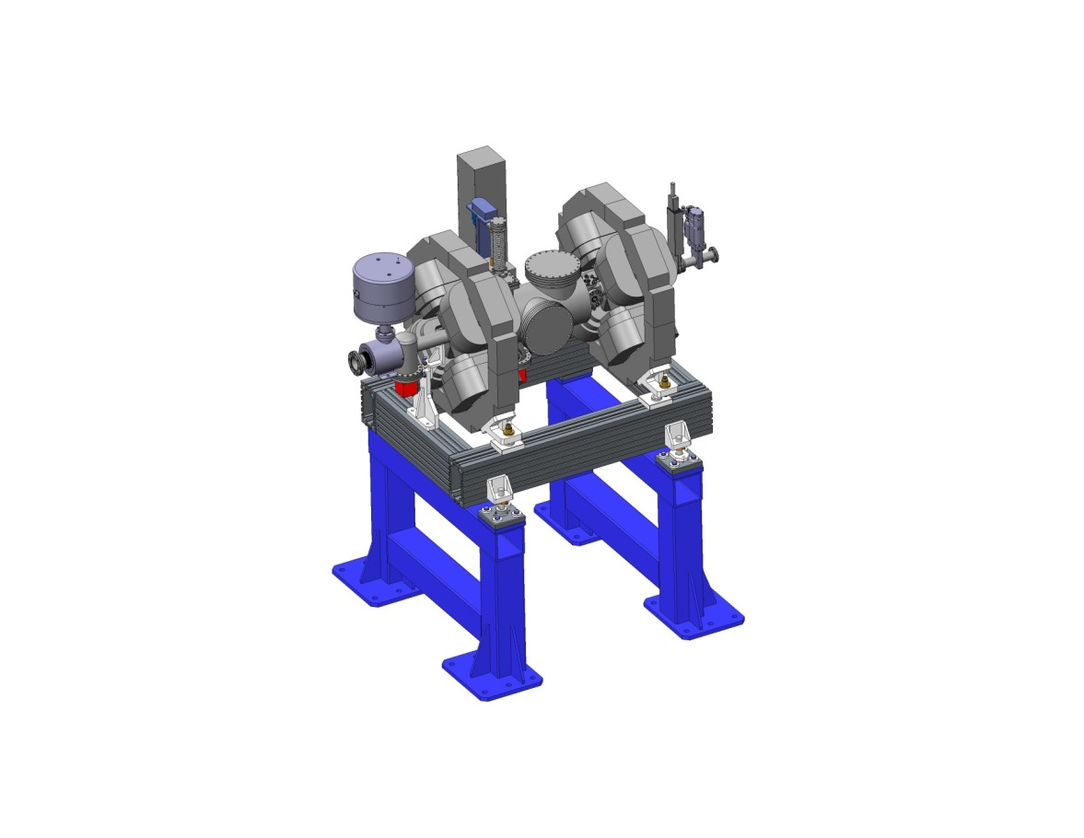

Figure 1- STFC - Low Energy Differential Pumping Unit (LEDP)

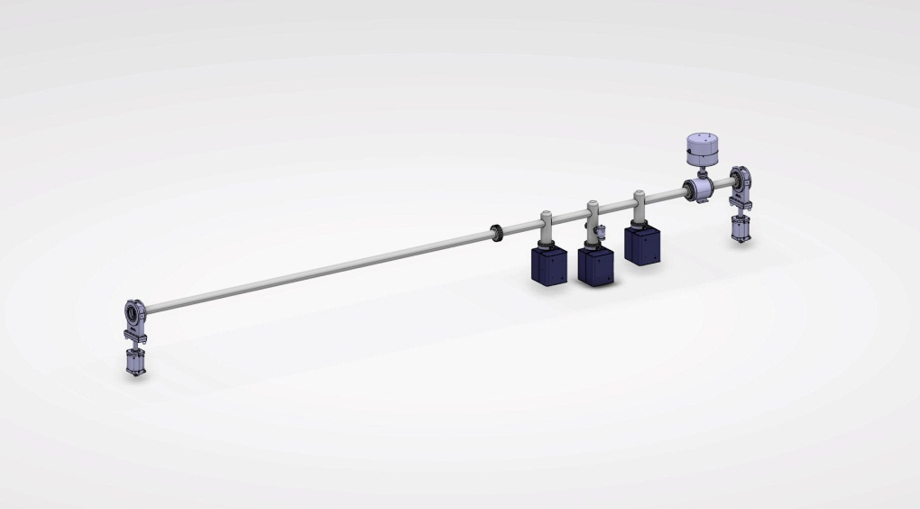

Figure 2 – ESS Design - High Energy Differential Pumping Unit (HEDP)

##### Linac Warm Units

The main package of work within this scope consists of 71 Linac Warm Units (LWUs), and two (2) prototype units. The LWUs will consist of a vacuum chamber and joining beam pipe to house BPMs, and pumping equipment. Each unit will also include four magnets (two quadrupoles and two correctors) and required support structure with adjustment. The units will have a variety of different designs depending upon the location along the beamline.  Each unit shall incorporate an overpressure protection burst disc, nominally rated at 1.2 bar differential pressure. This burst disc shall be sized to accommodate the maximum inflow of cryogens from the cryomodule in the event of failure of the cryogen containment boundary.

The LWUs assembled at the STFC will not include any diagnostics equipment (other than the BPMs & BCMs), all diagnostic equipment will be installed by ESS staff in the accelerator tunnel. Reference configuration is described in Chapter 2.1, Reference H. [SPN].

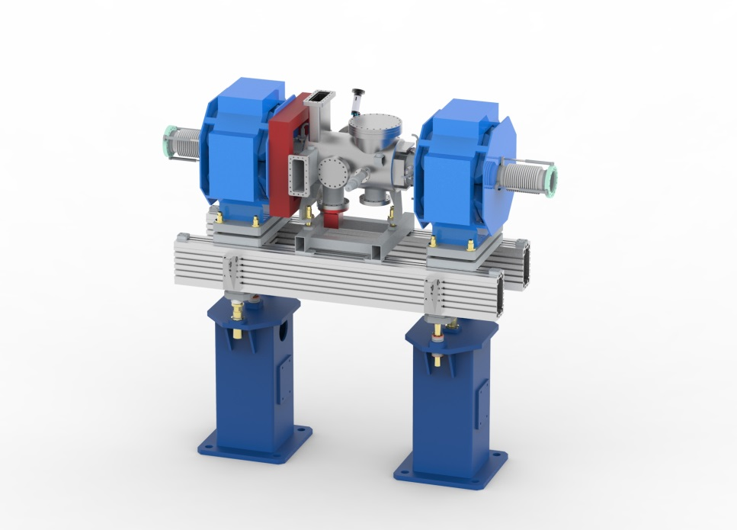

Figure 3- STFC CAD model of LWU

Two prototype LWUs will be required before production can start, one spoke and one elliptical. Due to current expected delivery time scales of the prototype magnets the, LWU prototype units will not include magnets.

Three dummy chambers for use by diagnostics team to test fitting of internal vacuum components, will also be supplied to ESS with the first prototype. They will be Vacuum chambers only and will sit on a basic none adjustable stand. They will not include any vacuum equipment.

The LWUs under discussion in this scope of work will sit in various locations along the accelerator including between adjoining cryo-modules, shown in Figure 4- LWU locations. At some points within the accelerator tunnel (specifically at the dogleg) the LWU/Beam Pipe Modules will need to straddle a trench, and as such a different support structure will be needed in these locations.

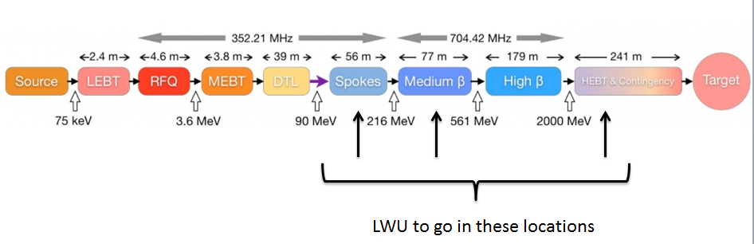

Figure 4- LWU locations

##### Beam Pipe Modules

This work package also contains 57 beam pipe sections, comprising a bellows at both end and a central pumping port, they do not require diagnostic ports or BPMs. The beam pipe sections will be supplied on a minimal support frame which offers adjustment only on the beam pipe and not on the frame work, is shown in Figure 5- STFC Beam Pipe Module Used for costing. The beam pipe sections will not be supplied with any vacuum equipment.

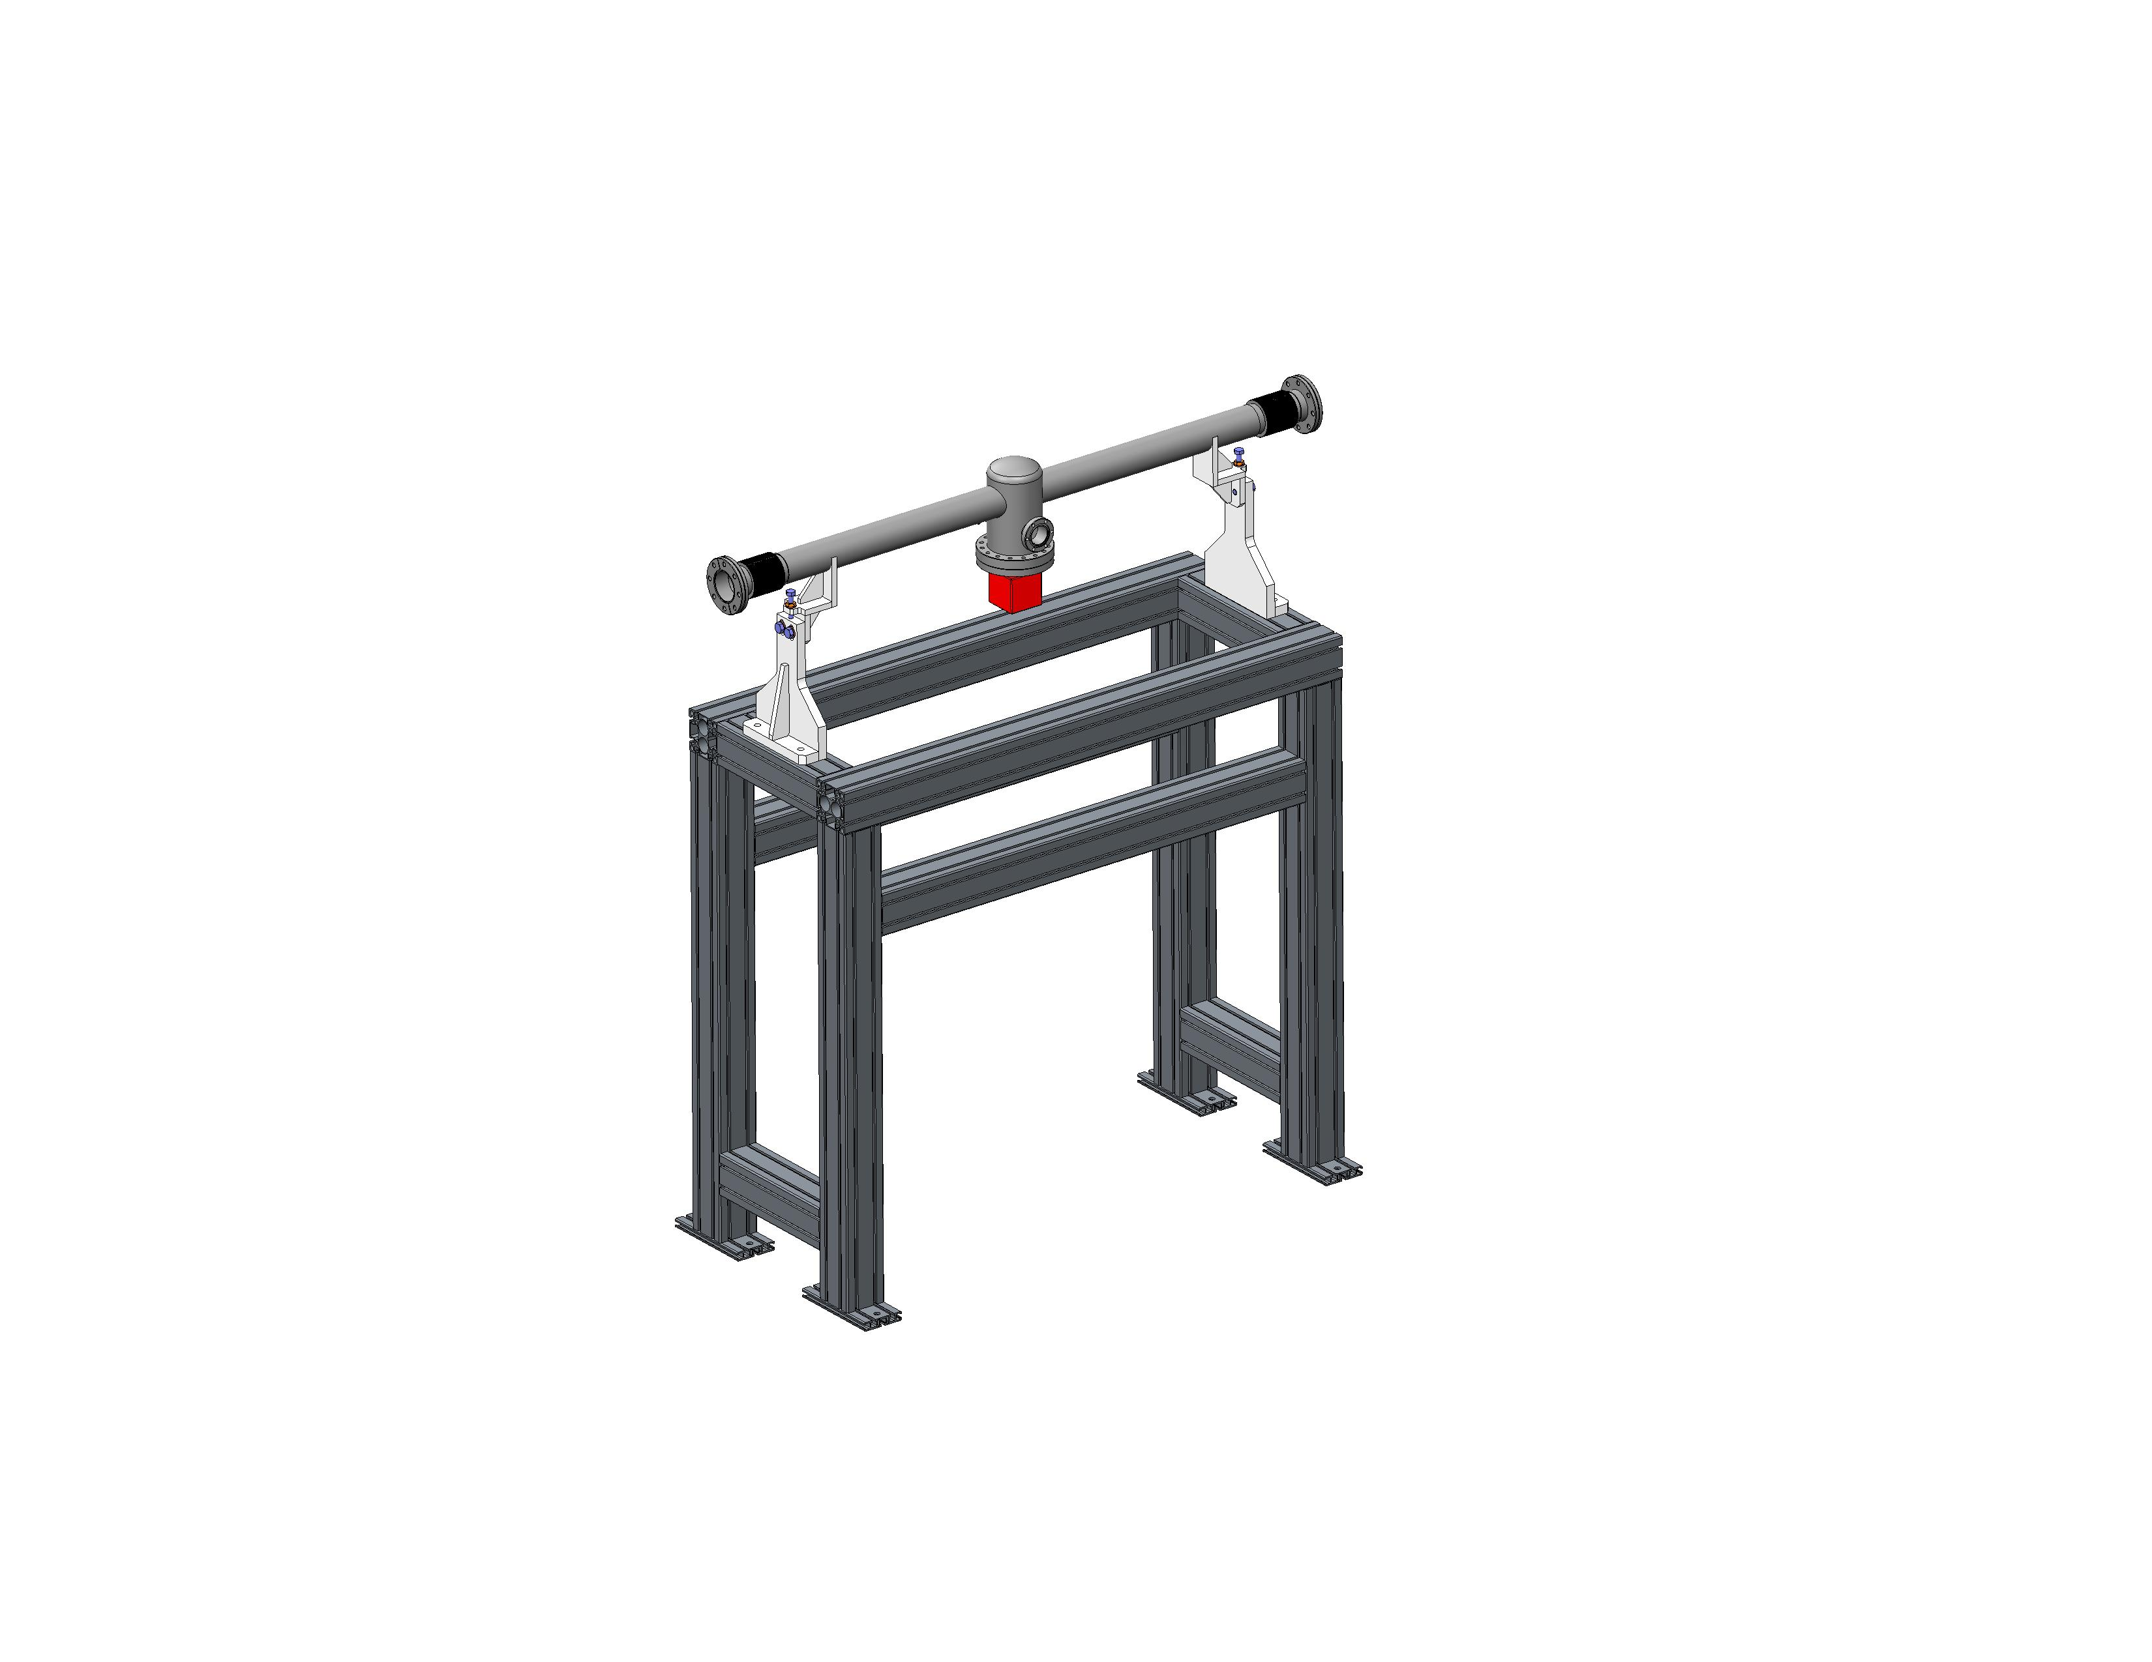

Figure 5- STFC Beam Pipe Module Used for costing

##### Mobile Cleanrooms

Portable Clean Rooms will be produced for installation of the LWU’s, LEDP and HEDP to provide a low particle environment for the beam line connection to the cryomodules during installation and also for the installation of beam line instrumentation. STFC will design and specify suitable mobile cleanrooms to be used for installation of beam transport modules and beam instrumentation in this work package.

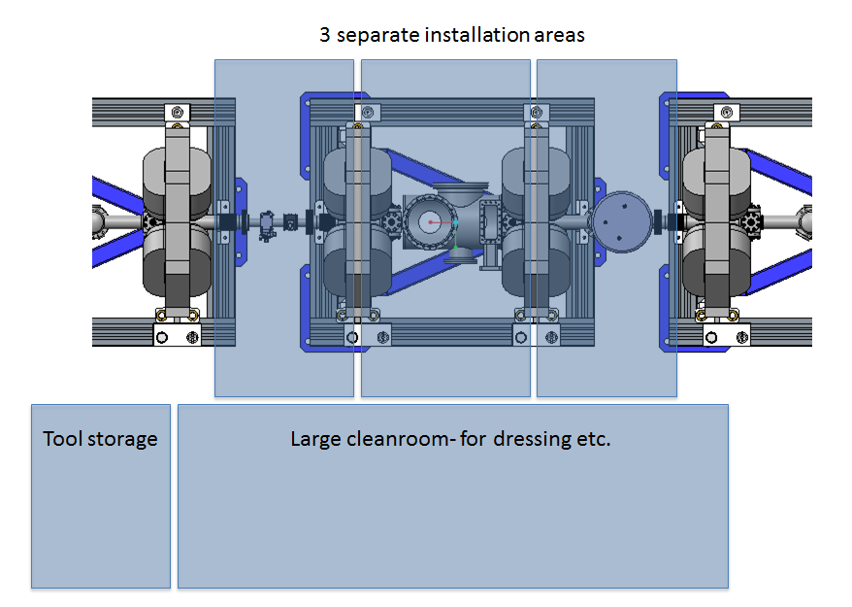

Figure 6 - One complete Cleanroom assembly example

This work package also include procurement and assembly of three (3) complete clean room assemblies.

Included

* Mobile cleanroom to fit over beam transport modules encompassing Cyromodule connections – ISO 5 or better
* Attached clean area for dressing – ISO 6-7 or better
* Attached clean tool area – ISO 5 or better
* 2 x Handheld and 3 x Portable Particle Counters

Excluded

* Leak detector
* Pumping Cart

A full mobile cleanroom specification is included in Chapter 2.1, Reference H. [SPN].

##### ESS Staff at STFC

In order to achieve the necessary experience level ESS will send eight technicians for training on handling and assembling of particle free chambers at STFC. It is suggested that the staff is split into teams of 2-4 and should spend upto 4 weeks at STFC Daresbury during the build phase, (between April 17 and October 19 to be agreed). STFC will supply all equipment and supplies for ESS Staff at STFC to undertake this work and ESS cover living expenses.

##### Magnets

Magnets will be supplied by ESS to STFC on contract loan for integration onto the LWUs. Each of the LWUs (excluding the two prototypes) will have two quadrupole magnets and one combined horizontal and vertical correctors. A total of 139 quadrupoles and 72 correctors will be supplied to the STFC for integration onto the LWUs (note, no other beam transport modules require magnets).

All magnets shall be designed to be within a given space envelope, and shall be designed in such as fashion as to allow horizontal splitting of the magnet for installation/removal of the vacuum chamber and beam pipes. It will be the responsibility of ESS to provide magnet fiducials and measurement of fiducial locations relative to magnet centres. It will be the responsibility of the ESS to provide suitable lifting points as agreed with STFC. The ESS must also supply 3D CAD files in STEP or IGES format for inclusion in the STFC CAD models.

STFC will work with the magnet IKC supplier to ESS to input into the design of the required interface to the STFC support structures, as well as to supply information regarding location of lifting provisions and survey points. STFC shall be included in magnet design reviews with the relevant in-kind contributors.

As noted above the magnets will not be ready in time for delivery with the prototype unit. Magnets have been assumed to be of pulsed design and do not require water cooling. Alteration of the LWU design due to magnet parameters will result in a delay to the project. The prototypes will be designed for a generic magnet space envelope and will be manufactured as such unless the final magnet design can be agreed upon before the prototype final design review.

Included

* Visual inspection on delivery for damage during transit
* Input into design reviews with magnet in kind contributor to discuss;
  + Size envelope
  + Survey and alignment
  + Mechanical mounting methods
  + Lifting points
* Assembly and Alignment of magnets on the girder
* Continuity tests will be carried out following assembly

Excluded

* Magnet Specification
* Magnet Design
* Magnet procurement
* Water cooling pipework
* All Magnet wiring
* Magnet testing at STFC
* 3D co-ordinates of magnet centre to be supplied by IKC

##### Diagnostics

No bolt in diagnostics will be included or assembled within this work package. The only diagnostics included are those listed below. This diagnostic equipment delivered to the STFC for integration into the vacuum vessel (either flanged or welded) should be UHV cleaned to ASTeC Vacuum Specifications, leak tested and come with RGA gas scan data. Port locations provisioned for the later installation of diagnostics by ESS will be fitted with blank flanges.

***BPMs***

Beam Position Monitors (BPMs) shall be of button type and shall be welded into a machined block which will be assembled on to the chamber by the STFC. BPM Pickups will be provided by ESS on contract loan to STFC.

Although the design is excluded the STFC shall be included in BPM design reviews with the relevant in-kind contributor.

Included

* Procurement and design of BPM block
* Assembly of BPM into vacuum chamber
* Inspection of BPM design files for manufacturing and mechanical integration into the LWU
* If required, propose modifications to the BPM design for any new requirement after coordinating this with ESS.
* BPM electrical centre measurement
* BPM Mapping Measurements of 10 BPM blocks, 1mm step size.

Excluded

* Procurement BPM Electrodes
* Procurement BPM Feedthroughs
* Procurement / assembly of BPM Local connections
* BPM Specification
* Design to be done by ESS & IKC, however STFC should be included in the design reviews.
* S-parameter measurement of individual electrodes and completed BPMs Procurement of BPM readout electronics based on the ESS centralised design
* BPM specifications
* BPM main design
* Electromagnetic simulations
* BPM cable
* Software
* Firmware
* Cabling

***BCMs***

Beam Current Monitors (BCMs) will be designed by The ESS, however STFC shall be included in BCM design reviews with the relevant in-kind contributor. Chamber design will be based around flanged BCMs. Four BCM units will be required in total.

Included

* Choosing proper ACCT size for mechanical integration
* Procurement of ACCT toroid’s and shielding
* Procurement and installation of ACCT ceramic breaks
* Installation of ACCT toroid’s and shielding on vacuum chamber
* Providing low-impedance path for return current
* Cable support points

Excluded

* Procurement of BCM readout electronics
* BCM specification
* BCM simulations
* BCM design
* ACCT specifications (except size)
* Cabling
* Any extra hardware for BCM calibration
* Software
* Firmware
* Testing

##### Survey and Alignment

Each beam transport module will include fiducial points on the girder and chambers in accordance with ESS-0012977 Fiducial Guidelines, Chapter 2.2, Reference P [SAG]. That is that fiducials should include one of the following methods for positioning of a 1.5” prism;

* 6H7 Machined Hole
* Glued assembly with M6 Hole
* Cone directly machined onto the component.

Fiducial locations, including orientation shall be approved by ESS survey and alignment team prior to STFC’s implementation.

Before packing final alignment of each module will performed in a temperature controlled room (22.5oC) and a report produced.

Included

* Alignment of BPMs and Magnets relative to the girder
* Documentation of survey equipment to be used
* Documentation of procedure and setup
* Data to be supplied in spatial analyser format
* Magnets and BPMs fiducials to be aligned within ±50µm to the fiducials on the girder which will form the local network

Excluded

* Responsibility for magnet fiducials
* Measurement of magnetic centre relative to the magnet fiducials
* Survey and alignment of the beam pipe modules

##### Vacuum Inspection and Particle Counting

Beam pipes shall be checked for cleanliness and leak tested in accordance with the ASTeC vacuum specifications (listed in Chapter 2.2, Reference Q) as well as the ESS Vacuum Handbook. A base vacuum of ~5x10-8 mbar at the 10 hour point shall be achieved with the bellows constrained and the end flanges blanked.

It has been agreed that only 44 of the LWUs require particle counting and only 21 of the beam pipe units, these units will be particle counted in accordance with the method detailed in Chapter 2.1, Reference H specification for WP12 Particle Count Procedure.

This activity shall include the following:

* Chamber / beam pipe design and procurement to conform to ESS Vacuum Handbook / ASTeC vacuum specifications
* Evacuation and leak testing
* RGA scans to clarify system cleanliness
* Particle counting and tests in accordance with the particle count procedure laid out in Chapter 2.1, Reference H specification for WP12 Particle Count Procedure – to be agreed between ESS and STFC
* Appropriate vacuum procedures to determine the base pressure of each system.
* Run outgassing tests
* All beam pipe to be cleaned and particle counted to ISO class 5 (or ISO 6 in certain circumstances) to be demonstrated with an agreed purge test method between ESS and STFC.
* Chambers shall be assembled in at rest ISO 5 Cleanroom.
* Blanking Flanges for unused ports
* Procurement of control units & power supplies for pumps & gauges, not including getter controllers

Excluded

* Integration of control units and power supplies
* Fast acting protection valves any beam transport modules not listed above
* Pumping carts for LEDP/HEDP
* Safety sector valves
* Pumping sector valves
* Gauge, Pump and BPM cables from unit to controller
* Integration Racks

##### Engineering, CAD and Accelerator Module Integration

All design work will be undertaken in PTC’s Creo, files can be shared via step format to the ESS through the ESS’s webportal, in accordance with the ESS CAD file handbooks.

Included

* Design of vacuum chambers, support structures and alignment mounts.
  + Beam pipe units will have limited adjustment and come on a basic aluminium extrusion frame structure
* Alignment design will be reviewed by ESS prior to production.
* Key milestones and gateways will be set and design reviews will take place at specified intervals, as detailed in the project plan
  + Conceptual design review
  + Before production of the prototype
  + After the prototype has been built but before full beam transport module production starts
* Provide CAD Models of each LWU, HEDP & LEDP before procurement
* Provide Assembly Drawings for each type of LWU, HEDP & LEDP
* Establish that the components fit in the space volume and there is adequate space for operations and maintenance
* Conduct value engineering with assessment of risks to provide a cost effective design
* Detailed drawings shall be submitted for review prior to manufacture
* Drawing package and parts list to be sent before initial shipment
* Design of support structures and adjustment components
* Design and produce prototype units prior in advance of main shipments
* Design and produce dummy 3 chambers and support stands for spoke LWU
* STFC to fully assemble and test all beam transport modules systems, which will include:
  + Dimensional checks
  + Mechanical component checks, vacuum performance and operation

Excluded

* Design of diagnostics equipment
* Integration of diagnostic equipment, other than BPMs and BCMs
* Design electronics racks and tray work
* No spares will be provided

##### Power Supply, Control and Instrumentation

Included

* Power supply and controllers for Ion Pumps
* Power supply and controllers for vacuum gauges
* Controllers for fast valves supplied

Excluded

* Local BPM electronics
* Testing of any diagnostic equipment including BPMS, BCMs,
* Magnet wiring
* Any magnet tests other than continuity tests
* Integration of diagnostic equipment, other than BPMs & BCMs
* All diagnostic ports to be blanked.
* Any controls support or EPICS protocol
* Any electrical support
* Integration of ion pump controllers and power supplies on to the LWU
* Integration of pressure gauge controllers and power supplies on to the LWU
* Installation of ion pump controllers and power supplies at ESS
* Installation of pressure gauge controllers and power supplies at ESS
* Shipping of control units and power supplies
* BPM Cables and patch panels
* Cables from LWU items to control unit

#### Extent of Supply of Vacuum Equipment

Included

* Specification of Ion Pumps or combined ion/getter pumps
* Procurement of Ion Pumps or combined ion/getter pumps
* Specification of Penning Gauges / Thermal conductivity Gauges
* Procurement of Penning Gauges / Thermal conductivity Gauges
* Design for a controlled (Soft Start) pumping and venting capability
* HEDP to include fast valve protection of upstream components
* LEDP to include fast valve protection of downstream components
* A2T LWU to include fast valve protection of upstream components
* Dump line LWUs to include fast valve protection of upstream components
* Fast acting vacuum sensors
* Fast acting valve / shutter controllers
* Specification of over pressure protection burst disc
* Procurement of over pressure protection burst disc
* Procurement of control units & power supplies for all vacuum equipment (pumps & gauges)
* Blanking flanges for unused ports

Excluded

* Integration of control units and power supplies for all vacuum equipment
* Fast acting protection valves any beam transport modules not listed above
* Pumping carts for LEDP/HEDP installation
* Safety sector Valves
* Pumping sector valves
* Gauge, Pump and BPM cables from unit to controller
* Integration Racks
* Ion Getter control units for combined pumps

## Project Stages Definition

### Stage 1: Design Stage

#### Preliminary Design

Preliminary design prepares for and precedes detailed design and may involve: design, safety and other analyses and simulations; prototyping; trade-off analyses, and the further development (updating) and documentation of requirements and specifications of the ESS baseline reference design, including definition of interfaces.

Preliminary design starts upon successful completion of a Kick-Off Meeting, which may include a review of ESS inputs for any baseline reference design including [REQ] and [SPN]. See Chapter 2.1 Preliminary design ends with the successful completion of PDR - Preliminary Design Review.

#### Detailed Design

Detailed design completes the Design Stage. Detailed design may involve: further analyses and simulations; prototyping; the further development and documentation of requirements and specifications including definition of interfaces; and other detailed documentation of the design through reports, 3D models and drawings which enable Realisation through procurement and/or construction / manufacture and assembly. The design is detailed and verified by way of analysis and/or test down to the lowest level selected by the Partner and agreed with ESS. This includes but is not necessarily limited to:

* Carrying out detailed optimization of the facility element mechanical, fluid, thermal, optical, electro- optical, electronic and electrical subsystems in relation to the requirements.
* Expanding and consolidating the interface definitions for the facility element including description of the interfaces with ESS Site Infrastructure / buildings and ESS Integrated Control System (ICS) (e.g. clearance for stations, access, power, storage, pre-assembly areas, data format and rate, signals).
* identifying and analysing possible design-related hazards to personnel who will operate and maintain the facility element,
* Scheduling for the manufacture, assembly and testing and establishing integrated logistics requirements and solutions for the future operation of the facility elements.
* Analysing estimating probability and consequences of failures in their equipment as well as foreseen main maintenance tasks and proposed spare parts. The objective is to estimate the contribution of their system to the ESS downtime requirements and to define the maintenance and spare parts that would be needed to reach such goals. ESS RAMI team will provide templates and guidance when needed.
* Documenting:
  + describing logistics needs for the facility element (e.g. test equipment, storage, transportation, handling and packaging, expected preventive and corrective maintenance activities),
  + updating design descriptions of the facility element including written specifications, CAD models, drawings, P&ID etc.
  + planning for test and verification activities
  + updating [REQ] with PBS level 4 requirements, and updating [SPN]

The Partner shall justify that their proposed detailed design descriptions (CAD models etc) conforms to or meets the updated {REQ] and [SPN], by showing:

1. the ability of the design to fulfil the requirements, supported by showing an appropriate traceability between the requirements and the proposed design features.
2. that preparations for procurement, manufacturing and assembly is advanced including for example:
   * procurement: technical specifications and statements of work for vendors/sub-contractors
   * in-house manufacture and assembly: manufacturing methods, processing and tooling requirements known.

Detailed design starts upon successful completion of Preliminary Design Review. Detailed Design (and Stage 1) ends with the successful completion of CDR - Critical Design Review.

### Stage 2: Realization and Verification

During Stage 2, systems and components are ‘realised’ (made real) and also verified. The deliverables of Stage 1 such as design reports, detailed design and prototypes, become tangible hardware and software products through procurement, manufacturing and assembling. Hardware systems are then verified, through inspection, demonstration, analysis and testing, comparing hardware physical characteristics and actual performance with agreed design, specifications and performance requirements.

Realisation and verification are overlapping phases and together include but are not necessarily limited to:

* Following up when applicable the fabrication actions and transportation process,
* Carrying out the verification activities including Factory Acceptance Testing (FAT).
* Storing and handling the product in conditions that ensure its integrity,
* Transporting the systems and components to ESS site and mailing or uploading corresponding documentation to the ESS WU coordinator.
* Reporting and documenting in verification reports, which will include test reports, the outcomes of the verification activities, and
* Presenting a technical data package including verification reports for review at System Acceptance Review (SAR).

Stage 2 starts with successful completion of CDR(s). Stage 2 ends with the successful completion of verification activities and the confirmation of this by SARs for each type of hardware deliverable.

### Stage 3: Support during Installation

See 4.1.2.1.6.

## Project Schedule and Key Milestones

The purpose of dates set out in table 5 is for the Parties to monitor SoW progress and for tracking Earned Value

| **Milestone ID** | **Short description** | **Planned/**  **Baseline date** | **Location** | **Comment** | **Weighted MS value %**  **See 5.1.5** |
| --- | --- | --- | --- | --- | --- |
|  | Progress meetings and reporting | Twice-monthly meetings  Monthly reports | As agreed | Physical meetings or via video/teleconference as agreed by Parties in advance of each meeting | 1 % |
| A41910 | Vacuum Lab commissioned | 31 July 2015 | ESS Lund |  | 8 % |
| A20146050 | PDR | 10 Nov 2015 | ESS Lund |  | 1 % |
| A20146060 | CDRs | Jun 20-21, 2016  November 2016 | Partner premises | 1 x CDR for each major equipment type | 15 % |
| A20146060 | SARs | Timetable to be agreed by Parties | Partner premises | 1 x SAR for each major equipment type | 50 % |
|  | Final Report & final deliverables |  |  |  | 25 % |
| **Total Weighted Milestone Value** | | | | | **100%** |

Table 5- Project schedule

The Partner shall use the following schedule for internal milestone tracking:

|  |  |  |
| --- | --- | --- |
| Date | Pipes Ready to Ship* | LWU Ready to Ship* |
| 31/01/2018 | 20 | 0 |
| 30/07/2018 | 30 | 0 |
| 26/01/2019 | 48 | 1 |
| 25/07/2019 | 52 | 31 |
| 21/01/2020 | 0 | 58 |
| 19/07/2020 | 0 | 74 |

Table 6- Project schedule

### Kick-off meeting

Took place on the 26/03/15.

### Status meetings

A status meeting shall be held twice every month during the whole duration of the project. Status meetings may be held at the ESS or Partner’s premises or over the telephone/video conferencing facilities available.

The purpose with the meeting is to review progress, risks, review/decide on change requests and discuss upcoming activities and potential challenges. The Parties shall take minutes for all meetings and record and track action items and their progress and resolution.

The Partner shall provide input for the ESS WU coordinator’s Monthly Status Report.

### Design Review(s) in Stage 1

#### PDR

Completed.

#### CDR

Critical Design Reviews (CDR) assess design completion. A successful CDR demonstrates that the design for any particular system or component is sufficiently mature for the Partner to proceed with series procurement, fabrication, assembly, integration, and verification for that particular system or component. The CDR should also review planning for verification. A successful CDR establishes a new baseline, described in [CMP] Chapter 5.1.5.3 as the ‘Design Baseline’ from which the Partner may proceed to Stage 2 Realisation and Verification. The Parties will plan and schedule sufficient number of CDRs to cover the design of each different system and component deliverable. See 4.1 including Table 1.

For planning purposes CDRs can be expected to be conducted at the Partners premises. The duration for a CDR depends on the complexity of design and the number of different systems and components whose design is planned for review at a particular CDR.

As early as possible before each CDR, ESS shall, in cooperation with the Partner develop a ‘charge’ confirming deliverables to be reviewed i.e. the exact contents of the technical data package, nominating the review committee, proposing and agenda, listing participants and containing other coordinating information for the review. Note that the technical data package for each CDR should be delivered at least five (5) weeks prior to that CDR, or on a specific date agreed between the Parties for each CDR.

The review meeting should include presentations by the Partner describing the design work undertaken, and explain each deliverable of the data package, and responding to questions raised by ESS in their pre-review of the technical data package deliverables.

ESS shall deliver a verbal report at the conclusion of each CDR and written report as soon as possible after the completion of each CDR stating outcome, approval or otherwise, and any actions or recommendations.

### Readiness / Acceptance Review(s) in Stage 2

#### TRR

Not applicable.

#### SAR

System Acceptance Reviews (SAR) examines each different type of series system and component hardware as-built and its type verification documentation (inspection reports, demonstration reports, test reports) for verification defined in verification planning, such as FAT. The SAR ensures that the all system requirements have been verified and that this type of equipment can be installed at ESS site. A successful SAR establishes a new baseline, described in [CMP] Chapter 5.1.5.5 as the ‘Performance Baseline’ from which ESS and/or the Partner may proceed with installation and commissioning involving all series delivers of the particular system or component successfully reviewed at SAR.

The review shall be organized by European Spallation Source ERIC and will involve the Partner as well as any other stakeholders at the discretion of the review chairman. The chair of the review committee is appointed by European Spallation Source ERIC. The membership of the committee is communicated to the review participants at the earliest possible time.

Parties may agree where and when a particular SAR for a particular system or component type should be conducted. For example any particular SAR may be conducted at the Partners premises, following FAT and other verification of a first-of type system or component at the Partners premises. Alternatively a SAR may be conducted at ESS site, after successful completion of any agreed verification at ESS site, including Site Acceptance Testing (SAT). The duration for a particular SAR depends on the complexity of the verification results to be reviewed.

As early as possible before each SAR, ESS shall, in cooperation with the Partner develop a ‘charge’ confirming deliverables to be reviewed i.e. the exact contents of the technical data package, nominating the review committee, proposing and agenda, listing participants and containing other coordinating information for the review. Note that the technical data package for each SAR should be delivered at least five (5) weeks prior to that SAR, or on a specific date agreed between the Parties for each SAR.

The review meeting should include presentations by the Partner describing the procurement, production, assembly and verification work undertaken, and explain each deliverable of the data package, and responding to questions raised by ESS in their pre-review of the technical data package deliverables.

ESS shall deliver a verbal report at the conclusion of each SAR and written report as soon as possible after the completion of each SAR stating outcome, approval or otherwise, and any actions or recommendations. The successful completion of a SAR may be a prerequisite for transfer of ownership as defined in [IKA] and for crediting values to the Partner.

### Reviews in Stage 3

Not applicable.

## Deliverables

### Status reports

The parties shall agree the format and content of the Partner’s input for Monthly Status Report.

### Technical Data Package for Design Reviews (Stage 1).

The Stage 1 data packages shall address outcomes and output for activities undertaken during Stage 1. When reviewed and approved at PDR and at CDRs, the documents of each data package establish new technical baselines. See [CMP] Chapter 5.1.5.

#### Technical Data Packages for PDR

#### Delivered in 2015.

#### Technical Data Packages for CDRs

The contents of the technical data package for each CDR shall be specifically agreed in each charge, and should include but not be limited to:

* Requirements, agreed or proposed updates to documents comprising the baseline reference design, such as [REQ] , [SPN] etc. See Chapter 2.1.
* Design Reports, including reports of prototyping and other design-related analyses, tests, simulations.
* Design Data, (detailed design level) including 3D CAD models and CAD drawings, general arrangement drawings, P&ID, FE models, etc., and detailed interface descriptions including interface identification and definition for controlling interface design.
* RAMI Report, a report of the estimation of the probability and consequences of failures in equipment as well as main maintenance tasks and proposed spare parts. See 4.2.1.2.
* Hazard analysis Report, an initial version of a report including identified hazards and evaluation of the likelihood of incidents occurring during operation and maintenance and severity of potential consequences on personnel, as well as the list of control measures). Examples of hazard analysis studies can be made available upon request.
* Verification Plan, (including planned FAT and any SAT activities)
* [PQP], updates for the Project Quality Plan applicable for the systems and components for each particular CDR, including identification of Standards applied in design, procurement, manufacture and assembly, and planning for compliance testing and inspection. See 5.5.3.

Where applicable, a CDR technical data package shall also contain documentation to initiate a competitive tender for the procurement of the systems or components whose design is the subject of the CDR. In such cases, the CDR data package should additionally include but not necessarily be limited to:

* Procurement Package, a complete documentation package for the procurement of the facility element including as a minimum a statement of work, manufacturing follow-up description, applicable and reference documentation
* Project Plan , updated plan in Gantt chart form, describing in detail remaining Stage 1 activities, describing in detail Stage 2 Realisation & Verification activities, and an outline of any Stage 3 Installation, Commissioning and Initial Operations activities for the Partner. See 5.1
* Risks, Risk Register, showing identified project management risks and/or technical risks. See 5.2.

### Technical Data Packages for Reviews, Stage 2

The technical data packages for SARs shall address outcomes and output for activities undertaken during Stage 2. When reviewed and approved at each SAR, the documents of each data package establish new technical baseline for the subject systems and components. See [CMP] Chapter 5.1.5.

#### Technical Data Packages for TRRs

Not applicable.

#### Technical Data Packages for SARs

The contents of the technical data package for each SAR shall be specifically agreed in each charge, and should include but not be limited to:

* Requirements, agreed or proposed updates to documents comprising the baseline reference design, such as [REQ] , [SPN] etc. See Chapter 2.1.
* Design Data, to conform with ‘as-built’, ‘as-verified’ and ‘as-delivered’ configuration, including 3D CAD models and CAD drawings, general arrangement drawings, P&ID, FE models, etc., and detailed interface descriptions including interface identification and definition for controlling interface design.
* RAMI Report, any updates to the report of the estimation of the probability and consequences of failures in equipment as well as main maintenance tasks and proposed spare parts, to reflect the ‘as-built’, ‘as-verified’ and ‘as-delivered’ configuration baseline. See 4.2.1.2.
* Installation instructions.
* Data for Operations and Maintenance, operator manuals or instructions, maintenance manuals, lists of tools and test equipment, illustrated parts lists / Bills of Materials, recommended spares lists
* Hazard analysis Report, any updates to the Hazard analysis Report needed to reflect the ‘as-built’, ‘as-verified’ and ‘as-delivered’ configuration baseline. See 5.5.2.Verification Plan, Specifications and Report(s). This includes:
  + verification plan (or updated plan delivered from a previous data package e.g. at CDR),
  + verification specifications for each planned verification activity (or updated verification spec. delivered from a previous data package
  + verification report(s) showing the summary of each verification activity, the results / outcomes for each verification activity, including from FAT, and if applicable SAT.
* [PQP], any updates to the Project Quality Plan needed to reflect the ‘as-built’, ‘as-verified’ and ‘as-delivered’ configuration baseline, and compliance records and certificates. See 5.5.3.

### Technical Data Packages during Stage 3

#### Technical Data Packages for ORR

No applicable.

### Final report

The Partner shall issue a final written report to the European Spallation Source ERIC within four (4) weeks of the earliest occurrence of the following: (a) completion of the stages, or (b) the expiration of this Agreement, or (c) prior termination of this Agreement. Such report shall include a comprehensive summary of the contributions made, works and services undertaken and Project Results achieved.

### Documentation package for supply

The Partner shall deliver at the completion of the project:

* Finalised Stage 1 data package(s),
* Finalised Stage 2 data package(s),
* data sheets for systems and components delivered,
* certificates for inspections, and qualifying / certifying / regulatory assessments
* all CAD models

# Tasks applicable to all project stages

## Project management and control

ESS is mandated to use Earned Value Management as a tool for managing progress and performance. This translates into a requirement for tracking deliverables from Partners. Below, Chapter 5.1.1 – 5.1.6, the requirements concerning scheduling and progress reporting in order to comply with this requirement. Templates and instructions for managing the milestone schedule, including the associated earn value basis are found within the Applicable documents.

### Use of a Planning Tool

The Partner should use a planning tool (MS Project, Oracle Primavera, Deltek Open Plan or similar). The purpose with this requirement is to enforce a systematic approach to planning, both creating and maintaining the plan.

As part of the monthly status report, the current schedule should be made available for ESS (electronic format).

### Delivery Milestones

Each distinct delivery should have a milestone with a date. This also includes part or incremental deliveries.

### Milestone Definition List

Each Milestone should have a number, name and a definition (captured in a Milestone Definition List such as Table 5). The definition should both explain the content and fulfilment of the milestone and delivery.

### Interim Milestones

If the duration of the project work producing the deliverable is more than 6 months, the plan should also contain interim milestones. The purpose with interim milestones is to measure progress and to be used for signalling issues in the fulfilment of the delivery (in the interest of both parties).

### EV – Weighted MS value

Each milestone, both interim and delivery milestones, should be associated with a weight (percentage between 0-100). The aggregated fulfilment of all milestones should result in 100%.

### Monthly Forecasting

In conjunction with the status reporting, the Partner should also provide an updated forecast for the upcoming milestones, as well as the final delivery milestone.

## Risk Management

ESS uses Risk Management as one of the Project Management tools to assist the execution of the Programme. The Partner’s contribution in this field is vital and shall therefor form a part of ESS Risk Management Process.

The contribution shall be characterized by risk awareness and open communication regarding risks. The common view of risks and uncertainties are utilized as a stepping-stone to the identification and exploitation of opportunities.

### ESS Risk Management Process

Risk Management shall be incorporated as a part of the day-to-day work with the contribution. The Partner shall work according to ESS Risk Management Process, including:

* Plan Risk Management
* Identify risk,
* Analyse risk,
* Risk treatment, and
* Monitor and control risk.

### ESS risk criteria

When analysing risk, ESS’ risk criteria shall be used. Using ESS’ criteria for likelihood and consequence enables Partner and ESS to analyse risks in a uniformed way.

The ESS acceptance criteria clarify what risk level that ESS accepts, and when risk treatments are required. All combinations of likelihoods and consequences correspond to a risk level, either being high, medium or low. This is graphically presented in the ESS risk matrix.

Risk treatments are the measures being taken in order to treat the risk to an acceptable level. High-level risks can never be accepted and require treatment. Medium-level risks can be accepted without treatment if the treatment is not proportional to the gained improvements. Low-level risks can be accepted without treatments.

### Risk register

The risk register shall contain the gathered knowledge of identified risks, including the assessed risk exposure. The register shall show identified risks in order of priority, including risk treatment plans.

The Partner should preferably use ESS Risk Management software system, used for systematic documentation of risk registers. If not, the Partner risk register format shall be according to ESS’ requirements.

### Risk status report

Risk status reports shall include summary describing news and relevant changes to the risk exposure, including on-going Risk Management activities. It shall furthermore contain an updated risk register including risk treatment status.

## Configuration management

The Parties shall identify and progressively develop configuration baselines for the systems and components described in this SoW. The Parties should follow the principles of configuration management as laid down in the ESS configuration management plan [CMP], or agree equivalent best practices.

## Organization

The persons nominated as the Work-Unit (WU) Coordinator according to 6.3 in the Agreement are:

For the Partner (local coordinator): Paul Aden

For European Spallation Source ERIC: Marcelo Juni Ferreira

## Product & Quality assurance and safety

### Applicable law, legislation and standards

The Partner shall ensure that all work and deliverables comply with applicable European and national regulations, directives and other acts, and also any additionally specified standard, regulation or restriction identified in the documents of the baseline reference design specified in Chapter 2.1. The Partner shall identify and list the standards the Partner will comply with in executing this Sow, in the [PQP] and deliver applicable compliance record(s) in the Stage 2 data package. See Chapter 4.4

### Safety

The Partner is responsible, in accordance with applicable European and national regulations for safety and health at work, for the safe conduct of the activities to perform this SoW.

The Partner is also responsible for any Hazard analysis identified as scope in Chapter 4.2, Hazard analysis Report(s) identified as deliverables in Chapter 4.4.

ESS is responsible, in accordance with applicable European and Swedish regulations for safety and health at work, for the safe conduct of all activities on-site at ESS Lund. The radiological safety at ESS site and facility remains under the exclusive and sole responsibility of ESS.

It is also the responsibility of ESS to identify and describe any specific requirements, any specific Partner deliverables and any specific process(es) to be followed by the Partner to enable ESS Facility to operate safely.

### Quality

The Partner shall prepare a consistent and comprehensive Project Quality Plan which should generally conform with ESS template for [PQP]. See Chapter 2.1.

Planning and compliance documentation required might be principally generated from the Partner’s own quality management system when applying a system manual with defined procedures. However, a quality plan does not replace and is not a substitute for such a quality management system.

### Licensing

Licensing refers to the granting of permits to ESS by Swedish Radiation Safety Authority (SSM) to, progressively:

* construct the ESS facility buildings;
* procuring and possessing technical devices and other Components that could generate ionizing radiation or have a radiation safety function ;
* installing and commissioning these devices in ESS facility buildings and
* operating and maintaining these devices for neutron science users.

Unless otherwise described in the SoW including documents specified in Chapter 2.1, the licensing for systems and components that are either the Partner’s deliverables or ESS deliverables is under ESS responsibility.

ESS remains directly responsible to SSM for licensing and it is the responsibility of ESS to identify and describe in this SoW and/or documents specified in Chapter 2.1, any specific requirements for the Partner, any specific deliverables to be provided by the Partner and any specific process(es) to be followed by the Partner which enable ESS to achieve SSM licensing. ESS may at a later stage, request of the Partner additional information required by, or in support of ESS’ responsibilities for SSM licensing.

# Documentation format

All documentation and correspondence shall be in English.

All office documents shall be in a MS Word and PDF format.

All mechanical models and drawings shall be provide in a format editable using Catia V6.

# Transportation and DELIVERY

All major hardware deliverables shall be delivered DAP 2014 Incoterms unloaded at the final destination of European Spallation Source ERIC, Lund Sweden, exact address to be advised by ESS. All major deliveries shall be executed in accordance with the [LOG]. See Chapter 2.1.

# WaRRANTY

1. The Partner shall be responsible for procuring warranties on procured items. The Partner’s warranty defects responsibility for those subcontracted items is satisfied by passing on the benefit of subcontractors’ warranties to ESS ERIC and the Partner’s responsibility and liability for such defects in respect of subcontracted items is limited to assigning the benefit of the relevant subcontractor’s warranties to ESS ERIC accordingly, including disclosure of the full terms and conditions applicable to all such procured items.
2. During the procurement process a minimum of 12 months warranty will be requested in the procurement documents for the period from the date of delivery in accordance with Article 9.1 of the Agreement, with extended warranty options of a further 12 months and potentially additional consecutive 12 monthly extensions if agreed with ESS ERIC will be included in the procurement documentation requests. The decision on the length of warranty to be procured will be agreed between the Partner and ESS ERIC, taking into account value for money and the impact on the scope of works within the fixed budget.
3. The Parties agree that notwithstanding the provisions of clause 7.2.2 of the Aagreement, warranties relating to components or tangible deliverables shall be limited to two (2) years from their date of delivery (in accordance with article 9.1 of the IKCA), but the Parties shall be free to agree in writing to any extension or reduction in that warranty period subject to the Change Control Procedure and/or Article 8 (Variation) of the Agreement.

# EXCLUDED BACKGROUND

Not used.

# ACCESS RIGHTS to sub-contractor’s background and foreground

ESS ERIC acknowledges that notwithstanding the provisions set out in Articles 13.3.1.1 and 13.3.2.1 of the Agreement, Access Rights to the Partner’s sub-contractors and suppliers will not be available to it in respect of commercial off-the-shelf procurements. To the extent that the Partner procures any other items or services (including but not limited to design services) the Partner will use all reasonable endeavours during the procurement process to acquire and maintain all necessary rights in those items or services to enable it to grant ESS ERIC Access Rights on a royalty-free basis and without limitation in time and on the same terms as set out in Art 13.3 of the Agreement. In any event where the Partner procures design and build services, the availability of Access Rights to the Partner’s sub-contractors and suppliers Foreground and/or Background shall be made on the same terms as set out in Art 13.3 of the Agreement and the Partner shall be responsible for informing ESS ERIC of such availability (or any restrictions thereto) at the earliest possible convenience, and the Parties shall discuss and agree the Access Rights (so far as reasonably possible) during the procurement process.

**In Witness whereof**, the Agreement has been executed in two (2) originals, of which the Parties have received one (1) each.

**European Spallation Source ERIC** **Name of Partner**

_______________________________ ______________________________  
*Date Date*

_______________________________ ______________________________  
*Signature Signature*

_______________________________ ______________________________  
*Name (in block letters) Name (in block letters)*

_______________________________ ______________________________  
*Position Position*