|  |
| --- |
|  |
|  |
|  |
|  |
|  |
|  |
|  |
|  |
|  |
|  |
|  |

|  | Name | **Role/Title** |
| --- | --- | --- |
| **Owner** | Øystein Midttun | System Leader ion source and LEBT |
| **Reviewer** | Lena Johansson  Edgar Sargsyan | Radiation Protection Expert, ES&H  Section Leader Front End & Magnets |
| **Approver** | Håkan Danared | Group Leader Linac |

|  |  |
| --- | --- |
| Table of content | Page |

1. Scope 3

2. protection againt electric hazard 3

2.1. Discharge of energy 4

2.2. Size of earthing conductors 5

3. Protection against radiation hazard 5

4. references 8

Document Revision history 9

# Scope

This document describes the high voltage (HV) safety fence for the ESS ion source. The main function of the fence is to protect against the electrical hazard of the platform, which is biased to 75 kV during operation. In addition the fence has lead shielded walls to reduce the level of x-rays from the ion source, and openings at the top to allow the hydrogen gas to escape in case of a leak on the gas bottle.

The Personal Safety Systems (PSS) group at ESS is responsible for the electrical safety aspects, and access procedures of the HV safety fence [1]. The area inside the safety fence is named PSS0 controlled area.

# protection againt electric hazard

The first function of the HV safety fence (Figure 1) is to protect against the electric hazard of the HV platform. The platform is biased to 75 kV during nominal ion source operation, but the maximum voltage that can be applied by the HV power supply is 100 kV. The platform is supported by six 770 mm HV insulators [2], and is electrically connected to ground through five 50 MΩ resistors in parallel (total resistance of 10 MΩ) [3]. The HV insulators fulfil insulation levels for an operational voltage of 75 kV as stated in SS-EN 50341 chapter 5.3. In addition, the HV platform connects to ground through a ceramic insulator for vacuum, non-conducting fibre optic cables, and a 20 metre long non-conducting water pipe. An isolation transformer provides the mains power (three-phase, 400 VAC) to the equipment on the HV platform.

To prevent access to the PSS0 controlled area when the HV platform is energized, grounded floor-to-roof walls surround the complete platform. The closest wall is 18 cm from the HV platform, corresponding to the dimension of the ceramic insulator. This distance fulfils requirements according to regulations SS-EN 60071-1 Chapter A.2 Table A.1, which states a minimum creepage distance of 12 cm when operation voltage is 75kV. The standard also specifies that the distance may be shorter if tests on the actual system prove that the standard impulse withstand voltages are met (section A.1). The ceramic insulator has been tested to hold a voltage up to 90 kV, and has been running with a voltage of 75 kV for more than 1 year. The other walls are approximately 1 metre from the HV platform. The fence is designed to provide sufficient protection against the expected electrical and mechanical stresses, following European standard EN 50110-1.

In case of HV discharges between the HV platform and the HV safety fence, proper grounding of the fence is necessary. Section 2.1 described the details of energy discharges. The fence is electrically connected to the ground mesh of the accelerator tunnel through one grounding point at the centre of tunnel. This point connects to the grounding in the foundation of the accelerator tunnel as specified in [5]. Copper bus bars run along each side wall of the fence, and connect to each individual side wall plate. Adjacent wall panels are also electrically interconnected. On the LEBT girder there is a grounding bar for connecting the LEBT components. All grounding conductors will have a cross section lager than 16 mm2.

The lowest 2.5 meters of the HV fence walls are made of solid plates of 2 mm thick lead sheets sandwiched between two 2 mm aluminium plates (total thickness 6 mm). The last metre to the roof is made out of a square mesh of stainless steel with 2 mm spacing. The reason is to allow hydrogen gas to escape in case of a leak. The fence design is made according to the IP3x standard, required by European standard EN 50110-1. The mesh is electrically connected to each of the sidewall panels to ensure a proper grounding.

The cooling water to the ion source arrives through a plastic water hose, shown in pink behind the fence wall in Figure 1. To increase the length of the water, the hose is rolled around a cylindrical support to a total length of 20 metres. The hose is then routed on the inside of the fence to the water inlet next to the LEBT. Steels pipes penetrate the HV safety fence at this location in order to have a proper grounding of the water pipes.

The temperature and humidity conditions inside the HV safety fence will be the same as in the accelerator tunnel because of the openings on the top of the fence. These conditions will be maintained by the HVAC system.

## Discharge of energy

A HV discharge short-circuits the HV platform to ground potential. The HV power supply (PS) delivers a maximum current of 150 mA during operation, and in case of a short circuit to ground the PS will switch off. The PS is a short-circuit and flashover proof CE marked product that fulfils applicable EMC and safety standards.

The stored energy of the HV platform itself is negligible (< 0.1 nF) as the HV platform has a large distance to ground (18 cm). The stored energy is mainly in the HV PS capacitors. Figure 3 shows the circuit diagram of the power supply. The calculations below consider the maximum voltage of 100 kV.

* The smoothing capacitor in the HV PS output stage has a capacitance 2.5 nF which corresponds to a stored energy of 12.5 J. Considering a 1.36 kΩ resistor in the HV PS output, the discharge current will be around 74 A, and the RC time constant will be about 3.4 µS.
* The capacitors in the HV PS cascade have a capacitance 50 nF which corresponds to a stored energy of 250 J. Considering a 6.48 kΩ resistor and a 1.36 kΩ resistor in series at the HV PS output, the discharge current will be around 13 A, and the RC time constant will be about 390 µS.
* According to the cable specification, a cable of 15 m has a capacitance of approximately 1.5 nF. There is no resistor to limit the current from the cable.

To simplify the calculation of the discharge time, we assume that we first discharge the smoothing capacitor completely, and then we discharge the capacitors in the HV PS cascade. This simplification over-estimates the current, and in addition there is an exponential decrease of the current during the discharge not taken into account. We have:

* A discharge current of 74 A for 17 µs (5xRC) for the smoothing capacitors.
* A discharge current of 13 A for 2 ms (5xRC) to completely discharge the HV PS cascade.

## Size of earthing conductors

The standard SS-EN 50522, Annex D, provides a formula to calculate the size of earthing conductors.

$$A=\frac{I}{K}\sqrt{\frac{t_{f}}{\ln{\frac{Θ_{f}+β}{Θ_{i}+β}}}}$$

Where:

* A is the cross-section in mm²
* I is the conductor current in amperes (RMS value)
* tf is the duration of the fault current in seconds
* K is a constant depending on the material of the current-carrying component (for copper, K = 226 A s1/2 mm-2)
* ß is the reciprocal of the temperature coefficient of resistance of the current-carrying component at 0°C (for copper, ß = 234.5°C)
* Θi is the initial temperature in degrees Celsius
* Θf is the final temperature in degrees Celsius

With this formula, and for a temperature increase on the cable from 20°C to 20.1°C, we find a cable cross section of:

* 0.068 mm2 for the discharge of the smoothing capacitor, and
* 0.13 mm2 for the discharge of the HV PS cascade.

We will use earthing conductors with a minimum cross section of 16 mm2, which will be more than sufficient to sustain a HV discharge. The ground mesh of the accelerator tunnel has larger dimensions than the earthing conductors [4], and will therefore also be able to sustain a HV discharge. The busbars will be mounted in the bottom of the fence and cover all sides. Doors and side panels will be individually grounded with earth braids item Erico MBJ 16-300-8 Art Nr 566660 or similar. Grounding of the system shall be carried out according to [6]. For protective bounding, rules stated in [7] should be taken in consideration.

# Protection against radiation hazard

While extracting the positive ion beam, electrons are accelerated from the ionised gas in the LEBT back to the plasma chamber. These electrons generate x-rays with energies up to 75 keV. No radiation above background is created when the ion source plasma is on without extracting the beam, i.e. the HV platform is at ground potential [8]. When there is access to the PSS0 controlled area (authorised or unauthorised), the HV will switch off and effectively stop the generation of x-rays.

The lowest 2.5 meters of the HV fence walls contain of 2 mm thick lead sheets. The measurements made at INFN-LNS show that 2 mm lead sheets attenuated these x-rays down to values below the natural background [8]. The ESS Radiation Protection Group will perform additional measurement campaigns at ESS during ion source operation.

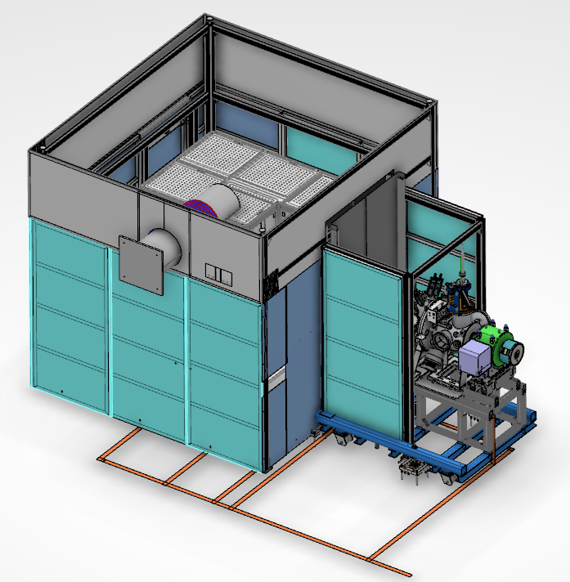

Figure 1 - Illustration of the high voltage safety fence (grounding scheme will be updated according to the description in the text).

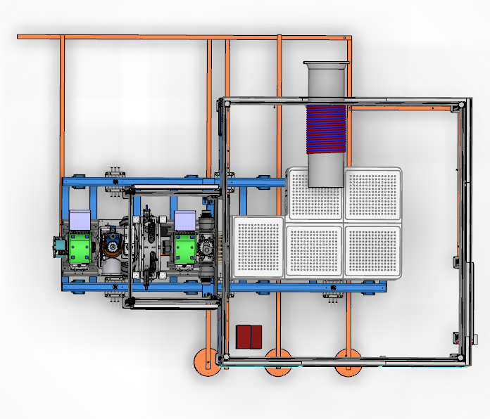

Figure 2 - Top view of the HV safety fence with grounding copper bars along the floor (grounding scheme will be updated according to the description in the text).

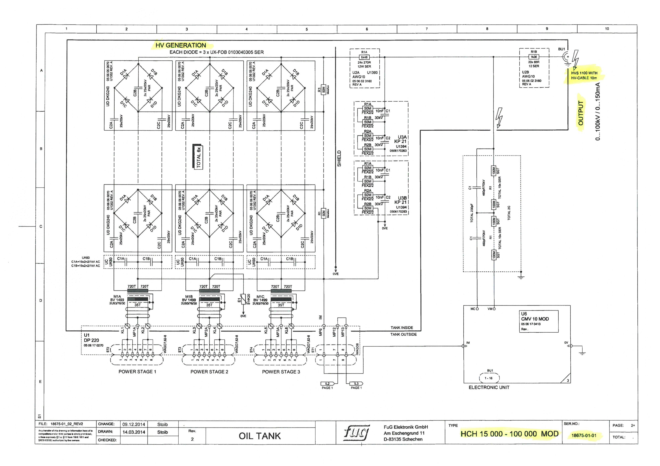

Figure 3 - Circuit diagram of the high voltage power supply.

# references

1. Concept of Operations For the Accelerator Personnel Safety System 0 (PSS0). ESS Document: ESS-0134492
2. Insulator for ESS platform. ESS Document: ESS-0135817
3. HVR-969 - High Voltage Resistors Metallux. ESS Document: ESS-00135818
4. E03-DT-DEDDDDG---TECHNICAL SPECIFICATION Grounding in Foundation. ESS Document: ESS-0018672
5. ESS Accelerator Requirement Document for ESS EMC Grounding System. ESS Document: ESS-0008003
6. E01-BS-DEDDDDA---General Grounding System Description. ESS Document: ESS-0018074
7. EQUIPOTENTIAL BONDING AT ESS. ESS Document: ESS-0153821. Draft version as per 2018-01-11
8. Ion source radioprotection report INFN-LNS. ESS Document: ESS-0114736

Document Revision history

| Revision | Reason for and description of change | Author | Date |
| --- | --- | --- | --- |
| 1 | First issue for review with regards to radiation protection only | Øystein Midttun | 2017-12-08 |
| 2 | Second issue with electric design included. | Øystein Midttun  Jörgen Jönsson | 2018-03-23 |