ESS Accelerator Collaboration Board meeting

ELETTRA SINCROTRONE TRIESTE
3 October 2018

Dear participants,

Please find hereby the latest relevant details about the ACCSYS meeting that will be held in the Seminar Room T2 at

Elettra Sincrotrone Trieste.
Full address: Elettra - Sincrotrone Trieste SCpA
Strada Statale 14 - km 163,5 in Area Science Park
34149 Basovizza, Trieste ITALY

The updated detailed Agenda is available at the event’s page:
https://indico.esss.lu.se/event/1097/timetable/ - 20181003

• Social Dinner:
The social dinner is booked at 20:00 at the following restaurant, located a short distance from the hotel.
Alessandro Fabris (mobile +39 335 1272648) will be waiting for you in the hotel hall at 19:45.

Ristorante  Antica Ghiacceretta  Via dei Fornelli, 2  34122 Trieste  Tel +39 040 3220307  http://www.anticaghiacceretta.com/ | 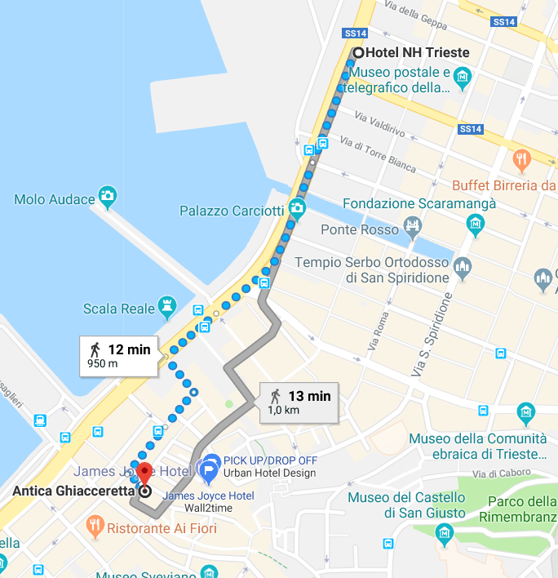

• Bus transport to Elettra Sincrotrone
On Wednesday morning a bus transfer will be departing from just outside the NH Hotel Trieste at 08:00 to Elettra.
Rodolfo Laghi from Elettra will be your contact there checking you are all in.

• Shuttle to the airport
At the end of the meeting there will be a shuttle transfer to Ronchi dei Legionari FVG airport.

• WIFI Connection:

EDUROAM is available at Elettra.

Alternatively you need to request username and password in advance online at the following link, by filling the form in with your details as specified below:
https://services.elettra.trieste.it/ST-GuestNet/rqst.php
Your Full Name (First, Last):
Your email address: | (this will be your username)
Device type:
Reason for this connection request: |  | ESS meeting
Trustee: |  | Secretarial Support
Known ST person of reference: |  | Roberta
Request connection starting from: |  | 3 October 2018
Request connection until: |  | 3 October 2018
Your password will be mailed to you, kindly REMEMBER to bring it along.

Feel free to contact me should you require additional information or support.
Best Regards

Roberta Casson
roberta.casson@elettra.eu
tel: +39-040-375-8522

