icBLM verification plan

 | Name | Role/Title
Owner | Clement Derrez | <<Role/ Title>>
Reviewer | Irena | <<Role/ Title>>
Approver | Irena | <<Role/ Title>>

Table of content | Page
1. Introduction 3
2. System characteristics 3
2.1. System purpose 3
2.2. System overview 3
3. test setup 6
4. verification identification 8
5. Glossary 16
6. references 16
7. Document Revision history 16

Introduction
This document describes the verification plan of the ionization chamber Beam Loss Monitor (icBLM) System for the ESS LINAC. In this document, an icBLM testbench and test plan is defined as the complete system needs to be verified before, during and after its installation.

System characteristics

System purpose
An important function of the icBLM system is to detect high beam losses potentially harmful to the linac components and inhibit beam production before damage occurs. In addition to the protection functionality, the system provides information about the particle rates during all linac modes of operation in order to enable tuning and keep the machine activation low enough for hands-on maintenance.

System overview
The icBLM system is based on ionization chambers as detectors. Thus it operates in current mode, where the measured current produced by the ionization chamber scales with the flux of incoming ionizing radiation that traverses the detector active area. Note that the scaling in general depends on incoming particle type, energy and incidence angle. [Ref to icBLM design document]

Components list
Component ID | Acronym | Description
AMC | AMC | 1 per up to 2 FMC, IOxOS 1411 type
FMC Digitizer | FMC | CAEN FMC-PICO-1M4-C3
Timing receiver | EVR | 1 per MTCA chassis, event receiver for trigger, clock, calibration announcement and beam/machine mode information
Chassis | MTCA | 1 per system
MicroTCA Carrier Hub | MCH | 1 per MTCA chassis
MicroTCA Power Supply | PS | 1 per MTCA chassis, 600/1000 W
MicroTCA CPU | CPU | 1 per MTCA chassis, intel i7
ECAT crate, populated | ECAT | 1 per HV supply
HV supply | HV | 1 per n systems, ISEG HV supply
Rack patch panel | PP | 1 per n systems, top of rack
Rack | U | 1 per n ACCTs, rack for electronics
Detector unit | icBLM | 1 ionization chamber
Beam line patch panel | BLPP | 1 per N ionization chambers

285FRUs delivery schedule
Component | Quantity | Delivery schedule | Remarks
Detectors | 285 | Delivered 2017 | Delivered from CERN
mTCA crate, populated |  |  | ICS delivery, apart from FMC which is CAEN delivery
ECAT crate, populated |  |  | ICS delivery
HV unit |  |  | ISEG delivery

test setup
The icBLM verification setup is composed of the instruments listed below, interfaced using EPICS CA.
Test data is stored in Insight under the corresponding object in HDF5 format.

Test instruments: list here all Gen/Meas instruments used in the system verification.
Uncertainties on each test result are traced back to each instrument using this table
Instrument ID | Instrument type | Link to Database | Used in:
 | DMM
 | oscilloscope
 | Rad source
 | Current source

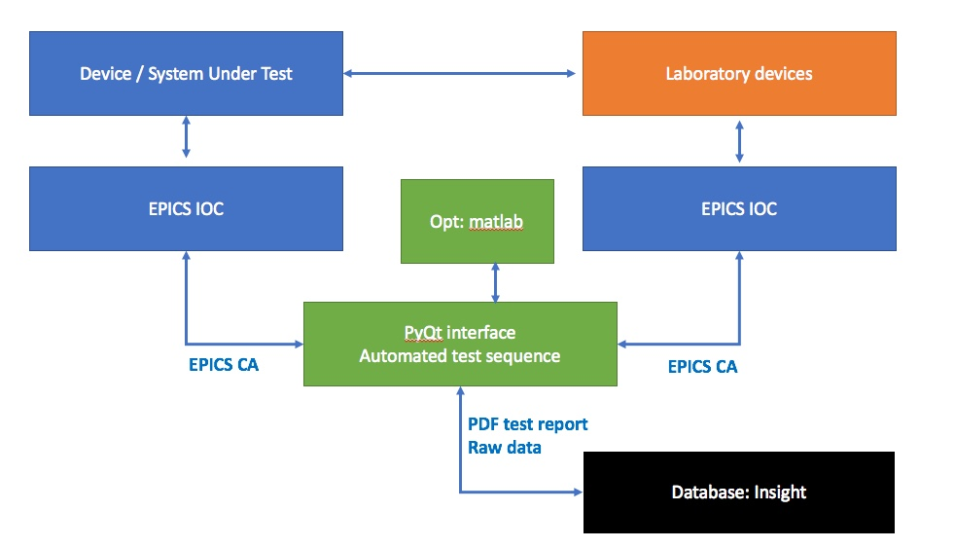

verification identification
HV supply
Part ID: NA
Detailed tests results document: links on CHESS, if applicable: Metrology results, any detailed tests report.
Test cable length: 100 m.
Note: The tests described below must be performed sequentially upon reception of the system
Test ID | Verification procedure | Threshold | Result | Pass / Fail
icBLM_1 | Visual inspection. Check visually the HV card delivered | No apparent damage
icBLM_2 | Install HV unit with ECAT. Connect to IC with test cable. Apply test voltage. Verify communication between ECAT and HVsupply | HV ID read correctly
icBLM_3 | Verify Current readback | Current RB < threshold
icBLM_4 | Verify Voltage readback | threshold 1 < voltage rb < threshold 2
icBLM_5 | Verify Voltage readback RMS | V_RMS < t threshold 3
Review pass/fail results: possible risks assessment when test is not passed etc. Explain why a particular step is ignored (if applicable)

Ionization chamber detector
Part ID: NA
Detailed tests results document: links on CHESS, if applicable: Metrology results, any detailed tests report.
Test cable length: 100 m.
Note: The tests described below must be performed sequentially upon reception of the system
Test ID | Verification procedure | Threshold | Result | Pass / Fail
icBLM_6 | Visual inspection. Check visually the Detector: SHV connectors, BNC connector, Serial number labels. | No apparent damage
icBLM_7 | Connect Signal cable to pico-ammeter in leakage testbench. Run automated measurement | Leakage < 2 pA
icBLM_8 | Connect Signal cable to pico-ammeter in Rad Source testbench. Run automated measurement | Threshold 1 < current < Threshold 2
Review pass/fail results: possible risks assessment when test is not passed etc. Explain why a particular step is ignored (if applicable)

Digitizer unit
Part ID: NA
Detailed tests results document: links on CHESS, if applicable.
Note: These tests are performed separately, upon reception of the FMC. Tests results exchange with ICS is tbd.
AMC carrier board used during test: SN
Test ID | Verification procedure | Threshold | Result | Pass / Fail
 | Run auto test software to measure:
icBLM_9 | Channels RMS noise, OC, RNG0 | < 250 nA
icBLM_10 | Channels RMS noise, OC, RNG1 | < 15 na
icBLM_11 | Channels RMS noise, with long cable and detector, RNG0 | < 150 nA
icBLM_12 | Channels RMS noise, with long cable and detector, RNG1 | < 180 nA
icBLM_13 | Bandwidth | 300 KHz
icBLM_14 | ADC ENOB | 14.5 bits
icBLM_15 | Crosstalk | < 0.1% FS
Review pass/fail results: possible risks assessment when test is not passed etc. Explain why a particular step is ignored (if applicable)

The next tests require a complete system installation.
Prerequisites:
- Full Control System, including complete configuration
- Long haul cables installed and tested
- Timing
- MPS
Assembled system: detector, uTCA electronics, ECAT electronics
Cold check out
Part ID: NA
Detailed tests results document: links on CHESS, if applicable.
we use the control room OPI for all these steps from now on
Test ID | Verification procedure | Threshold | Result | Pass / Fail
icBLM_16 | Check signal RMS and pkpk noise in RNG1 | < 180 nA
icBLM_17 | Self -test verification: Check signal continuity through the HV modulation signal
icBLM_18 | Detector mapping and complete acquisition chain verification: Use a plastic hammer to induce a shock to the detector. Verify the corresponding signal peak on the OPI
Review pass/fail results: possible risks assessment when test is not passed etc. Explain why a particular step is ignored (if applicable)

System self-test
SW version: NA
Detailed tests results document: links on CHESS, if applicable.
Test ID | Verification procedure | Threshold | Result | Pass / Fail
icBLM_19 | Apply HV modulation signal. Run autotest procedure from control room OPI
Review pass/fail results: possible risks assessment when test is not passed etc. Explain why a particular step is ignored (if applicable)

Commissioning with beam
Part ID: NA
Detailed tests results document: links on CHESS, if applicable.
The test requires RF (with stable settings - not necessary nominal) present.
Test ID | Verification procedure | Result | Pass / Fail
icBLM_20 | - Trigger delays / Verify background subtraction, offline analysis procedure:  - For each trigger setting: raw data without baseline subtraction (one of the Data on Demand-DoD buffers) is acquired. Average baseline is subtracted (calculated from another DoD buffer where waveforms that are used for baseline subtraction are stored).  - For each pulse period (14Hz) average baseline waveform from the raw data is subtracted to obtain "processed" waveform.  - From at least 100 "processed waveforms" an average is computed. Report average processed waveform with the best trigger setting. | average processed waveform
icBLM_21 | - Trigger delays / Monitor accumulated loss (or neutron counts) over the beam pulse: (ie. loss over BEAM_ON period inside the pulse period):  - For each trigger delay setting an average value for this loss is computed  - Report the trigger setting with highest average value | trigger setting with highest average value
icBLM_22 | - Monte Carlo Simulation verification and equivalent loss scaling factor:  - Define a set of controlled losses for simulation verification  - Compare simulated and measured results. In case of larger discrepancies find the source and modify simulation model accordingly.  - Once the simulation geometry model is verified, use the results to define scaling factors.  - For each detector connect number of lost protons to measured current for particular loss scenario. This gives a factor that can be used to calculate "equivalent lost protons" from the measurement during operation.  - Here each group of detectors has a loss scenario assigned to.
icBLM_23 | - Protection function commissioning  - Identify controlled loss scenarios with different loss time evolution (different time constants) and tune the protection function algorithm  - Produce these controlled losses to tune the protection algorithms
icBLM_24 | - MP thresholds  - Identify a few likely accidental scenarios that are most damaging  - Use Monte Carlo simulations (Geant4) coupled with thermo-mechanical simulations (ANSYS) to understand damage potential.  - Produce risk matrix which serves as a bassline to select MP thresholds.
Review pass/fail results: possible risks assessment when test is not passed etc. Explain why a particular step is ignored (if applicable)

Glossary
Term | Definition
FRU | Field replaceable unit

references
- <<Sample reference to CHESS document: ESS Document (ESS-00XXXXX)>>

Document Revision history
Revision | Reason for and description of change | Author | Date
1 | First issue | Clement Derrez | 2019-01-29

