Discussion baseline for potential rig designs of Rig2 and Rig3 for the ESS.
- All rigs have the option to rotate a sample inside under load.
- Please update/complete the document and save as “RigDesigns-Rig+12_ESS_v(n+1)”

Contents
Table with Specs 2
Psylotech 4
Deben stages 4
FRM2 rig(s) 5
Robin rig(s) 6
RAMS 7

Table with Specs
Rig | Sample rotation | Axial Force compression | Axial Force max | Max Torsion | Stroke | height | Weight | Additional options | Distance between bars: | Costs | Comments
ESS Rig1 (exists at NPI)  No sample rotation | No |  | 100kN  (Nominal load: 60kN) | None |  | 2300mm  (Can be shortened as well) | 600kg | Vacuum chamber  Cooling system is in place | 600mm |  | Integration with ESS SW and HW ongoing
ESS Rig2 (conceptual) | Yes |  | 50kN | 100Nm |  |  | <200kG | Furnace (gas flow enough, i.e. no vacuum))?  Enough width between columns  Adjustable height
ESS Rig3 (conceptual) | Yes ? |  |  |  |  |  |  | Low cycle Fatigue?
Psylotech xTS | Yes |  | 1.6kN - 45 kN | 350Nm | 50-100mm | 40cm -110 cm  600mm | 6 – 135kg | temperature chamber available |  | xTS  45kN Base System* - $195K  300Nm Torsion Add-On - $50K  xTS Temp Chamber(-100C to 300C) - $65K  CT Scanner Integration - $18K  On-Site Installation - $4900
Deben CT20K | yes | -20kN | 20kN | 100Nm |  |  | 120kg | optional furnace 1000C
FRM2 rig  (for diffraction and not imaging so far) | Not full 360deg? Need to check. | 50KN(?) | 50kN | 100Nm (max angle 49deg) | 75mm | ? | ? | Mirror furnace up to 1000C. Euler cradle
Robins rig (UTK) | Yes: freely | -24kN | Range of 5 load cells:  900N, 9kN, 11kN/11Nm, 22kN/111Nm, 44kN | 11Nm (110Nm) | 80mm | 70cm | 55kg | Flexible design (height, width can be adjusted). Alignment software developed (LabView) based on ASTM standard. |  | 6500 Euro parts  12000 Euro Controllers (NI)  8000 Euro for set of load cells  (no development/machining included)
RAMS | Yes | 2-kN | 2kN | None |  | 73cm | 73kg

Psylotech
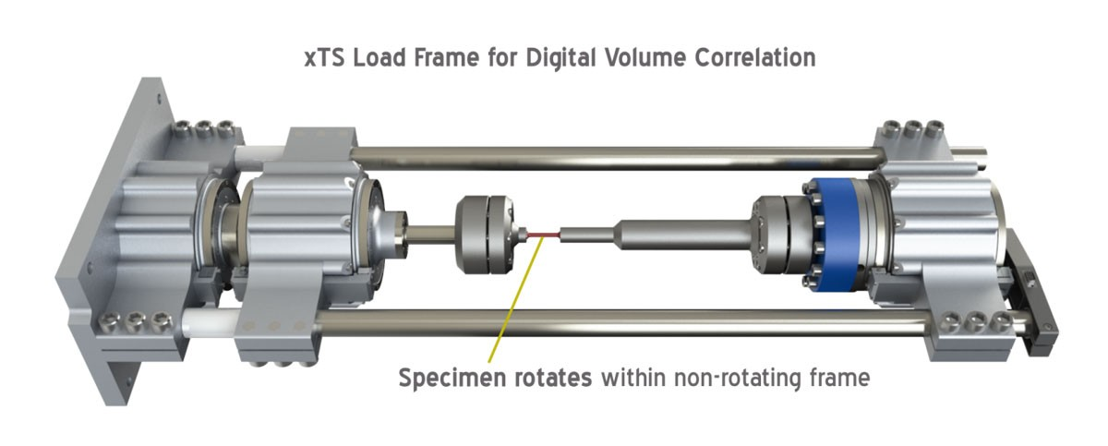
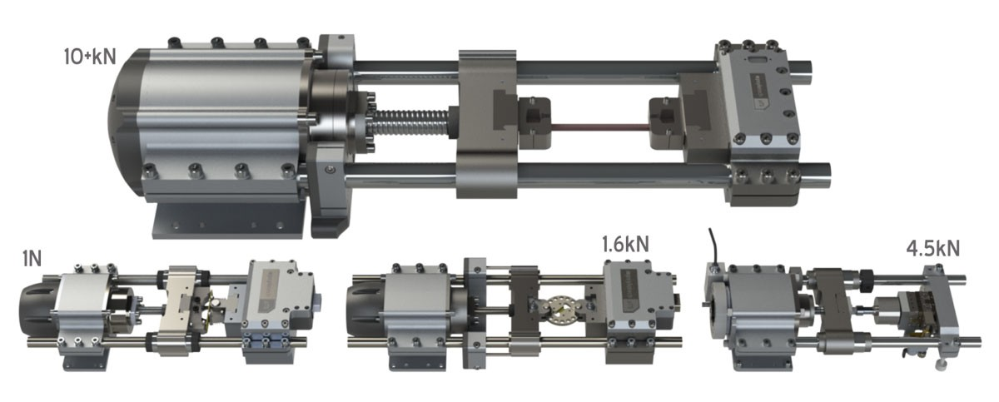
https://www.psylotech.com/loadframe/

Deben stages
Commercial systems that are optimized for uXCT and synchrotron. The CT20K looks intertsing.
https://deben.co.uk/tensile-testing/open-frame-torsion-tension-and-compression-stage/
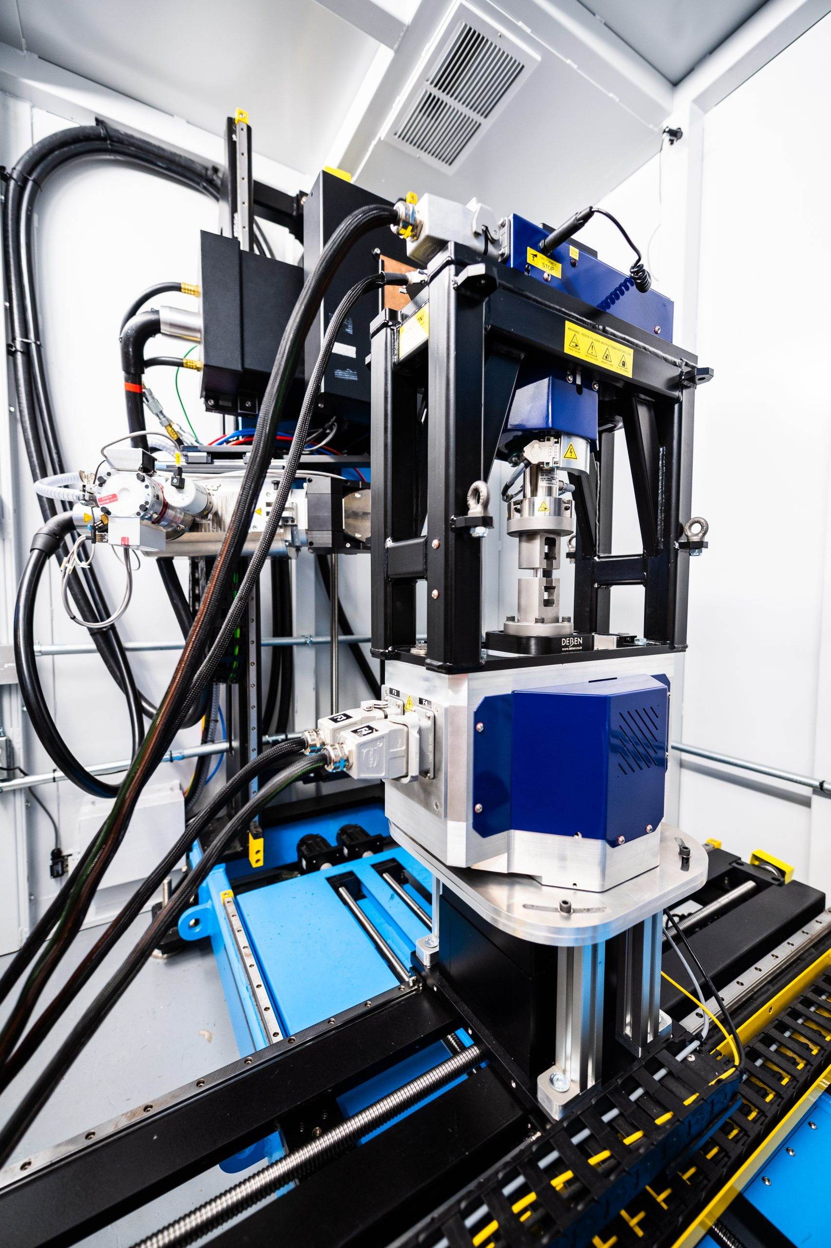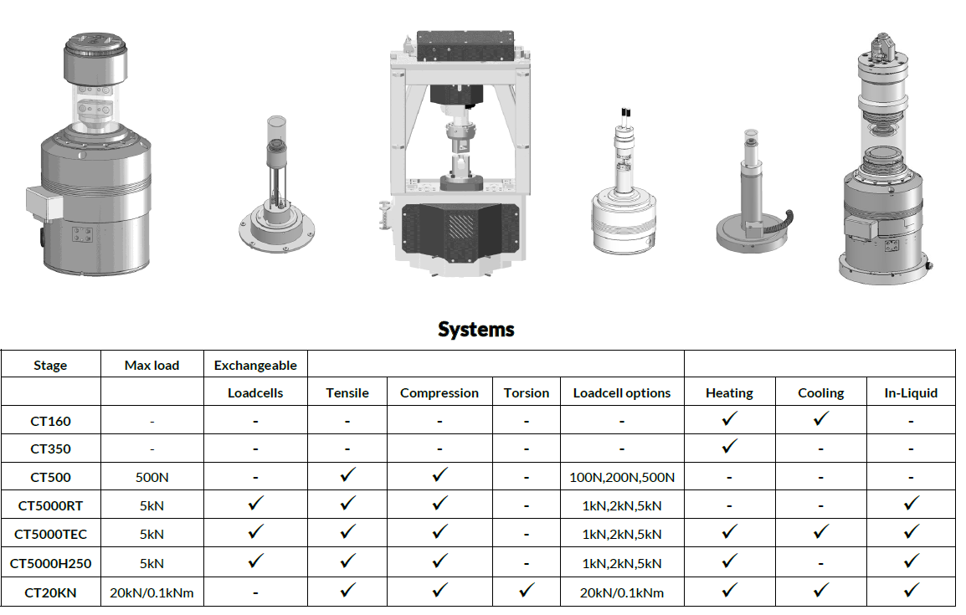

FRM2 rig(s)
Hoelzel, M., Gan, W. M., Hofmann, M., Randau, C., Seidl, G., Jüttner, P., & Schmahl, W. W. (2013). Rotatable multifunctional load frames for neutron diffractometers at FRM II—design, specifications and applications. Nuclear Instruments and Methods in Physics Research Section A: Accelerators, Spectrometers, Detectors and Associated Equipment, 711, 101-105.
Developed at FRM2 and in use at Stress-Spec and SPODI. HZB (E3) bought uniaxial version.
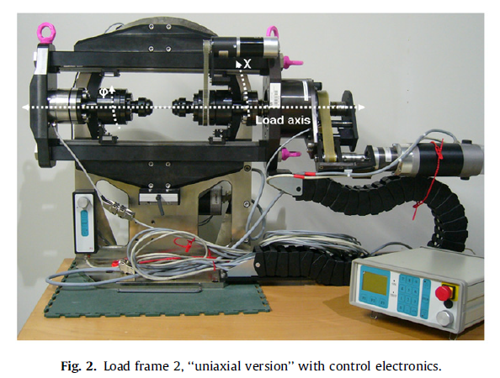

Robin rig(s)
https://trace.tennessee.edu/utk_graddiss/3375/
CAD available in SolidEdge
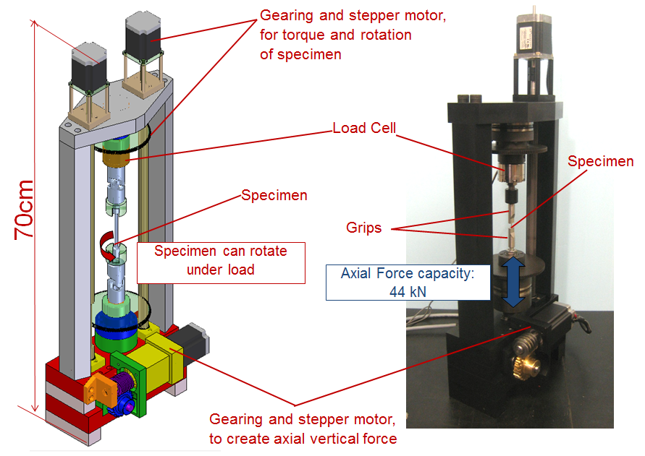

RAMS
Shade, P. A., Blank, B., Schuren, J. C., Turner, T. J., Kenesei, P., Goetze, K., ... & Lienert, U. (2015). A rotational and axial motion system load frame insert for in situ high energy x-ray studies. Review of Scientific Instruments, 86(9), 093902.
Designed for small samples with 1mm x 1mm cross section. Interesting alignment features that could be copied.

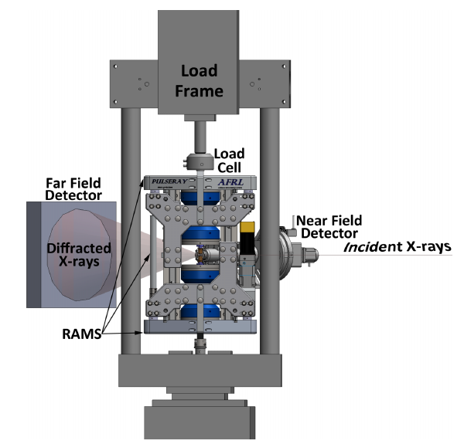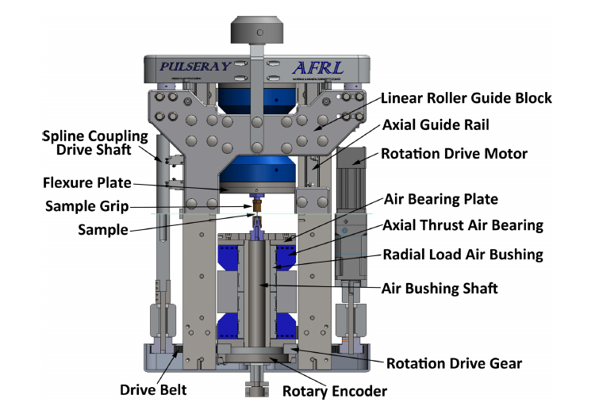
Focus on alignment fixtures:
