Spectroscopy STAP, April 2020
Update on the progress of BIFROST

Cave
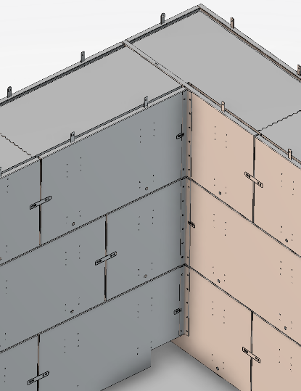
The BIFROST team have gone to tender for the cave design presented in the last STAP report, and several bids came in, all of them above budget. Since one of the cost drivers was non-magnetic stainless steel rebar, we have loosened the requirement for non-magnetic rebar be valid within an exclusion zone around the sample position (3.6 meters) and around the guide upstream the sample (2 meters). After crude analytical estimations of magnet forces, preliminary COMSOL calculations, and since there is magnetic steel rebar in the floor of the E01 hall, 3.7 meters from the sample position, we believe this to be a safe decision. Some components within that 3.6 meter boundary will be magnetic steel, like load carrying rails, lifting points and bearings.
The cave will mainly consist of cast-in-place blocks, weighing around 8.7 tons. Between the blocks vertically, there is a very thin layer of wax. Horizontally, the block interface is cast in a waveform (see figure). The blocks are removable with the E01 hall 10 ton crane. The Sub-TG3 for the cave will likely happen in May, after which the production and later installation can commence. Depending on current developments, the installation of the cave is likely to start in the summer, and finish by the end of the year.

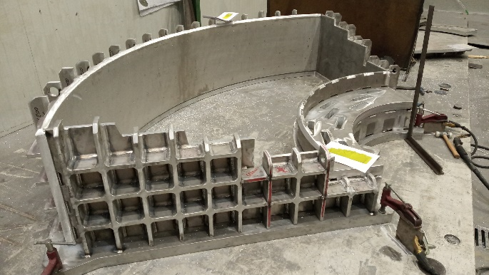
Spectrometer tank
The spectrometer tank project has been progressing well, and production has started – see figure to the right. The factory acceptance test is likely to be this summer, and installation will be by the end of the year – after the cave installation has finished. Motors and encoders for tank motion have been bought, and on-site testing and motion control integration will be possible this year.
Detectors
After the CTV for the detector procurement is passed, we hope to be able to purchase the detectors via direct award, and are therefore likely to place an order within a few months, during the summer. In order to start production of the detector triplet modules, we need to pass the sub-TG3 for the detectors, which involves input from mainly LLB and the ESS. We will likely start the process of moving the firmware to the R5560 ADC-module during the summer, to be sure we will have working electronics, not only for hot commissioning but also for prototype testing. We hope to be able to test the detector tubes at the LLB, using a portable neutron source. The alternative is going to the PSI in summer 2021.
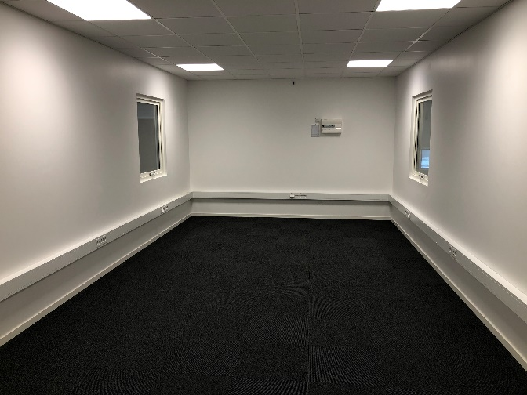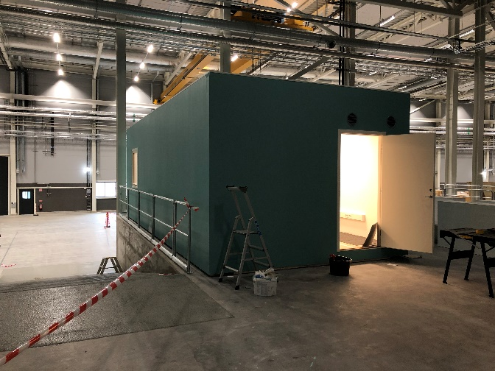
Control hutch
The control hutch has been built in the E02 hall, see above. It is around 35 m2 and well insulated for sound. We plan to have at least three work stations in there, as well as a small conference table.
Software
We will likely not use Mantid to do data reduction and analysis. The University of Copenhagen have been proactively creating a software program for the PSI project CAMEA, called MJOLNIR, that is well suited to deal with BIFROST data. This is to be used in conjunction with SCIPP, a DMSC-developed software package, C++ based. This software project will be led by the data scientist on BIFROST to be hired in 2020 or 2021, and the software interfaces will be handled by this person, who is shared between BIFROST and CSPEC.
Other procurement updates
The guide tender is out, and we hope to receive favorable bids before May.
The chopper tender is about to go out, hopefully before May.
We hope to place an order for graphite before the end of the summer.
We have placed the order for a goniometer and are likely to place an order for the sample table soon
The borated aluminum used for cross talk shielding in the tank has arrived ready to be cut.
Conclusion
We are still in the process of procuring major items, and signing the major contracts is currently the main goal. After that, the focus will be on finishing the detailed design and completing the TG-3 process, concurrently with installation of the cave and spectrometer tank. Once the data scientist have been employed at the end of this year, we will start working closely with the DSMC to make sure that the software is developed to suit the needs of both the instrument teams and future users.

