Demonstrator test at LET 12-13 November 2020
A demonstrator test is planned with the MG.SEQUOIA module at the LET instrument at ISIS in November 2020 with two days of beamtime. Detailed testplan has been prepared and discussed with the ISIS crew. The tests will focus mainly on dark noise, linewidth and signal to noise of the MG detector. The measurement will be used to identify areas for improvements, if any, towards desired performance levels for the CSPEC instrument.
The MG.SEQUOIA module design was originally optimised for thermal wavelengths, i.e. the TREX instrument, in terms of the number of voxels per grid and thicknesses of the ¹⁰B₄C coating per blade. A module has been rebuilt with radio-pure Aluminium and with the radially orientated blades also coated, as shown in the photos below of it under construction, and under initial tests in Utgård. The lessons learnt during the evaluation of the SEQUOIA data were fed into the rebuild - and as can be seen in the data presented to the right hand side - the data is now relatively smooth in the rebuilt module (top) compared to several features seen in the original module (bottom). The areas where features and issues were identified are indicated by the red boxes in the bottom figure.
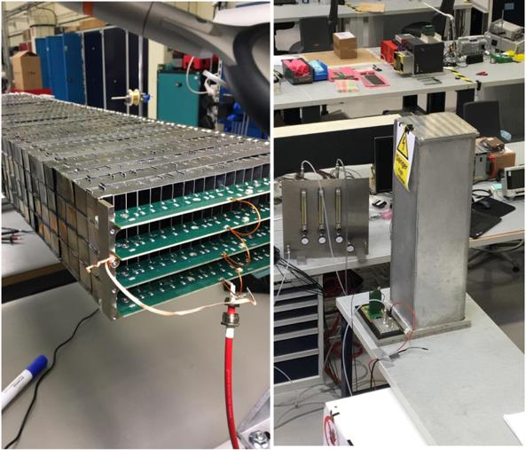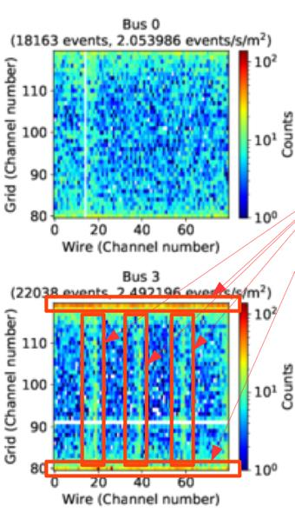
Figure 1. Rebuilt MG.SEQUOIA module with radio-pure Aluminium and with coated radial blades

An elevated low-level of electronic noise has been observed in the MG.SEQUOIA during the tests at Utgard, not the best environment for such measurements. We believe these low-level noises are related mostly to grounding and impendence mismatch in the girds and wires PCBs connectors, which could be removed with an optimised electrical design. We had better performance results with the previous design that was used in the MG.CNCS detector which was modified later in the MG.SEQUOIA demonstrator.

Analysis: V20 data
Tests of the MG.SEQUOIA modules were done at the V20 beam line in HZB in September 2019, as requested by the CSPEC team and the Spectroscopy STAP. Results have been obtained on re-verifying the Multi-Grid efficiency, determining the effect of the radial blades on suppressing scattering, and also on extraction the fundamental time resolution of the Multi-Grid and Helium-3 tubes. Additionally, the rate capability of the Multi-Grid detector was determined to be greater than 2 MHz/cm² incident on the detector, with no signs of saturation starting. The Helium-3 tubes saturated well- below this: as expected. The efficiency and the time resolutions measured were as expected from calculations. The results on scattering verified the result seen from the SEQUOIA data and in the detector simulations that the coating of the radial blades in the Multi-Grid has a highly significant effect on suppressing internal scattering.
The results from the tests at V20 are written up in a manuscript submitted to J. Measurement Science and Technology (arXiv:2006.01484).
Prototype mechanical detector vessel
The prototype mechanical detector vessel for CSPEC has arrived in Utgård from CECOM, Italy. This is intended as a verification of the design, and of the QA procedures necessary to qualify it. Over the coming months it will be combined with the ca. 300 (280 in 2 columns of 140 each and >20 training) grids assembled last summer to finalise the QA and assembly procedures for the Multi-Grid detector for both TREX and CSPEC. The prototype vessel dimensions are: 3985mm (height) x 322mm (width) x 288mm (depth) with a weight of 350kg.
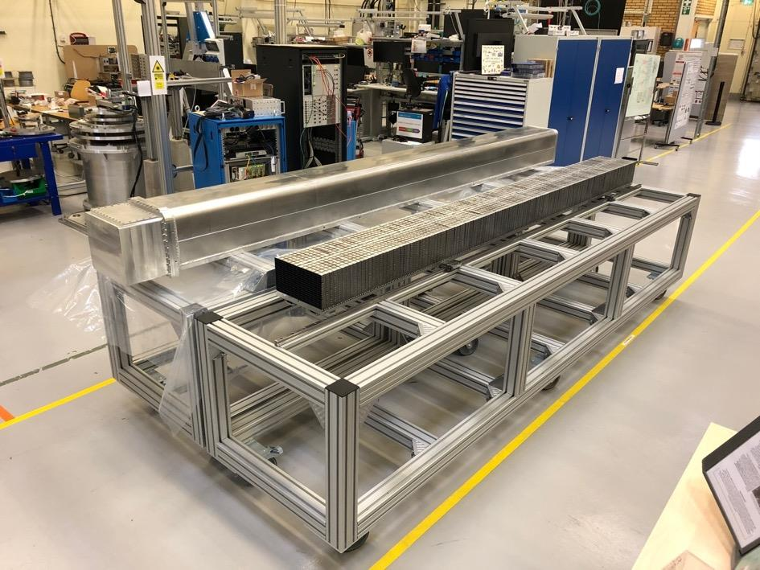
Figure 2. The prototype mechanical detector vessel for CSPEC in Utgård, Lund.
Additionally, 2 additional wooden mockup vessels for CSPEC have been constructed. These will be invaluable in validating alignment installation and maintenance procedures, as well as fine tuning the interface with the CSPEC vacuum tank.
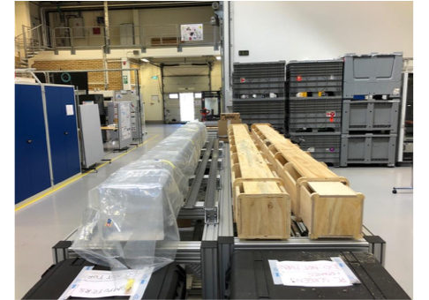
Figure 3. Two wooden mock-ups sitting next to the prototype mechanical detector vessel for CSPEC in Utgård, Lund.

Multi-Grid Detector Technology Review
On August 27 and 28, a review of the Multi-Grid detector technology was held. The charge for the review was to consider whether the performance demonstrated by the MultiGrid detector is sufficient to start production for ESS instruments, also ascertain whether ESS has the capability to start production. Additionally, the review was to identify if there are recommendations on further investigations of performance that could be looked at whilst construction is ongoing, to enable a smooth hot commissioning period for the instruments.
The panel was Karl Zeitelhack from FRM-II, Graham Smith from BNL, Ralf Engels from JCNS, Toby Perring from STFC, and Jon Taylor from DMSC at ESS.
The slides from the review are available here: https://indico.esss.lu.se/event/1496/
In summary, the outcome of the review report was:
As a general comment, it should be said that the panel was extremely impressed by the material presented and the results shown and congratulated the ESS and its detector group on their excellent and enormous work. The MultiGrid detector technology has been developed and analyzed comprehensively and systematically in the 10 years since its invention. In particular, the production of high-quality, large-area B4C coatings was perfected during this period and brought to industrial maturity. The performance of the MultiGrid detector has been extensively studied through simulations and tests with various prototypes and is considered to be well understood.
... The panel therefore recommends starting the construction of the MultiGrid detector for CSPEC now, especially taking into account the installation plan for CSPEC presented and the lack of a suitable detector alternative.
Based on the material presented, the panel is of the opinion that the ESS detector group has the technical and personnel expertise to start building the detectors. However, in the opinion of the panel, the group needs a substantial increase in suitable personnel in order to be able to manage the construction and commissioning of the CSPEC detector in the planned time frame.
MG Detector Delivery project for CSPEC Instrument
The Multi-grid detector delivery project has officially stared in June 2020. Since then, two project steering board meetings took place, on the 21st of August and 5th of October, where budget, project milestones, risk analysis were discussed. The steering board committee consists of

- Shane Kennedy: Executive Sponsor, responsible of the overall success of the project.
- Jonathan Taylor: Independent expert on spectroscopy, advise on overall performance.
- Marie-Louise: Resources provider, Engineering/Technical support, as well as to advise on project management issues,
- Oliver Kirstein: Head of Instrument Technologies Division, where the detector responsibility will be handed over.
- Pascale Deen: Major stakeholder and “customer representative”. Key interface with the CSPEC Instrument.
- Richard Hall-Wilton: Core support of the project including all the Engineering, performance and technical aspects.

Procurement of ultra-pure Aluminium alloy and ¹⁰B₄C powder have been initiated in August 2020. Following a market survey conducted in 2019, two suppliers of Radio-pure aluminium, of total of 4 worldwide, were invited to respond to the Request for Quotation (RFQ) call. An internal evaluation board, consists of 5 ESS experts, was set up on the 20th of September to assess the two offers according to specific selection criteria that covered the technical and trading requirements. The best tender was chosen with award noticed sent out on the 5th of October. The first batch of 500kg of Super-pure aluminium sheets is expected to be delivered to ESS in December 2020.

The ESS detector group has several years of experience dealing with ¹⁰B₄C powder manufacturer Ceradyne, Inc. For this reason and to speed the procurement process up, ESS had agreed to a sole source justification request that was submitted in the summer of 2020 allowing direct purchase of ¹⁰B₄C powder from Ceradyne, Inc. First batch of 20kg is expected to be delivered to ESS the 2nd week of January 2021.

Tenders for ¹⁰B₄C target manufacturing, Blade-Cutting and Detector vessels are next in the pipe-line.

