Spectroscopy STAP, October 2021
Update on the progress of BIFROST

General progress summary
Currently, we are in final stages of procuring the last major components; the purchase orders for the detector tubes and electronics is close to being signed. The other subprojects for guide, choppers and sample stacks are progressing nicely – with guides ready for manufacture and the CDR for the BW-chopper being complete. The sample stack is currently being installed, and we expect delivery of the orange cryostat by the end of 2021. General installation is proceeding well, as shown in the pictures below.
We expect to be done with most of the scientifically relevant detailed design by the end of the year. The final touch on the mechanical design of the detector modules and the cabling strategy is to be completed and reviewed, as well as the filter design. Once these reviews are passed, we can start production of the beryllium filter and detector system. We are testing the HOPG crystal with neutrons in the end of October, after which we should be able to start making and assembling the analysers themselves.
Regarding infrastructure, we still need final offers from the ESS, and thus electrical infrastructure, utilities and Personal Safety System (PSS) is still unbudgeted and design work has not commenced. This currently poses the main project risks in terms of both budget and schedule.
Once the final reviews are passed from our side, focus will remain on installation, including Factory Acceptance Tests (FAT) and Site Acceptance Tests (SAT). Scientifically, we start directing more focus towards software, upgrade designs and commissioning planning in the new year. Additionally, we will test the detector system firmware with neutrons, including the readout chain, mitigating as much hot commissioning risk as possible.
Below follows a comprehensive list of component status updates.
Component progress summary – from monolith to sample
- NBOA – Manufactured and Assembled. Awaiting shipping to ESS.
- BBG – Manufactured and Assembled. Awaiting shipping to ESS
- In Bunker Guides – In manufacture.
  - FAT planned for February 22
  - SAT planned for March 22
  - Installation complete by June 22
  - ESS may need to remove installations afterwards for Target installation works.
- In Bunker Choppers
  - Slow discs in manufacture
  - Fast discs CDR in October
  - Spindles ordered
  - Rack SAT at ESS
  - Chopper CDR in November
  - Planned installation Q2 22
- Bunker Wall Insert – In manufacture. FAT planned for Jan 21
- Beam Monitors – In design
  - CDR with ESS should have happened in July
  - Still awaiting new CDR date
- Out of Bunker Guides – In manufacture.
  - FAT planned for February 22
  - SAT planned for March 22
  - Installation complete by June 22
- Beamline Shielding
  - Certain D03 blocks installed to allow further installations
  - E02 side blocks installed
  - All E01 blocks installed
  - All blocks installed (or ready to install) by end of 21
- Thermal Shutter – Assembled at ESS
  - PSS information has changed so modifications needed
  - Base to be installed in November
  - Still awaiting control box and PSS inputs
- E02 Chopper
  - Slow discs in manufacture
  - Spindles ordered
  - Rack SAT at ESS
  - CDR concluded in July
  - Planned installation Q1 22
- Cave – Installed and complete
- Divergence Slits – SAT complete and awaiting installation in Q2 22
- Sample Stack
  - Rotation Stage Installed
  - Some mechanics still in manufacture
  - Goniometers at ESS awaiting installation during Q4 21
- Orange Cryostat in manufacture and planned delivery is Q4 21
- Tank – Installed and complete
- Background Shielding
  - Cadmium at ESS and awaiting installation during Q4 21
  - Cross Talk Shielding at ESS and awaiting installation during Q4 21
  - Borated Polyethylene at ESS or in manufacture. Install Q1 22
- Beryllium Filter
  - Beryllium ordered
  - CDR in October
  - Planned delivery in April 22
- Detectors – In design
  - Tubes contract still not signed. Quote received after tender period
  - Mechanical design almost complete. CDR in October
  - Electronic design to go through TG3 in November
  - Planned assembly Q4 22
- Beam Stop – Installed and complete
- Crane – Installed and complete
- Hutch – Installed and complete
- Electrical Design – No progress – Waiting for ESS common project resource
- Utilities Design – No progress – Waiting for ESS common project resource
- PSS Design – No progress – Waiting for ESS common project resource
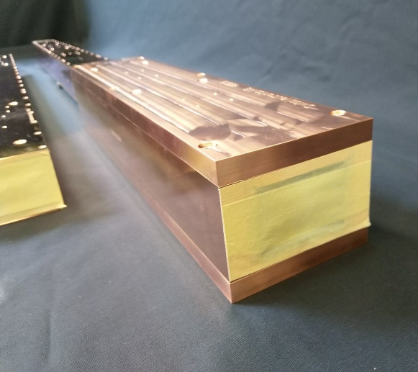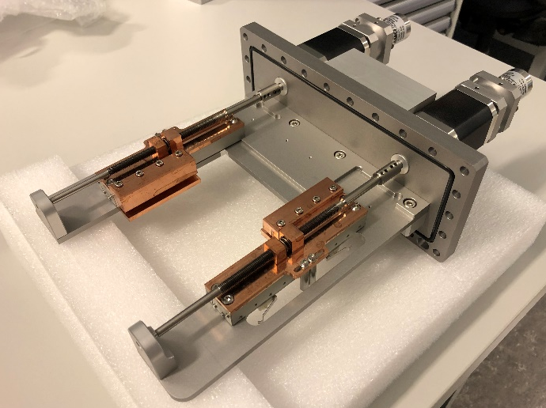
Figure 1 - Bifrost NBOA @SWISS NEUTRONICS (left) and 1 of 3 Divergence Slits before SAT (and blade installation) (right)

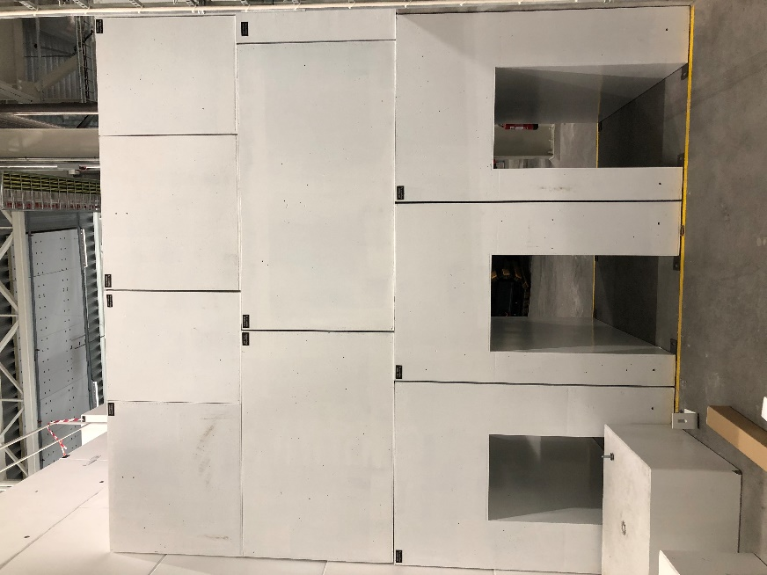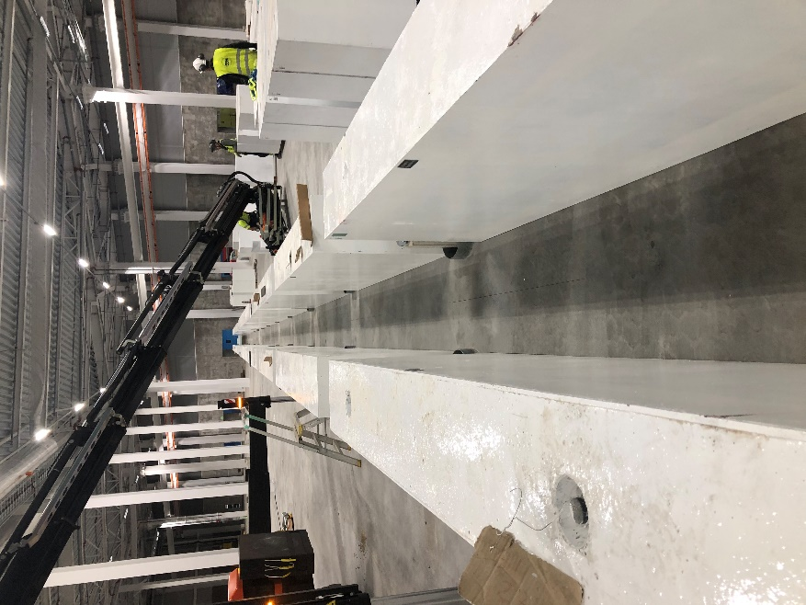
Figure 2 – Installed E01 Shielding (left) and E02 Side Shielding Blocks (right)
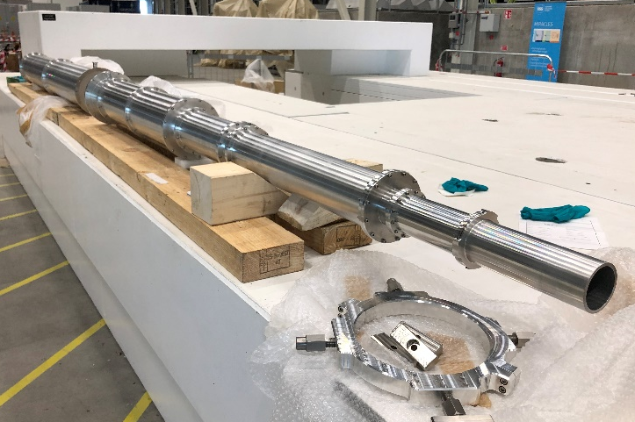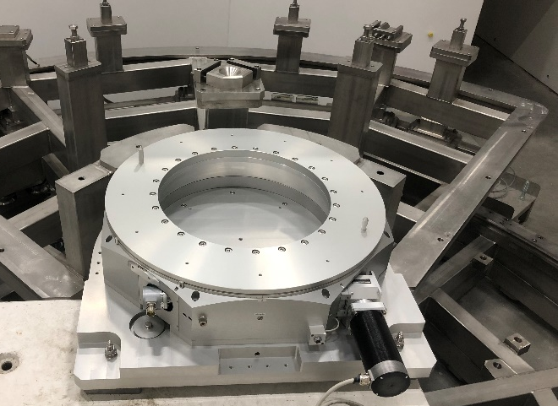
Figure 3 - Get Lost Tubes awaitng B4C (left) and Sample Rotation Stage installed (right)
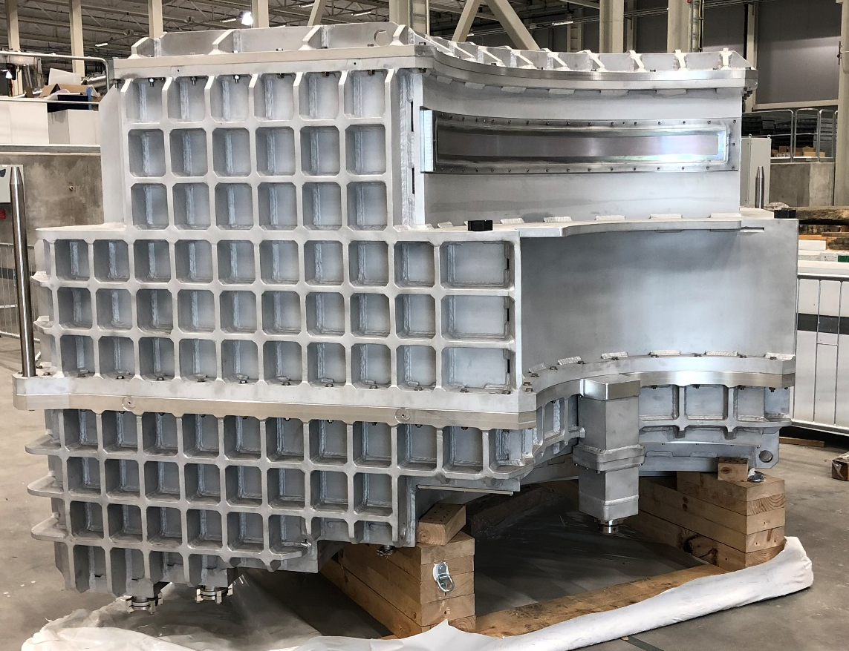
Figure 4 - Spectrometer Tank awaiting Cd installation
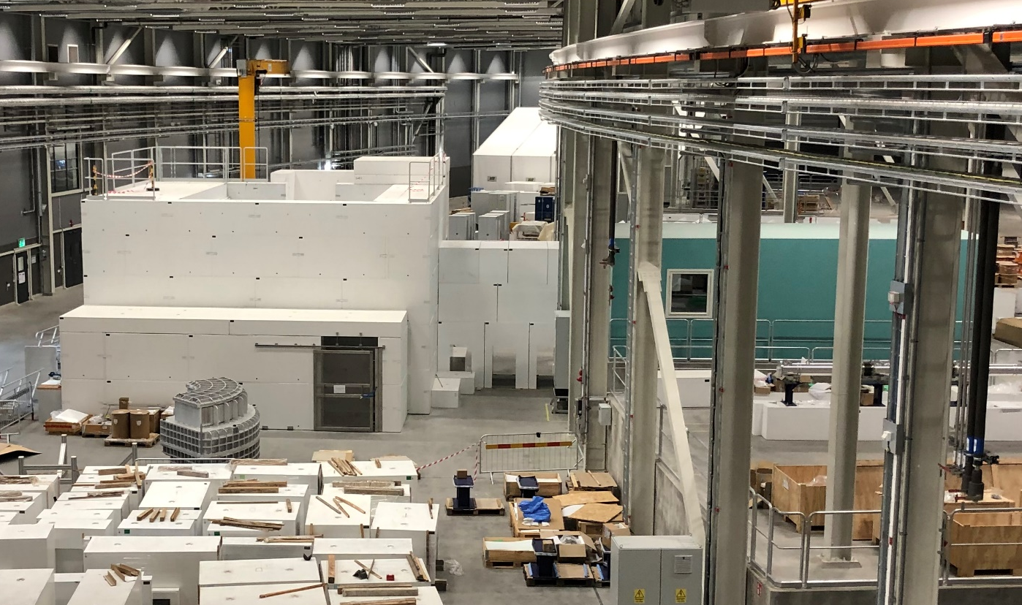
Figure 5 - Current view of installation area, with hutch (right), E01 shielding, cave, ground access door and instrument crane. Plus beamline shielding awaiting installation

