The HEIMDAL Instrument at ESS
Diffraction STAP Meeting October 2022
Update Summary

(1) In-kind Agreements and Technical Annex

Partner | MOU | TA
Aarhus University (Denmark) 30% | Signed | Approved by ESS
PSI (Switzerland) 35% | Signed | Approved by ESS  Approved by Swiss Government
IFE (Norway) 35% | Signed | Approved by ESS

Current Status: Heimdal has all TA's signed and approved by ESS as of February 2020. The Swiss Government has also not approved the PSI in-kind agreement. We are now moving forward again with procurement of the guide optics and detector with PSI.

(2) Current (and future) Instrument Timeline:
The latest Heimdal time line is shown below. We are starting to have real contracts in place for large scale items. Swiss neutronics have the contract to deliver the guides (as of september 2022). Mirrotron will deliver the cave and CDT the 2D detectors and monitors. The ESS common projects will deliver the Guide shielding, choppers and T0 chopper. AU will delivery the heavy and light shutters. The years of 2023 and 2024 will be busy period for Heimdal in terms of TG3s and components delivery. The current focus is to have all items installed in the bunker before BOT.

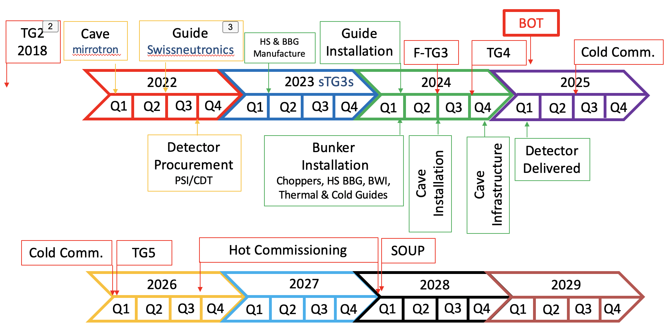

Change of Construction focus:
With delay to BOT until late 2024 and with new ESS rebaseline, Heimdal have decided to change focus for the instrument construction program. Previously, we were building from the cave and working back to bunker, with bunker access provided during a scheduled shutdown in 2024. There is now an extended open bunker period and we plan to priortise all of the in-bunker components for take advantage of the delay to BOT.

(3) Change of scope request:
A change request to include more cold guide into scope of Heimdal was made in 2019, but refused until Heimdal has more contractual costings especially of the large scale items on the instrument.
Before summer 2022, we published a call for tender for the guides, to have accurate costings of the total thermal and cold guide systems and vacuum housings and also a coherent detailed design of how the thermal and cold guides would eventually be installed in various upgrades. This contract has now been awarded to Swiss Neutronics via in-kind partner PSI. We have been informed that the total thermal guide and vacuum housings together with a cold guide option-1 sections fits within the PSI budget. See letter below from PSI:

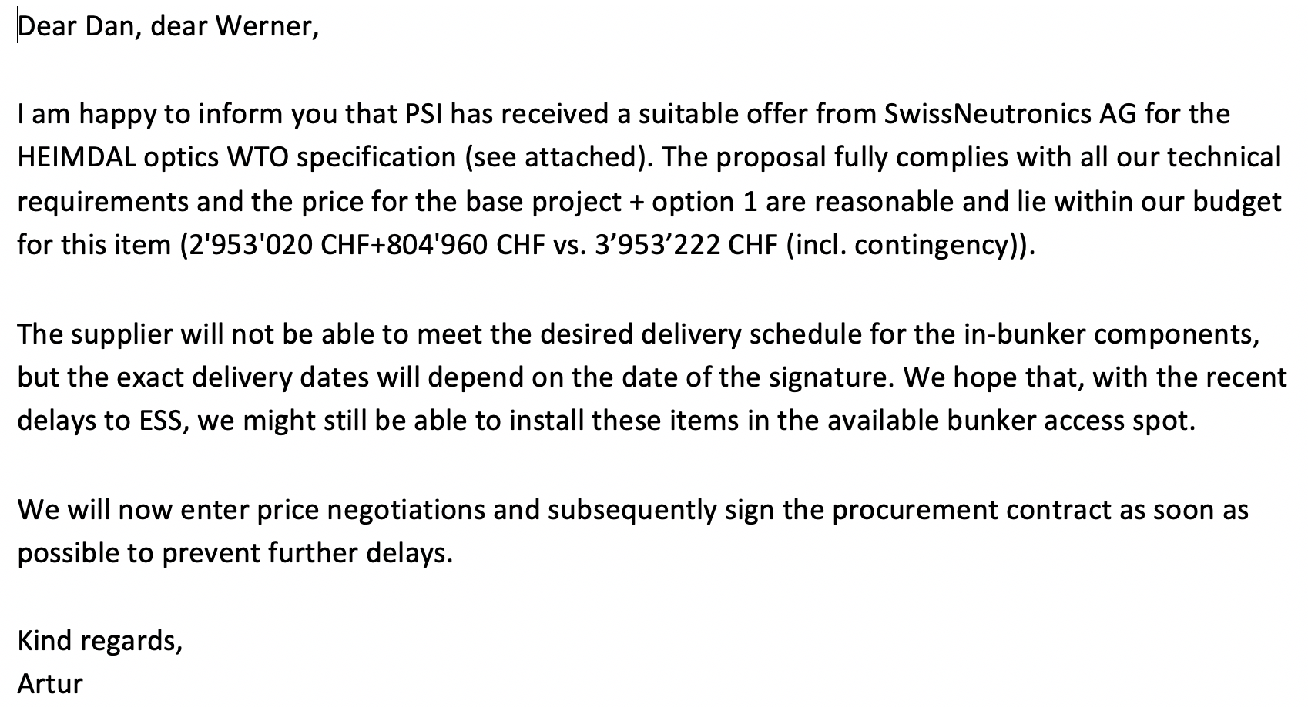

The cold guide option-1 consists of the in-bunker sections and long-straigh section including vacuum housing. This corresponds to around 116meters of additional scope cold guide. See figure below. This is fantastic news in terms of a streamlined upgrade of the Heimdal instrument to simultaneous diffraction and SANS. We now only need to fund 35 extra meters of cold guide and vacuum housings (464k Euros) to complete the guide systems to full scope.

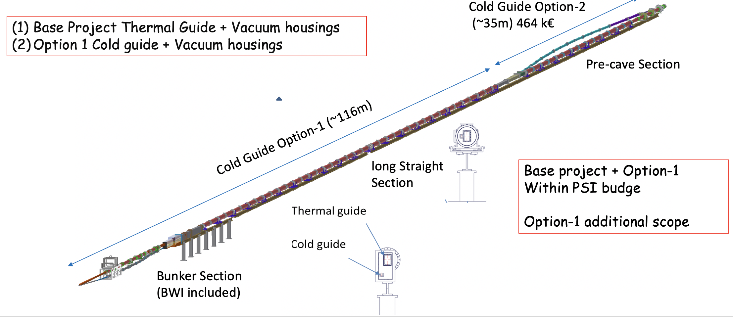

Figure 1. Drawing of the thermal and cold guides. The thermal guide and vacuum housings (base project) and the cold guide option-1 are within budget for the PSI guide systems. The corresponds to additional scope of 116meters of cold guide and vacuum housings in the bunker and long straight section.

(4) Toll Gate Milestones Schedule.
The ESS has instigated an alignment of the P6 TA milestones with the new rebaseline of the ESS. This review has led to new dates for certain milestones. The Final TG3 is
now rescheduled for June 2024, TG4 October 2024, TG5 February 2026. Cold Commissioning January 2025 and Hot Commissioning Q3 2027. The current focus of the instrument is completing the procurement tenders for large items to have real costs of the instrument. We are also now very focused on completing the installation of in-bunker components before BOT which is currently forecast between Nov 2024 and May 2025.

(5) ICEB meetings: The next Heimdal ICEB will take place in 18th October 2022.

(6) Instrumentation
6.1 NBOA
The NBOA detailed design is completed and reviewed for sTG3 and should be delivered by the end of 2022.

6.2. Choppers
We now have a full costing of our chopper systems and will move ahead with procurement. We have joined and had kick-off with the common chopper project. The Choppers are expected to arrive from ESS before BOT = Q3 2023. The scope is transferred to ESS and the Chopper project is within budget.

The T0 chopper: The T0 chopper based on the prototype developed by Mirrotron is being developed by ESS with some slight modifications. The technical specifications have now been finalised and reviewed. Scope will be transferred to ESS. The T0 Chopper project is currently with-in budget. It is not certain that the T0 will arrive before BOT. If not at piece of vacuum tube will be temporally installed until Bunker access in mid 2026.

6.3 Guides
We have been re-working the design of the cold guide, following the opportunity of cost saving we realised with the ESS common guide shielding project. We now have a new cold guide design with a long straight section ready for approval by the ESS. We have performed McStas neutronics of the cold guide as shown in figure 2 below. The contract for the guide systems has been awarded to Swissneutronics as of September 2022.
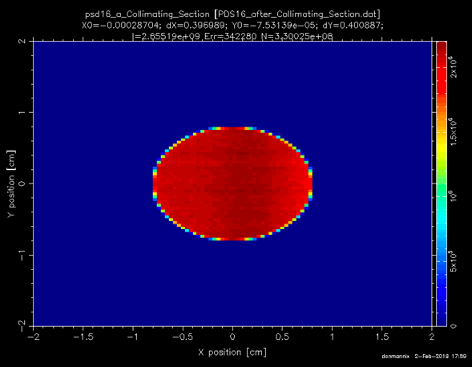

Figure 2 McStas simulations of the beam intensity profile in the collimating section of the new straighter cold guide system. The simulations indicate a slightly higher flux than for the current cold guide.

6.4 Detector:
The 2D detector procurement is ready to start, but has been on hold due to in-kind agreement with PSI. We are now moving ahead with this procurement and it will be addressed after the guide procurement is finalised with PSI in 2022. This is scheduled to go ahead in November 2022.

6.5 Shielding
As stated previously, there is a possibility for Heimdal to make large savings from ESS common shielding project. He have been working on getting a detailed costing for our shielding to include in the change of scope setting. This has been a slow process due to the stretched resources at ESS for shielding neutronics calculations. We now have a good calculation for the Heimdal source and these can be fed into calculations to optimise the guide shielding. This work is still in progress. Below are some preliminary calculations of shielding designs, but this still needs to be optimised as is give a back-ground of around 3μSv/hr at the surface. Once these calculations are finished and the shielding costed, we plan to submit the change of scope request.
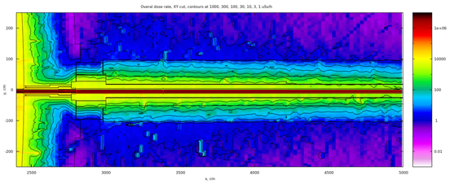

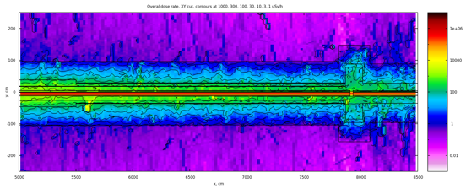
Figure 3. Preliminary shielding calculations for Heimdal guides. Top is for the section after the bunker wall from 25M to 50M. Bottom is from 50m to 85M, just after the frame-overlap chopper. The current design is still giving too high back ground and is being refined. This can be seen by the dark blue area just after the bunker.

The neutronics are performed for the below shielding.
Interface (28-30m, first 2 meters from bunker wall) 20 cm steel 40 cm heavy concrete (3.8 g/cm3)
30-45 m: 25 cm steel 50 cm regular concrete (2.3 g /cm3)
45-55 m: 20 cm steel 55 cm regular concrete
55-chopper pit: 10 cm steel 65 cm regular concrete
Chopper pit shielding according to common shielding project (will need extra steel when contribution from thermal neutron beam will be considered)
Beyond chopper pit: 60 cm regular concrete.
Inner steel shielding is lined with 5 mm B4C both inside and outside B4C/epoxy tiles.

6.6 Cave Shielding Neutronics:
The Call for Tender for the cave was awarded to Mirrotron with a bid including cave shielding and beamstop which was within budget. We have now moved ahead with a preliminary design for the cave. We have decided on a modular design for the SANS section of the cave shielding. It can be completely demounted so that the SANS tank can be added from the back in the upgrade. The SANS cave can also be extended in future upgrades. It is currently constructed to have length of 8 meters. This can easily be extended to at least 10-12 meters in future upgrades if required.

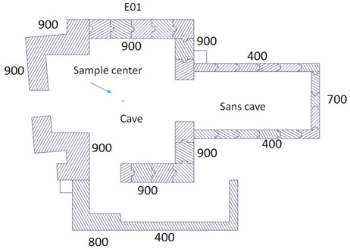

Figure 4. Cave shielding calculations with walls of 40-90cm thick concrete.

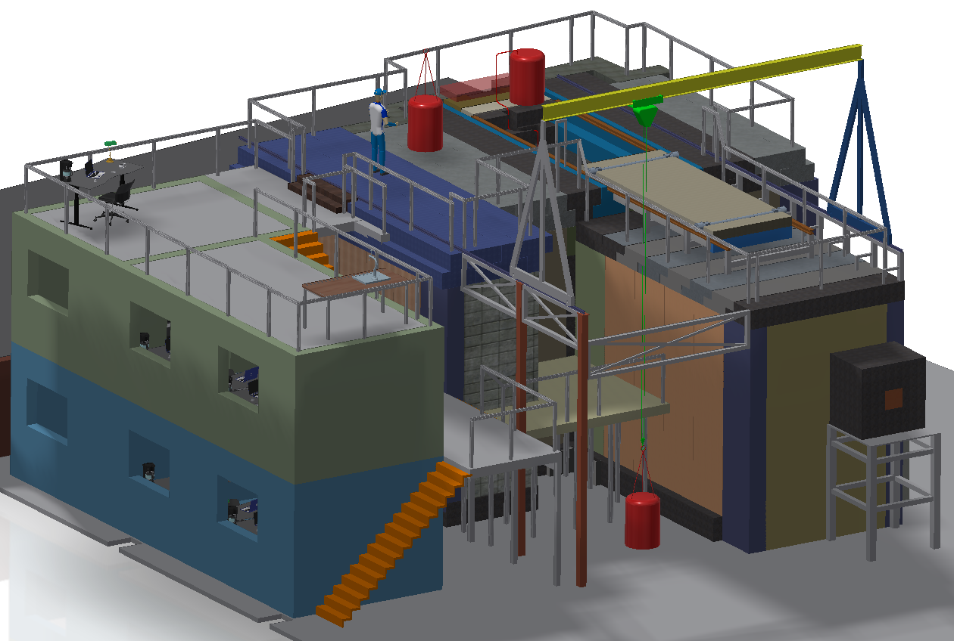
Figure 5: Design of the Heimdal Cave.

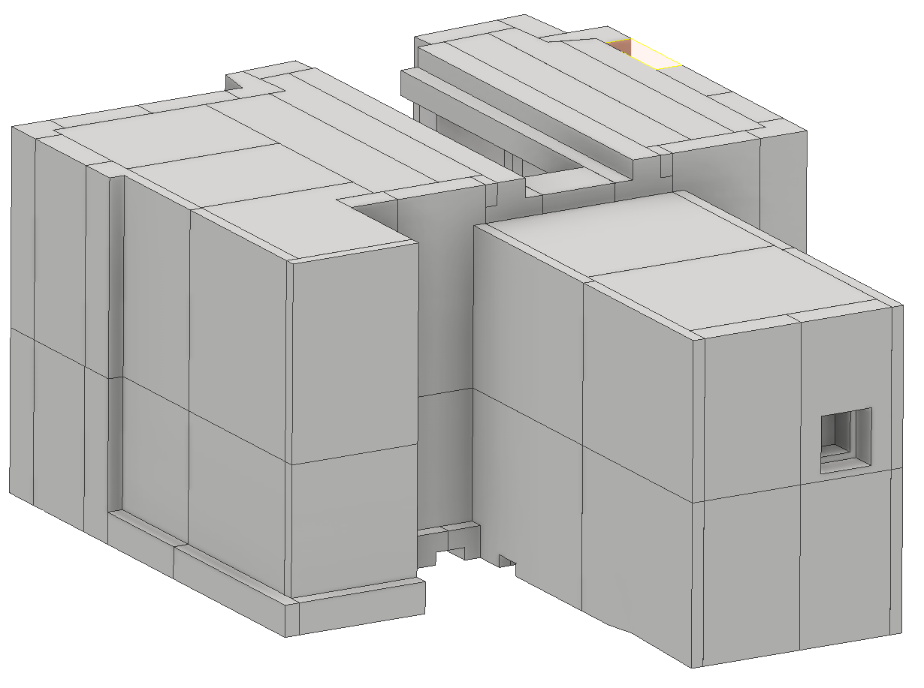
Figure 5: Preliminary Design of the Heimdal Cave. Note that the SANS section currently 8meters is a modular design and can be extended in future upgrades of the instrument to at least 10-12 meters.

6.7 Possible Polarised Neutrons on Heimdal
We have participated in the recent polarised neutron workshop organised by ESS. and we expressed an interest in polarised neutrons for Heimdal. The instrument could easily offer cold polarised neutrons as part of the SANS upgrade, by using a polarising mirror instead of the last deflecting mirror of the cold guide, maybe in some translatable double mirror solution. We have also discussed the possibility of polarised thermal neutrons as part of the initial thermal diffraction installation. This might also be possible using a 3He cell for polarisation analysis, with one section for the diffracted beam and another for the SANS scattered beam. This is still work in progress and we would like to leave open the possibility of polarised neutrons on Heimdal in long term upgrades.

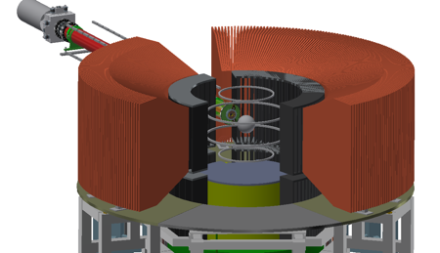
Figure 6: A sketch of the implementation of a possible 3He cell for polarised neutrons and how it might fit onto Heimdal.

7.0 Heimdal Instrument Risk Register

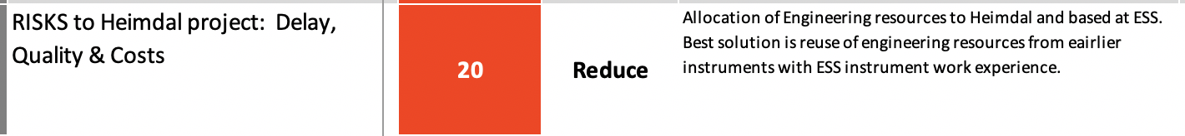

The highest risk to the instrument come from lack of man-power resources especially in engineering compared to other instruments and given the workload for instruments for TG3 at ESS. Currently, Heimdal has only one engineer support who is not based at ESS. We are pushing hard to use our resources to fund and additional engineer on the instrument.

Other RISKS on beamline largely being reduced or mitigated. The RISK of SANS upgradability looks to be reduced by the inclusion of significant cold guide into the PSI/swiss neutronics project.

