Spectroscopy STAP, Oct 2022
Update on the progress of BIFROST

General progress summary
Most major procurements are now wither finalized or close to finalization. The guide is being installed in Oct/Nov 2022 (now), the BW chopper has been installed and undergoing commissioning. The two FOCs are being installed in Nov/Dec 2022. The pulse shaping chopper is being produced and will be tested in April 2023, to be installed when other installations in the bunker allow it. The orange cryostat has not been accepted yet, due to leaks, this is being sorted out in early 2023.
The detector cabling design is done, and the detectors are to be delivered end of Oct 2021. The detector module assemblies are to be finalized by the end of the year and tested with portable source neutrons by early 2023. The data format has been agreed with the ESS, the firmware has been modified and tested with portable source neutrons in June 2023. The full readout chain will need to be tested in Lund, once the detector modules arrive. When the detector group has regrouped, we will start efforts in collaboration with them.
The beryllium filter is ready for assembly, we expect two-staged FAT, a pre-assembly FAT by Nov 2022 and a cooldown test in January 2023. The graphite is awaiting delivery, but since Panasonic will stop production, the have been allowed to buy spares from the spares budget at the ESS. The cave hatch has been produced, and successful FAT was conducted in Oct 2022 to be installed in November 2022.
Regarding infrastructure, we have received favourable offers from the common electrical project (CEP) and the common utilities project (CUP), and accepted. Much uncertainty remains regarding the schedule for designing and installing electrical infrastructure, due to internal resource shifts at the ESS. We emphasize that electrical installations are a prerequisite for cold commissioning and are thus most likely on the critical path for instrument completion (TG-5). Early cold commissioning would allow problems to be identified and mitigated early, and postponing this until the time of beam-on-target would be a considerable risk. Since networks has not been installed, we can already now see an impact on cold commissioning of chopper. Efforts are ongoing to remedy these issues, and NSS is engaged to keep these critical resources engaged in the common electrical project. The Personal Safety System (PSS) is still unbudgeted and BIFROST specific design work has not been completed. Since we are already in the process of installing the relevant doors, hatches and access pathways, this results in unfavourable requests to alter or even reject already procured components.
Below follows a comprehensive list of component status updates.
Component progress summary – from monolith to sample
- NBOA – Manufactured and Assembled. Shipped to ESS.
- BBG – Manufactured and Assembled. Shipped to ESS
- In Bunker Guides – undergoing installation.
  - FAT done in February 22
  - SAT planned for March 22
  - Installation to be completed by December 22
  - ESS may need to remove installations afterwards for Target installation works.
- In Bunker Choppers
  - Slow discs manufactured
  - Fast discs manufactured
  - Spindles received
  - Rack SAT at ESS done
  - BW chopper installed
  - Installation of two FOCs to begin in December
- Bunker Wall Insert – Installed
- Beam Monitors – Opted out of the common beam monitor project
  - Fission monitor ordered, will arrive in December. Beam monitors to be ordered in Nov 2022
- Out of Bunker Guides – undergoing installation
  - Installation complete by December 22
- Beamline Shielding
  - All blocks ready to be installed
- Thermal Shutter – Assembled at ESS
  - PSS information has changed so modifications needed
  - Base installed
  - Still awaiting control box and PSS inputs
- E02 Chopper installed
  - Commissioning ongoing
- Cave – Installed and complete
- Divergence Slits – SAT complete and awaiting installation in Q3 22
- Sample Stack
  - Rotation Stage Installed
  - Mechanics installed, including goniometer, but awaiting cabling
- Orange Cryostat delivered and SAT postponed due to leaks
- Tank – Installed and complete
- Background Shielding
  - Cadmium installed in tank
  - Cross Talk Shielding installed
  - Borated Polyethylene at ESS or in manufacture. Install Q4-22 or Q1-22
- Beryllium Filter
  - Beryllium delivered
  - TG3 done
  - Planned assembly December 2022
- Detectors – manufactured, to be delivered in Oct 2022
  - Mechanical design complete. Sub-TG3 done
  - Electronics design complete
  - Planned assembly Q4 22
- Beam Stop – Installed and complete
- Crane – Installed and complete
- Hutch – Installed and complete
- Electrical Design – Detector cable paths designed, and offer accepted. Otherwise, no design progress – Waiting for ESS common project resource
- Utilities Design – Offer received and accepted, PDR complete
- PSS Design – (Liam)No progress – Waiting for ESS common project resource

Financial status:
Most financial risks are now minimized and ESS common project offers were very reasonable. We hope and believe that our current budget is sufficient.
Risks:
Given the estimated BoT date, we see few relevant schedule risks. The major project & scientific risks are the following:
- Component breakage during installation
- Loss of key ESS or partner personnel for component integration and fulfillment of the common project responsibilities (especially detectors)
- Lack of ressource availabity.
- Delays on electrical design and installation postponing cold commissioning

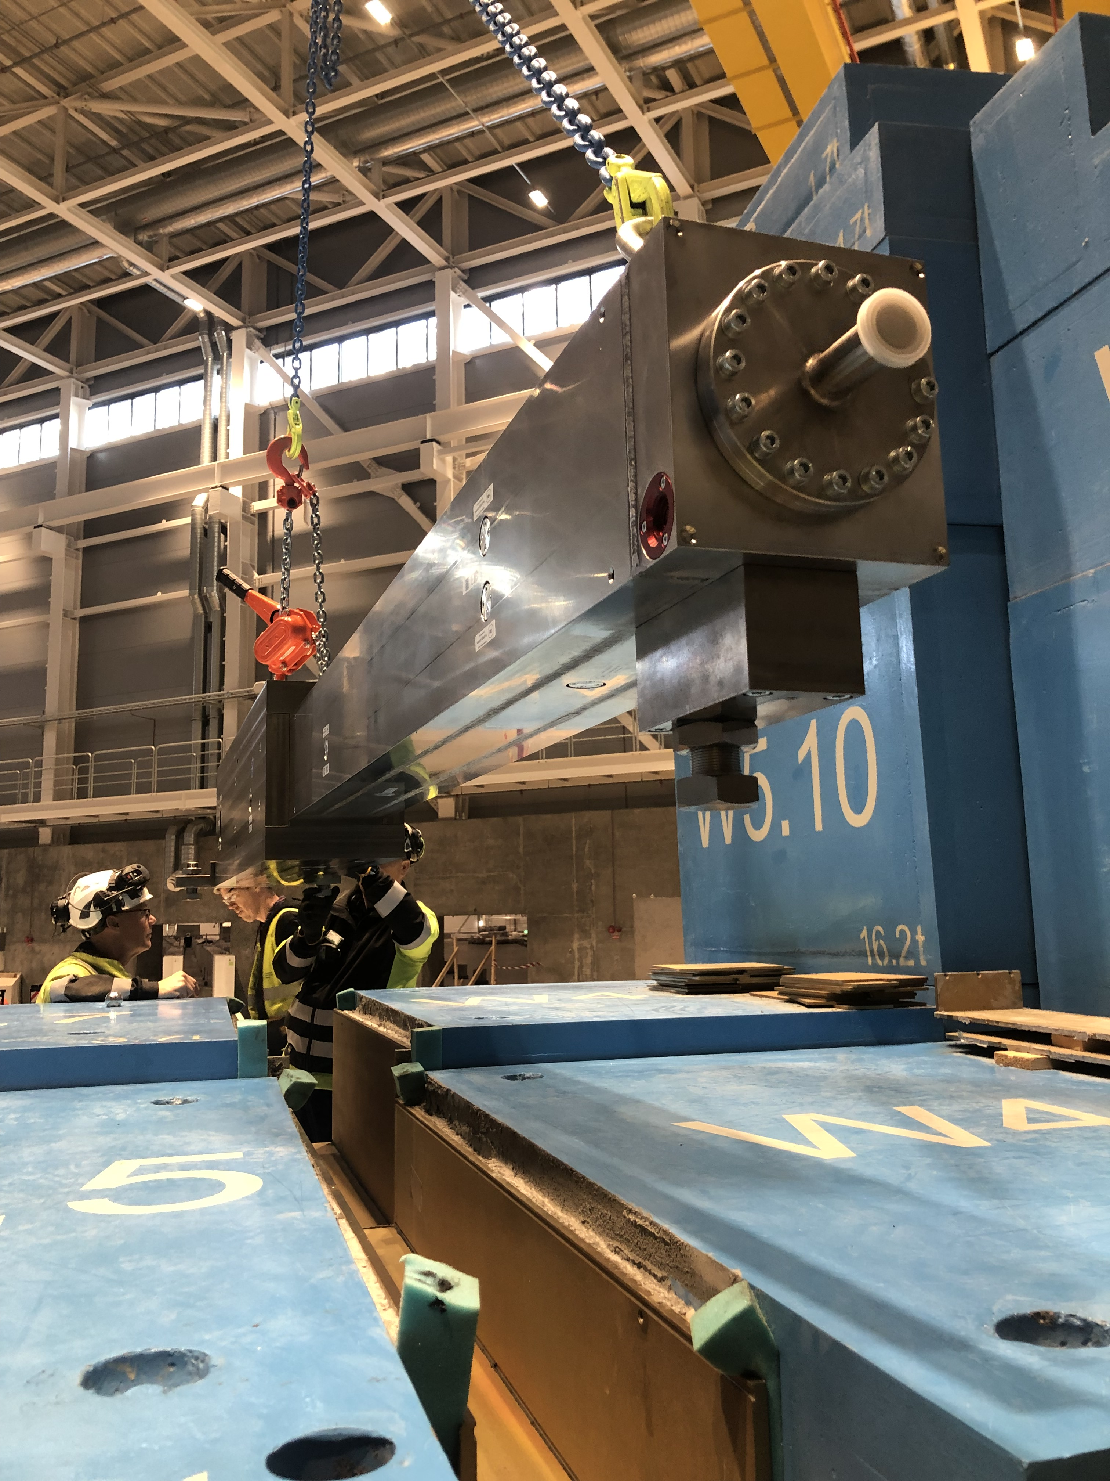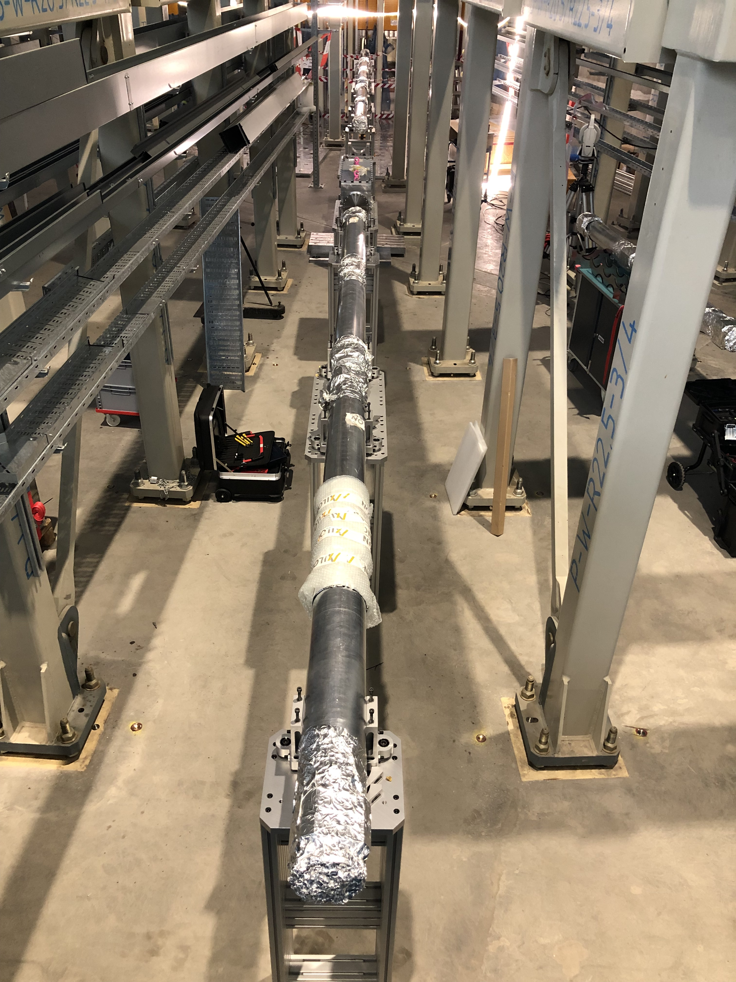

Figure 1 – (left) Bunker wall insert installation. (right) Curved in-bunker guide installation.
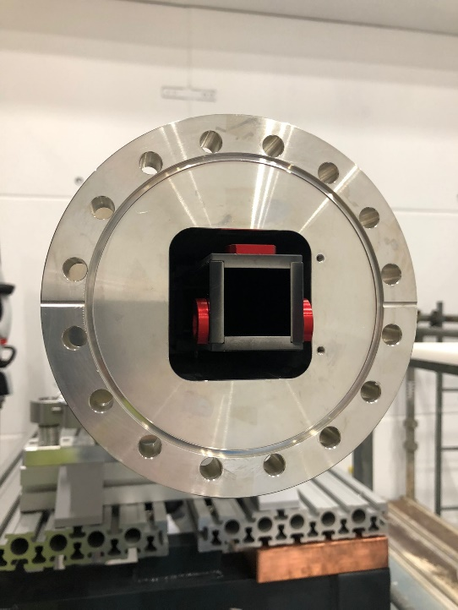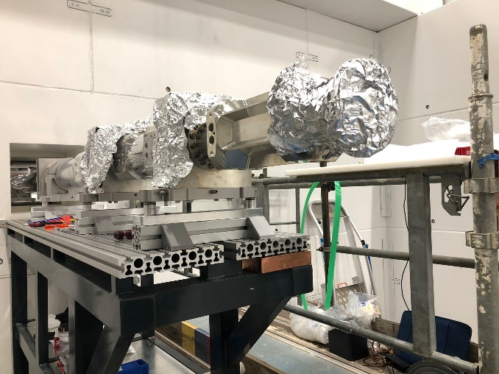
Figure 2: (left) End of the BIFROST guide. (Right) In-cave guide installation

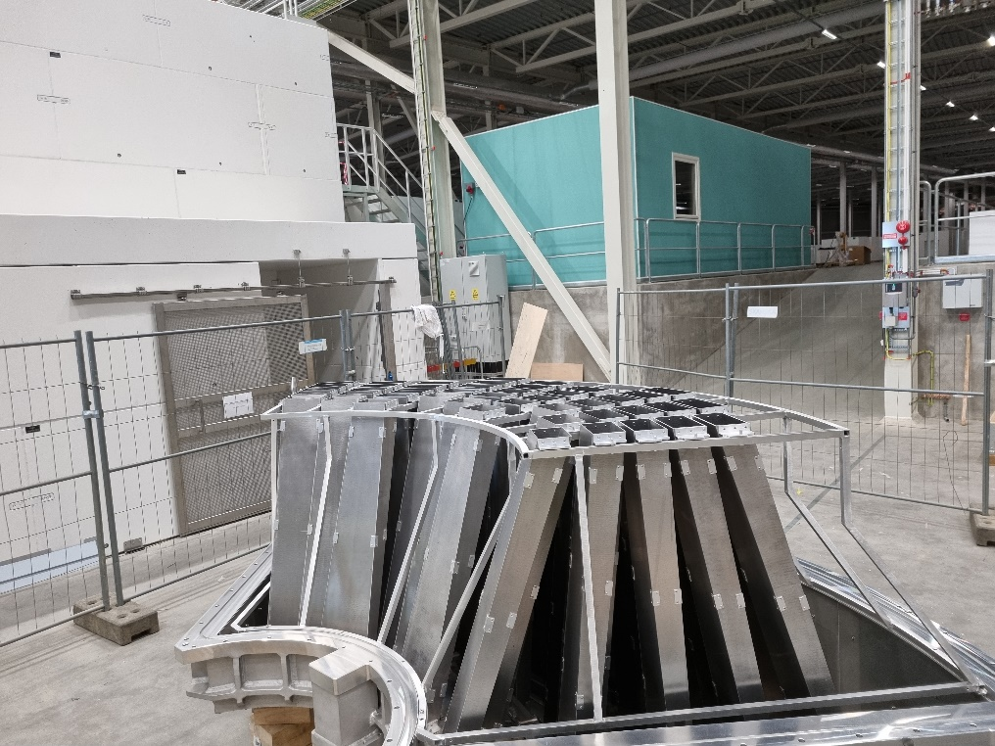
Figure 3: Cross talk shielding installed.

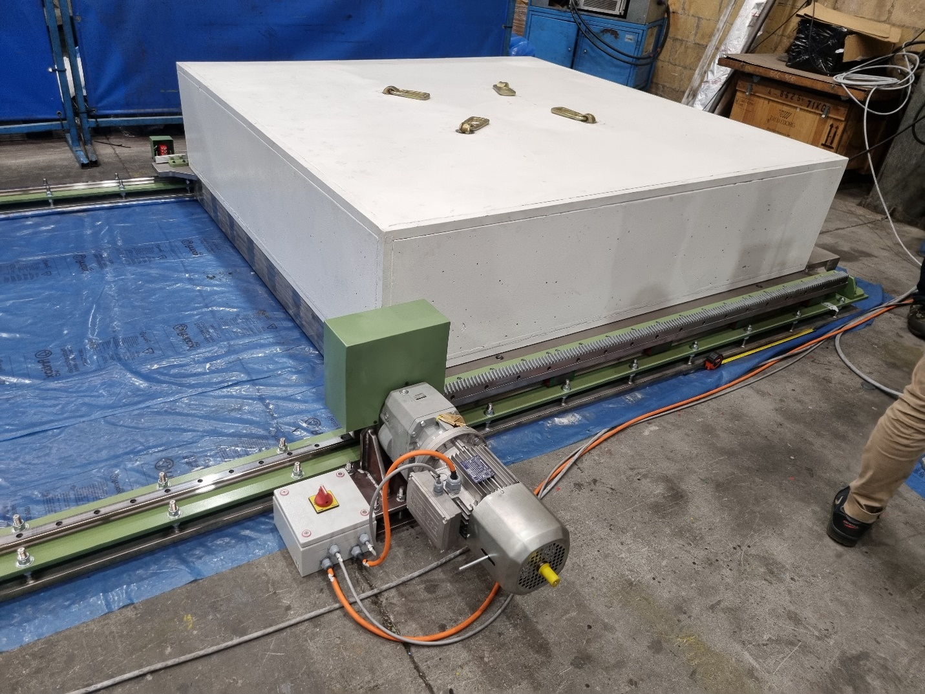
Figure 4: FAT of cave hatch in spain
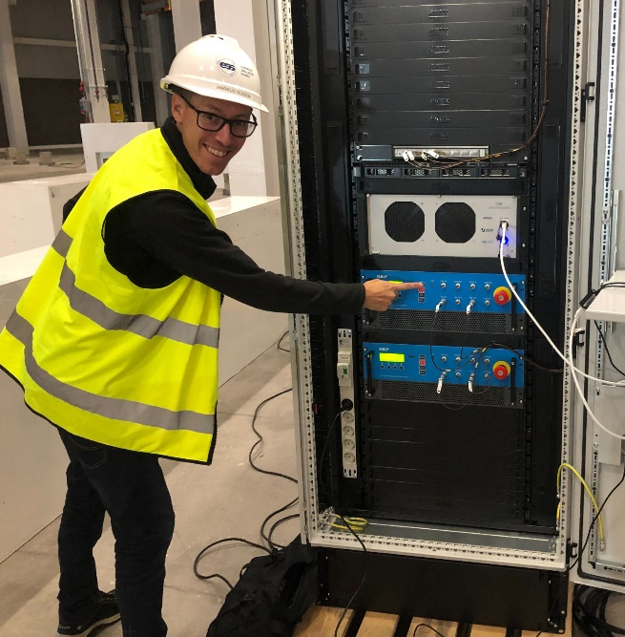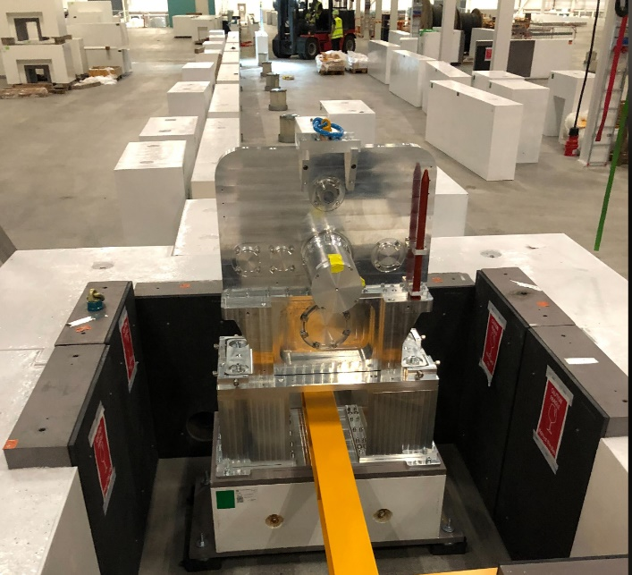
Figure 5: (left) Markus Olsson from ESS chopper group turning on the BW-chopper. (right) The BW chopper just after the installation, residing in its chopper pit.

Figure 6

