

T-REX instrument project: Report of activities for the STAP
meeting in October 2022

Instrument project overview
The T-REX instrument project is a collaboration between the German JCNS (75%) and the Italian CNR (25%), with a total agreed value of 16.85 M€. The project passed officially TG2 in August 2017. The Technical Annex has been signed and endorsed in January 2020.
The project of T-REX is expected to achieve completion in June 2026. The access dates to ESS buildings for installation are foreseen for the end of 2022 in building E01 (first access) and in May 2023 for the bunker area.

The agreed scope includes the delivery of a world class DGCS, capable to perform INS experiments for a broad user community spanning from magnetism to functional materials and functional soft matter, including the option of using polarized neutron for x-y-z neutron spin analysis. In the first-day, T-REX will be equipped with about 40% of detector area, equivalent to 0.8 sr. The instrument specific SE will be a dedicated cryostat.

We here provide a brief overview of the progress in Q2-2022 and Q3-2022, in preparation of the next STAP meeting in October 2022.

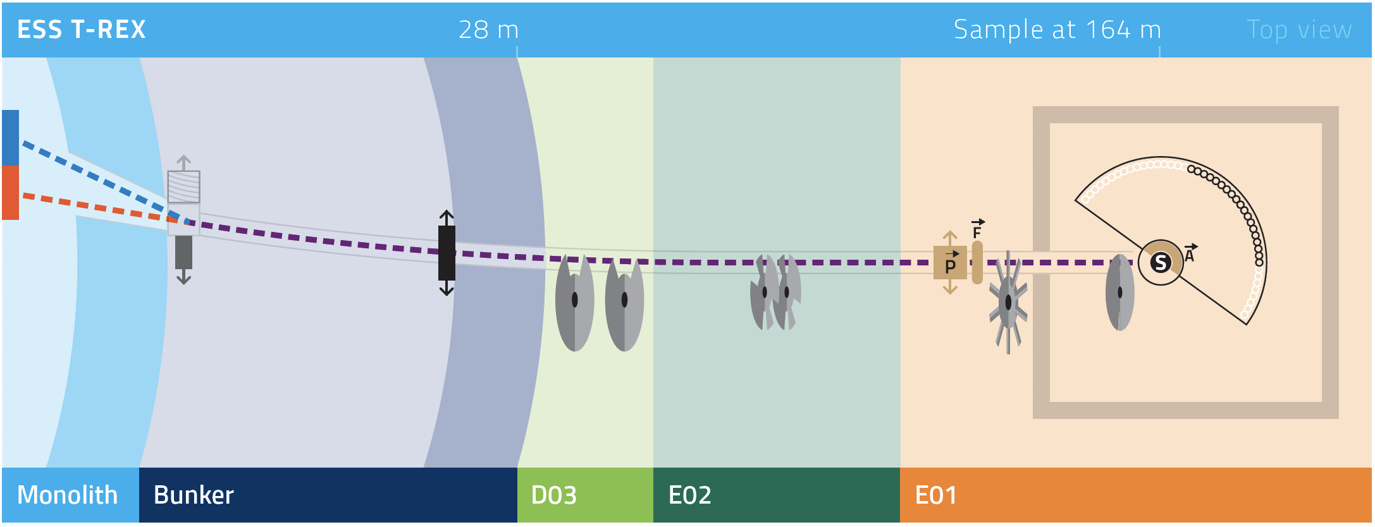

Figure 1. T-REX layout overview.

Beam transport system

Neutron guide

- NBOA is delivered to ESS
- Neutron guide in-bunker: sTG3 process started, received review transmittal on 30.08.2022:
https://confluence.esss.lu.se/x/ajxiG.
- Neutron guide out-of-bunker: contracted awarded to S-DH. Kick-off meeting on the 1st of April. Waiting for completion of in-bunker guide to start the design work. S-DH is a small company and the resources are now allocated to the in-bunker project with a focus on solving the clash with HEIMDAL’s chopper.
- BBGOA: CTV approved, procurement in progress. The m=4 coating of the bender (from NOB) has a slightly reduced reflectivity compared to the benchmark from Swiss Neutronics. Specific simulations have been performed and show no impact on the instrument performance.

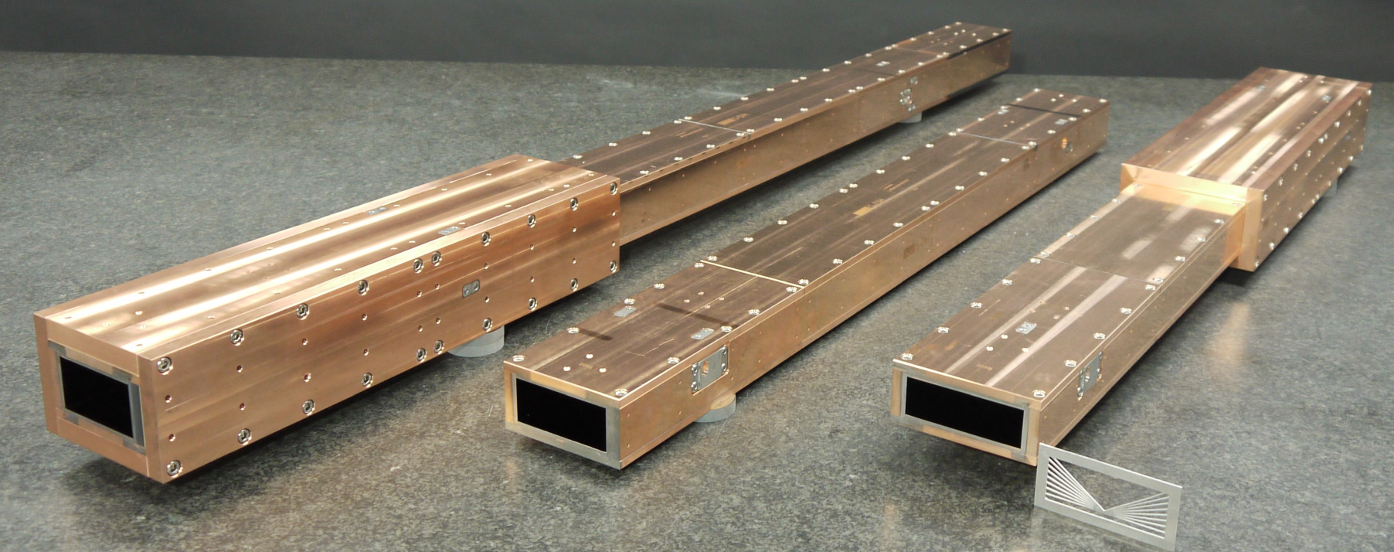
Figure 2: NBOA as delivered to ESS

Heavy shutter
- sTG3 has been approved (16-08-2022)
- Procurement of parts is ongoing.

Shielding

- Pending decision on procuring it through the common shielding project or not. The offer from the common project is way over available budget. Possible solutions are under investigation.
- Technical work to produce the preliminary engineering design is done, including neutronic calculations.

Choppers
- Bandwidth choppers: pending decision on procuring it through the common chopper project or not. All offers (Common project, mirrortron and Airbus) are way over budget. Investigating the possibility to use smaller discs to stay in budget.
- P- and M- choppers: the sub-project is on the way with ZEA-1, currently waiting for offers for chopper discs and discussing spindle options (internal FZJ or SKF type).
- FAN chopper: project it on the way, currently a series of internal design reviews is happening.

Primary collimator
- Detailed analysis showed the possibility of misalignment from deformation of the vacuum vessel after evacuation. Design changes to avoid the problem are currently on the way.
- We discussed the alignment procedure for the guide element and primary collimator with S-DH. A solution using a laser tracker with fiducials under a bell-shaped glass is found. Tests at S-DH showed negligible influence of the glass on the precision.

Polarization
- Cold neutrons polarizer: conceptual design complete, CTV successful (25-06-2022), procured from Swiss Neutronics, final design on the way, currently discussing the interface with the holding magnetic field.
- Thermal neutrons polarizer: design ready for review.
- Guide field (spin transport): magnetic field calculations in progress, necessary components identified. Guide fields after the M-chopper fixed.
- Adiabatic field (spin rotation): magnetic field calculations in progress, necessary components identified.
- Guide/polarizer exchange unit: design ready for review.
- PASTIS set-up: unstarted.

Scattering characterization system

Detector vacuum vessel
- Contract is awarded to the company AVS
- A pre-installation phase is foreseen in Jülich in 2024 to integrate equipment such as the gate valve, radial collimator etc. Vacuum test with the full assembly will also be done. A pre-installation phase in Jülich proved to be very beneficial for DREAM. The plan was presented and acknowledged at the T-REX review meeting. Delivery to ESS is foreseen for early 2025.
- Detector support structure and alignment tool are in production in Jülich, along with the elevated floor for the vessel.

Detectors Integration box
Manufacturing of the prototype of the detectors integration box is ongoing. A minor delay occurred due to a health issue with the machine operator. Restart of manufacturing beginning of November.
The pedestal for detector installation into the chamber is in production in Jülich, as well as the transport trolleys for the detector boxes.

MG-Detector
CSPEC switched to ³He Detector technology. As T-REX is a thermal instrument, we would need higher pressures, which would significantly increase the price, well beyond budget. Therefore T-REX is bound to the MG detector technology. Because Kevin Fissum, the new group leader, is now in place at the ESS detector group, we asked for a presentation of the development roadmap at the next IKON meeting. The detector is currently the largest risk for the project.

Oscillating collimator
- Parts including bearing are now ordered. The bearing has a long lead time of 16 weeks. It is a non-magnetic, low Co content component to fulfil requirement from sample environment and provide low activation.
- A test setup is currently in production, where operation can be tested with test weights and ensure smooth operation. The test stand components

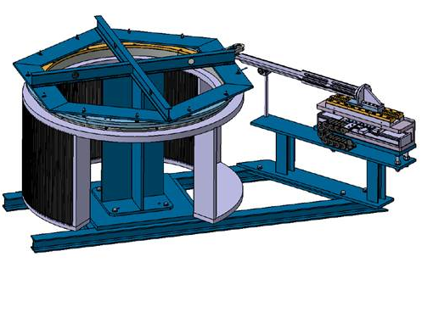
Figure 3: Test stand for the oscillating collimator

Experimental cave
- IDR level civil engineering design
- Radiation levels validated
- Developing the interfaces (e.g. polarization equipment requires a laser lab)

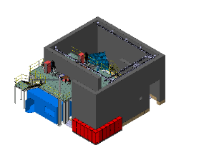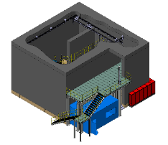
Figure 4: Schematic view of the experimental cave

Safety systems
Nothing to report on this.

Project Risks

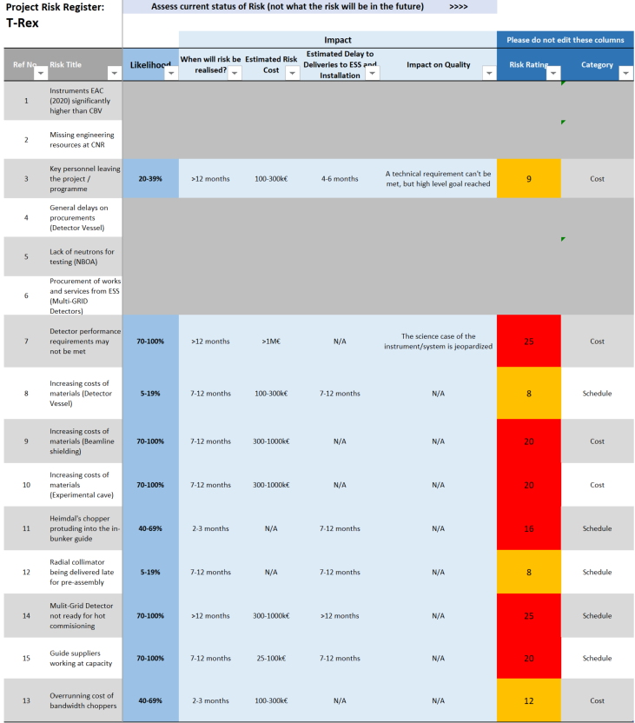

Staffing
The project is currently seeing severe changes in staffing. The exchange of the lead instrument scientist is naturally causing delays for the project. To mitigate these delays we agreed on a transition period to transfer knowledge. Newly arrived personnel will help the project to stay in budget and time.

FZJ:
- There is a transition period in the position of the lead instrument scientist from Nicolò Violini to Christian Franz until end 2022, when Christian Franz will take over. Nicolò Violini will move into the position of project assurance.
- Mario Koenen is back from paternity leave
- Ralf Engels is taking a consulting role for decisions regarding the neutron detector
- Werner Schweika is acting in advisory capacity for all ESS interactions
- Stephan Kleefisch is a trained quality engineer and will help with documentation management

CNR:
Enrico Zanieri is now supporting the project as a project engineer

The position of an installation engineer, possibly joint for all Jülich instruments, is currently under discussion with ESS.

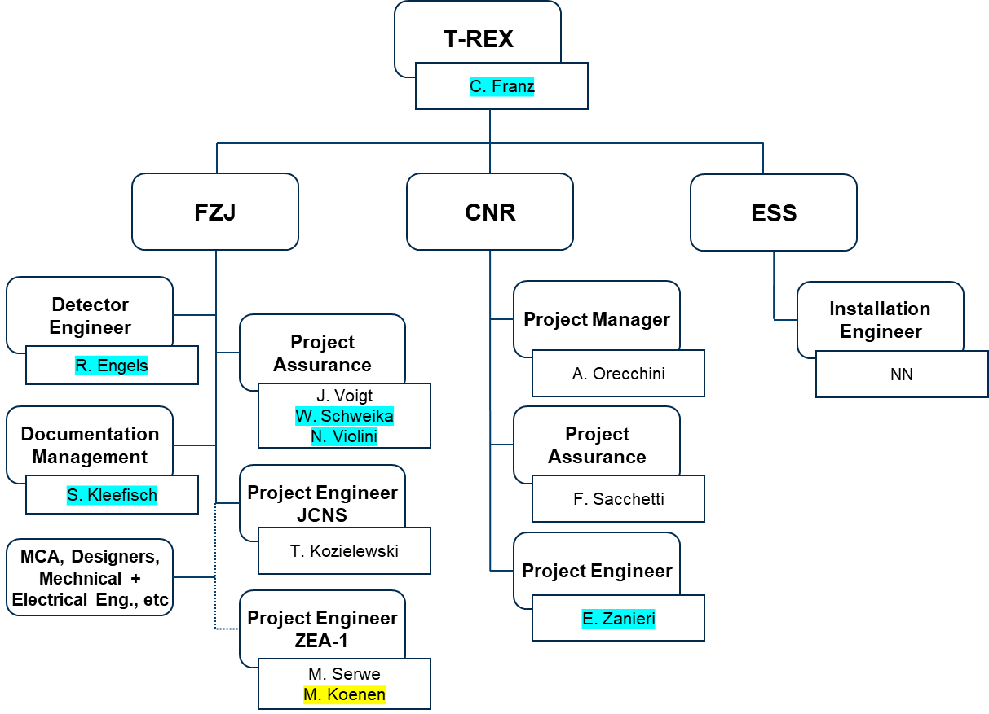
Newly arrived
Back from parental leave

Participation in Common Projects
- Common chopper project
Fast choppers are designed and manufactured by ZEA-1 at FZJ. For the bandwidth choppers we would very much like to participate in the common chopper project, however large choppers (ø 1200mm) require additional development work and are over budget. We investigate the possibility to switch to standard size (700mm) discs.
- Common shielding project
As mentioned above, we would like to participate in the common project. However, the offer received by ESS is way over budget.
- Common Electrical Project
We will participate, but not yet started.
- Common Utilities Project
We will participate, but not yet started.

Detector readout and analysis
As the detector and detector readout electronics are delayed, the interaction with DMSC is currently pending.

