Spectroscopy STAP, Apr 2023
Update on the progress of BIFROST

General progress summary
Most major procurements are now wither finalized or close to finalization. The guide installation has finished, the BW chopper has been installed and integrated into EPICS/NICOS. The two FOCs have been installed but not hooked up yet. The pulse shaping chopper has experience a set-back, since the first of the two disc broke in testing. The chopper group is working on a contingency design, and continuing with the current disc supplier to find the problem, and correct it if possible. The orange cryostat have been accepted, with a minimum temperature of 1.35 K.
The detector cabling design is done, module assemblies are finalized. The first test with portable source neutrons will be performed in mid-April. The data format has been agreed with the ESS, the firmware has been modified and tested with portable source neutrons in June 2023. The full readout chain will need to be tested in Lund, once the detector modules arrive by August 2023. Efforts to hand over responsibility to the ESS are ongoing. We will ship the prototype detector triplet to the ESS, to be installed at Utgård and finally at the Lund source facility. Here, the full readout chain will be tested, with the ESS detector group being the main responsible from then on.
The beryllium filter is almost assembled ready for assembly, but has experience several minor setbacks causing delays (of trivial nature performance-wise). We therefore postponed the two-stage FAT to May 2023, and we expect full project completion before the summer. The HOPG (graphite) has been delivered, and the analyser blade si-wafers and clips have been ordered. Efforts to finalize the production of the analyser assembly is ongoing – the analyser base plate is in production, and we are producing a final prototype (machined in the right way) for testing. After that, production of all analyser holders should take a few months, and we should be ready to install analysers by August/September 2023.
The schedule for the common electrical project (CEP) have now been finalized, and we expect electrical installations to start in September/October. Regarding network and utilities and especially PSS, we have yet to have a clear schedule. We re-emphasize that electrical installations, utilities and network are a prerequisite for cold commissioning and are thus most likely on the critical path for instrument completion (TG-5). Early cold commissioning would allow problems to be identified and mitigated early, and postponing this until the time of beam-on-target would be a considerable risk. It is essential to start being able to control motors, choppers, and run the installed systems as envisaged well before beam-on-target.
Below follows a comprehensive list of component status updates.
Component progress summary – from monolith to sample
- NBOA – Manufactured and Assembled. Aligned and ready to install
- BBG – Manufactured and Assembled. Shipped to ESS
- In Bunker Guides – undergoing installation.
  - FAT done in February 22
  - Installation completed
  - ESS may need to remove installations afterwards for Target installation works.
- In Bunker Choppers
  - Slow discs manufactured
  - Fast discs pending developments
  - Spindles received
  - Rack SAT at ESS done
  - BW chopper installed
  - Installation of two FOCs to begin in December
- Bunker Wall Insert – Installed
- Beam Monitors – Opted out of the common beam monitor project
  - Fission monitor arrived, and all other monitors ordered, will arrive in May 2023
- Out of Bunker Guides
  - Installation complete
- Beamline Shielding
  - All blocks ready to be installed
- Thermal Shutter – installed
  - Still awaiting control box and PSS inputs
- E02 Chopper installed
  - Commissioning ongoing
- Cave – Installed and complete
- Divergence Slits – installed
- Sample Stack
  - Rotation Stage Installed
  - Mechanics installed, including goniometer, but awaiting cabling
- Orange Cryostat accepted
- Tank – Installed and complete
- Background Shielding
  - Cadmium installed in tank
  - Cross Talk Shielding installed
  - Borated Polyethylene at ESS or in manufacture. Installation after tank repositionin Q3-23
- Beryllium Filter
  - Beryllium delivered
  - TG3 done
  - Planned FAT April 2023
- Detectors – assembled
  - Mechanical design complete. Sub-TG3 done
  - Electronics design complete
  - Planned test Q2 23
- Beam Stop – Installed and complete
- Crane – Installed and complete
- Hutch – Installed and complete
- Electrical Design – Detector cable paths designed, and offer accepted. PDR complete
- Utilities Design – Offer received and accepted, PDR complete
- PSS Design – Awaiting PDR

Financial status:
Most financial risks are now minimized – unless unforeseen issues arise
Risks:
Given the estimated BoT date, we see few relevant schedule risks. The major project & scientific risks are the following:
- Component breakage during installation
- Loss of key ESS or partner personnel for component integration and fulfillment of the common project responsibilities (especially detectors)
- Lack of ressource availabity.
- Delays on electrical design and installation postponing cold commissioning. If a serious problem is encountered just before BoT, a very unnecessary delay might ensue.

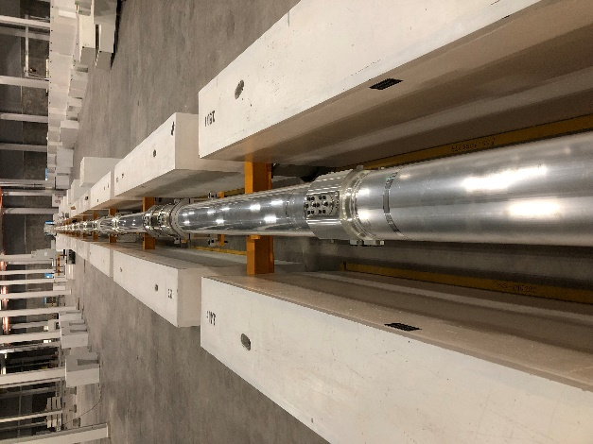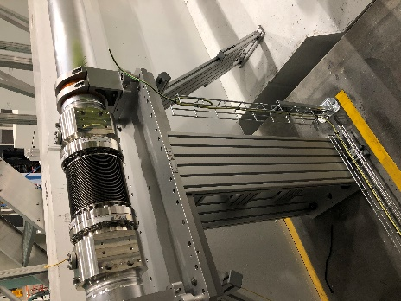

Figure 1 – Long guide in the E02 section
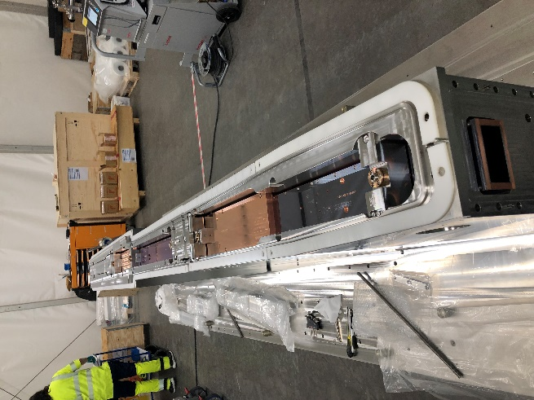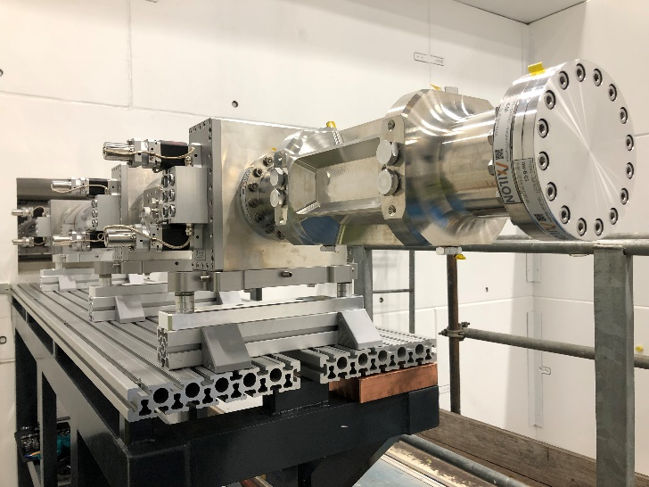
Figure 2: (left) NBOA installed (Right) Divergence jaws installed

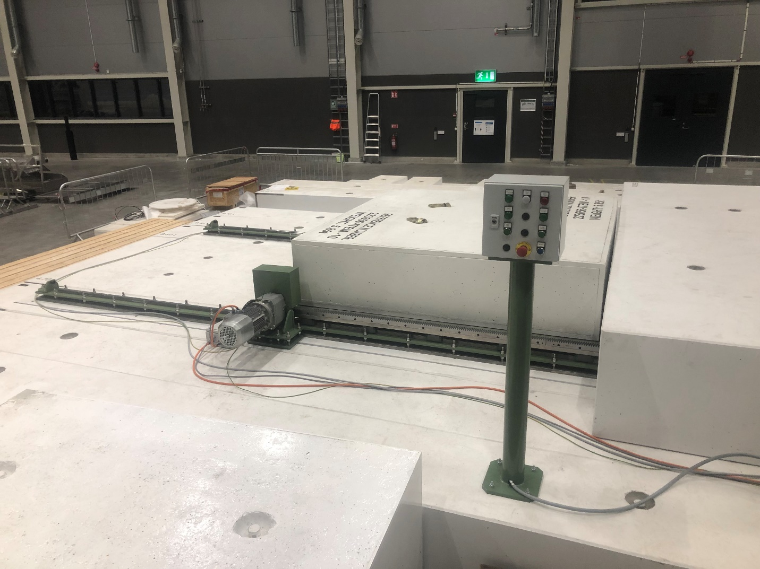
Figure 3: Cave hatch installed and accepted
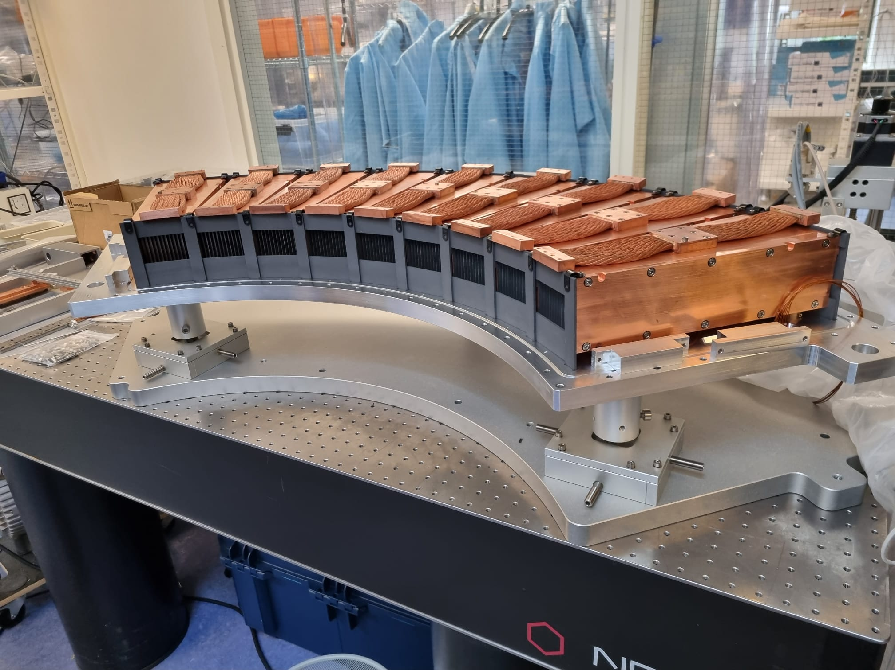
Figure 4: Beryllium filter elements assembled

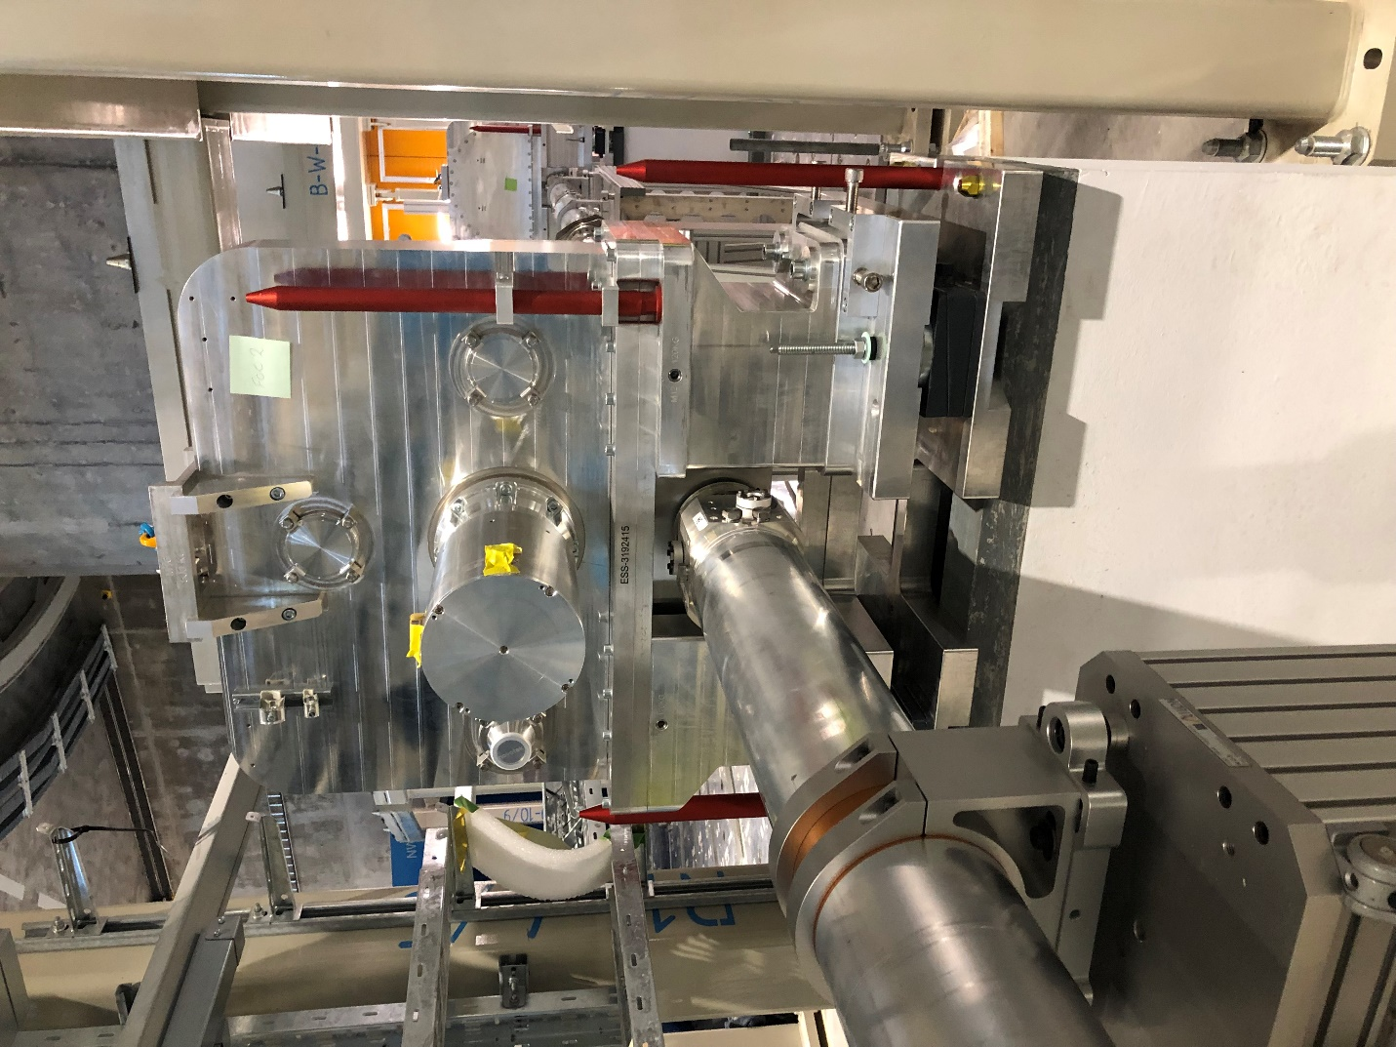
Figure 5: FOC installed

