Bragg Edge Round Robin

Part 1: Strain Mapping

Ranggi Ramadhan1,*, Winfried Kockelmann1, …

*1Science and Technology Facilities Council (STFC) Rutherford Appleton Laboratory, ISIS Facility, Harwell OX11 0QX, UK*

*…*

*ranggi.ramadhan@stfc.ac.uk

# Introduction

Bragg edge neutron imaging provides unique insight into the structural properties of materials. The technique offers capabilities to provide 2-dimensional (2D) or 3-dimensional (3D) maps of materials information (e.g., residual strain, phase, texture and crystallographic information) in the interior of components, with a relatively simple setup and non-destructively. Taking advantage of these unique traits, the usefulness of Bragg edge imaging for material science and engineering applications has been shown repeatably for the 2D case[1],[2],[3] and a few times for the 3D case[4],[5]. These studies motivate further development and establishment of Bragg edge imaging for material science at various neutron facilities. Several aspects pertaining to this emerging technique need addressing. Experimental and data analysis methods may benefit from evaluation of protocols, benchmarking, and possibly harmonisation across instruments.

In the past, efforts have been made to establish emerging neutron methods. For example, a round robin exercise and inter-laboratory comparisons were carried out within the VAMAS TWA20 working group to assess the repeatability and accuracy of methods at different instruments and facilities to produce standards or codes of practices for the measurement of stress inside materials using neutron diffraction. This work aims to carry out similar cross-facility exercises and inter-laboratory comparisons, albeit on a much smaller scale in terms of number of participants and expected end products/ outputs.

In this work, we propose a round robin activity which refers to the measurement of a set of common/agreed samples at several neutron facilities with Bragg edge imaging capability, aiming to include the major neutron imaging beamlines around the world. The scope of this current project is Bragg edge neutron imaging for 2D strain analysis, with an outlook of expanding it to phase analysis, texture, and 3D strain analysis in the future. **Specifically, this work will address how the instrument and experimental setup as well as data analysis methods affect the repeatability and accuracy of Bragg edge strain mapping.** The following paragraphs will describe each aspect in more detail.

# Technical overview

## Bragg edge strain mapping

Details regarding underlying principles of Bragg edge strain mapping can be found elsewhere[6] and will not be repeated here. Strain is deformation of material due to stress (applied and/or internal). Strain is a tensor quantity, and it ties to the stress tensor through the constitutive relationship that describes the elastic properties of a material. Stress analysis is one of the most important aspects in engineering.

Similar to neutron diffraction, strain measurement with Bragg edge imaging relies on measuring the change in lattice spacings of polycrystalline materials. Here, the change in lattice spacing is reflected by the shift in Bragg edge position. Therefore, the accuracy of Bragg edge strain measurement depends heavily on the determination of Bragg edge position.

## Instrument and experiment setup

For the vast majority of work regarding Bragg edge strain mapping, experiments are carried out on time-of-flight (TOF) imaging instrument at pulsed sources. In this case, the experimental setup should be relatively simple, which comprise beam aperture(s) and a time-resolving imaging detector. One aspect that might influence the accuracy of the strain mapping is the accuracy of detector placement in the beam, which can affect the variation of neutron flightpath across the field of view[7].This variation of flightpath translate to systematic wavelength variation across the field of view and can be mistakenly attributed to sample features. This effect will be characterised for each instrument.

Alternatively, Bragg edge imaging can be realised at continuous sources, utilizing either monochromisation technique using crystal monochromators[8] or the more recent Frame Overlap Bragg edge Imaging (FOBI) method[9]. The wavelength resolution of such methods can affect the accuracy of Bragg edge strain mapping, and comparison between these methods and TOF Bragg edge imaging will be made and discussed.

Finally, this work will address issues regarding sample alignment. Sample alignment in transmission geometry is simpler compared to neutron diffraction, as it can be done by simply observing the sample image on the detector and correcting it accordingly. That said, the fact that strain information obtained from Bragg edge imaging is averaged through thickness in beam direction, means that the analysis will be sensitive to how parallel the intended strain component is with the beam direction. This aspect will be looked at in the round robin exercise.

## Data analysis methods

The accuracy of Bragg edge strain analysis relies heavily on the accuracy of the determination of Bragg edge position. Analytical functions[10],[11],[12], which can improve the accuracy of Bragg edge wavelength determination, are often used to achieve a good accuracy from measured Bragg edges. There are several other approaches available, including analysing the derivatives of the edge[13], cross-correlation[14], and Bayesian non-parameteric fitting[15]. Datasets from round robin campaign are invaluable to assess the accuracy of different approaches. For any analytical description of the Bragg edge function it is highly beneficial to separate parameters of instrument resolution from parameters of sample broadening, as done in ref-6.

# Sample description

## Sample requirements

A number of requirements for standard sample(s) need to be defined to ensure the round robin campaign can be performed successfully. For a Bragg edge round robin with a scope of strain mapping, the requirements are as follows.

*Materials* – To allow efficient measurement, standard sample(s) need to be made of polycrystalline materials, with low and/or high coherent scattering cross section and well separated Bragg edges. Engineering materials such as Iron, Copper, and Aluminium are good candidates.

*Size* – The size of the sample need to be considered so that the region of interest (ROI) to be investigated fits within the field of view (FOV) of the imaging detector. A number of neutron imaging facilities uses microchannel plate (MCP) detector with 28×28 mm2 FOV. Other detector and/or instrument combination can provide smaller or larger FOV, however the MCP FOV seems a good ballpark figure.

*Shape* – As the information provided by Bragg edge strain mapping is through-thickness averaged, the shape or features of the sample is preferably homogeneous in the beam direction.

*Crystallographic texture* – Standard sample(s) is preferably isotropic or weakly textured, as highly textured specimen will likely alter the shape of the Bragg edges and produce challenges in the analysis.

*Grain size* – Due to the through-thickness averaged data on each pixel of the imaging detector, grain size effect is less severe compared to, e.g., neutron diffraction. However it is preferrable to have sample with relatively small grain size, approximately < 500 µm average grain size.

*Strain* – As the focus of this round robin is strain analysis, the sample/ sample feature should have ideally > 1000 µɛ across the FOV.

*Fiducials markers* – It is important for the standard sample to have fiducial markers so that accurate inter-laboratory comparison can be made. Fiducial markers should be easy to measure using sample alignment system available on an instrument, and even better if can be measured with other metrology system, e.g., CMM.

*Reproducibility* – As the standard sample will be measured at different facilities subsequently, it is imperative that the sample can be reproduced consistently in case of the sample being lost or damaged during the transport.

## Sample description

Based on the sample requirements, a number of round robin samples have been defined. The description of each sample can be found in the Appendix of this document.

## Stress-free reference sample

Stress-free reference or d0­ sample is crucial in any strain analysis. Based on the ISO standard for neutron diffraction, the d0­ can be:

* Measurement in a material at a position known to contain a negligible stress
* Measurement on a powder which is representative of the material being examined
* Measurement on small coupons, cut from large blocks of material

The choice will be made depending on the standard sample being measured.

## Calibration powder sample

Power calibration sample will be made of standard powder, most likely high-purity Fe or ceria, enclosed inside a square aluminium container with dimension of 100 × 100 × 15 mm3 and wall thickness of around 1.5 mm. Calibration powder samples are prepared for three calibration purposes:

1. Calibration of instrument flight path
2. Calibration of flight path variation across detector field of view
3. Determining the resolution function

For flight path calibration, Bragg edge positions in time-of-flight or wavelength will be determined from the whole detector area. The result will then be compared against the tabulated d-spacing data, and flight path can be determined. Flight path variation across the detector field of view is done in the same manner, however the Bragg edge spectra are taken from subsets of detector area.

# Experimental procedure

As one of the main goals of the round robin activities is to do an accurate inter-laboratory comparison, the experiment at each facilities need to be done as identical, or at least as comparable, as possible. Therefore, it is important that certain procedures are followed.

For round robin measurement at each facility, a minimum of 4 type of scans need to be performed:

* Open beam/ Flat field measurement
* Calibration powder measurement
* Benchmark sample measurement
* Stress-free reference measurement

Details for each measurement is described in the following paragraphs. The summary of required measurements can be found in the diagram in Fig. 1.

## Open beam/ Flat measurement

Open beam/ Flat measurement without the presence of a sample in front of the detector. The measurement needs to be done using the same instrument parameters (e.g., *L/D*, wavelength range, trigger-delay, etc) as the measurements of which it will be used for normalisation. Exposure time should be comparable to exposure time of the benchmark sample measurement.

## Calibration powder measurement

Calibration powder sample should be aligned so that the sample face is perpendicular with the beam direction and placed at a given distance to the detector, not necessarily close to reduce neutron scattering into the FOV. The centre of the sample should be aligned with the centre of the detector. Exposure time needs to be made sufficient so that Bragg edge spectrum can be obtained from subsets of detector areas.

A second measurement is recommended with the powder sample rotated 180 degrees around the vertical axis to eliminate the possibility of the sample introducing systematic variation across the field of view.

## Standard/benchmark sample measurement

Standard sample should be aligned so that the region of interest is in the field of view of the detector, and its face is perpendicular to the beam direction. The region of interest is different for each standard sample and more details can be found in the appendix. The sample should be placed as close as possible to the detector to optimize spatial resolution. The distance sample-centre to detector sensor should be recorded. Exposure time will depend on the desired statistics on each pixel/ macro-pixel used to reconstruct the strain map.

Each standard sample will come with their own fiducial marker(s), and a radiograph (hence faster exposure time) of this fiducial marker should be obtained. If the image of fiducial marker cannot be taken within the same field of view of the image of the region of interest, then the shift between them should be recorded, e.g., by recording the sample stage motor position of the fiducial marker vs region of interest.

## Stress-free reference measurement

Stress-free reference sample should be measured in the same fashion as the standard sample.

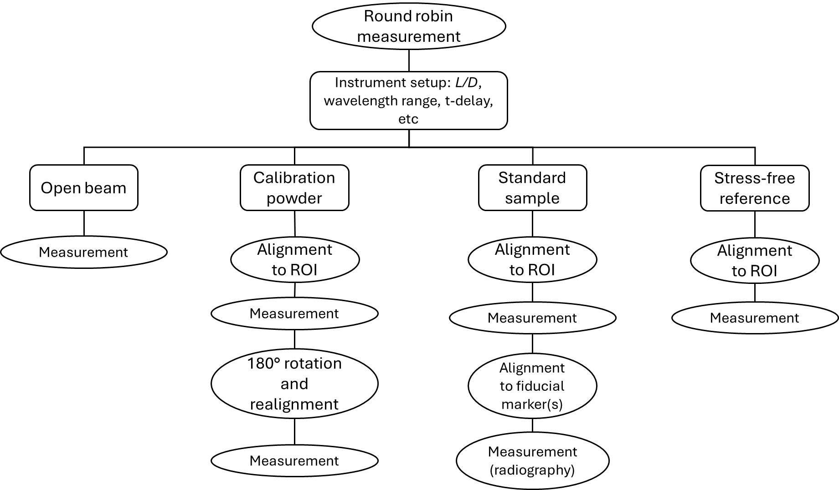

Figure 1. Diagram of the required activities and measurements in the round robin exercise

# Reporting

In order to ensure the traceability and reproducibility of the data, metadata needs to be included in the reporting of round robin measurements. While not exhaustive, the list of important metadata to be included are:

* Detector type and details, including sensor type, pixel size, optics, scintillator, trigger delay, etc, if applicable.
* TOF range, wavelength range, TOF bin widths, monochromator details
* L/D
* Sample stage motor position
* Sample-to-detector distance

Appendix A1: U-flexures & U-bend

# Summary

The first set of Bragg edge round robin standard sample is U-flexures (F) and U-bend (B). The U-flexures were electrical discharge machined directly to the geometry shown in Fig. A1 1, and can be loaded in compression (FC), tension (FT), or left unloaded (FN). The U-bend samples started as an electrical discharge machined 10mm x 20 mm x 160 mm blank which was subsequently subjected to three-point bending according to ISO 5173.

Figure A1 1. Front view (left) and side view (right) of the U-Flexure samples, showing the geometric dimensions and tolerances in millimetres.

For the U-flexures, the two legs of the sample can be brought closer together, or pushed further apart by means of a 316L stainless steel locking turnbuckle and their position inferred by a dial/digital test indicator (DTI) mounted to a fixture as shown in Fig. A1 2. The maximum displacement of the U-flexures was determined such that they remained solely elastically loaded. The target deflection is ±0.4mm for FT and FC specimens at the measurement position indicated with the devised loading fixture.

# Materials

Grade S355J0Z35+N hot rolled structural steel. The chemical is summarised in Table A1 1.

Table A1 1. Summary of chemical composition (certificate) for S355J0Z35+N

|  |  |  |  |  |  |  |  |  |
| --- | --- | --- | --- | --- | --- | --- | --- | --- |
| **C,%** | **Si,%** | **Mn,%** | **P,%** | **S,%** | **Cr,%** | **Mo,%** | **Ni,%** | **AL,%** |
| 0.15 | 0.34 | 1.45 | 0.014 | 0.003 | 0.02 | 0.001 | Trace | 0.036 |
| **Cu,%** | **Nb,%** | **Ti,%** | **N,%** | **V,%** | **Fe,%** |  |  |  |
| 0.02 | 0.025 | 0.004 | 0.0052 | 0.005 | Balance |  |  |  |

Figure A1 2. Sample configurations and coordinate system. a) samples with fiducial reference points for FT (Tension), FC (Compression) U-flexure and B U-bend samples (‘RD’ indicates the rolling direction of hot-rolled plate) from which they were cut. b) dial-test indicator (DTI) fixture readings for the different FT (tension), FC (compression) and FN (neutral/unloaded) U-flexure samples.

# ROI

The ROI for both the U-flexures and U-bend sample is at the inflection point of the curvature, as indicated in the Fig. A1 3 below.

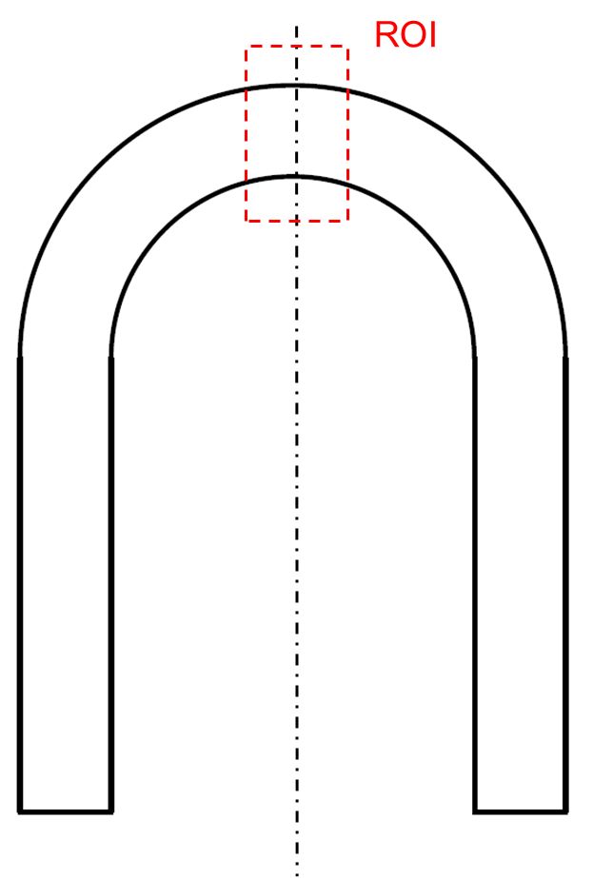

Figure A1 3. Region of interest for Bragg edge strain mapping

# Stress-free reference

The unloaded sample (FN) serves as reference for the U-flexures while a pin is used for the U-bend (see Fig. A1 4 below)

Figure A1 4. Stress-free reference pin for the U-bend sample

# Fiducial markers

Fiducial balls, 4 for the U-flexures and 3 for the U-bend, are attached to the samples. This should provide high visibility markers, for both imaging detectors and alignment systems available on neutron instruments, e.g., theodolite, alignment cameras, etc. The displacement of fiducial markers on the loaded U-flexures can also be employed to determine the specific loading as boundary conditions for FE analysis.

1. R. Woracek, et al. Nuclear Instr. and Methods in Physics Research, Section A, 878 (2018) 141.
2. R.S. Ramadhan, et al, Mater. Des. 143 (2018) 56.
3. A.S. Tremsin, et al., Strain. 52 (2016) 548.
4. C. Carminati, et al., J. Appl. Cryst. 53 (2020) 188.
5. R. Ziesche et al., J. Imaging 6 (2020) 136.
6. Santisteban, J. R., et al., *Journal of Applied Crystallography* (2001). *34*(3), 289–297.
7. Tremsin, A. S., et al. Nuclear Instr. and Methods in Physics Research, Section A, *1009* (2021) 165493
8. Treimer, W., et al. Appl. Phys. Lett. (2006) 89, 203504
9. Busi, M., et al. *Scientific Reports* (2020) *10*(1)
10. Vogel, S. (2000). *A Rietveld-Approach for the Analysis of Neutron Time-of-Flight Transmission Data*.
11. Santisteban, J. R., et al. *Journal of Applied Crystallography*. (2001), *34*(3), 289–297.
12. Sato, H., et al., *Materials Transactions*. (2011), *52*(6), 1294–1302.
13. Morgano, M., et al. (2020), Additive Manufacturing, 34(March), 101201.
14. Ramadhan, R. S., et al. (2018), Materials Research Proceedings, 4, 149–154.
15. Hendriks, J., et al. (2020), *The Journal of Strain Analysis for Engineering Design*, *56*(6), 371–385