BIFROST - Report to the spectroscopy STAP
14th October, 2024

BIFROST is the indirect geometry spectrometer for extreme environments at the ESS, employing a polychromatic incident beam and a multiplexing analyser backend, utilizing the prismatic analyser concepts. BIFROST is optimized for efficiently measuring the horizontal scattering plane, with very efficient trade-offs between energy resolution and neutron flux. A crude outline is shown below.
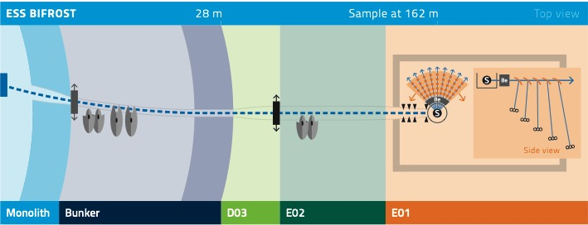

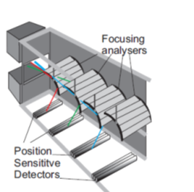

Project progress:
BIFROST is in the final stages of construction, and moving into the cold commissioning phase. We are currently finalizing the detector tests and debugging, and installing the last cables. There is power and network in the cave area, and the BW chopper has been commissioned. TG5 is currently estimated to be in Q2 or Q3 2025. The installation of the Personal Safety System is ongoing.
The current challenges is getting our motion control and detector racks finalized and powered up, so that the integrated tests of the motion systems and detectors can begin. These tests involve two distinct timing systems, PtP for motion and reference pulse timing for the detectors, and the integration of timing as well as the data path from hardware to nexus file has not been tested.
Another challenge is the infrastructure in the bunker which is currently not installed. This is needed for testing the fast PSC chopper and the two FOC choppers in the bunker. The PSC chopper system is rather complicated and several months of testing is expected to be necessary.
If this infrastructure installation is delayed much further, readiness for BoT in Oct 25 is jeopardized.
Detectors: Our detector system is standard He-3 technology, and thus among the most simple detectors at the ESS. While the tests have been mostly successful, minor noise issues have been found. These are expected to be solved after TG5
Sample environment: We have the sample environment systems we need, a 15 T magnet, dilution inserts and clamp pressure cells. We do not expect sample environment to impede early science at this point.
Data reduction: Our instrument data scientist has recently simulated phonons on BIFROST using a digital twin that mimics the BIFROST data stream, in event mode, through EFU and Kafka. The data reduction methodology has been shown to work, and SCIPP as a tool works well. We have a detector debugging GUI for quick view of the detector output. EFU’s and live views for the monitors should be well in hand. We are well underway to be able to do hot commissioning.
Hot commissioning: We have a list of hot commissioning task for each subsystem, some tests are not detailed enough, such as absolute flux measurements and calibration procedures. These two topics will be the focus before the next STAP.
Rescoping: BIFROST was not drastically descoped back in 2016, and we have aimed to complete a finished secondary spectrometer. The only rescoping is polarization analysis. This would be extremely valuable, but require a lot of design work before a fully funded project is feasible.
Commissioning ressources: For integrated cold commissioning, the instrument scientist and instrument associate are needed full time, while the lead engineer and the data scientist are necessary part time. The actual commissioning work is done by the technology teams, as they know their systems and as they are often the architects of the interfaces.
For hot commissioning we need 2 instrument scientists, 1 instrument operational engineer and 1 instrument data scientists. We also need much support from technicians, hall managers, workshops and colleagues from other instruments. On BIFROST we hope to involve the scientists from the spectroscopy division in the commissioning and in some of the early science experiments. This would spread knowhow of the interfaces we all share, and give scientific output to the division as a whole.
Early science:
In February 2025, we will have an early science workshop with key stakeholders of the consortium but also including interested parties from the wider community. The aim of this workshop is to generate a list of concrete and feasible experiment ideas, that are both realistic and scientifically valuable. In our view, the experiments should have the following aim:
- Known physics. Reproducing known magnons in simple systems, including both dispersion relation and intensity. The aim of this is to kickstart the early science phase by demonstrating that BIFROST is in a state to reproduce well known results
- Incremental experiments. Experiments that to a large extent build on existing knowledge, but where an investigation of a temperature series, a field series or a full map of the dispersion is needed to finalize the project. These experiments are to produce a scientific output relatively quickly, and not surprising results needed years of modelling.
- Demonstrating resolution We need experiments that demonstrate the very good resolution obtainable with BIFROST. These could be tiny splittings of modes otherwise thought to be degenerate, overlapping near-flat bands, modes splitting in field. These experiments should be infeasible elsewhere
- Demonstrating flux Experiments where the full ESS pulse is used, either on small samples or samples with very small ordered moments. These could be flux grown samples (needles etc), heavy fermion systems, cuprates. Here, it does not seem disadvantageous to produce a very good dataset with high signal/noise on some well-known challenging system
- Demonstrating mapping The real efficiency leap of BIFROST lies in the mapping of the horizontal plane, so interesting parametric studies are of high interest.
- Sample environment demonstration This type of experiment should demonstrate the feasibility of otherwise infeasible experiments in extreme environments. This would therefore not likely be magnets with dilutions sticks, but rather applied pressure or electrical fields. Such experiments are best performed with high accelerator power.
Of course, specific experiments can fall in more than one category. We are very open to suggestions, and believe the best strategy is to look for science cases that best demonstrate the strengths of the instrument to the wider neutron community. A wide collaboration therefore seems advantageous.

