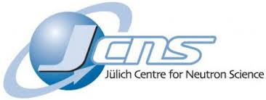 

**T-REX instrument project: Report of activities for the STAP**

**Meeting in October 2024**

Christian Franz, Andrea Orecchini

# Instrument project overview

The T-REX instrument project is a collaboration between the German JCNS (75%) and the Italian CNR (25%). The instrument is a bi-spectral, direct geometry chopper spectrometer with full polarisation analysis. It uses repetition rate multiplication mode to use the full intensity of the ESS pulse.

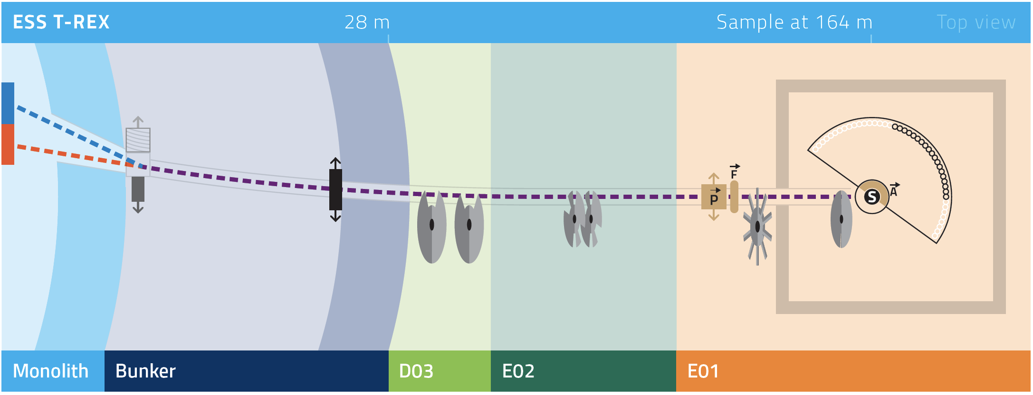The project of T-REX is expected to achieve completion in August 2027. The driving component for this milestone is the MG detector which should be supplied by ESS.

Figure : T-REX layout overview

The agreed scope includes the delivery of a world class Direct Geometry Chopper Spectrometer (DGCS), capable to perform INS experiments for a broad user community spanning from magnetism to functional materials and functional soft matter, including the option of using polarized neutron for x-y-z neutron spin analysis. In the first-day, T-REX was planned to be equipped with about 40% of detector area, equivalent to 0.8 sr. The instrument specific SE will be a dedicated cryostat.

We here provide a brief overview of the progress in Q4 2023 and Q1-Q3 2024, in preparation of the next STAP meeting in April 2024.

Ein Bild, das Text, Screenshot, Software, Webseite enthält.

Figure : TG5 date for T-REX together with critical path leading to that date

## Beam transport system

### Neutron guide

* **Neutron guide in-bunker**: Installed, BBGOA manufactured, but waiting for neutrons at BNC to align
* **Neutron guide out-of-bunker**: Tranche 1 in production, tranche 2 in detailed design

### Heavy shutter

* Installed

### Beamline Shielding

* Joined common project, in detailed design phase

### Choppers

* **Bandwidth choppers**: Hybrid solution, common project for electronics, external company for hardware (housing and disc). Purchase order for hardware components is out.
* **P- and M- choppers:** In production.
* **FAN chopper:**In detailed design and testing of components phase. We face a lack of resources to move faster.

### Primary collimator

* In detailed design phase, subTG3 in November

### Polarization

Components such as the thermal polarizer or spin flipper are not commercially available and must be developed according to the instrument needs and constraints. We are in contact with Hal Lee (Polarisation group ESS).

* **Cold neutrons polarizer**: Manufacturing complete.
* **Thermal neutrons polarizer**: Documentation and certification of components difficult.
* **Spin flipper***:* We are currently designing a broadband neutron spin flipper for the use with cold and thermal neutrons.
* **Guide field (spin transport)**:Magnetic calculations are finished
* **Adiabatic field (spin rotation)**: magnetic field calculations are finished
* **Guide/polarizer exchange unit**: Preliminary design finished, waiting for final design of the thermal polarizer.
* **PASTIS set-up:** Started, in collaboration with ESS polarization group.

## Scattering characterization system

### Detector vacuum vessel

* Detector vessel is in Jülich.
* Pre-installation is ongoing, with detector feet and false floor installed.

### Detectors Integration box

Detector box is finished and in Jülich. The ESS detector team together with JCNS inserted the demonstrator column successfully into the box. The box is waiting for installation in the vessel.

### MG-Detector

The detector remains the highest risk for the T-REX project. The instrument depends on the Multi-Grid technology, mainly for the high expected count rate at thermal energies and budget reasons. Tests of prototypes for shielding and electronics are currently tested at ISIS (EMMA and MERLIN).

### Oscillating collimator

The contract was awarded to JJ X-ray, manufacturing will start soon. The drive motor is in Jülich and will be installed during the vessel pre-installation phase.

## Experimental cave

The detailed design of the experimental cave is concluded. The sub-TG3 is planned in November. The experimental cave is a prerequisite for the installation of the polarization equipment, M-chopper and detector vessel. Several other work packages depend on the detector vessel, therefore the timely installation of the cave is a major focus of the instrument team at present.

# Rescoping of the instrument

The three options for rescoping are in the order of priority: (1) full detector coverage, (2) additional discs for the P-chopper and (3) a T0 chopper. Full detector coverage is needed to fulfill the scientific requirements, additional discs increase resolution for deep inelastic scattering, the necessity of a T0 chopper will be judged after first neutrons.

# Comissioning and first science

The team for instrument commissioning will be comprised of partners CNR, FZJ and ESS. ESS is currently hiring a scientist for T-REX who will be permanently on site. Expert teams from FZJ and CNR will travel for cold commissioning of e.g. chopper system. A major focus will be the identification and suppression of background of the instrument, which is a prerequisite for first science.

First scientific experiments will benefit from collaboration of partners Christian Franz (JCNS-2 in-house, ConQuMat (<https://www.trr360.de/>)) and Andrea Orecchini (University of Perugia, Italy). An early demonstration of polarization analysis capabilities could highlight the uniqueness of the instrument in today’s landscape of direct chopper spectrometers.