|  |
| --- |
|  |
|  |
|  |

|  | Name | Role/Title |
| --- | --- | --- |
| Owner | Adrien Perrichon | Lead Scientist for VESPA |
| Reviewer | Pascale Deen  Mikhail Feygenson  Andrew Jackson | Division Head for Spectroscopy  Division Head for Diffraction & Imaging  Division Head for Large Scale Structures |
| Approver | Giovanna Fragneto | Science Director |

TABLE OF CONTENT PAGE

1. AIM 3

2. Introduction 3

3. Figure of merits 3

3.1. Detected intensity 3

3.2. Signal-to-noise 4

4. Added scope: spectroscopy MODULES 5

4.1. Description & costing 5

4.2. Instrument performance 6

4.3. Cost-benefit evaluation 7

5. Added scope: T0 chopper 7

5.1. Description & costing 7

5.2. Cost-benefit evaluation 7

6. Added scope: diffraction panels 8

7. CONCLUSIONS AND RECOMMENDATIONS 9

8. Glossary 10

9. references 10

# AIM

This document describes and provides a cost benefit analysis of the added scope required to complete the VESPA spectrometer and ensure that the instrument is state-of-the-art.

# Introduction

VESPA is the neutron vibrational spectrometer of the ESS. The instrument capabilities are broad band neutron spectroscopy using 14 spectroscopy modules, and medium resolution neutron powder diffraction and pair distribution function using one backscattering and 6 lateral diffraction banks. VESPA end-station also includes a transmission monitor, mainly used to normalise the spectra to absolute units. VESPA beam transport and conditioning system (BTCS) is constituted of a high-*m* supermirror with elliptic profile, 3 pairs of high-speed pulse-shaping choppers (PSC), 1 frame overlap chopper (FOC) disk, 3 subframe overlap chopper (sFOC) disks, a T0 chopper, and a single slit package to control the size of the beam spot from (width × height) 3 × 4 cm2 down to 1.6 × 1.0 cm2.

The added scope to complete VESPA, with respect to its day 1 scope, can be classified in three independent categories. These are, by order of priority in terms of scientific impact: (1) adding the T0 chopper, (2) completing the spectroscopy bank, and (3) completing the diffraction banks. Indeed, the day 1 scope of VESPA does not include the T0 chopper, and only includes 4 of the 14 analyser modules, and 2 of the 6 lateral diffraction panels.

Beyond the performance of VESPA in terms of flux, signal-to-noise ratio (SNR), and energy resolution, the scientific impact on the instrument is closely linked to the capability and capacity of its sample environments, and to the instrument ability to perform high throughput measurements using a sample changer, which is also not included in the day 1 scope.

# Figure of merits

## Detected intensity

Metrics to evaluate VESPA performance with respect to other instruments of its class are (1) the peak flux at sample position in the so-called “fingerprint region” of the spectral, ΔE = 60 – 220 meV, and at low energy, ΔE = 0 – 85 meV; (2) the SNR; and (3) the energy resolution in the fingerprint region. As most experiments are flux limited, a suitable figure of merit (FOM) is to simply consider a quantity proportional to the detected intensity:

$$FOM[DI]= ∙\frac{}{4π}∙T_{Be}∙∙∙R$$

where is the peak flux (brightness) on a 1 × 1 cm2 area in n/s/cm2, integrated in energy over the fingerprint or low-energy regions, Ω is the solid angle coverage of the analysers in sr, *T*Be is the transmission of the beryllium filter in %, η is the detection efficiency of the detectors in %, Δθ is the mosaic spread of the analyser crystals in degrees, and *R* is the peak reflectivity of the analyser crystals in %.

The parameters of FOM[DI] for VESPA are reported in Table 1. The estimated parameters for TOSCA and its future upgrade, TOSCA+, at the ISIS Neutron and Muon Source, and for VISION at SNS, before and after the source upgrade, are also reported in Table 1.

Table 1 – Instrument parameters used in the calculation of FOM[DI]. All fluxes are simulated. The fluxes of VESPA are updated to reflect the latest design of the chopper system [1]. The parameters for TOSCA and TOSCA+ are obtained from references [2] and [3]. The parameters for VISION are estimates based on private discussion with the VISION team [4]

|  |  |  |  |  |  |  |  |
| --- | --- | --- | --- | --- | --- | --- | --- |
| **Instrument** | **Φ [fingerprint]** | **Φ [low-energy]** | **Ω** | ***T*Be** | **η** | **Δθ** | ***R*** |
| **105 n/s/cm2** | **108 n/s/cm2** | **sr** | **%** | **%** | **°** | **%** |
| **VESPA HR 0.8 MW** | 1.86 | 7.12 | 7.0 | 78 | 89 | 3 | 80 |
| **VESPA HF 0.8 MW** | 7.52 | 13.04 | 7.0 | 78 | 89 | 3 | 80 |
| **VESPA HR 2.0 MW** | 4.66 | 17.79 | 7.0 | 78 | 89 | 3 | 80 |
| **VESPA HF 2.0 MW** | 18.80 | 32.59 | 7.0 | 78 | 89 | 3 | 80 |
| **TOSCA** | 3.10 | 3.74 | 1.0 | 48 | 81 | 2 | 80 |
| **TOSCA+** | 3.10 | 3.74 | 6.3 | 78 | 89 | 3 | 80 |
| **VISION 1.4 MW** | 6.38 | 7.13 | 3.5 | 70 | 80 | 2 | 80 |
| **VISION 2.0 MW** | 9.12 | 10.19 | 3.5 | 70 | 80 | 2 | 80 |

## Signal-to-noise

Alternatively, for weakly scattering samples or experiments that are close to the limit of detection (LOD) or of quantisation (LOQ), a figure of merit which include the SNR could be considered, where the SNR here is defined as the average background level when the detected intensity is normalised to 1. The current SNR of TOSCA and VISION are estimated to 3×10-3, and the SNR target for next generation NVS instruments, TOSCA+ and VESPA, should be 10-4 or better.

Note that the above-mentioned SNR numbers are qualitative. Indeed, a quantitative evaluation of the background level is impossible as it is strongly sample-dependent and potentially textured (non-uniform) as a function of energy transfer. The historical dependency of NVS background on the sample is mainly due to thermal leakage through the beryllium filter of high-energy neutrons scattered by the (004) and higher order (00l) reflections of the HOPG analyser. Even if the thermal leakage could be suppressed to negligible level, the presence of significant multi-phonon scattering in NVS spectra, which appears as peaks at low energy transfer but as broad continuous features at high energy transfer, means that it is impossible without materials simulation support to identify region of the spectra that are only “background”. Despite the difficulty in assessing background, it is critical to ensure that the intensity of all contributions that are not originating from the sample scattering laws are negligible.

It follows that, with the help of instrument simulations, all individual contributions to the background should be minimized. These are (1) parasitic streams and other unwanted cold and thermal neutrons transported by the BTCS to the sample position, (2) epithermal and high energy neutrons reaching the end of the guide, (3) aluminium powder lines reaching the detector, (4) thermal leakage of high energy neutrons through the beryllium filter, and (5) detection of γ or high-energy neutrons by the detector. Practically, every individual contribution to the background should be lower than 10-5, so that the total instrumental contribution to the background is lower than 10-4.

Evaluating the contribution of the T0 chopper to the background is particularly complicated. A qualitative estimation can however be obtained from experimental data from existing instruments. For instance, for the 4SEASONS spectrometer at JPARC, the background increases by a factor 5 to 10, from a level of 0.02 with the T0 chopper, to 0.1-0.2 without it [5].

Another particularly relevant example is the VISION spectrometer at SNS. Indeed, test measurements of the empty cryostat while progressively dephasing their T0 chopper up to 30 μs from its nominal phase have been performed by the VISION team [4]. Their results indicate that, in the TOF range where the pulse is generated, where γ and epithermal neutrons can be directly detected by the detectors, the background increases by a factor 17, from a level of 5 when the T0 chopper is phased to a level of 85 when the T0 chopper is dephased by 30 μs. At the beginning of the frame, in the energy transfer range 800-1000 meV, the background increases by a factor 2.7, from a level of 1.1 when the T0 chopper is phased, to a level of 3.0 when the T0 chopper is dephased by 30 μs. Finally, integrating the detected intensity over all detectors and over the entire time frame, the total count is increased by a factor of 80, from a count of 700 when the T0 chopper is phased, to a count of 56000 when the T0 chopper is dephased by 30 μs. Note that these catastrophic degradations of the background are occurring when the T0 chopper is dephased by 30 μs: the background increase would be worse if the T0 chopper was to be parked open. Note also that having the T0 chopper fully dephased – or parked open – is considered an emergency issue at SNS and will cause a shutdown of the beamline.

Because ESS will have a long pulse and significantly larger source power than existing MW spallation facilities, the background issues due to high energy neutrons can be expected to be significantly worse. In the absence of T0 chopper, the elastic line and the high energy region of the spectra, corresponding to the TOF range 0-10 ms, are expected to be unusable.

Assuming that the SNR target of 10-4 with the T0 chopper can be achieved on VESPA, a FOM can be established based on a multiplication factor *M* which represents the probable background increase depending on the presence (*M* = 1) or absence (*M* = 5) of the T0 chopper.

$$FOM[SNR]= \frac{FOM[DI]}{SNR∙M}$$

# Added scope: spectroscopy MODULES

## Description & costing

Each spectroscopy module of VESPA is constituted of:

* Analyser. One analyser backplate in Al, precisely machined, coated in 10B. 660 highly-oriented pyrolytic graphite (HOPG) tiles (considering a 10% rejection rate), of dimension 12×12×2 mm, with 3±2° mosaicity, and with their back coated in 10B. The cost estimate for one analyser is 60 kEUR.
* Filter. One beryllium filter with complex shape, constituted of 14 kg of beryllium (S-200-FH, I-70-H or O-30-H from Materion), sliced into 10 wedges with the inner faces polished, and with 0.7 mm thick cadmium sheets intercalated between the beryllium wedges. One thermally-conductive clamping frame for the beryllium filter, with Al radiative shields on the neutron facing sides and neutron-absorbing materials on the other external sides. The cost estimate for one filter is 175 kEUR.
* Cooling. One (or half) closed cycle He cryocooler (CCR) to cool the beryllium filters, with copper bellows to connect cryoheads and beryllium filters, cables, gas lines and compressor to operate the CCR. The cost estimate is 30 kEUR.
* Detector. 20 position sensitive detector (PSD) 3He tubes, with 20 bar of 3He, 25 cm long active area and a PSD resolution along the tube of 3 mm, and 20 preamps. One detector cartridge to hold the PSD tubes and their preamps, manage cables, with appropriate backplate shielding. The cost estimate for one cartridge is 95 kEUR.

The total cost estimate for one spectroscopy module, including the analyser, the beryllium filter and its CCR, and the detector cartridge, is then 360 kEUR. For the 10 missing modules, the total is then 3.6 MEUR.

## Instrument performance

The FOM[DI] metrics, normalised to the completed VESPA in high-flux (HF) setting and with 2.0 MW source power, are reported in Figure 1. The day 1 performance of a descoped VESPA with reduced source power are only 11% of that of the complete instrument at nominal power. In the fingerprint region, the high-flux setting of a descoped VESPA has comparable performance to those of VISION, while the high-resolution setting, which has an energy resolution comparable to that of VISION, has about 3 times less flux. Rescoping the instrument by fully completing the spectroscopy banks corresponds to a gain of 3.5 in detected intensity and makes the high-resolution setting on par with VISION. Note that both a fully rescoped instrument and the 2.0 MW source power are required to provide a significant improvement in flux compared to existing instrument.

In the low energy range, because of the large cold neutron brightness of ESS, even a descoped VESPA in high-resolution mode has comparable performance to those of the existing NVS instruments.

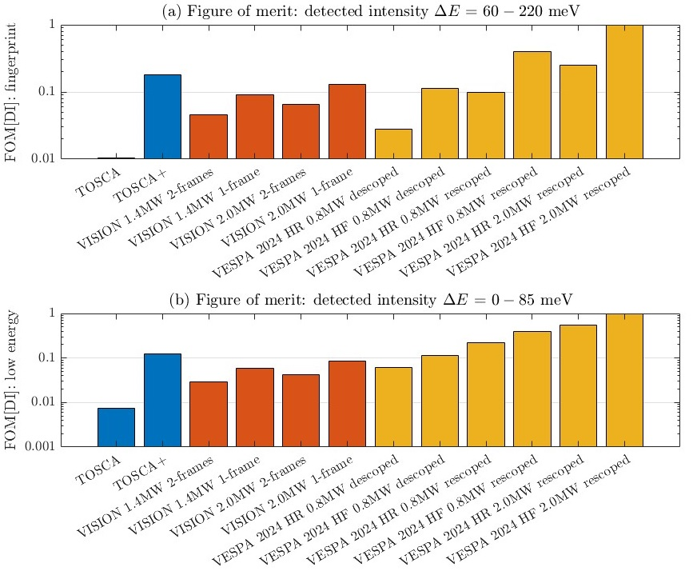

Figure 1 – Normalised FOM[DI] of VESPA and other NVS instruments, for (a) the fingerprint region of the spectra and (b) at low-energy.

## Cost-benefit evaluation

Considering a cost of 360 kEUR per spectroscopy module, a cost-performance relationship for a staged rescoping can be established, shown in Figure 2. A minimum of 3 additional spectroscopy modules, for a total of 7 modules out of 14, have to be added to match the performance of the upcoming TOSCA+ instrument. Fully rescoping the spectroscopy modules of VESPA lead to a gain factor in intensity, in high-flux setting, of 32 over TOSCA, 1.9 over TOSCA+, 3.7 over VISION at 1.4 MW, and 2.6 over VISION at 2.0 MW.

Each additional spectroscopy module is a 25% increase in flux compared to the day 1 scope, at the cost of 0.36 MEUR, which is a ratio of 0.25/0.36 = 0.694 per MEUR.

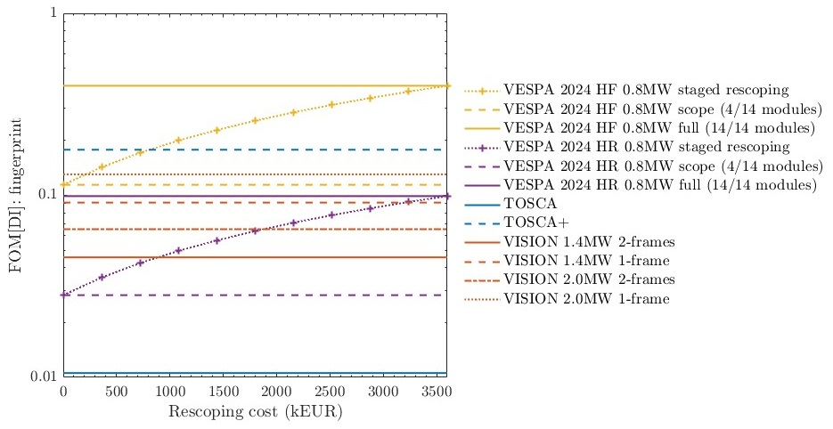

Figure 2 – Dependency between the normalised FOM[DI] and the rescoping cost upon the addition of spectroscopy modules.

# Added scope: T0 chopper

## Description & costing

Located downstream of the bunker wall, between 15 and 18 m (exact position TBC), with a total length window-to-window of ca. 32 cm and a frequency of 28 Hz, the T0 chopper has the function to decrease background and thus improve the signal-to-noise ratio of the instrument. The cost estimate from the ESS chopper group, under the assumption that we are using the existing T0 chopper design of ODIN [6] or HEIMDAL [7] (i.e. without development cost) is 850 kEUR.

## Cost-benefit evaluation

The cost benefit relationship of a stage rescoping, when considering the SNR, is shown in Figure 3, where the T0 chopper is the first component to be added, followed by the spectroscopy modules. This figure is based on the hypothesis that a SNR of 10-4 can be achieved with the T0 chopper, and that the absence of the T0 chopper degrades the SNR by a factor *M* = 5.

The addition of the T0 module is thus a 400% increase of the FOM compared to the day 1 scope, at the cost of 0.85 MEUR, which is a ratio of 4/0.85 = 4.7 per MEUR. It is thus evident that it is more efficient to improve the performance of the instrument to first add the T0 chopper and then complete the spectroscopy bank. The threshold at which the spectroscopy modules become more cost-effective than the T0 chopper, under the same assumption that a SNR of 10-4 can be achieved, is *M* = 1.59 (a 59% increase in background). Practically, if the absence of T0 chopper leads to a degradation of the background level of ca. 60% or more – which is probable given the experimental data on instruments from other MW spallation facilities which suggest >400% background increase (see section 3.2) – the T0 chopper is the most critical added scope to improve the instrument performance.

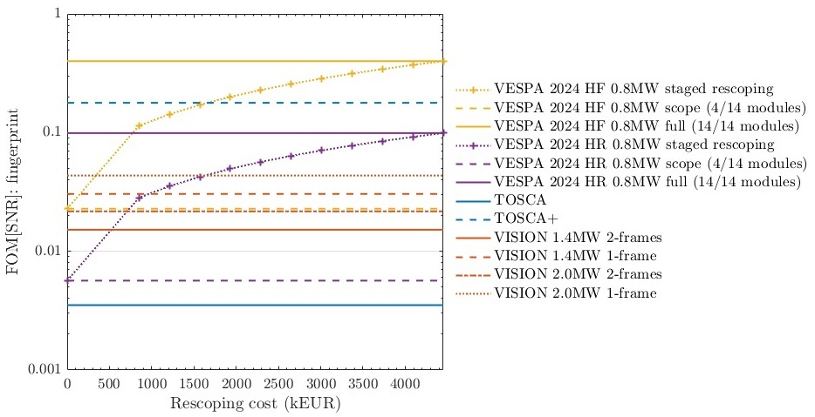

Figure 3 – Dependency between the normalised FOM[SNR] and the rescoping cost. The first added scope is the T0 chopper, followed by the 10 spectroscopy modules.

# Added scope: diffraction panels

The day 1 scope of VESPA only includes 2 of the 6 lateral diffraction panels. The 4 missing panels have a dimension of 200 × 400 mm2. If using 3He tubes as currently considered, each panel would require 25 PSD tubes with 40 cm active length. Including the preamps and cables, the cost estimate is 140 kEUR per panel. For the 4 panels, the total is 560 kEUR. A redesign with a different detector technology, such as 10B CDT multi-wire chamber as exploited on ESS diffractometers [8] or scintillation detector such as wavelength-shifting fibre [9], could significantly decrease the cost of the panels.

As the diffraction capabilities are secondary compared to the spectroscopic capabilities of VESPA, completing the diffraction banks has lower priority than the adding the T0 chopper and the spectroscopy modules.

# CONCLUSIONS AND RECOMMENDATIONS

The added scope to complete VESPA includes, by order of scientific priorities to maximise the impact of the instrument and insure its competitiveness, (1) the addition of a T0 chopper, (2) the addition of 10 spectroscopy modules, and (3) the addition of 4 diffraction panels.

We emphasise that the addition of the T0 chopper has the highest priority. Besides the better benefit-to-cost ratio of the T0 chopper in terms of instrument performance, there is a practical aspect motivating this prioritisation. Indeed, a reduced flux (from the incomplete spectroscopy banks) can be compensated by longer counting times. This means that, even if the impact of VESPA is limited on day 1 by its descoping and the reduced source power, challenging experiments can be performed and data with outstanding quality can be recorded, even if a limited number of experiments can be supported. Conversely, if the SNR level is degraded beyond what is available at other facilities because of the absence of a T0 chopper, there is nothing that we can do about it, and VESPA will be unable to support challenging experiments, which would be catastrophic for its impact and its reputation.

If a staged rescoping is necessary based on financial constraints, the minimum added scope to ensure that VESPA is state-of-the-art at the start of its user program is the addition of the T0 chopper and at least 3 additional spectroscopy modules (for a total of 7 out of 14). Note that both a fully rescoped instrument and the nominal 2.0 MW source power of ESS are required to provide a significant improvement in flux compared to existing instrument, thus pushing the technique capabilities and enabling new science.

# Glossary

| Term | Definition |
| --- | --- |
| BTCS | Beam transport and conditioning system |
| PSC | Pulse-shaping chopper |
| FOC | Frame-overlap chopper |
| sFOC | Subframe-overlap chopper |
| SNR | Signal-to-noise ratio |
| FOM | Figure of merit |
|  |  |

# references

1. ESS-5392752 VESPA chopper system
2. M. Zanetti et al., *Physica* *B* **562** (2019) 107-111
3. A. Perrichon et al., *NIMA* **1047** (2023) 167899
4. Private communication with Luke Daemen, instrument scientist of VISION
5. R. Kajimoto et al., *J. Phys. Soc. Jpn.* **80** (2011) SB025
6. ESS-3920897 Technical specification for ODIN T0 chopper
7. ESS-4025742 Technical specification for HEIMDAL T0 chopper
8. ESS-4133448 Detector technology report for diffraction instruments DREAM, MAGIC, HEIMDAL
9. G. Mauri et al., *J. Appl. Crystallogr.* **57(3)** (2024) 690-699

Document Revision history

| Revision | Reason for and description of change | Author | Date |
| --- | --- | --- | --- |
| 1 | First issue | Adrien Perrichon, Liam Whitelegg, Monika Hartl, Lorenzo Di Fresco, Roberto Senesi | 2024-09-02 |
|  |  |  |  |