|  |
| --- |
|  |
|  |
|  |

|  | Name | Role/Title |
| --- | --- | --- |
| Owner | Christian Franz  Andrea Orecchini | T-REX Lead Instrument Scientist  T-REX Scientist CNR |
| Reviewer | Pascale Deen | Division Head for Spectroscopy |
| Approver | <<Name>> | <<Role/ Title>> |

|  |
| --- |
| NOTE: The authoring instruction box should be deleted from the document before it is finalised  Authoring instruction   * This document is a standard template. Please remove any headings not needed * Instruction text is placed between text entry points shown as << >>. * Header and Footer information in Controlled Documents are mandatory and must not be changed manually. It contains document attributes which will be updated automatically when document is checked in to Chess. * Title field between the two bold lines on first page must not be changed as that contains similar attribute information which will display the title. * Follow the ESS Authoring Guide [ESS-0025989](https://chess.esss.lu.se/enovia/tvc-action/showObject/dmg_Guideline/ESS-0025989/valid). * Please use Insert Cross-reference when referring to references. |

TABLE OF CONTENT PAGE

1. SCOPE 3

2. CONTRIBUTORS 3

3. ISSUING ORGANISATION 3

4. INTRODUCTION 3

5. CONTEXT (ASSUMPTIONS) 3

6. <<BODY >> 3

7. CONCLUSIONS AND RECOMMENDATIONS 3

8. Glossary 4

9. references 4

# SCOPE

This document describes a 2024 view of the upgrades necessary to complete the T-REX spectrometer and provides a cost benefit analysis of the added scope required to ensure that the instrument is state-of-the-art when it goes online and beyond.

# INTRODUCTION

T-REX is a bi-spectral, direct geometry chopper spectrometer at the ESS. The instrument will measure a wide dynamic range with good wave-vector resolution and polarisation analysis over the energy transfer range from 20µeV to 140meV. The full scope layout offers its users a variety of configurations and capabilities to study a wide range of scientific questions. Here, only a few examples, related to the scientific scope that T-REX should cover, are provided:

* Magnetism research: weak magnetic moments, interplay between magnetic order and superconductivity, quantum criticality, orbital and charge ordering, appearance of novel phases in low dimensional, topological and frustrated materials, electronic correlations and competing degrees of freedom in multifunctional oxides,
* Energy research: catalysis, nanomaterials such as nanoporous or metal-organic frameworks for hydrogen storage, thermo-electrics and magneto-calorics, iontransport materials, in-operando batteries, fuel cell membranes, nanofiltering membranes,
* Soft matter and Life Science: disordered materials and liquids, natural and artificial polymers, functionalized “smart” polymers and gels, proteins, nucleic acids and lipid membranes, large biological complexes (e.g. chromatin), entire living cells.

The beam transport and conditioning system (BTCS) comprises elliptic super-mirror neutron guides, loss-of-sight (LOS) at 96m and a versatile chopper system with two 14Hz bandwidth choppers (BWC), a fast pulse shaping chopper (PC), a bespoke FAN chopper for pulse suppression and a fast monochromating chopper (MC).

At the scope-setting meeting, and consequently at the TG2, the upgrade path of the instrument was defined in a way to comprise three independent categories. These are, in order of expected scientific impact: (1) upgrading the neutron detector from four banks (day-1 scope) to ten banks (full coverage of the detector vessel), (2) adding two discs to the pulsing chopper assembly and (3) adding a T0-chopper.

# Upgrade of the detector to full scope

## Description and costing

The full detector system comprises detector boxes, multi-grid columns, front-end electronics, front-end assistor (FEA) racks, main electronic racks, timing system and gas supply system. The full-scope covers a horizontal angular range of -36° to 144°, with a gap of +-1° for the direct beam dump. The polar angle coverage is -25° to +15°, sample to detector distance is 3m. The solid angle coverage is 2sr.

Ein Bild, das Text, Screenshot, Diagramm, Reihe enthält.
On initial scope, the instrument will only have four boxes, limiting the horizontal angular detector angle to 1° to 72° and the solid angle coverage to 0.8sr. This reduces the accessible reciprocal space range from 10 Å-1 to less than 6 Å-1, as shown in Figure 1 for an exemplary incoming neutron energy of 80meV. Furthermore, for low scattering angles, half of the scattered beam intensity is lost by the absence of the detectors -1° to -36° (red shaded area).

Figure 1: Reciprocal space and energy transfer coverage for day-1 and full detector scope

The reduced angular coverage limits the scientific use of the instrument for a variety of scientific cases from magnetism to functional materials and soft matter. Figure 2 highlights some recent publications from thermal direct chopper spectrometers at SNS, ISIS and J-PARC. The investigation of itinerant ferromagnetism requires large momentum transfers as the spin carrying particles act (almost) as individual particles [1]. More generally, in magnetic materials the separation of phonons from magnons is of crucial importance and a typical way to achieve this is measuring the *Q*-dependence of the respective scattering intensities. This requires a wide enough *Q*-range and thus a large detector coverage.

In the field of functional materials, new materials for e.g. thermoelectric converters and solid-state electrolytes require a good understanding of their thermal conductivity, ionic diffusion and their interplay. To this end, a detailed knowledge of the phonon density of states is needed, the measurement of which requires a large detector for an as-wide-as-possible *Q*-integration [2]. The latter is of particular importance for all systems whose scattering is mainly coherent, where a very wide *Q*-range is the only possibility to measure a good approximation of the density of states.

Next-generation electronic devices might rely on magnons instead of electrons, with outstanding potential in computation speed and power efficiency. A key requirement is the understanding of magnon modes throughout the entire Brillouin zone. Large detectors on time-of-flight neutron spectrometers can provide that information, as demonstrated by the magnon modes in the seminal material YIG [3]

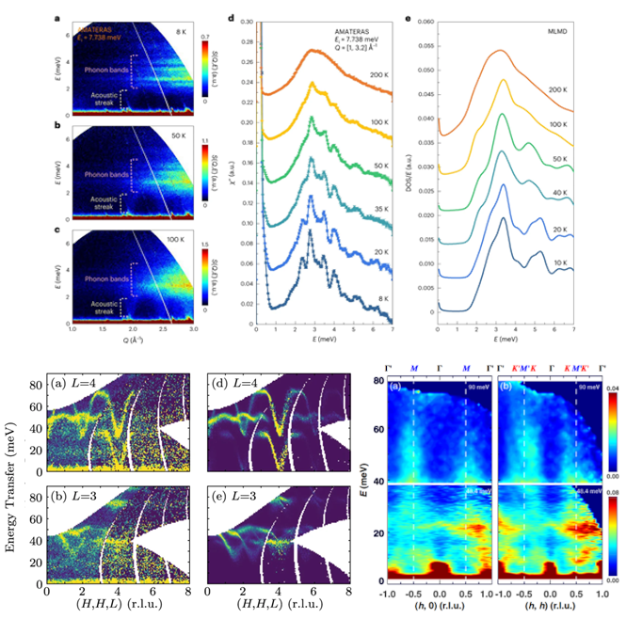

Figure 2: Scientific examples from recent publications at thermal chopper spectrometers. Full detector coverage of large scattering angles, allowing to measure an extended Q-range, is often a prerequisite to collect the desired information. Examples shown here, from top to bottom and left to right, include functional materials for thermoelectrics [2], magnons for applications in devices [3] and research in itinerant and localised magnets [1].

## Cost benefit analysis

At the time of writing, a final detector design does not exist. Therefore, the overall cost of the detector cannot be accurately determined. The cost can however be divided into detector boxes (housings that host the actual multi grid columns), the multi grid columns, electronics and gas supply.

* Additional detector boxes (6 boxes): 6x 200k€ = 1.2M€. Estimate based on prototype box, potential savings by ordering several boxes.
* Cost of multi grid columns Needs to be determined by ESS detector group.
* Electronics: Needs to be determined by ESS detector group.
* Gas supply: Needs to be determined by ESS detector group.

Ein Bild, das Text, Screenshot, Schrift, Diagramm enthält.

Figure 3. Comparison between the normalised figure-of-merit of T-REX and other existing thermal neutron spectrometers. Left: with day-1 detector coverage. Right: with full detector coverage.

An analysis in terms of a figure of merit (FOM) for the detector is described in [4]. Figure 3 shows the competitive ability of T-REX with respect to existing instrumentation, on the left panel with day-1 scope coverage, on the right panel with full detector coverage. Full coverage is needed to match ARCS at 2MW SNS in single pulse mode, with estimated gains of a factor of six from RRM mode.

# Additional discs for P-Chopper

## Description and costing

The P-chopper at 108m is cutting the long ESS pulse into sub-pulses up to 24 RRM (repetition rate multiplication) pulses and controls the incident wavelength resolution of these pulses. In day-1 scope, the chopper system is equipped with two chopper discs separated by 10cm along the neutron path. The chopper housing is already designed and built to host up to 4 discs in 2 pairs in over/under configuration. In day-1 scope, only the two upper discs exist. All discs feature two openings of 35° and 20° for high-flux and high-resolution measurements, respectively.

The upgrade to four discs would allow to decouple the energy resolution of the primary spectrometer from the repetition rate of the chopper by allowing advanced pulse shaping options [5] [6]. Essentially, the triangular transmission function of a two-disc assembly can be changed to a trapezoidal or rectangular shape, therefore cutting tails that worsen the resolution. This is especially useful in cases of deep inelastic scattering, where the resolution of the primary spectrometer can be matched to the already very good resolution of the secondary spectrometer. This situation is a unique capability of T-REX in the suite of ESS instruments.

## Cost and benefits analysis

The chopper housings are already designed to host 4 discs. The additional cost can be broken down to two additional chopper discs, two additional chopper drives and two sets of drive electronics. The existing chopper rack including chic unit can be used to host additional electronics. According to an estimation by the FZJ Jülich chopper group, the cost is 300k€ per additional disc, leading to 600k€ for two discs including drive and electronics.

# T0 Chopper

## Description and costing

Ein Bild, das Text, Screenshot enthält.
A T0 chopper has proven to be unconditionally necessary for example at the 4Seasons spectrometer at J-Parc [T0]. However, the T‑REX detectors are a factor four further away from the source, allowing curved neutron guides and LOS at 96m. The current assumption is that the effect of fast neutrons propagated through guides and shielding can be mitigated beyond the instruments required background level by following good design criteria [7]. However, in the preliminary design phase of T-REX, potential locations of a 14Hz T0 chopper have been identified in the bunker, between 15.5 and 19.5 m [8]. In that area the T0 chopper would have the function to stop significantly the fast neutrons beam, therefore contributing to further decrease the experimental background and thus improve the signal-to-noise ratio of the instrument [5]. As agreed at the scope setting the T0 chopper should be considered an upgrade priority if the expected signal-to-noise is not achieved. With this respect, it should be considered that, even if the curved neutron guide loses line-of-sight at 96 m from the source preventing unstopped epithermal neutrons to end up in the T-REX detector, they might still either reach those of adjacent beam-lines, or be moderated along their primary path and then scattered all around, thus producing a general increase of the environmental background. Based on previous experiences in other neutron facilities, the initial signal-to-noise ratio of any new instrument produces an important imprinting on its reputation within the user community. As such, it has to be taken in careful consideration since the beginning.

Figure 4: T0 Chopper operated at J-Parc, Japan. (a) Photograph of the chopper (b) data collected with chopper (c) data collected without chopper. Image taken from [11]

## Cost and benefits analysis

1. The cost estimate from the ESS chopper group, under the assumption that we are using the existing T0 chopper design of ODIN [9] or HEIMDAL [10] (i.e. without development cost) is 850 k€.
2. The benefit in terms of enhanced SNR level for the instrument is hard to calculate and needs to be measured after BOT.
3. To install the chopper in the bunker a guide element of 4 m should be replaced. The in-bunker guide has been designed having in mind the potential locations of the chopper, therefore mitigating the costs of the replacement.

# CONCLUSIONS AND RECOMMENDATIONS

1. Re-scoping of T-REX includes, in order of scientific merit, (1) upgrading the neutron detector from day-1 coverage of 40% area to 100%, (2) upgrading the P-chopper from two to four discs and (3) insertion of a T0 chopper.
2. Upgrading the detector can be done step by step whenever a new detector module, covering 18° horizontal angle, is ready as integration time and cost allow. The full detector coverage is needed to provide a significant improvement over existing instruments at 2MW ESS power. The P-chopper upgrade enables distinct resolution enhancements for one of the core science cases, deep inelastic scattering. The addition of a T0 will be re-evaluated after hot commissioning of the instrument.

# Glossary

| Term | Definition |
| --- | --- |
| <<Sample term>> | <<Sample explanation >> |
|  |  |
|  |  |

# references

1. Bao et al., Phys. Rev. X **12**, 011022 (2022)
2. Ren et al., *Nature Materials* **22**, (2023)
3. Princep et al., *npj Quantum Materials* **2**, 63 (2017)
4. ESS-5290872 - ESS NEUTRON SCATTERING INSTRUMENT CAPABILITIES
5. Vickery, A., & Deen, P. P. *Rev. Sci. Instr.*, *85* (11), 115103 (2014).
6. Voigt et al. J. Phys.: Conf. Ser. 746 012018 (2016)
7. ESS-0039408 - European Spallation Source Instrument Technologies Handbook on Optics and Shielding
8. Violini et al. JEAE Conf. Proc. (2015)
9. ESS-3920897 - Technical specification for ODIN T0 chopper
10. ESS-4025742 - Technical specification for HEIMDAL T0 chopper
11. Sakasai et al.*, Quantum Beam Sci.* 10 (2017)

Document Revision history

| Revision | Reason for and description of change | Author | Date |
| --- | --- | --- | --- |
| 1 | First issue | Christian Franz | <<2024-10-14>> |
|  | <<Keep only full number revisions when approving document>> |  |  |
|  |  |  |  |