MIRACLES: Rescoping and impact in Science to STAP/SAC
José E.M. Pereira, on behalf the MIRACLES team

Current status and rescoping
The current MIRACLES project scope includes half scattering-detector angular coverage (i.e., the analyzer, radial collimator and ³He detectors are only placed on the left side of the scattering vessel).
The completion of the instrument will include the full coverage of the scattering system: a second analyzer, another radial collimator and ³He detectors on the right side. The upgrade can be done without any disruption of the operation program, since all the integration, installation and adjustment features were already manufactured, in anticipation to this completion exercise.
In this case, one half of this right-side analyzer will be covered with Si(111) crystals, whereas the other half will utilize Si(311) peaks, similar to other backscattering instruments (BASIS, DNA). The idea is to achieve higher Q values.
There is the idea that Si(333) reflections can be exploited using the Si(111) crystals. Although some Si(333) peaks have been observed in BASIS, there is no proof that the reflections can be utilized for QENS measurements; and if so, this can only be demonstrated in MIRACLES at full power, i.e., at 5 MW. That is why we prefer to use, in the first decade of operation of MIRACLES, Si(311) crystals.

Strategy for rescoping
The feasibility of Si(333) reflections to carry out QENS measurements need to be demonstrated, so the completion needs to be done during hot commissioning.
Thus, the strategy for the rescoping we propose is the following:
- To install the detector banks of the right side + preamps (the digitizer will be available with extra channels for this right-side ³He tubes).
- To install the right-side radial collimator.
- To install the frame of the analyzer, prior to hot commissioning.
- To install ½ of the right-side analyzer panels with Si(111) crystals (we recommend the top part).
- To wait until Si(333) reflections are tested to decide the completion of the bottom part with either Si(111) crystals or Si(311) crystals. To determine if the Si(333) study has to be carried out only with 2 MW or at an earlier stage (is it a question of noise-statistics, or is it a question of background?).

Impact of rescoping in science
There are two main effects in the rescoping exercise of MIRACLES.
Anisotropy dynamics
On one hand, it is interesting to test the anisotropy of the dynamics of water in some materials, like oriented films.
- An example can be shown in hydration in layered clays.
- In neural fibers such as nerve, white matter in spinal cord, or white matter anisotropic water diffusion is sensitive to the underlying tissue microstructure and provides a unique method of assessing the orientation and integrity of these neural fibers. With the full capability from both instrument and source smaller samples can be used and systematic studies using various fibers or membrane proteins will allow for pertinent pathological models.

- With full coverage, simultaneous measurements in the transmission mode and in the reflection mode can be carried out, with exactly the same conditions.  - With the current, scope, the only option is to rotate every time the samples, and measurements will not be done at the same time. | 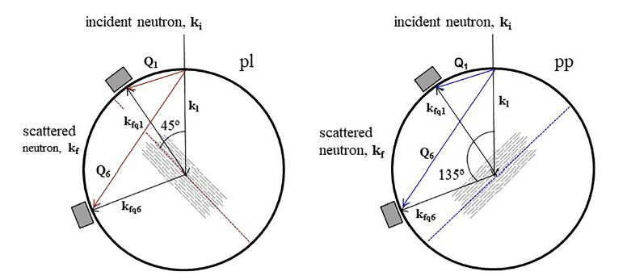

Flux increase (and likely Q-range increase)
Depending on the feasibility of the Si(333) reflections to carry out QENS measurements, the impact of full coverage in the MIRACLES science case can be:
- Assuming Si(333) can be used: Neutron flux will increase a factor of 2 (100%). This opens new windows to hidden features that require high flux on sample.
- Assuming Si(333) cannot be used, then full coverage consists of ½ Si(111) and ½ Si(311): Neutron flux will increase 50% working with Si(111) reflections. Moreover installing Si(311) analyzer will widen the Q range leading to higher Q values (see kinematic range figures on page 3), plus a wider bandwidth around the elastic (larger energy-gain side).
Expanding the Q range to Q>3 Å⁻¹ will allow exploration of restricted and confined diffusion effects at the atomic length scale (of the order of d < 2 Å).

  - Kinematic range
The kinematic range (Q, ΔE) covered by the MIRACLES instrument for Si(111) crystals is illustrated in Figure 9a. This map defines the operation parameters in terms of momentum transfer, Q, and energy transfer, ΔE, and the intermutually dependence of Q ($Q^{2}=\left|{\vec{k}}_{i}^{2}+{\vec{k}}_{f}^{2}\right|{=k}_{i}^{2}+k_{f}^{2}-2k_{i}k_{f}\cos{θ{=\left(\frac{2π}{λ_{i}}\right)}^{2}+{\left(\frac{2π}{λ_{f}}\right)}^{2}-2\frac{2π}{λ_{i}}\frac{2π}{λ_{f}}\cos{θ}}$) and ΔE ($E=\frac{81.82}{λ^{2}}$) with λ.
Completion of the instrument envisions a full coverage, adding another analyzer (plus detectors and radial collimator) to the right side. Two strategies have been envisioned, both oriented to extend the kinematic range towards higher momentum transfers, Q, that improves the analysis of elastic incoherent structure factor (EISF) and an extension of the science case by widening the scattering momentum transfer window. This will be essential to better understand dynamics of systems where motions occur in a confining potential with barrier crossing.
The selection of one or other strategy will depend on the feasibility, tested during commissioning, to utilize the Si(333) reflections for spectroscopy measurements, that have a relaxed energy resolution of about δE_{S} ~33 μeV. If the Si(333) reflections can provide an exploitable signal the Q range can be extended significantly up to 6 Å⁻¹ in QENS measurements, see Fig. 9b.
Alternatively, some sections (one quarter) of the analyzer can be completed with Si(311) crystals, to have simultaneously three values for the energy resolution in one take (for Si(311) crystals, δE_{S} ~15 μeV and Q range up to 3.8 Å⁻¹ in QENS measurements, see Fig. 9c).
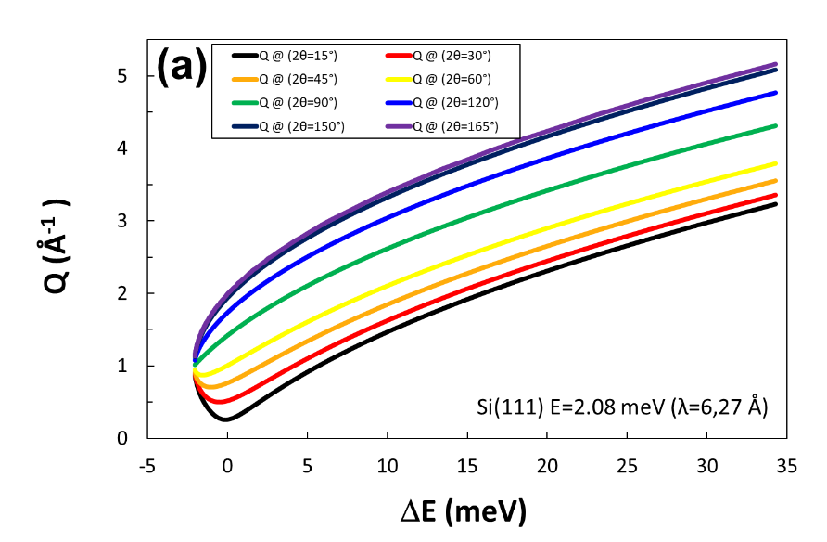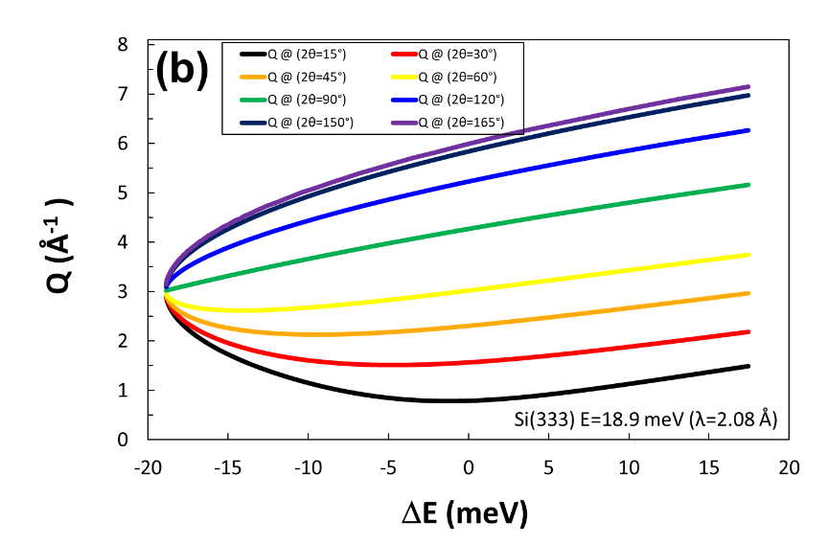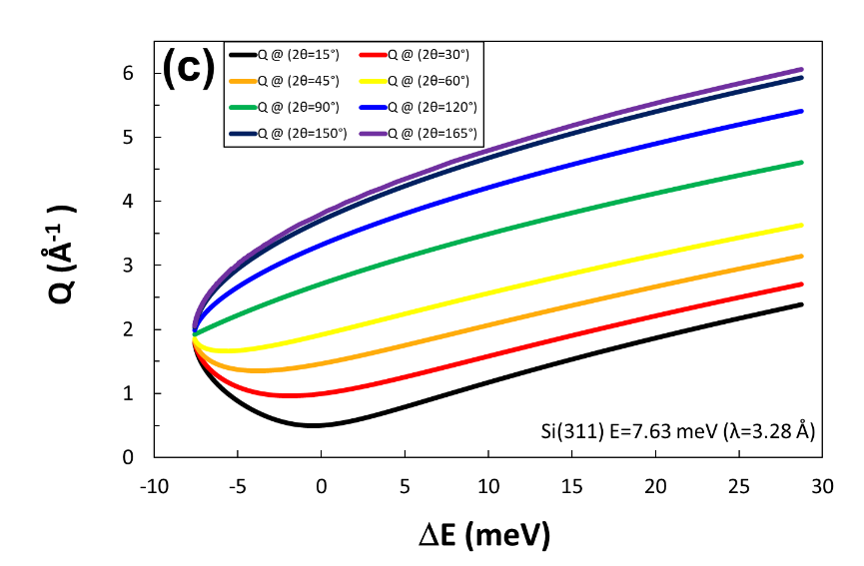
Figure 9. Kinematic range (Q,ΔE) space for the MIRACLES instrument: (a) current project using an analyzer with Si(111) crystals; (b) upgrade using Si(333) reflections; (c) upgrade using Si(311) crystals.

There is the idea that Si(333) reflections can be exploited using the Si(111) crystals. Although some Si(333) peaks have been observed in BASIS, there is no proof that the reflections can be utilized for QENS measurements; and if so, this can only be demonstrated in MIRACLES at full power, i.e., at 5 MW. That is why we prefer to use, in the first decade of operation of MIRACLES, Si(311) crystals.
Applied Clay Science 201 (2021) 105928 & J-Parc new data
E. Mamontov, “Implementation and assessment of resolution-dependent elastic incoherent neutron scattering measurements at a backscattering spectrometer for probing relaxations in complex systems”, Nucl. Instrum. & Meth. Phys. Res. A 949, 162534 (2020).
Y. Kawakita, M. Matsuura, T. Tominaga, T. Yamada, H. Tamatsukuri, H. Nakagawa,and K. Ohuchi, “Recent Progress on DNA ToF Backscattering Spectrometer in MLF, J-PARC”, EPJ Web of Conferences 272, 02002 (2022)

