STAP report for the BIFROST spectrometer
Rasmus Toft-Petersen, Oct 8th 2025

General update:
The BIFROST spectrometer is essentially completed, and commissioned, with a few key caveats elaborated in later sections. On September 5th, we had our System Acceptance Review (SAR), the purpose of which was to go through the documentation, the cold commissioning results and the tracked NNS issues (NITs). There were around 80 unresolved issues, which were all accepted by the technology teams as primarily their responsibility – working with the core team of course. The in-kind partners involvement in the instrument construction and commissioning phases is essentially coming to an end. What remains is to solve the remaining issues, complete the Safety Readiness Review (SRR) and prepare for hot commissioning. The open issues relevant to the STAP are outlined in sections below.
Remaining issues (NITs):
Of the 80 issues, quite a few are trivial, tagging cables, putting up a fence or a concrete block. A few are crucial, the most relevant for the STAP are the following:
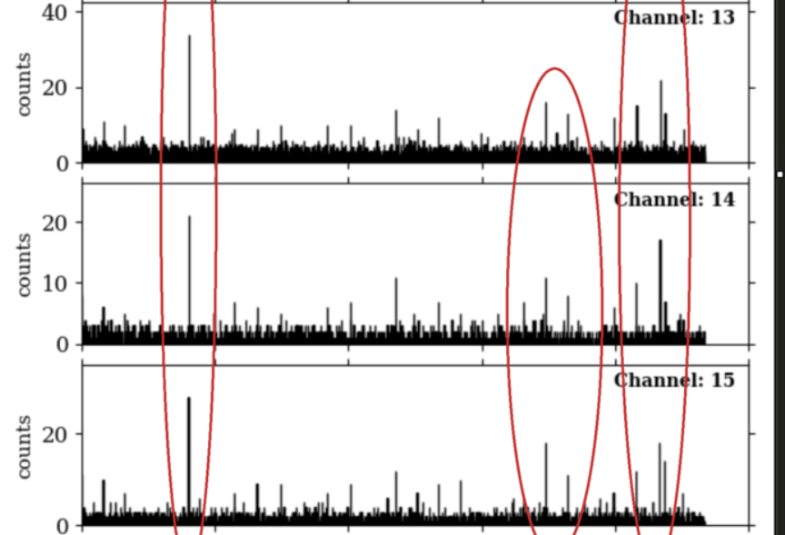
Detector grounding issue. Once installed, and properly cabled up, the detector system showed noise spikes. We witness those directly in the EFU logical map, and could retrace the time in the nexus file. The plot on the left shows a recent confirmation. This noise consists of a few spikes pr hour, localized in time, with a few dozen counts pr spike. We have later found out, that the star shape grounding scheme on the instrument is faulty. Everything is connected to the same ground, shared with the building ground. As we have once had the detector racks isolated, we believe the problem is upstream the detectors. At the ESS, the detector systems does not have a separate ground, so this common grounding of all equipment on the beamline is naturally problematic. The NSS is taking this very seriously and very sparse resources are set aside to solving this before BoT.
Figure 1: Timeseries of detector counts of 3 triplets (apologies for the lack of x-axis). Clear common peaks, from electronic noise, are evident
Monitors. The readout chain of the BIFROST monitor system has not yet been finalized. For the ionization beam monitors, there are issues with the 18 to 24 bit conversion in the firmware, and the signal is thus cropped in the amplitude distribution. The EFU and firmware still needs to be tested on site for our normalization GEM/Cascade monitor. For these reasons, the monitors have not yet been cold commissioned. The monitor group is working hard to solve this and we hope a new test can be conducted in November. On the positive side, live aggregation of data from the monitors works nicely.
SRR preparation:
For the SRR, some work remains to be done from the core team and the NSS. Motion safety has to be implemented, emergency stop buttons for motion and PSS linked blocking of certain motors when entering the cave. Substantial documentation still needs to be prepared for the meeting itself. This, and solving the remaining issues, will take up the rest of the year of the core team.
Hot commissioning:
Hot commissioning will consist of two types of measurements, if possible. First, we aim to use the accelerator commissioning beam, of around 20 W, for calibrating detectors, tweaking firmware, testing normalization monitor etc. For a few days pr week after BoT, we will have 140-500 kW beam, with 2.86 ms pulse and 14 Hz, to be used for proper commissioning.
Attached to the indico page, you can find the preliminary cold/hot commissioning plan for BIFROST. We ask the STAP the following questions regarding our plan:
- Is anything missing? Have we overlooked something necessary, in terms of calibration or long term monitoring?
- Is there overkill? Are some of the proposed measurements not enough; i.e. should they be put on a nice-to-have list, if the commissioning time starts extending into early science?
- Do you think this can be done in the days available, and are the manpower estimates reasonable?
Both the ESS, core team and partners are itching to do the first real experiments on the beamline, so any advice to make hot commissioning more efficient would be appreciated.
Manpower for hot commissioning:
We currently have only 1.5 scientists on the beamline, myself and our instrument data scientist, Greg Tucker. We are currently in the process of hiring another scientist, who should start early next year, after the SRR. We have also hired an instrument operations engineer, Manon Chesneau, who will start in November. For hot commissioning we will have 3 full time staff on the beamline, and our IDS at DMSC – who will be heavily engaged as well. In addition we plan on involving the other instrument scientists in spectroscopy, as them familiarizing themselves with an operating instrument at ESS could help them get ahead of certain issues on their own beamlines. Sabbaticals are planned for Henrik Rønnow and Jakob Lass, in addition. We therefore think that the manpower levels will be sufficient, but substantial effort will be dedicated to onboarding two new colleagues in the coming months.
Data tools:
The DMSC and ECDC are well prepared for hot commissioning. We have live visualization tools for the detector system (Greg’s Fylgie), live aggregation and chopper diagnostics in NICOS, and the live visualization tool Beamlime is highly configurable, to allow our more complicated live visualization needs to be fulfilled. Working with scipp on VISA already works well. The remaining issues are finalizing normalization and monitor data storage, but these issues are being addressed.

