BIFROST - System VALIDATION & VERIFICATION Plan

 | Name | Role/Title
Owner | Rasmus Toft-Petersen | BIFROST – Lead instrument scientist
Reviewer | Giuseppe Aprigliano/Gabor Laszlo  Per Roos  Helen Boyer  Hanna Wacklin-Knecht | NSS Engineering  RP  OSH  SSD  DMSC
Approver | Pascale Deen  Rob Connatser | Head of Spectroscopy Division  Head of Neutron Scattering Systems Division

TABLE OF CONTENT PAGE
1. Introduction 5
1.1. Purpose of this document 5
1.2. Definitions, acronyms and abbreviations 5
2. Cold commissioning (VERIFICATION) 5
2.1. FBS and Test Reports 6
3. Hot Commisioning (VALIDATION) 7
3.1. High Level Scientific Requirements 7
3.2. Hot Commisioning Plan 8
3.3. Assumptions & methodology 9
3.4. Fulfil radiation protection requirements 9
3.4.1. Instrument thermal shutter (4 days) 9
3.4.2. Cave and guide shielding structure (3 days) 10
3.5. TBL measurements 10
3.6. Primary spectrometer 11
3.6.1. PSC fission monitor (M1) commissioning (1 beam days) 11
3.6.2. Pulse-shaping chopper commissioning (2 beam days) 12
3.6.3. Frame overlap choppers – Ionization beam monitor 1 (M2) (1 days) 13
3.6.4. Bandwidth chopper (BWC) – Ionization beam monitor 2 (M3) (2 days) 14
3.6.5. Sample spectrum, GEM beam monitor (M4) (1 days) – High level requirements 3 and 5 15
3.6.6. Primary flight path calibration, GEM beam monitor (M4) (1 day) 16
3.6.7. Nice-to-have: Guide characterization and acceptance diagram measurement, GEM beam monitor (M4) (10 days) 17
3.6.8. Divergence jaw characterization, GEM beam (2 days) 17
3.6.9. Nice-to-have: Sample slit characterization, GEM beam monitor (M4) (6 days) 18
3.6.10. Initial flux measurement – high pressure ³He-tube (1 days) High level
requirements 4 and 6 18
3.6.11. Beam monitor normalization (M4) (2 days) 19
3.6.12. Attenuator tests, GEM beam monitor (M4) (1 day) 20
3.6.13. Gold foil measurements (1 day) High level requirements 4 and 6 20
3.7. Secondary spectrometer 20
3.7.1. Detector charge division limits calibration (2 days) 21
3.7.2. Beryllium filter/radial collimator (2 days) 22
3.7.3. Calibrating overall tank scattering angle (BM5) (3 days) High level
requirements 7, 8 and 9 24
3.7.4. Ef calibration (2 days) 26
3.7.5. Cross talk shielding High level requirement 12 27
3.7.6. Secondary spectrometer normalization (2 days) 27
3.7.7. Sample environment (1 days) 27
3.8. Benchmarking experiments 28
3.8.1. Elastic line (2 hours) 28
3.8.2. Flat modes – High level requirements 1 and 11 28
3.8.3. Flat modes below 10 meV (5 hours) 28
3.8.4. CEF modes below 60 meV (1 day) 29
3.8.5. Flat modes at low energy: γ-picoline-N-oxide. High level requirement 2 (1 day) 29
3.8.6. Dispersion: Well-known simple system (2 days) 30
3.8.7. Intensity and normalization check ( 3 days) 31
3.8.8. Dispersion: Well-known complex system (3 days) 32
3.9. Initial schedule of hot commissioning activities 33
3.10. Resources 33
4. Regular calibration procedure 34
4.1. In case of major problems with guide 34
4.2. Yearly 34
4.3. Biannualy 34
4.4. Every cycle 34
5. references 34

list of Figures
Figure 1 - TBL measures the neutron spectrum directly, without using a neutron guide,
at specific points in the field of view of BIFROST 10
Figure 2 - Simple ToF diagram with the positions of the 4 monitors 11
Figure 3 - Simulated PSC pulses at the M1 position 12
Figure 4 - Pseudo-continuous beam at BIFROST using a fully open PSC 15
Figure 5 - (Top left) Bragg edges of pure aluminum. (Top right) setup for primary
flight path calibration. (Bottom) Simulated Bragg edges in the monitor spectrum from
the aluminum windows in the guide 16
Figure 6 - Proposed setup for measuring the acceptance diagram of the guide 17
Figure 7 - Acceptance diagrams of three jaw settings 18
Figure 8 - Suggested flux calibration setup 19
Figure 9 - CAD model of the secondary spectrometer 21
Figure 10 - Example of charge division result when uniformly illuminating one triplet,
with the three tubes separated by "dead ratios" for charge division, which are created
by the resistors between tubes 21
Figure 11 - Example of limits on all 45 detector triplets (y-axis) 22
Figure 12 - (left) design of single filter unit. (Right) Assembly of 9 filter units 22
Figure 13 - Bifrost sample coordinate system 23
Figure 14 - Scattering angle calibration methodology. The top view shows diagram of
powder diffraction peaks in a scattering versus wavelength plot. Backscattering geometry
gives more well-defined peaks and larger Q-range. Several angles can be chosen 25
Figure 15 - (left) Simulated intensity distribution on a detector triplet resulting from
pencil-beam illumination of a single analyser. The mean value of the intensity on each
tube should be at the same position. (Right) Simulated full illumination of a detector
bank, including the angle dependence of the final energy – subject to calibration. 26
Figure 16 - Crystal field excitations of pure LiHoF4 below 10 meV 29
Figure 17 - Flat modes in C60 29
Figure 18 - Figure from the IN16 BATS commissioning paper 30
Figure 19 - CAMEA measurements of the dispersion relation of MnF₂ where mode
splitting has been disproven down to the measurement limit 30
Figure 20 - Horace scans of RbMnF₃ from MERLIN 31
Figure 21 - Magnon modes below 5 meV as measured with high resolution on IN5 32

Introduction

Purpose of this document
This document describes the plan for verification and validation of the FREIA system during cold and hot commissioning using the available neutron beam. The first part of this will document the strategy for verification activities, which will be used to verify and ensure that a product or system meets its requirements. The second part describes the testing of the instrument necessary to validate the realized product against the high-level requirements, derived from the scientific requirements documented in the Concepts of Operations Description for the BIFROST Instrument (ConOps) [2].
The contents of this release, which the acceptance test plan will cover, are the main systems of the Instrument according to the Facility Breakdown Structure (FBS) of BIFROST. The design of the BIFROST instrument is described in the high-level system design description [4], which contains references to subsystem design descriptions, which in turn contain references to detailed design information, like drawings and materials sheets

Definitions, acronyms and abbreviations
Term | Definition
ConOps  SciReq | Concept of Operations  Scientific Requirements
PBS  FAT  SAT  RP  PSS  PSC  BWC  FOC  CF  FBS | Product Breakdown Structure  Factory Acceptance Test  Site Acceptance Test  Radiation Protection  Personnel Safety System  Pulse Shaping Chopper  Bandwidth Chopper  Frame Overlap Chopper  Conventional Facilities  Facility Breakdown Structure

Cold commissioning (VERIFICATION)
The cold commissioning activities for the instrument shall be carried out following the processes outlined in [1].
The cold commissioning is performed via a connected series of local tests and integrated tests, culminating in an integrated test report for the whole instrument demonstrating readiness for hot commissioning.
Each FBS item given below will have an integrated test plan that is designed to validate that the given sub-system meets requirements given in [3] are fulfilled.

FBS and Test Reports
FBS |  |  | System Name | Integrated Test Report | Integrated Test Plan
=ESS.NSS.H01.BIFRO |  |  | FREIA
 | .G01 |  | Vacuum System (BIFROST) | N/A | N/A
 | .F01 |  | Personnel Safety System (BIFROST PSS) | N/A | N/A
 | .A01 |  | Beam Transport and Conditioning
 |  | .B01 | Beam Validation System | ESS-5795896 | ESS-5764649
 |  | .F01 | Neutron Guide Shielding | N/A | N/A
 |  | .R01 | Neutron Chopper System | ESS-5759687 | ESS-5690504 [8]
 |  | .R02 | Beam Geometry Conditioning | ESS-5760672 | ESS-5690168 [9]
 |  | .R03 | Beam Cut Off | ESS-5760672 | ESS-5690168 [9]
 |  | .W01 | Beam Delivery System | N/A | N/A
 |  | .W02 | Beam Extraction System | N/A | N/A
 | .A02 |  | Sample Exposure System
 |  | .W01.W02 | Rotational sample stack | ESS-5764655 | ESS-5690169 [10]
 |  | .W01.W01 | 2-circle goniometer | ESS-5764655 | ESS-5690169 [10]
 |  | -- | Sample environment | ESS-5795924 | ESS-5764650
 | .A04 |  | Support Systems | N/A | N/A
 | .B01 |  | Scattering Characterisation System | N/A | N/A
 |  | .B01 | Neutron Detector System | ESS-5704822 | ESS-5637422 [11]
 |  | .C01 | Neutron Detector Electronics | ESS-5704822 | ESS-5637422 [11]
 |  | .W01 | Detector tank motion carriage | ESS-5764655 | ESS-5690169 [10]
 |  | .V01 | Beryllium Filter System | ESS-5764655 | ESS-5690169 [10]
 | .K01 |  | Instrument Automation Control System | N/A | N/A
 | .U01 |  | Experimental Cave | N/A | N/A
 |  | .A01 | Roof hatch | N/A | N/A
 | .K02 |  | Data Management & Experiment Control System | N/A | N/A

Hot Commisioning (VALIDATION)
The validation activities are designed to validate the instrument against its high-level scientific requirements from the ConOps [2].

High Level Scientific Requirements
ID | Requirement
13.6.14.r1 | Using the full ESS pulse in the coarsest resolution mode, the primary spectrometer of Bifrost shall have an energy resolution dE/E_{i} < 0.05 at E_{i} = 5 meV
13.6.14.r2 | Bifrost shall have a tuneable energy resolution down to 0.03 meV in the finest resolution mode at E_{f} = 2.7 meV, as measured by FWHM of the elastic line
13.6.14.r3 | Bifrost should be able to employ an incoming bandwidth of 1.7 Å taking up the full-time interval between pulses at the sample position, having constant energy resolution within the frame and no frame overlap
13.6.14.r4 | For an incoming wavelength band 2.5-4 Å, Bifrost shall have a neutron flux larger than 10¹⁰ n/s/cm² in coarse resolution mode, and 10⁸ n/s/cm² in the finest resolution mode – at 5 MW
13.6.14.r5 | Bifrost shall allow cold spectroscopy studies on samples smaller than 1 mm³ and up to 20x20x20 mm³.
13.6.14.r6 | At an incoming wavelength 1.2 Å, Bifrost shall have a neutron flux larger than 5 % of the flux at an incoming wavelength of 3 Å
13.6.14.r7 | Bifrost shall be able to measure at least 4 scattered energies from the sample in a single setting and designed to be upgraded to 5.
13.6.14.r8 | Bifrost should fully cover a 90-degree scattering angle interval for all analyzer energies in two settings, and be able to reach scattering angles between 15-135 degrees
13.6.14.r9 | Bifrost shall have an angular resolution in the horizontal plane down to 0.7 degrees (FWHM)
13.6.14.r10 | Bifrost shall be able to accommodate a vertical (horizontal) magnetic field of 15 T (10T) at the sample position and be easily upgradable to 35 T vertical field and 20 T horizontal field – allowing for a 0.9m diameter cryomagnet at the sample position.
13.6.14.r11 | Bifrost shall have an inelastic background of less than 30 cts/min on a single detector array belonging to a single analyser, as measured using the full ESS pulse and the 2.1-3.8 Å wavelength band on an empty ILL orange cryostat, using both radial collimation and Be-filtering.
13.6.14.r12 | The detector ensemble belonging to any analyser shall not be able to detect scattering from any of the adjacent analysers (assuming 4 pi scattering off the analysers)
13.6.14.r13 | Bifrost shall be upgradable to allow polarization and flipping of the incident white beam
13.6.14.r14 | Bifrost shall allow a two-stage upgrade path for polarization analysis, using a He-3 filter in stage 1 and either Heusler analysers or wide-angle supermirrors in stage 2.
13.6.14.r15 | Bifrost shall generally be designed to accommodate all types of sample environment equipment needed to meet the science case
13.6.14.r16 | Bifrost shall be upgradable to allow using the HOPG(004) reflections for energy transfer analysis
13.6.14.r17 | Bifrost should serve the user and science and instrumental development program without interruptions during source operation.
13.6.14.r18 | Bifrost shall allow a safe operation for both users and bystanders

Comments about the verification of the high-level system requirements. Requirements 13-18 are not verifiable in hot commissioning, 13 to 16 were design guides, and have been implemented, but they are not verifiable here. We thus focus on requirements 1-12 in this document.

Hot Commisioning Plan
Hot commissioning will need to be carefully planned in order to demonstrate fulfilment of the high-level scientific requirements from the ConOps [2]
A suite of simulations will be performed prior to hot commissioning in order to identify possible issues and interesting cases. Many of these steps will be continuously repeated during the ramp-up of the proton beam.
The envisaged activities for a successful hot commissioning are as follows:
- Fulfil radiation protection requirements
- Hot commissioning of beam monitors
- Choppers verification
- Characterize beam profile
- Characterization of collimation and sample positioning systems
- Flight path calibration
- Gold foil measurements
- Calibration of tank positioning
- Calibration of detector charge division
- Calibration of tank scattering angles
- Normalization validation
- Energy resolution validation
- Commissioning of sample environments
- Test sample measurement

Assumptions & methodology
Before any of the following activities we expect that the instrument has undergone all verification activities that do not require neutrons following the Verification Plan in section 2. The hardware will have undergone cold commissioning, survey (including detailed survey of the detector panels) and alignment. All of the software will have been tested for motion control, the data acquisition stream and the data reduction pipeline. A variety of McStas simulations will be available to help verify particular instrument set-ups.
The plan described in the following will be outlined in chronological order, in order to make the interdependencies clear. For each overall activity, the components and people involved are noted. The assumed plan for accelerator is the following
- 12 weeks test beam, 1 Hz, 5 us, 17 W (3 months)
- 4 weeks with 8 beam days, 140 kW (1 month)
- 14 week shutdown (3.5 months)
- 14 weeks with 28 beam days, 270 kW (3.5 months)
- 11 week shutdown (2.5 months)
- 16 weeks with 40 beam days, 570 kW (4 months)
- 8 week shutdown (2 months)
- 8 weeks 44 beam days, 570 kW (2 months)
Total duration in real time: 21.5 months, roughly 1 year and 9 months

Fulfil radiation protection requirements
- Key personnel: RP, PSS, and the instrument team
- Requirements/assumptions: Successful cold commissioning, accelerator stable enough for the duration of each test measurement

Instrument thermal shutter (4 days)
Hot commissioning of the thermal shutter is the responsibility of the instrument team, in collaboration with the RP and PSS teams. We need the following:
- Verify that the shutter has a high neutron attenuation by putting a neutron camera at the end of the guide, when the shutter is closed.
- Verify a low dose rate in the BW chopper pit (scaled to below 3 uSv/h at 5 MW), when the shutter is closed using a dosimeter
- Verify the radiation levels near the shutter enclosure when the shutter is closed, ensuring that the shielding is sufficient for the high gamma intensity at the shutter point. This is also using a dosimeter.

Cave and guide shielding structure (3 days)

It is assumed that the functionality of the doors, roof and PSS systems are cold commissioned when hot commissioning commences.

The guide and bunker shielding should be tested using the Accidentally Unchopped Beam (AUB), as described in the BIFROST hazard scenario document [5] – as the radiation levels produced by this beam has been thoroughly simulated.

For the guide shielding:
- Using AUB, measure the dose rate outside the guide shielding at 20 places in the D03 hall, near shielding interfaces and dog-legs, and calculate the average and scale to beam power
- Using AUB, measure the dose rate outside the guide shielding at 20 places in the E02 hall, near shielding interfaces and dog-legs, and calculate the average and scale to beam power

For the cave shielding:
- Using AUB, measure the dose rate at 20 places on the outside of the cave in the E02 hall, near shielding interfaces and dog-legs, and calculate the average and scale to beam power
- Using the electronic and remotely read out dosimeter in the BIFROST cave, place the B4C attenuator in the beam and place a cadmium sheet at the sample position. This gives the gamma dose rate of the H2 scenario inside the cave, scaled down by the attenuator and the beam power. This should be used to benchmark the cave shielding calculations, spotting potential problems well before 5 MW is reached. It could also be used by RP as an empirical estimate of worst-case radiation levels inside the cave.

Note on scaling to beam power:

The largest problem with scaling radiation measurements to beam power is the proton energy. During ramp-up, proton energies between 600 and 2000 MeV will be hitting the target, with the fast neutron spectrum depending on the proton energy, and likely with some difference in the slow neutron spectrum as well. These measurements should be repeated every time the proton energy is increased.

TBL measurements
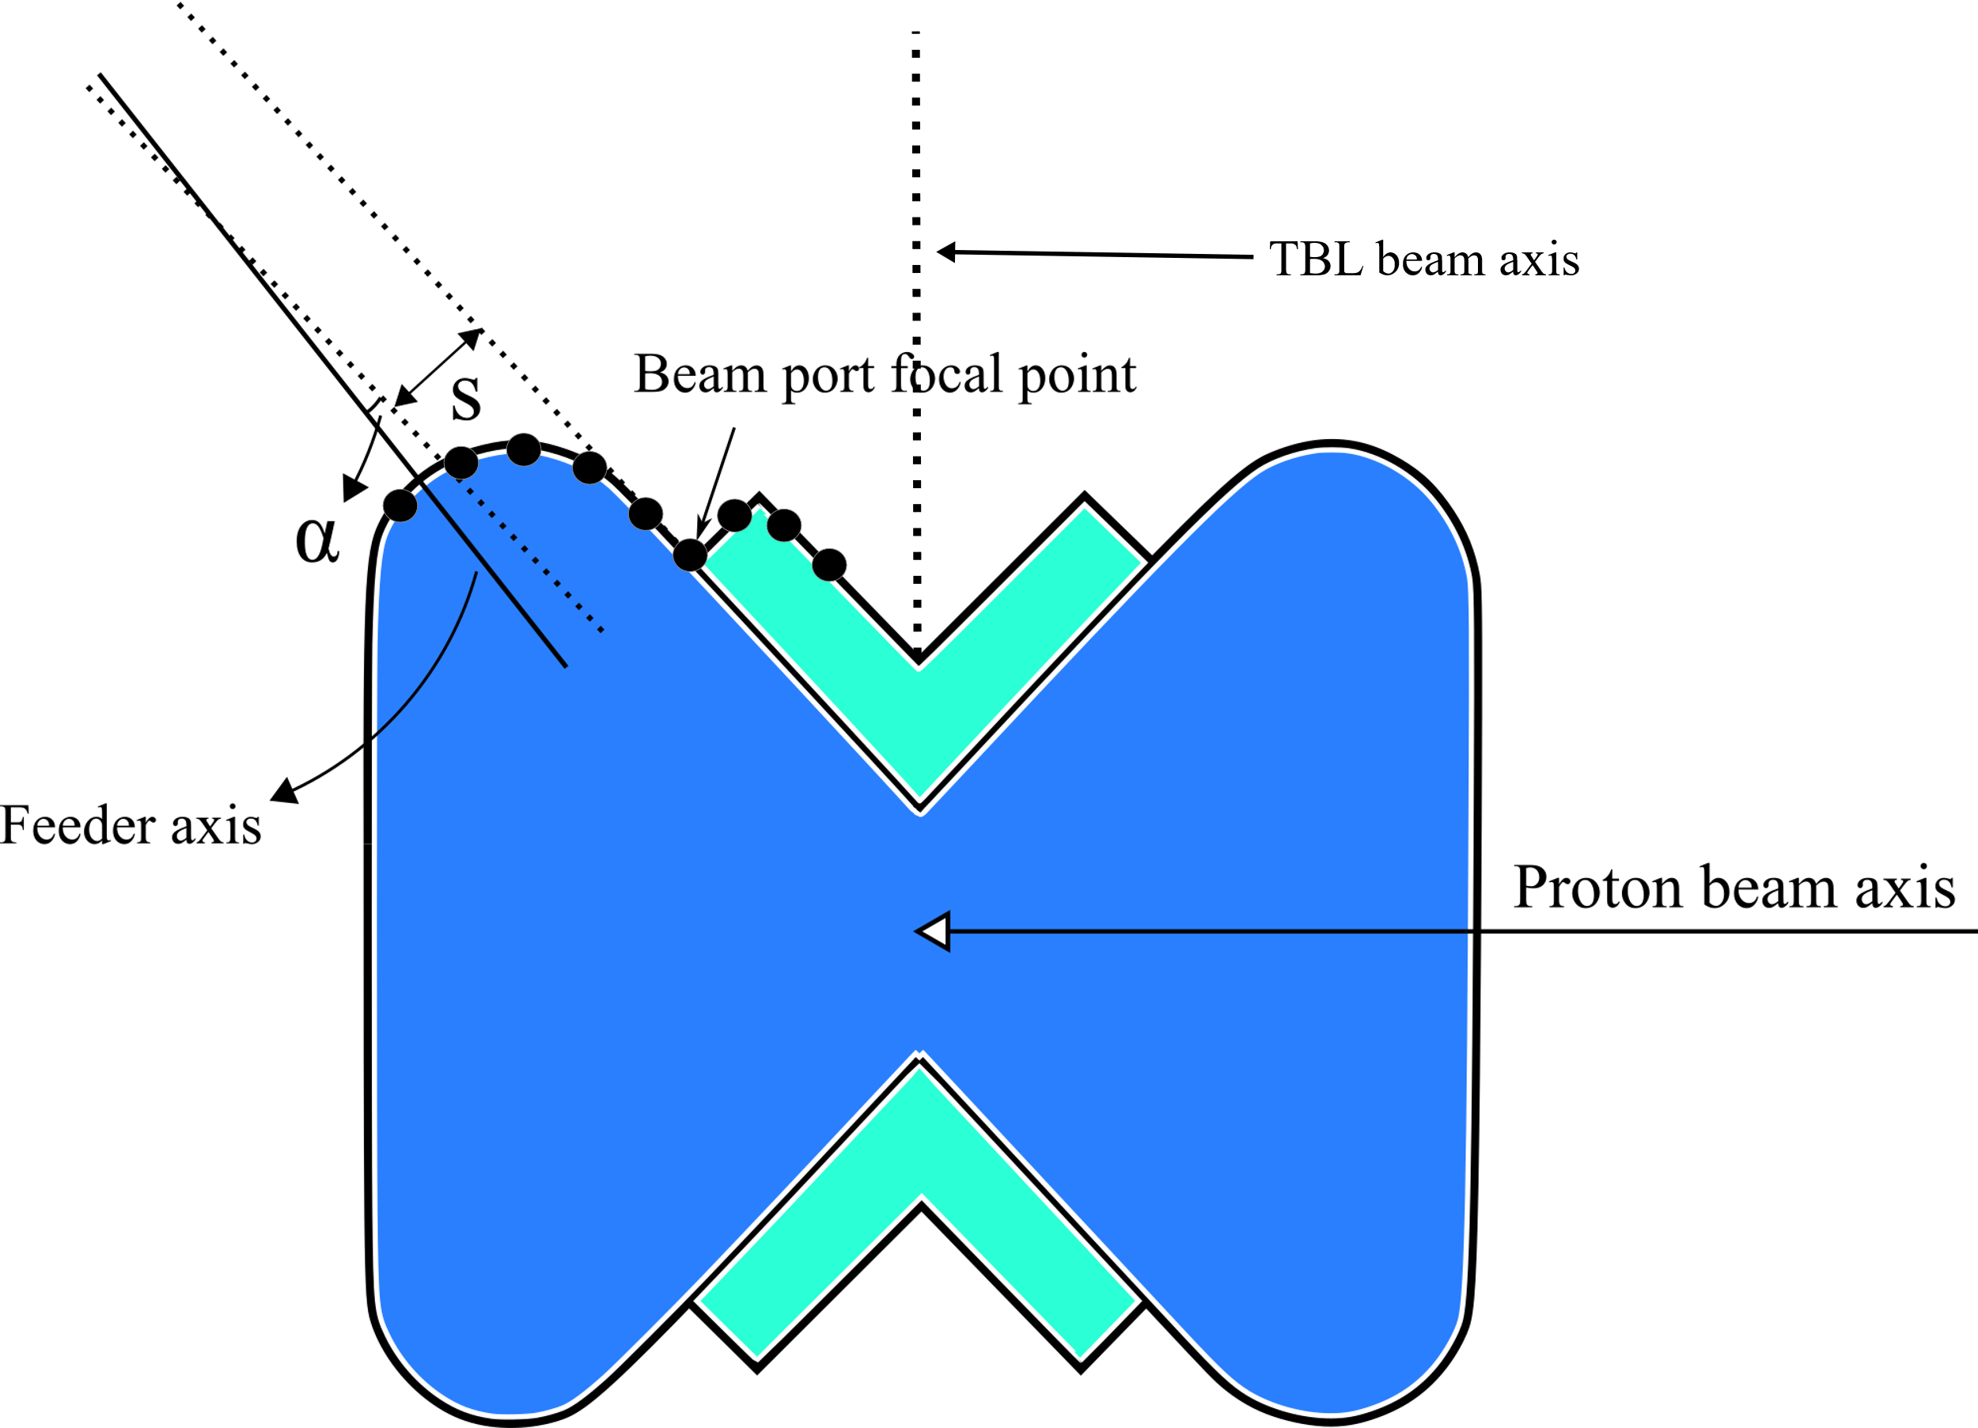
Figure 1 - TBL measures the neutron spectrum directly, without using a neutron guide, at specific points in the field of view of BIFROST

The a priori knowledge about the moderator spectrum comes from the TBL measurements, where they scan the surface of the moderator using two pinholes. They then use Bragg edge transmission measurements to measure the brilliance of the moderator, benchmarking the simulated spectra. This could serve as an empirical basis for validating the guide performance, if enough information is obtained in the calibration measurements. There is an angular dependence that could be a systematic error in such an approach, but that either has to be accepted, or accounted for via simulated data.

Primary spectrometer
Understanding the choppers and the beam monitors is a prerequisite for understanding the incident beam on the sample and would therefore be a first step in hot commissioning

People involved:
- Available at all times: Instrument scientists (x2), instrument data scientist, IOE
- On call for ad hoc problems: Chopper engineer, detector scientist for monitors

Components involved: PSC chopper, FOC choppers, BW chopper, Beam monitors 1-4

A simple drawing of the ToF-diagram is shown in Figure 2.

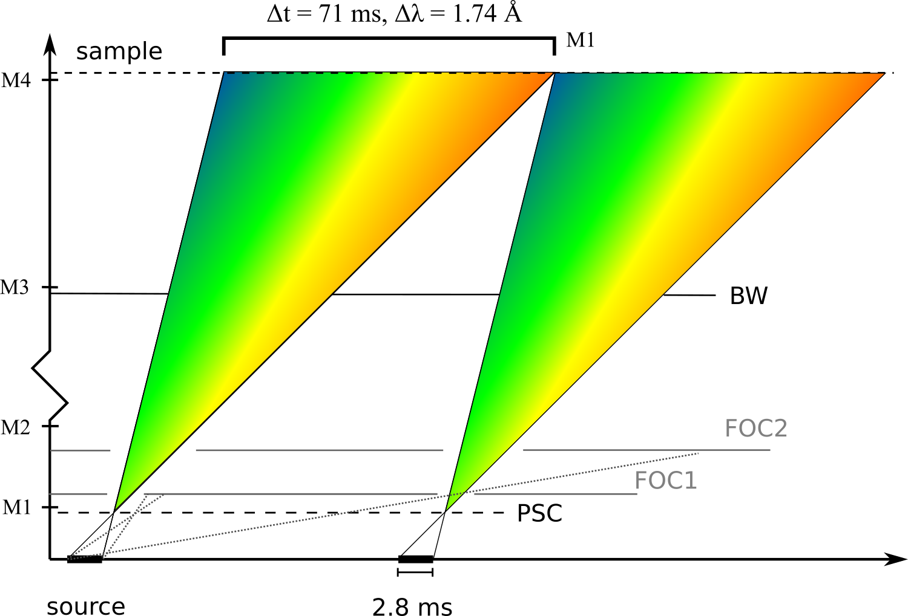
Figure 2 - Simple ToF diagram with the positions of the 4 monitors

PSC fission monitor (M1) commissioning (1 beam days)
FBS: ESS.NSS.H01.BIFRO.A01.B01.B01 – Beam monitor M1
ESS.NSS.H01.BIFRO.A01.B01.C01 – Beam monitor M1 DAQ system
- Park the PSC in closed mode. Measure the fast neutron signal on the fission monitor and confirm the prompt pulse timing is consistent with the accelerator T₀. The data should be recorded in histogram mode, and enough statistics gathered for 2 % intensity error bars.
Criterion for success: Consistency of measured T₀ with expected T₀ from ESS reference pulse
- Park the PSC in open mode. Measure the full spectrum from the source, subtract the fast neutron background. Normalize intensities for 1/λ. Compare the timing of the measured intensity peak with what is expected from the simulated and measured moderator spectrum from TBL. This is as a consistency check, as NBOA brilliance transfer comes into play, obscuring the distribution. But the time of peak intensity should be consistent with the peak wavelength of the moderator spectrum, and the ToF spectrum recorded by the fission monitor should be consisted with the spectrum from our field of view of the moderator as measured by the TBL.
Criterion for success: Spectrum characteristics and peak as expected from simulations

Pulse-shaping chopper commissioning (2 beam days)
FBS: ESS.NSS.H01.BIFRO.A01.R01.R01.R01 – PSC mechanical assembly
ESS.NSS.H01.BIFRO.A01.R01.R01.K01 – Bunker control system
For the pulse shaping chopper, verifying operational stability is important, to ensure consistency between anomalies measured by M1 and anomalies measured by the SKF spindle. The latter measurement is deemed far more accurate, though. More importantly, characterization of the PSC pulse is crucial, since the pulse shape essentially determines the energy resolution function.
Below, a simulation of various PSC opening times, at various frequencies are shown.
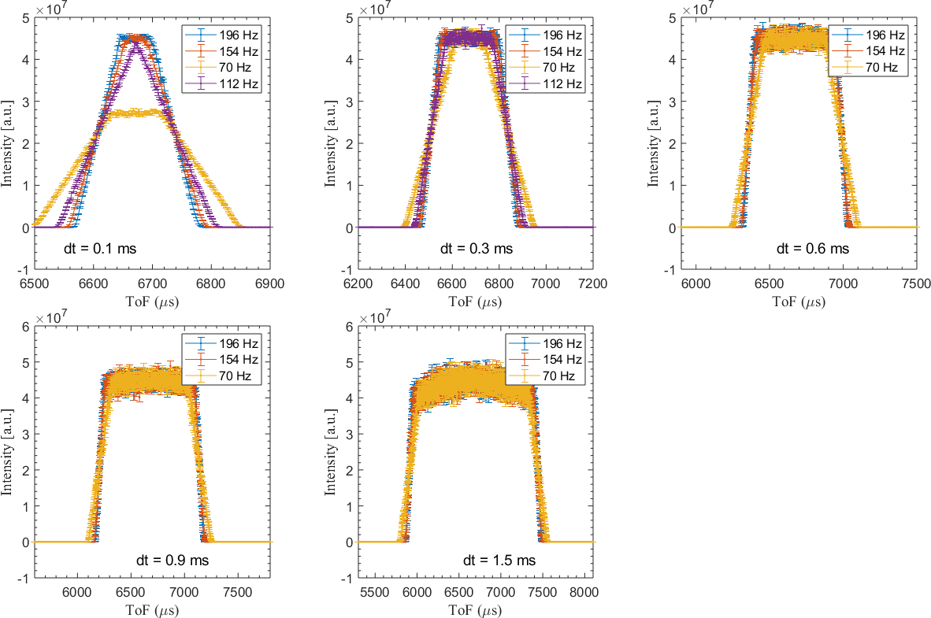
Figure 3 - Simulated PSC pulses at the M1 position

The envisioned to-do list for PSC hot commissioning is the following
- For each of the PSC discs, slow scan each of them over the guide opening, confirming that the phase where the edge of the chopper disc opening starts overlapping with the guide centre is as expected – via a M1 intensity versus phase plot
Criterion for success: Midpoint of sweep curve has the phase expected from chopper control
- Rotate each disc at 14 Hz – separately, confirming this phase calibration at 14 Hz – using an M1 time histogram. Criterion: cutoff time should be in line with that expected from the spindle phase and frequency information.
- For each disc, repeat this measurement at max speed (126 Hz or 210 Hz, depending on the disc)
- Spinning both discs at max speed in corotating mode, set the PSC opening time to its minimum, 0.1 ms. Record a well-defined peak in a M1 time histogram. Criterion: verify that sweep time and mean value of the PSC pulse is as expected. Record 3 histograms pr hour overnight. Criterion: Verify that the peak is stable on the timescale of 1 day – the time histograms should overlap after being normalized with respect to each other.
- Jitter check: Make a small slit with the PSC phasing and create a narrow 10-20 us peak – and confirm during a long measurement that the peak width is constant and as expected.
- At max speed, adjust the phase of the PSC peak relative to the proton pulse. Confirm that the T₀ cutoff is as expected. Verify and characterize the M1 time histogram for all recorded phases with enough statistics.
- Finally, vary the PSC pulse width at max speed, ensuring that the relative phasing of the two PSC disc is as expected, and give the peak shapes shown in Figure 3.
Note: While the PSC commissioning is going on, certain measurements can be performed simultaneously. One can open up the chopper system, park the slower choppers in open, place a vanadium sample on the sample position, and illuminate the detectors fully. This would allow calibration of detector edges – like described in 3.7.1.

Frame overlap choppers – Ionization beam monitor 1 (M2) (1 days)
FBS: ESS.NSS.H01.BIFRO.A01.R01.R01.R02 – FOC-1 Mechanical assembly
ESS.NSS.H01.BIFRO.A01.R01.R01.R03 – FOC-2 Mechanical assembly
ESS.NSS.H01.BIFRO.A01.R01.R01.K01 – Bunker control system
ESS.NSS.H01.BIFRO.A01.B01.B02 – Beam monitor M2
ESS.NSS.H01.BIFRO.A01.B01.C02 – Beam monitor M2 DAQ system
Once the PSC and spectrum has been commissioned, pulses with well known shape, intensity and timing can be adjusted at the PSC position. There are two FOCs preventing frame overlap. These both spin at 14 Hz and have an opening adjusted to the maximum allowable, to create margins. The functionality of these two choppers can be tested by the ionization beam monitor (IBM), which deliver an intensity versus time histogram with an adjustable offset and time bin. The IBM is analogue, and does not deliver events, and therefore a histogram is the only analysis option.
The test of the FOC system is as follows:
- Spin the two FOCs at 14 Hz and the desired phase, as determined by the phasing of the PSC relative to T₀. Scan the phase of each FOC, to confirm both cut-off points, at which the FOCs are sufficiently dephased to fully absorb the PSC pulse. The phase difference between the desired phase, and each of the cut-off points should be the same, to confirm that that the phasing of the FOC is calibrated to the PSC
- In a 24-hour measurement, confirm that there are no additional frames by measuring only the PSC pulse, with the expected ToF mean value and width, with enough statistics to measure satellites and parasites at least 3 orders of magnitude weaker than the main peak.

Bandwidth chopper (BWC) – Ionization beam monitor 2 (M3) (2 days)
FBS: ESS.NSS.H01.BIFRO.A01.R01.R02.R01 – BWC Mechanical assembly
ESS.NSS.H01.BIFRO.A01.R01.R02.K01 – BWC control system
ESS.NSS.H01.BIFRO.A01.B01.B03 – Beam monitor M3
ESS.NSS.H01.BIFRO.A01.B01.C03 – Beam monitor M3 DAQ system
The BWC consists of two axis, each having a disc with a 161-degree opening. In standard operation mode, these choppers will spin in counterrotating mode to minimize sweep time. In special cases, where the bandwidth needs to be reduced, the two discs will be set to co-rotate, allowing a phase adjusted effective opening angle. Behind the BWC, there is an additional ionization beam monitor referred to as M3. We will use M3 to commission the BW chopper in a similar fashion as for the PSC, executing the following steps:
- For each of the BW discs, slow scan each of them over the guide opening, confirming that the phase where the edge of the chopper disc opening starts overlapping with the guide centre is as expected – via a M3 intensity versus phase plot
- Rotate each disc at 14 Hz – separately, confirming this phase calibration – using an M3 time histogram. Here the cutoff time should be in line with that expected from the spindle phase and frequency information.
- Spinning both discs at 14 Hz counter-rotating mode, record a well-defined peak in a M1 time histogram, and verify that sweep time and mean value of the BWC broad pulse is as expected. Record 3 histograms pr hour overnight and verify that the peak is stable on that timescale – the time histograms should overlap after being normalized with respect to each other.
- Repeat the step above for the co-rotating mode, choosing an effective opening of 80.5 degrees.

- Using a PSC opening time of 0.1 ms, the pulse reaching the BWC would be only negligibly longer than the BW opening time. Scan the overall phase of the BW to verify the edges of the incident pulse, using a M3 intensity versus phase plot. This serves to verify the internal consistency of the chopper system as a whole – and to verify time-of-flight

Sample spectrum, GEM beam monitor (M4) (1 days) – High level requirements 3 and 5
FBS: ESS.NSS.H01.BIFRO.A01.B01.B03 – Beam monitor M4
ESS.NSS.H01.BIFRO.A01.B01.C03 – Beam monitor M4 DAQ system

The GEM/CASCADE beam monitor is a fairly complicated detector. It has two conversion layers, a high efficiency and a low efficiency one, to allow for high statistics intensity histograms with fine time-binning to be recorded at high and low incident fluxes respectively.
It has the capability to have 2D sensitivity across a 32 x 32 mm area, with 32 x 32 pixels, with a 1 MHz count rate capability. It can be operated in 0D mode, allowing for count rates up to 5 MHz. As a normalization monitor, we predominantly will use the 0D mode to decrease detector dead time.
For hot commissioning, we would often use the 2D mode, effectively using the monitor as a neutron camera.
For recording the spectrum at the sample, the GEM monitor is operated in 0D mode. A simulation of the monitor response for 3 consecutive pulses is shown in Figure 4.
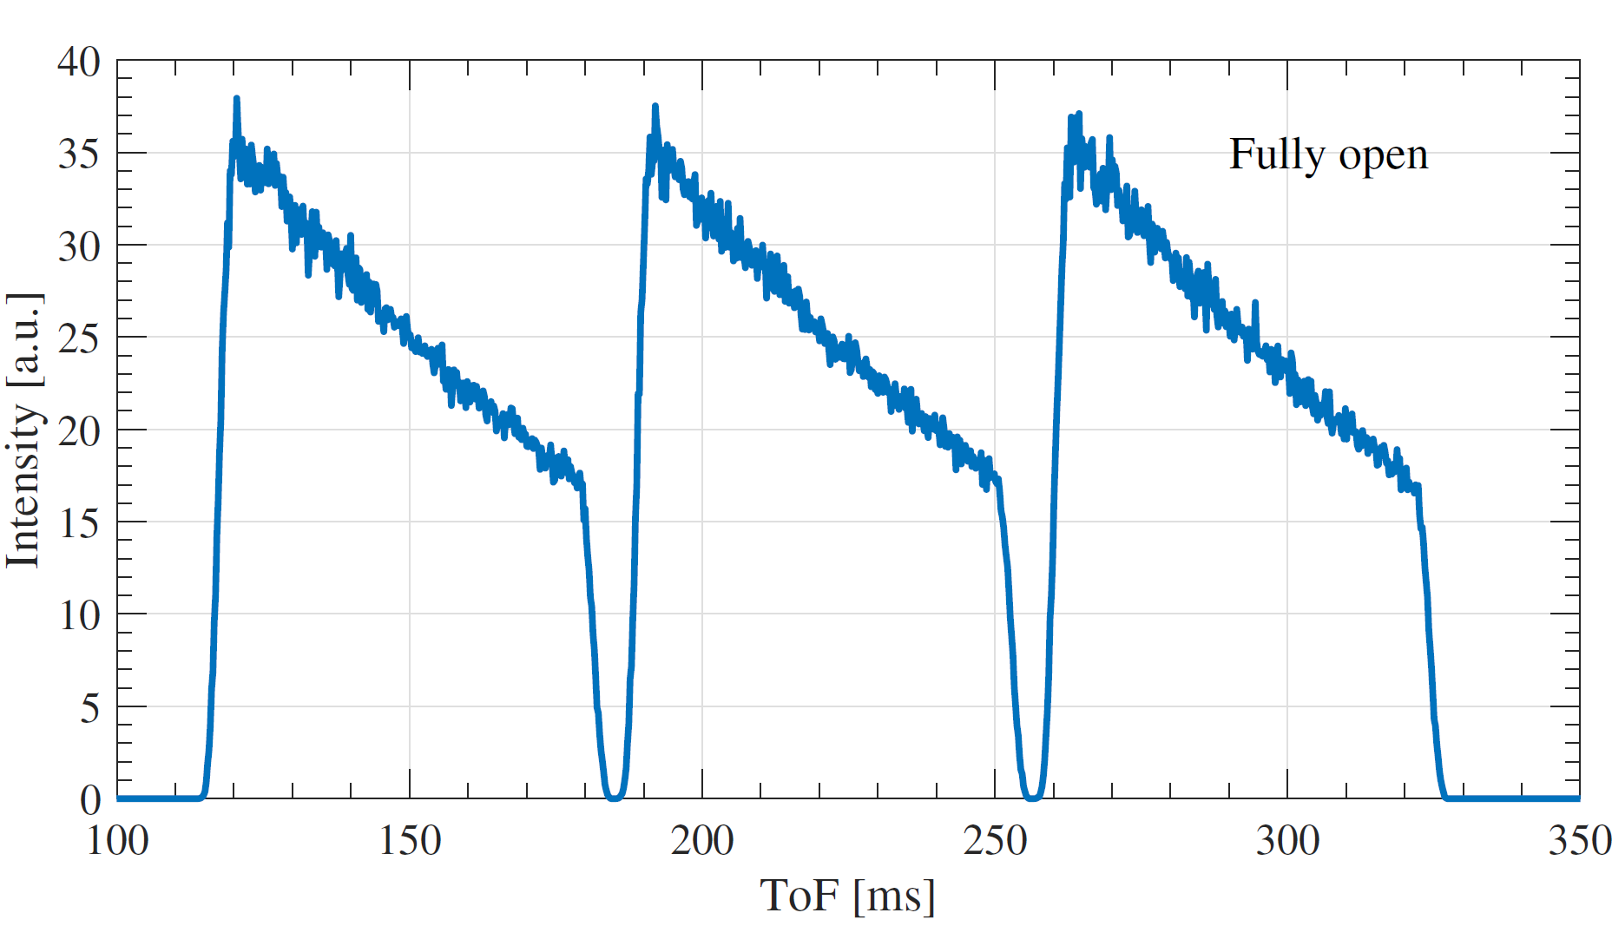
Figure 4 - Pseudo-continuous beam at BIFROST using a fully open PSC
The characterization of the incident beam would be as follows:
- Measure the monitor spectrum using a 2.3-4.04 Å wavelength band, and verify the time interval of 0 intensity that occurs between pulses, is as expected from the chopper system phasing
- Record a high statistic monitors spectrum, for 20 chopper system phase settings varying from a band center wavelength of 1.5 Å to 5.5 Å. This serves as a reference.
- Analysis: normalize for 1/λand identify aluminium Bragg edges for initial flight path verification.
- Perform the same measurements in 2D mode and characterize the wavelength dependence of the beam spot size.

Primary flight path calibration, GEM beam monitor (M4) (1 day)
In calibrating the primary flight path, we use a standard powder of iron or Al₂O₃, mounted in a standard container placed right after the guide, as shown in Figure 5.
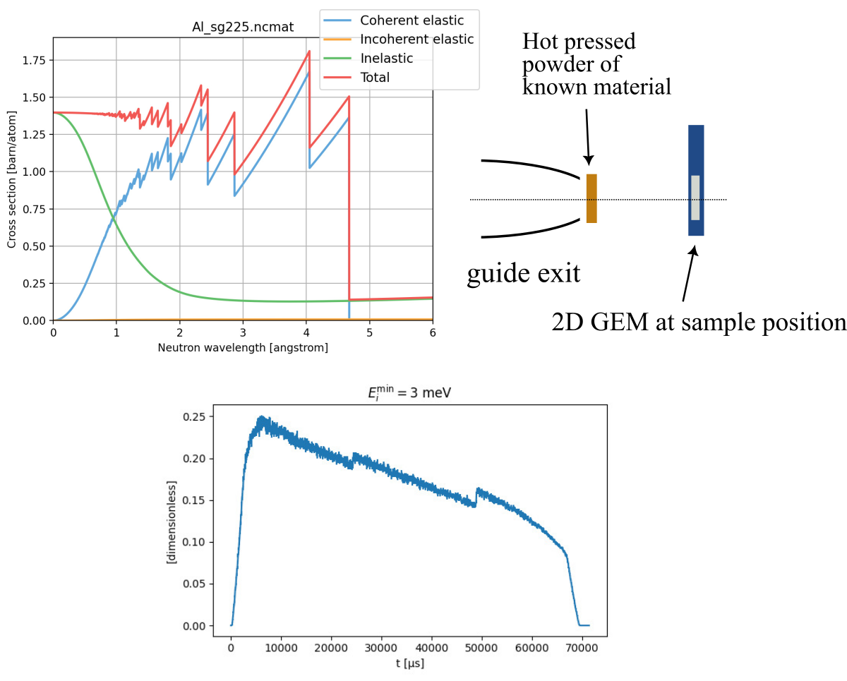
Figure 5 - (Top left) Bragg edges of pure aluminum. (Top right) setup for primary flight path calibration. (Bottom) Simulated Bragg edges in the monitor spectrum from the aluminum windows in the guide
Using a PSC opening time of 0.1 ms, we would observe a set of Bragg edges with a fitted uncertainty below that – less than 100 us. Knowing the flight time and the wavelength, the flight path between PSC and sample position can be fitted from the observed edges. The detector depth is of the order of 10 mm, which would be the minimum uncertainty of the flight path calibration.

Nice-to-have: Guide characterization and acceptance diagram measurement, GEM beam monitor (M4) (10 days)
In order to characterize the guide, to validate performance and create a benchmark measurement for this performance, we aim to measure the acceptance diagram of the guide, by placing M4 at the sample position, and scanning a spinhole across the guide opening.
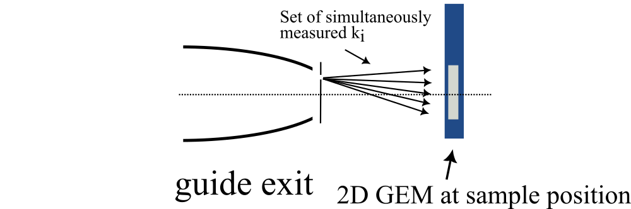
Figure 6 - Proposed setup for measuring the acceptance diagram of the guide
For each pin hole setting, this defines 32 distinct incident wavevector directions that are measured. For each of these, an intensity versus wavelength spectrum is obtained.
This can be used to obtain the transmitted phase space of the guide as a function of wavelength and can be directly compared to McStas simulations.
In the future, if such a measurement is properly made, it can serve as a benchmark. If guide coating breaks down, or large misalignments happen, we can spot asymmetries or irregularities in the phase space, in addition to a loss of intensity. For a guide 160 meters long, this may be crucial in order to diagnose potential problems.
Note: The measurement may take a very long time. It is possibly best done with an automatised pinhole and a more efficient neutron detector. The measurement is not crucial for science – we de facto have the beam that we have – but it is important to diagnose problems in a guide as long as BIFROSTs.

Divergence jaw characterization, GEM beam (2 days)
FBS: ESS.NSS.H01.BIFRO.A01.R02.R01.R01 – Divergence Jaw 1
ESS.NSS.H01.BIFRO.A01.R02.R01.R02 – Divergence Jaw 2
ESS.NSS.H01.BIFRO.A01.R02.R01.R03 – Divergence Jaw 3
Using a measurement similar to the one described in section 3.5, we can characterize the horizontal divergence at various divergence jaw settings. This measurement could be restricted to a horizontal pin-hole scan, or even better, using a specialized rig to specifically measure divergence profiles, e-g by using a Soller collimator setup.
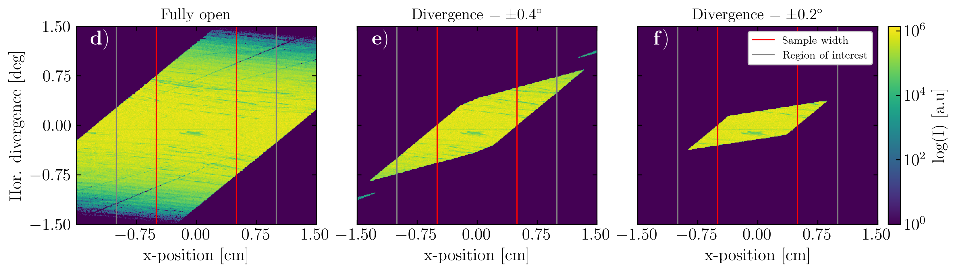
Figure 7 - Acceptance diagrams of three jaw settings
These measurements should be conducted with high exposure times, in order to pinpoint potential parasitic beams like the one shown in Figure 7. The one shown in the figure is no problem, but if the jaws to not work as expected in conjunction with the guide system, it needs to be discovered in this measurement.
In addition, some refinement of jaw settings should be expected, perhaps there are a few divergence jaw settings that are more clean than others. These should be identified as standards.
A final test is to measure powder peaks with increasingly smaller incoming divergence. Due to the good resolution of the BIFROST secondary spectrometer, the peak should narrow significantly

Nice-to-have: Sample slit characterization, GEM beam monitor (M4) (6 days)
FBS: ESS.NSS.H01.BIFRO.A01.R02.R01.R04 – Sample slits
The sample slit motors has been tested. But it would still be valuable to measure the beam profile at the sample position, for realistic sample slit distances from the sample. This is to quantify the beam for future designs of pressure cells etc.
- For the sample slit positioned at the closest distance to an orange cryostat, measure the beam profile of 1x1 mm, 2x2 mm, 5x5 mm and 10 x 10 mm slits
- For the sample slit positioned at the closest distance to an 15 T cryomagnet, measure the beam profile of 1x1 mm, 2x2 mm, 5x5 mm and 10 x 10 mm slits
- Repeat the two measurements above for the most aggressive divergence jaw setting, as the beam profile is supposed to be more controllable.
If necessary, repeat for other settings of interest.

Initial flux measurement – high pressure ³He-tube (1 days) High level requirements 4 and 6
After the beam geometry has been characterized, a first attempt to understand the absolute flux will be made. For this, a high pressure He-3 tube would be suited, since for high wavelengths, the efficiency is close to 1 for the entire band (saturation). The challenge is then to reduce flux enough to avoid saturating the tube – staying well below the maximum count rate of 100.000 counts pr second.
Maximum flux at 2 MW is around 5*10⁹ n/s/cm², and the B4C attenuator on BIFROST reduces flux by a factor of 50. Operating the source at 200 kW reduces flux by another factor of 10. We then plan to construct a mask for the guide, which has small uniformly distributed holes across the guide opening, sampling the entire guide phase space, but absorbing a factor of 100. In such a setup, the overall neutron flux hitting the sample position is reduced by a factor 50.000 – leaving a flux at the sample of 10⁵ n/s/cm². Then a 3x3 mm2 slit in front of a 12.6 mm detector tube, would only illuminate the center of the tube with a neutron current of around 10.000 n/s, see Figure 8.

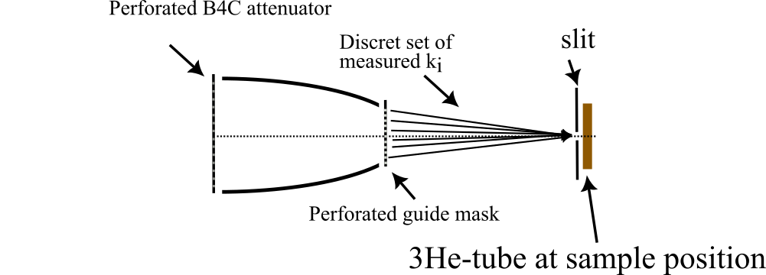
Figure 8 - Suggested flux calibration setup
By using the wavelength band of [5.3, 7] Å, we would avoid the aluminium Bragg edges and would therefore allow an almost correction free flux measurement on the sample position in that interval.

Beam monitor normalization (M4) (2 days)
FBS: ESS.NSS.H01.BIFRO.A01.B01.B03 – Beam monitor M4
ESS.NSS.H01.BIFRO.A01.B01.C03 – Beam monitor M4 DAQ system
The GEM monitor 4 is a fairly complex detector. However, the efficiency should still scale inversely with incident wavelength. This is not true for detectors with a large gas pressure with an efficiency close to 1.
We propose to validate the performance of the normalization monitor M4 in the following way:
- Repeat the measurement described in 3.6.10, only with removal of the slit in front of the guide. This will give a monitor spectrum, free of Bragg edges, to be normalized for 1/λand compared to the He-3 tube measurement. Check that the spectrum can be reproduced, and use the He-3 flux measurement to normalize the monitor efficiency (note: The monitor efficiency can and will drift with time, electrode performance, gas flow, gas composition will all influence the detector efficiency – the M4 will NOT be an absolute calibrated detector, however a ball park can be checked)
- Spectrum test using our Bragg peak monitor. This monitor has 0.1 bar 3He pressure, and an efficiency of around 1 % at 3 Å. We plan to put a thin capillary containing Al₂O₃ powder on the sample position and measure a ToF powder spectrum using our Bragg peak monitor at a fixed scattering angle. We use the M4 spectrum normalize flux for 1/λand will normalize the recorded spectrum for 1/λas well. This should allow us to refine the powder diffraction pattern to with a few percent peak intensity. A peak intensity reproduction within a few percent would be very good – a 20 % discrepancy disappointing.
Once incident beam normalization has produced an acceptable powder diffractogram, the incident beam is well understood

Note on Intensity normalization on BIFROST in general:
It is worth noting that on BIFROST – like on a TAS - there will be a considerable amount of material between the sample and the detector. Aluminum rings in the magnet, aluminum windows, 200 mm of beryllium, si-wafers and pyrolytic graphite. These all have absorption, phonon scattering, potential Bragg edges etc, which will reduce the measured peak intensity as compared to the nominal one. In addition, these effects are not easily understood, since the analysers operate in the large wavelength regime, where few Bragg peaks are present for any material. Vanadium normalization will be performed, but this is using one sample geometry, one sample characteristic etc.
A systematic intensity uncertainty of around +/- 5 %, or larger, is to be expected. An understanding of the incident spectrum significantly better than these systematic errors in the secondary spectrometer, will be relatively futile.
We are working towards a Union model (in McStas) of the BIFROST backend, to quantify these errors. While the effects may not be directly measured, such calculations could be used to correct the data, and benchmarked against known systems, measured on direct geometry spectrometers.

Attenuator tests, GEM beam monitor (M4) (1 day)
FBS: ESS.NSS.H01.BIFRO.A01.R03.R04 – Beam attenuators
Using the beam monitor spectrum, measure the spectrum using all three attenuators.

Gold foil measurements (1 day) High level requirements 4 and 6
Once the primary spectrometer has been characterized, we aim to perform gold foil flux measurements – using the existing gamma ray spectrometer in a nearby lab. These would be done using the wavelength bands [1.5 - 3.25], [3.25 - 5], [5 6.75] and lastly [5.3 – 7] Å, in order to benchmark the flux measurement using the attenuated beam. If these two measurements are consistent, the flux curve for the instrument across the entire band, can be but on absolute scale, using the M4 data

Secondary spectrometer
People involved:
- Available at all times: Instrument scientists (x2), instrument data scientist, IOE
- On call for ad hoc problems: motion control engineer, detector scientist for monitors and detectors

Components involved: Sample stack, detector tank, detector system, BM4 and BM5

The secondary spectrometer is outlined in Figure 9.
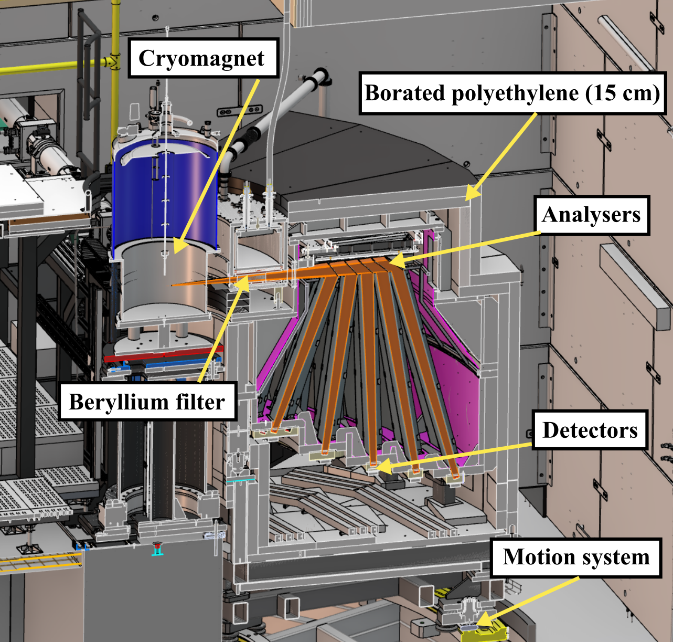
Figure 9 - CAD model of the secondary spectrometer

Detector charge division limits calibration (2 days)
FBS : ESS.NSS.H01.BIFRO.B01.B01 – Detector System
ESS.NSS.H01.BIFRO.B01.C01 – Detector electronics
Before calibrating the filter and the scattering angle it is important to ensure that the discrimination limits of the detector triplets and their internal calibration is set correctly, at least to first order. Figure 10 shows an example of event distribution (color scale) on a single triplet, with a uniformly illuminated triplet. The resistors separating the tubes create dead ratios, since they mimic resistive wire without neutron sensitivity. Therefore, 6 delineating points need to be defined, by measuring a uniformly illuminated triplet, separating the tubes. The charge division result within the ratio region corresponding to a tube, then yields the position of that tube – hopefully in a linear fashion. This is not necessarily the case for long tubes, yet we expect a non-linear correction to be small on tubes shorter than 50 cm. This remains to be tested. The active length of a tube is known to within 1 mm, as per the FAT test.
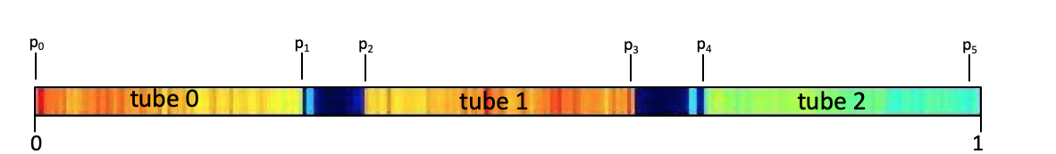
Figure 10 - Example of charge division result when uniformly illuminating one triplet, with the three tubes separated by "dead ratios" for charge division, which are created by the resistors between tubes

By placing a vanadium sample on the sample position, and illuminating this with the proper wavelength band, the detector limits can be delineated, as per the simulation shown in Figure 11.
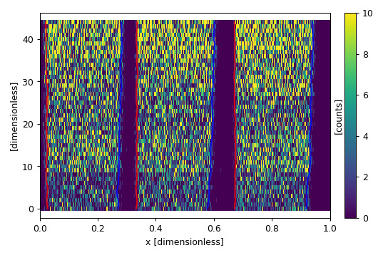
Figure 11 - Example of limits on all 45 detector triplets (y-axis)

Beryllium filter/radial collimator (2 days)
FBS: ESS.NSS.H01.BIFRO.B01.V01 – Beryllium filter
The beryllium filter is a combined beryllium filter and a radial collimator, consisting of 9 separate units as shown in the figure below.

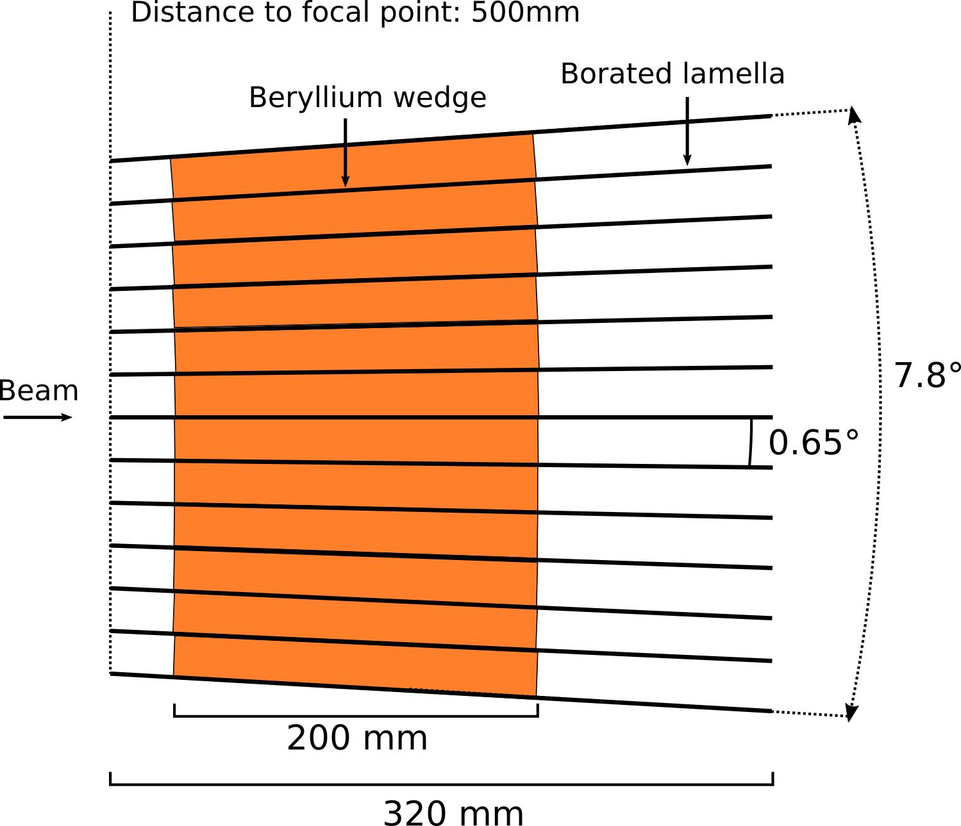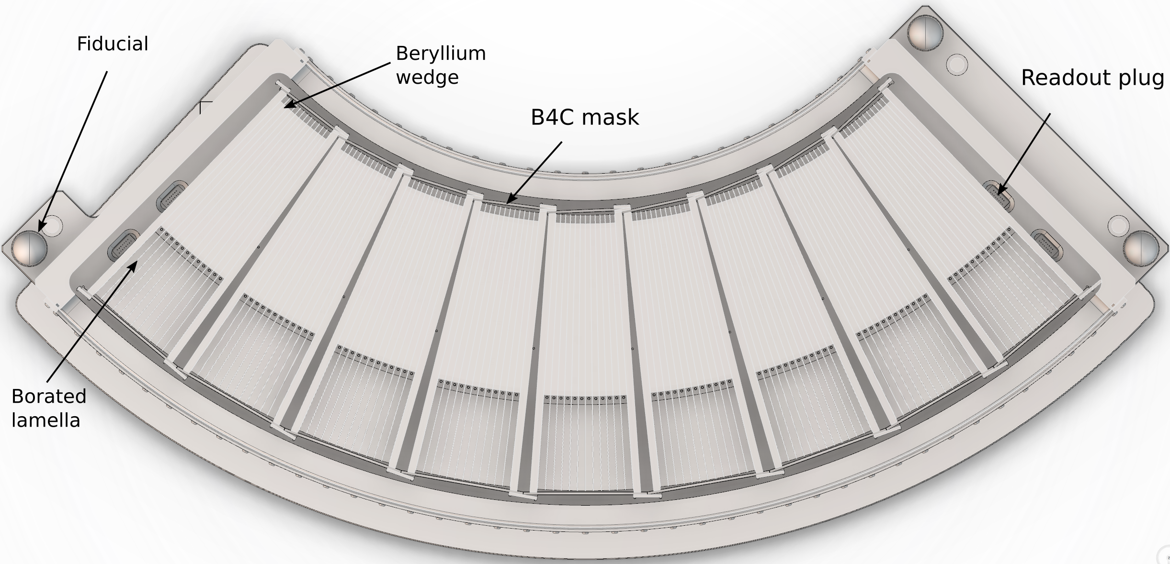
Figure 12 - (left) design of single filter unit. (Right) Assembly of 9 filter units
Each unit is masked with B4C masks, supposed to prevent streaming outside the units. The validation of the filter consists of 4 steps:
- Testing the acceptance height of the mask. Using a small 3x3x3 mm scatterer, select a Bragg peak at 4.04 Å, and scan the vertical sample position, confirming a reasonable scattering profile (lack of strong spurions), as the sample is translated out of the beam. This serves to confirm that the large copper mass in the Be-filter is not illuminated to a large degree
- Choosing a Bragg peak at 90 degree scattering angle and 135 degree scattering angle at 4.04Å, translate the small sample along the beam, confirming the triangular acceptance function of the radial collimator.
- Transmission of desired neutrons. Choosing a Bragg peak at the five final energies, measure the Bragg peak intensity with and without filter (craning the filter out of the way). It is important that this test is done without attenuating the detectors
- Attenuation of undesired neutrons. Choose a Bragg peak at 2.02 Å accepted by the 5.0 meV analysers. Measure the intensity of this Bragg peak with and without the filter. Again, the intensity the Bragg peak should be small.
The two last tests should of course be combined.
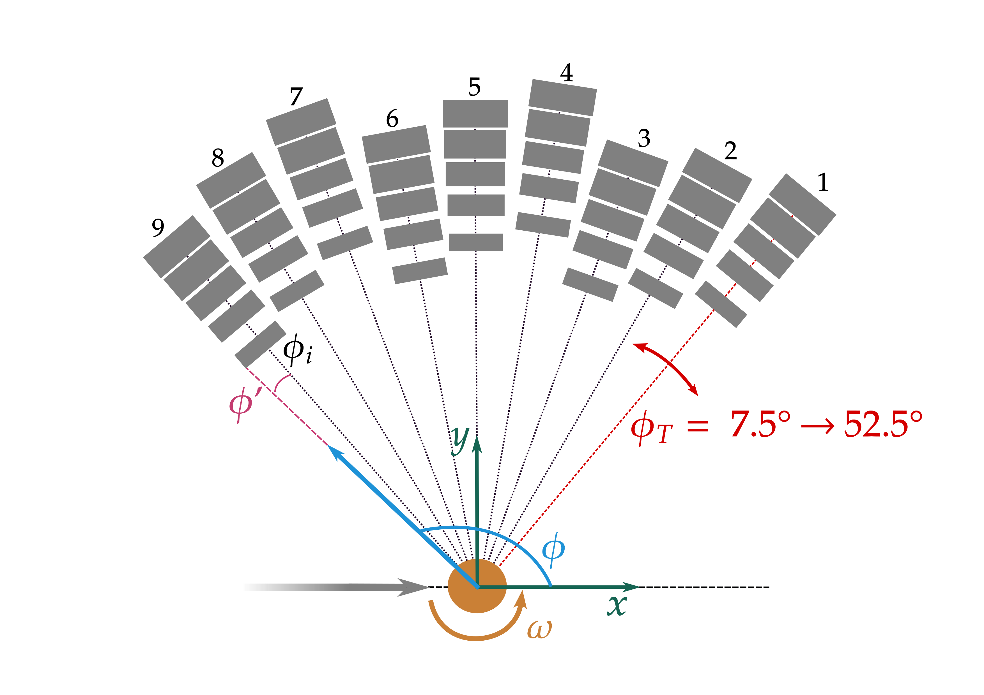
Figure 13 - Bifrost sample coordinate system

Calibrating overall tank scattering angle (BM5) (3 days) High level requirements 7, 8 and 9
FBS: ESS.NSS.H01.BIFRO.B01.C02 – Detector tank
ESS.NSS.H01.BIFRO.B01.W01 – Detector tank motion carriage
ESS.NSS.H01.BIFRO.B01.B02 – Neutron analysers
ESS.NSS.H01.BIFRO.A02.W01.W02 – Rotational sample stack
The coordinate system of the secondary spectrometer is defined relative to the sample position as shown in Figure 13. The overall tank scattering angle should be calibrated with a powder sample, likely Al2O3 or YIG. The powder sample should be in a 2-3 mm capillary, and shielded with a B4C plate
The Bragg peak monitor, which is mounted outside the Be-filter, is a low pressure He-3 tube, which is about 1 % efficient. In front of this monitor, there is a space for a slit, which can be made to any size, with a positional precision of about 1 mm. One 2 mm slit should be put in front of the monitor, to define the scattering angle φ to within 0.2 degrees, which is better than the angular resolution of the analyser/detector system, and better than the finest resolution we need from the divergence jaws.
For a specific tank rotation angle, the angle interval allowed by the slit, as compared to the incoming beam, might not be exactly the encoder value – a soft zero offset might be needed. Recording a ToF spectrum of a powder diffraction pattern, using the Bragg peak monitor at the smallest possible PSC opening time, allows us to fit the spectrum. Since we know T₀ (of the PSC), the flight path to the monitor and the lattice constants very well, we can fit the scattering angle of such a spectrum. This would be repeated for all divergence jaw settings for consistency, to check that the jaws do not alter the incident beam unit vector.
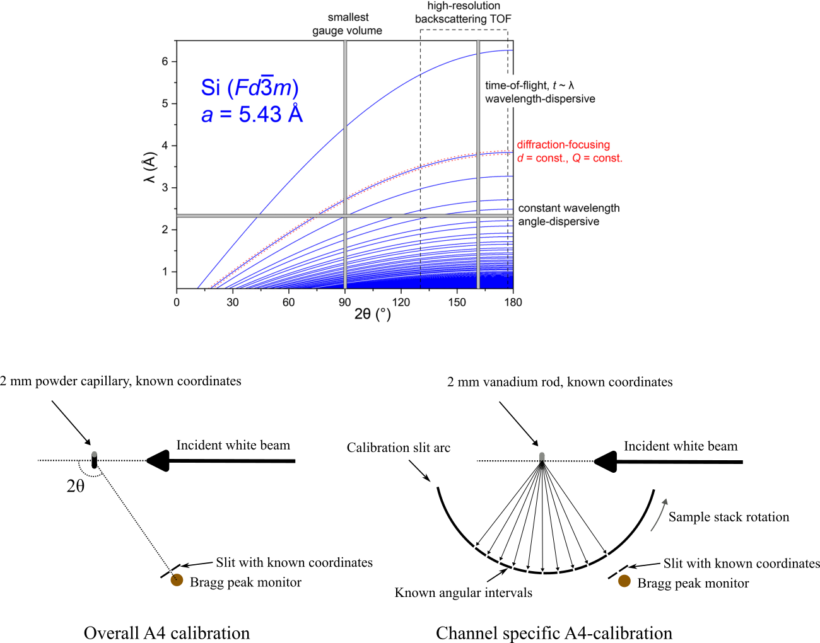
Figure 14 - Scattering angle calibration methodology. The top view shows diagram of powder diffraction peaks in a scattering versus wavelength plot. Backscattering geometry gives more well-defined peaks and larger Q-range. Several angles can be chosen
Once we have an absolute tank scattering angle known, we can place a slit cylinder on the sample rotation stage, with 10 slits, the first 9 should be 10 degrees apart – corresponding to each of the analysers, and the last one should be separated from the other 9 to fit the Bragg peak monitor slit position. We can now scan this slit system using the sample rotation stage, until the 10th slit allow the known φ to pass though the BM5 slit. See Figure 14.
We now know the absolute scattering angle of the 9 slits, regardless of rotation stage calibration. We can now change the sample to a small vanadium rod and can calibrate all analysers.
With these slits fixed, we can now scan the tank rotation, thereby scanning these narrow collimated peaks across the analyser, confirming the charge division to scattering angle conversion for all triplets.
First, we check the internal consistency of a triplet, by illuminating a line on the analyser and see a corresponding line in the charge division histogram for the triplet, like the McStas simulation shown in Figure 15.
The charge division result can then be tested to be consistent across the tube. If not, a calibration function needs to be implemented. If it is, the charge division has been calibrated. The length of the tubes have been confirmed at the FAT; and the corresponding scattering angle calibration will be described in a later section.
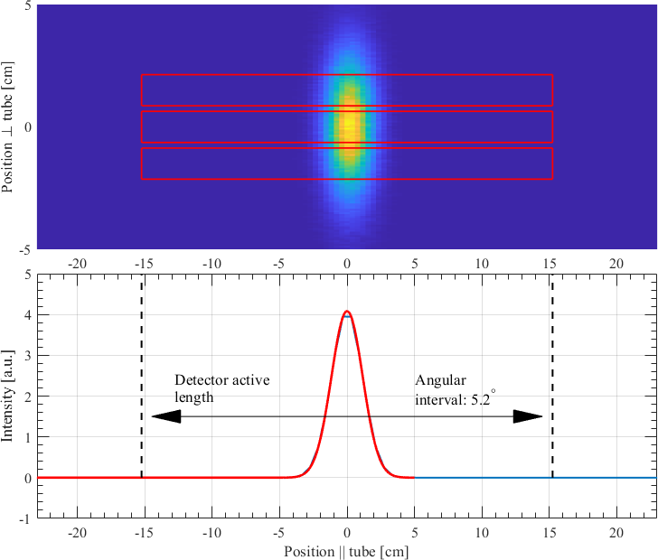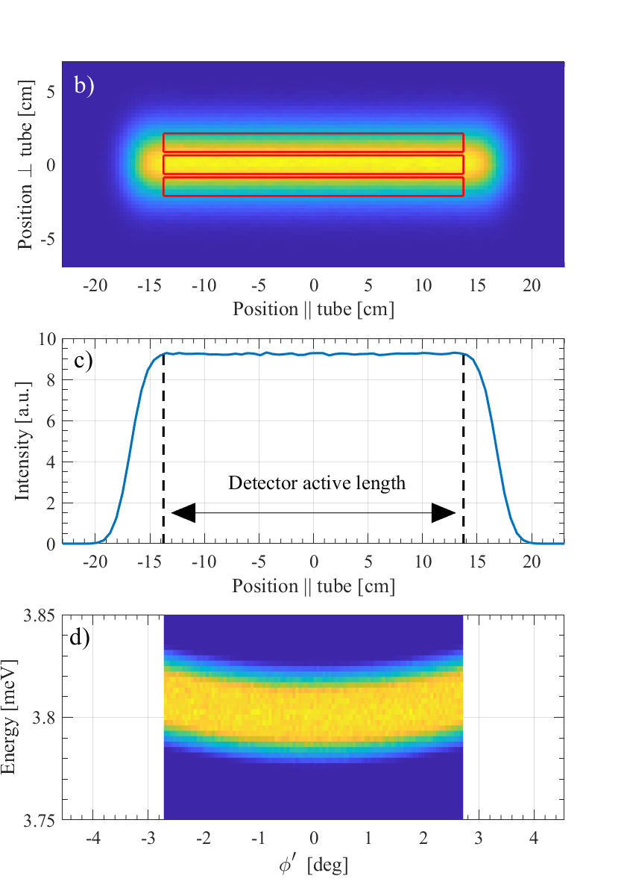
Figure 15 - (left) Simulated intensity distribution on a detector triplet resulting from pencil-beam illumination of a single analyser. The mean value of the intensity on each tube should be at the same position. (Right) Simulated full illumination of a detector bank, including the angle dependence of the final energy – subject to calibration.
Once the charge division has been calibrated, the absolute a4 position can be calibrated for the tube as well, confirming the edges of each analyser in terms of angle, rather than charge division. This will ensure that the position of each pixel is correctly transformed to scattering angle in the data reduction workflow.
Once calibrated for scattering angle the 5.0 meV analysers should be able to measure a powder spectrum and reproduce the correct scattering angles across the bank. It may be necessary to move the tank to test all the analysers. A powder spectrum correct in scattering angle to within 0.1 degrees is the success criterion

Ef calibration (2 days)
Using a known flat mode scatterer, we will calibrate Ef using the elastic line, and the two modes on the positive and negative energy transfer side. The difference between the mode separation in energy reflects the difference in final energy across the detector bank. Using this measurement, including the elastic line, we can then assign a final energy to each scattering angle pixel, which should be dependent on detector position, see Figure 15.

Cross talk shielding High level requirement 12
FBS: ESS.NSS.H01.BIFRO.B01.F01 – Cross talk shielding
The cross talk shielding is difficult to test directly. One way of testing would be to make sure that a Bragg peak goes into a given channel, without being reflected by any of the analysers. This gives a background measurement with an intense neutron beam in the tank. Then one can change the angle slightly, and probe the same Bragg peak, albeit now with an energy matching one of the analysers. If the detectors adjacent to the channel in question have the same intensity as the background, the cross talk shielding works – this is the success criterion.

Secondary spectrometer normalization (2 days)
For normalization we should use a small sample, residing well within the uniformly illuminated part of the beam spot – a cubic vanadium sample of 5 x 5 x 5 mm. This will then uniformly illuminate an analyser bank. For a single analyser, the scattering angle seen by a single position on the detector tube is the following
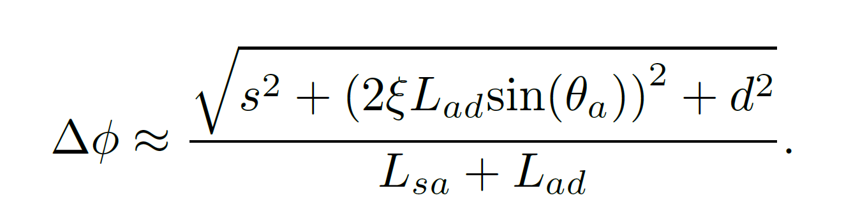
Where s is the sample FWHM, d is the detector resolution (not pixel size), ξ is the analyser mosaicity, θ_{a} is the analyser take-off angle, while L_{sa} and L_{ad} is the distance from sample to analyser and from analyser to detector, respectively. Within a single analyser bank, there is a slight difference in geometry. For the analysers furthest away from the sample for instance, L_{sa} and the detector tubes are slightly longer. A longer tube worsens the spatial resolution, so in the equation above, these two effects counteract each other to some extent.
Within a single analyser arc, a single E_{f}, the problem is thus that the pixels in each distinct analyser geometry sees different scattering spatial angles and needs to be normalized accordingly. The way we pixelate the detector tubes, every pixel represents the same scattering angle interval.
The pixels that receive scattering from a slightly smaller analyser area, probe a slightly smaller portion of the dispersion surface, and should therefore be weighted comparatively higher as a result. Therefore, normalizing all pixel to give the same intensity, for a single analyser arc, would be a good normalization starting point.

Sample environment (1 days)
FBS: ESS.NSS.H01.BIFRO.A02.AS01 - Sample environment equipment
For all day-1 sample environments, the hot commissioning amounts to measuring an empty cryostat or cryomagnet, and record the ‘spectrum’ of spurions at 300 (30 mbar exchange gas) and 1.5 K (3 mbar exchange gas).
For the 15 T magnet, a normalization scan using a fixed and reproducible magnet position, should be performed.

Benchmarking experiments
Since diffraction tests have already been made during hot commissioning the benchmarking test refers only to inelastic measurements. We here focus on the test cases outlined below.
NOTE: Some of these tests may not be necessary or might be performed with other samples, which could make this period more efficient. Some of these tests are not completely necessary – if one can reproduce the complex dispersion mentioned at the end of this section, the rest might be moot. However, if that turns out to be a challenge, performing the whole set of benchmarking, recalibrating, when necessary, might be necessary.
The goal of this phase is to determine what the instrument can and cannot reliably do, before start of user operation, in order to accommodate the community.

Elastic line (2 hours)
Check elastic linewidth as a function of PSC opening times, for all analyser arcs, and compare with simulations and calculatations

Flat modes – High level requirements 1 and 11
Studying flat modes allows one to test the energy transfer calculations for an entire detector bank, without worrying about understanding more complex dispersions. This is a first step towards more complex measurements. Since the dynamic range is so large, we need two separate tests with flat modes, below 10 meV and below 60 meV.

Flat modes below 10 meV (5 hours)
For low energy modes, the well-studied quantum dipolar AFM system LiHoF₄ would be useful. The modes are well separated. There is a strong signal, and we will study a diluted sample, where the moments interacts much weaklier. Reproducing the well understood experiments at low energies would be a first step.
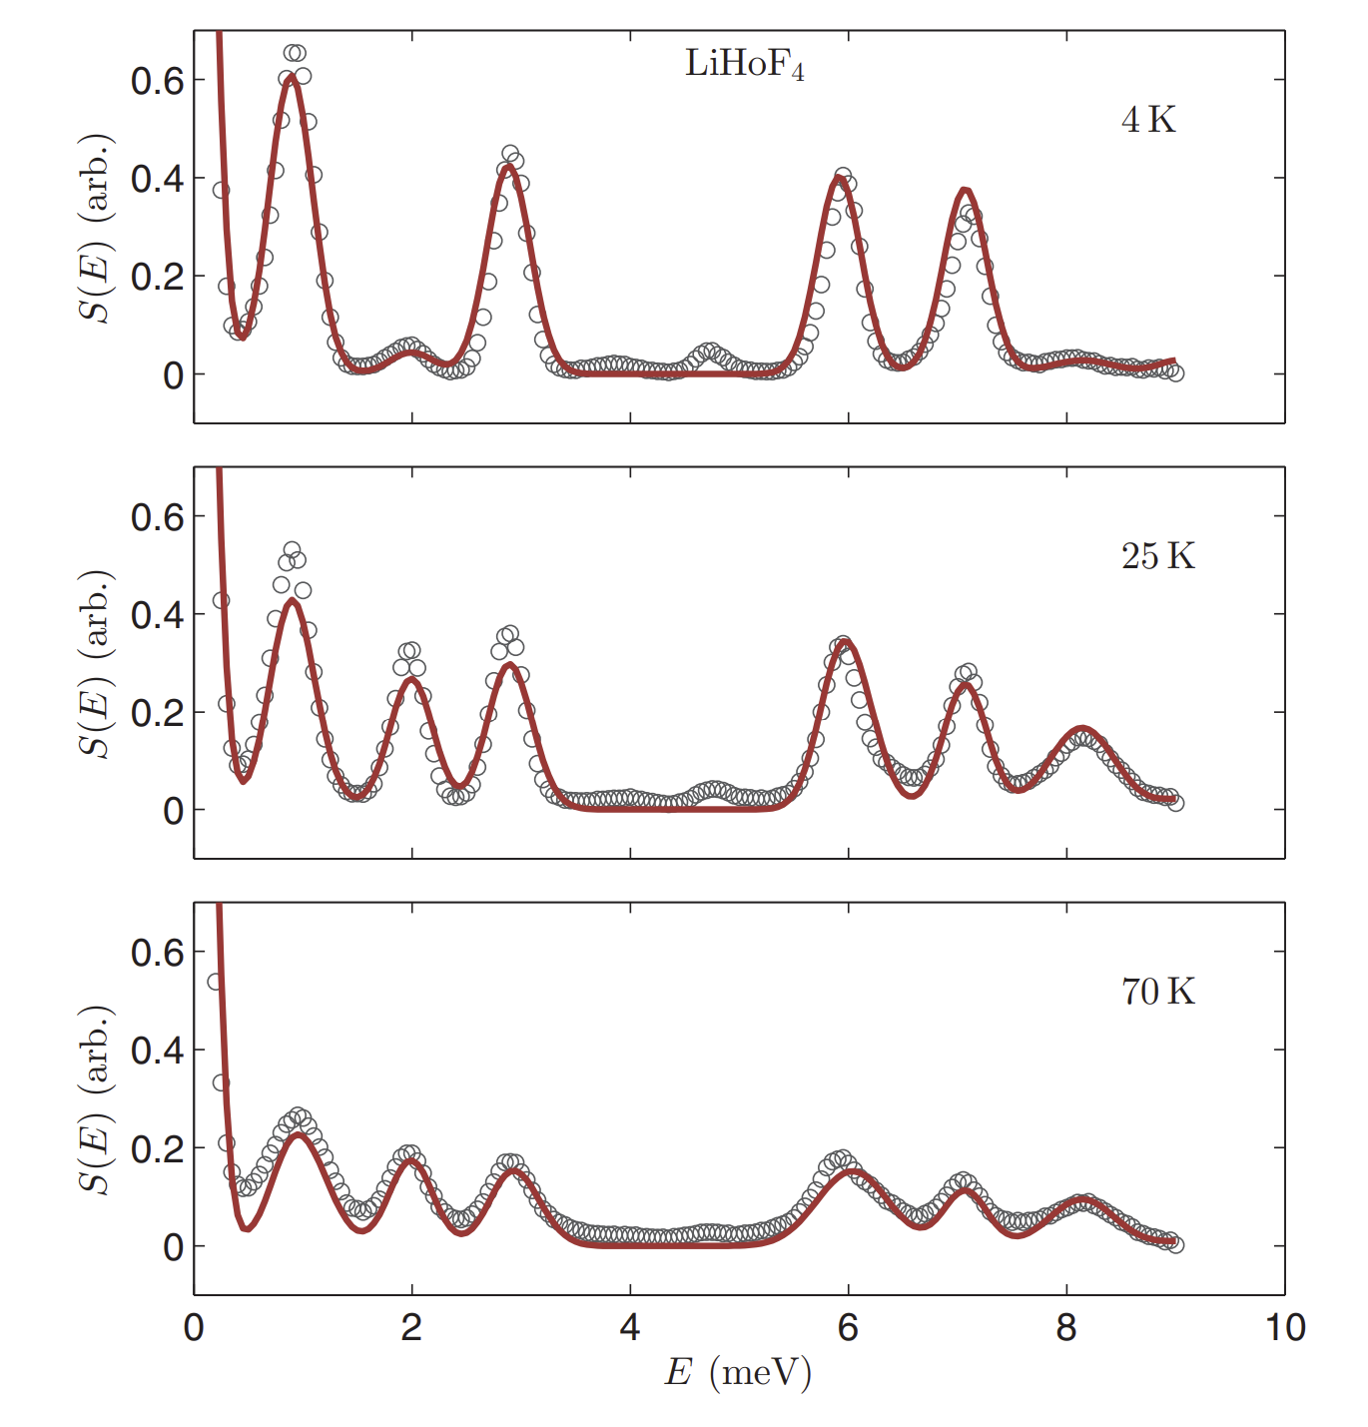
Figure 16 - Crystal field excitations of pure LiHoF4 below 10 meV

CEF modes below 60 meV (1 day)
At higher energies, we suggest to use C60, which have flat modes that cannot disperse. See Figure 17.
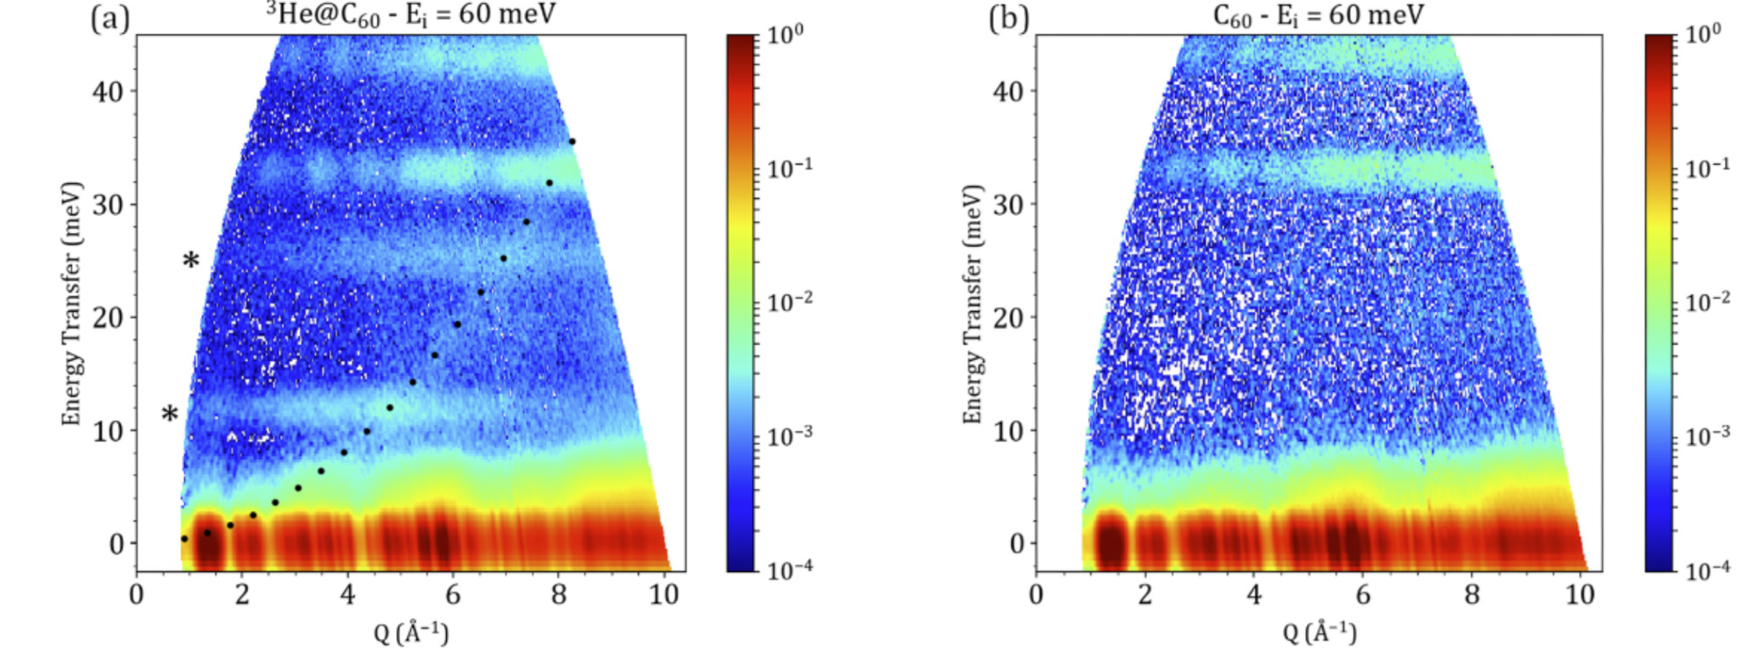
Figure 17 - Flat modes in C60

Flat modes at low energy: γ-picoline-N-oxide. High level requirement 2 (1 day)
Once the energy transfer has been confirmed to be correctly calculated, we can test the resolution on flat modes at very low energy transfer. For the low energy transfers, determining the energy resolution with high precision, on a sample free of line broadening, becomes crucial. We propose to useγ-picoline-N-oxide, as used on BATS: https://www.sciencedirect.com/science/article/pii/S0921452618307804
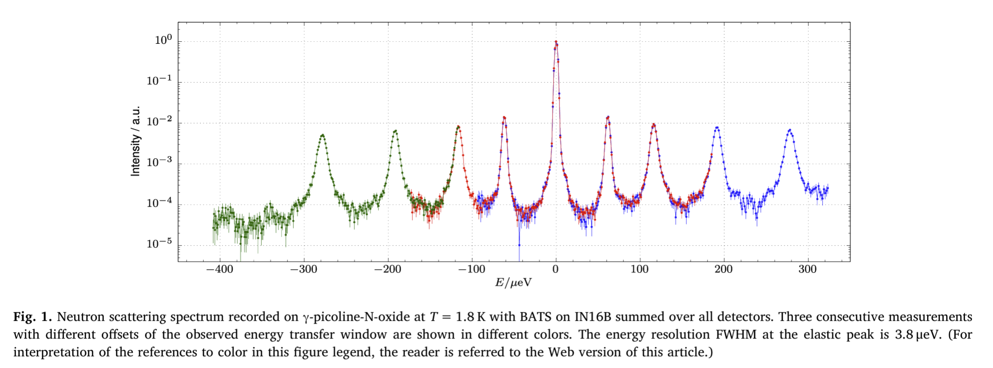
Figure 18 - Figure from the IN16 BATS commissioning paper
Using this compound, the linewidths are so far below the energy resolution minimum of BIFROST, which is 20 ueV, that we can effectively benchmark the performance near the elastic line using this compound – without worrying about line broadening obscuring the test results.

Dispersion: Well-known simple system (2 days)
For a check of the data reduction and verifying our understanding of the scattering angles and the instrument in general, we aim to perform a measurement of a well-known system, studied and confirmed on many spectrometers. At low energy resolution, there is no better system than MnF2, which has been studied on TAS, ToF and spin echo machines. Since this system has been a candidate for altermagnetism, it has even been studied recently, for instance on CAMEA, see Figure 19.
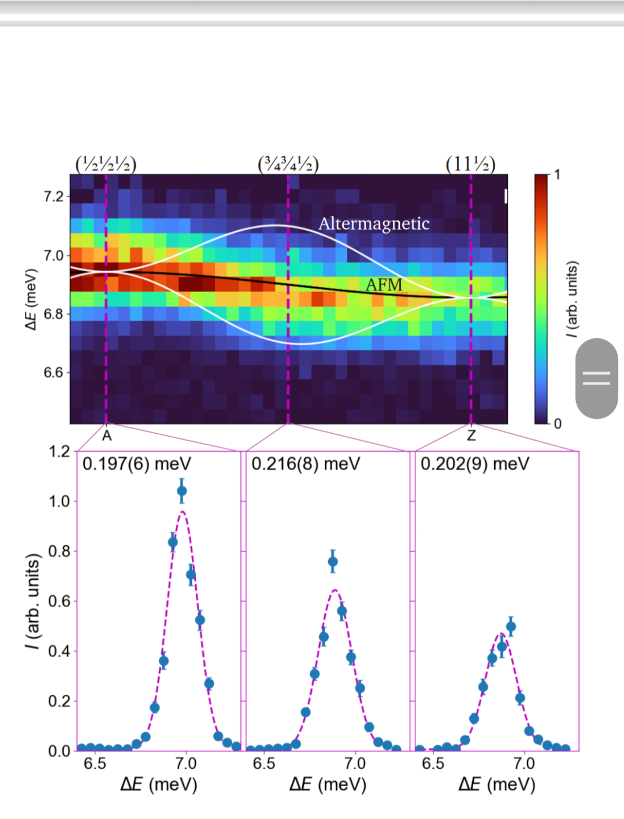
Figure 19 - CAMEA measurements of the dispersion relation of MnF₂ where mode splitting has been disproven down to the measurement limit
The aim of this measurement is to confirm the dispersion relation at low resolution, making sure that the instrument geometry producing S(Q, w) is well understood.

Intensity and normalization check ( 3 days)
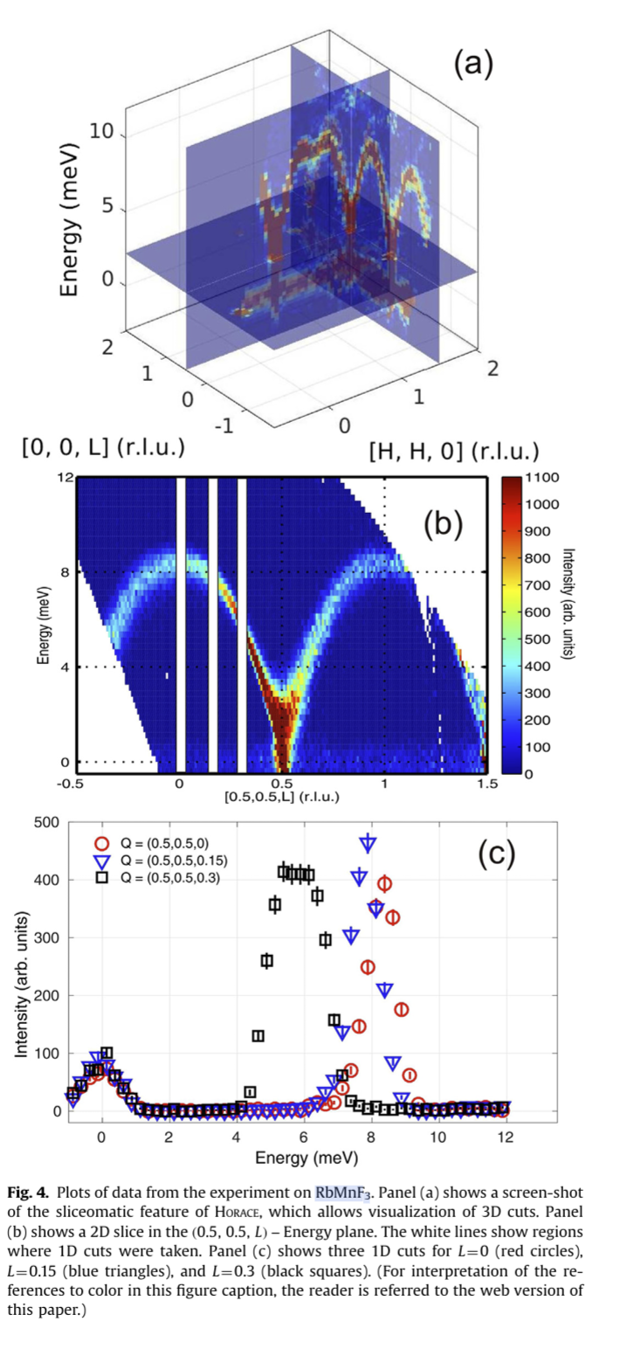
Figure 20 - Horace scans of RbMnF₃ from MERLIN
For double checking the normalization, we need to compare data with well understood spectrometers, preferably with direct geometry ToF-machnines, since they operate under constant Ei, and have very little material between sample and detector.
There are many candidates for a material, but one of them is RbMnF3, the system used in the HORACE publication:
https://www.sciencedirect.com/science/article/pii/S016890021630777X
There is a single mode below 10 meV, with well understood magnon mode intensity. Reproducing literature values of magnon intensity of RbMnF₃ and MnF₂, to within 15 % is a key goal of benchmarking.
For this particular goal, it is important to be cautious. Theoretically, the magnon mode intensities are extremely rarely modelled well to below 1 %. Very few spectrometers can be claimed to be calibrated on that level, due to irregularities in detector efficiency, aluminum windows and normalization errors.
This becomes almost paradoxical, as there are few gold standards for mode intensity around, for this very reason. The only option available is to find a system so well understood theoretically, that there can be no doubt about the neutron scattering cross section
The goal of benchmarking here is not to embark on a quest to set new standards in neutron spectroscopy. The goal is to obtain an understanding of the normalization limits of the instrument and verify existing data sets to a level of confidence good enough for first science. We can then progressively try to improve our understanding.

Dispersion: Well-known complex system (3 days)
When moving to more complex systems, we start approaching first science. Yet, we would like to start with a complex measurement that has already been made and is well understood. An excellent candidate for BIFROST would be looking at the spin dynamics in the square-lattice cupola system Ba(TiO)Cu₄(PO₄)₄, studied here: Spin dynamics in the square-lattice cupola system | Phys. Rev. B.
The measurements in that paper were done on IN5 and IN12, and the IN5 data has excellent resolution, which can be seen in Figure 21. Not only the mode positions and dispersions are well modelled, but also the intensities.
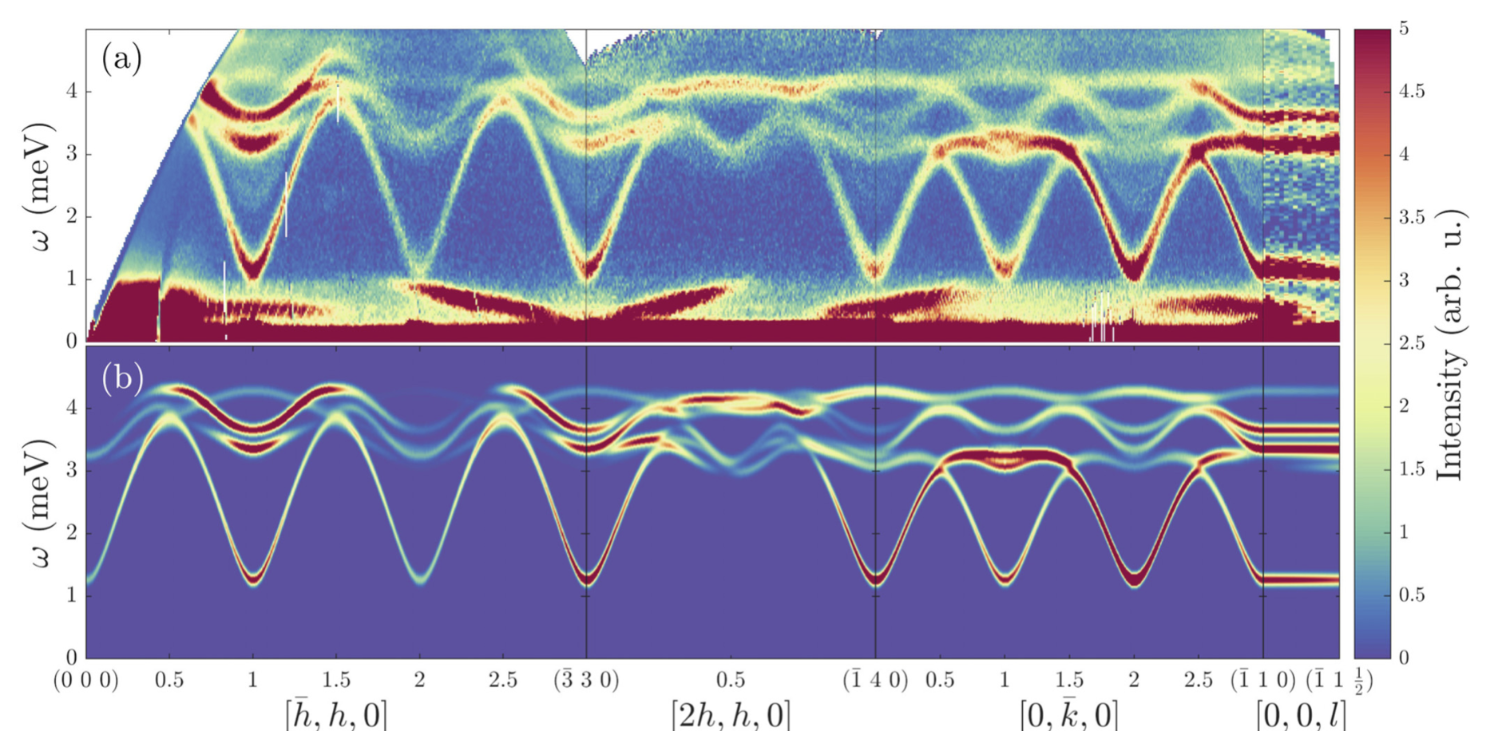
Figure 21 - Magnon modes below 5 meV as measured with high resolution on IN5
A good first measurement would be to look at the [-h, h, 0] direction, where ‘only’ 4 modes are seen. These are clearly separated and could be well resolved. A second measurement, venturing into early science, would be to focus on high-resolution mapping of the [2h, h, 0] direction, where even the resolving power of IN5 is challenged.

Initial schedule of hot commissioning activities
In the following, the draft schedule as per 3/6 2025 is assumed to hold.
Schedule after BoT:
- 12 weeks accelerator testing: Test equipment, measure Bragg peaks
- 4 weeks – 8 beam days: M1, PSC, FOCs and BW
14 week shutdown
14 weeks: 270 kW operation, 2 days pr week:
- Week 1-2: Sample spectrum, flight path calibration, divergence jaw characterization
- Week 2-4: Intial flux measurement, normalization measurements, attenuator tests
- Week 5-6: Golf foil measurements, Charge division tests
- Week 7-9: Be-filter calibration, tank scattering angle
- Week 10-11: Final energy calibration
- Week 12-14: Cross talk shielding, Secondary spectrometer normalization, sample environment tests
11 week shutdown
If nothing goes wrong, beamline ready for early science after 55 weeks.
Benchmarking experiments and/or early science:
16 weeks 570 kW, 2.5 day pr week:
- Week 1: Elastic line and flat modes below 10 and around 30 meV’
- Week 2: Low energy flat modes
- Week 3: Simple dispersion
- Week 4: Intensity and normalization validation
- Week 5: Verifying a complex dispersion

Resources
In terms of resources, it is assumed that the two instrument scientists, the IOE and 60 % of the IDS is available during the whole period. For the technical assistance, the shutdown period is included, as these are intense periods of analysis and tinkering.
For the 20 weeks commissioning period of the primary spectrometer, we need
- 50 % Chopper engineer
- 50 % Monitor detector scientist
- 50 % EC/DC NICOS and EFU assistance
- 20 % Motion control engineer
- 30 % Technician
For the 23 weeks secondary spectrometer commissioning period, we need
- 50 % Detector scientist (monitor and He-3)
- 50 % EC/DC NICOS and EFU assistance
- 50 % Motion control engineer
- 30 % Technician
For the benchmarking and early science, we need only the core team and external collaborators
Total duration of hot commissioning is about 1 year – depending on weekend work.
A normal working year in Sweden is around 45 working weeks (taking holidays, vacation etc into account), so we require
6 months of detector scientist (3-month monitor, 3-month He-3)
6 months ECDC – NICOS and EFU
3 months chopper engineer
3 months MCA engineer
7 months technician

Regular calibration procedure
Below follows a proposed regular calibration procedure. The estimate here is subject to change. We will monitor the instrument intensely in the first years, becoming more efficient later, as we learn where the weaknesses are.

In case of major problems with guide
- Repeat 3.6.7

Yearly
- Repeat 3.7.1
- Repeat 3.7.3

Biannualy
- Flux measurement – compare He-3 tube measurement, proton current and fission monitor count rate
- Primary flight path calibration
- T₀ calibration
- Repeat 3.7.2

Every cycle
- A4 calibration using powder peaks on
- Vanadium normalization

references
- NSS Guideline for Instrument Construction Projects – Integrated Testing (Cold Commissioning) and System Acceptance Review (Tollgate 5) (ESS-0177447)
- BIFROST Concepts of Operation (ESS-0135232)
- BIFROST System Requirements (ESS-0122343)
- BIFROST - System Design Description (ESS-1138675)
- H1 and H2 scenarios for the radiation shielding of BIFROST (ESS-1417912)
- BIFROST Guide Shielding Neutronics Simulations (ESS-2727570)
- BIFROST Cave neutronics - submitted (ESS-2495661)
- Integrated test plan for the BIFROST chopper system (ESS-5690504)
- Integrated test plan for the BIFROST beam collimation and attenuation system (ESS-5690168)
- Integrated test plan for the BIFROST sample and detector positioning system (ESS-5690169)
- Integrated test plan of the BIFROST detector system (ESS-5637422)

Document Revision history
Revision | Reason for and description of change | Author | Date
1 | First issue | Rasmus Toft-Petersen | 2025-06-04

