MIRACLES: STAP Spectroscopy report (May 2025 – October 2025)
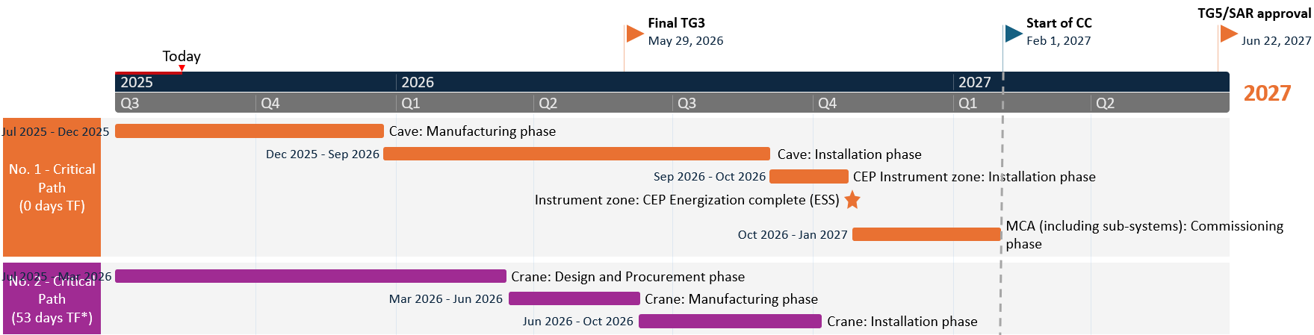
Benedetta Rosi, José Pereira, Félix J. Villacorta, on behalf of the MIRACLES team
Installed
- NBOA(2021)  - BBGOA (2024)  - In-bunker guide (2024)  - In-bunker guide supports (2024)  - BWI (2024)  - Control room (2024) | - D03 out-of-bunker guide supports (2024)  - Scattering vessel (2024)  - D03 out-of-bunker guide (2025)  - Shutter (2025)  - E02 out-of-bunker guides supports and guides (partially, 2025)  - FO chopper (2025)
Manufactured (FAT ongoing or approved) | Manufacturing
- PWD-PS chopper module  - Detectors  - Detectors electronics (front end)  - Vessel shielding  - Get-lost tube/Beam stop | - Analyzer  - Radial collimator  - Cave
Detailed design | Preliminary design / Specs
- Sample loading area equipment (hatch): sliding slab, sample flange, slit, stick holder) | - Infrastructure (utilities, electrical, …)  - Beam monitors  - Polarization coils  - Crane

In the following, a general update on the activities from ESS Bilbao and ESS groups related to MIRACLES during the second half of 2025 is reported.

Primary spectrometer

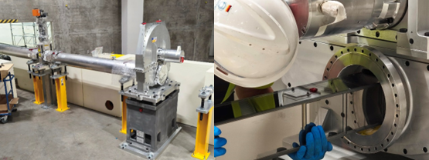
Guide system. During 2025 the installation of the out-of-bunker guides has progressed, and the first section has been completed and successfully integrated with the thermal shutter and frame overlap (FO) chopper in E02 (see Figure 2) at the end of June. During the same campaign, the installation of the second guide section (from the FO chopper to the focusing section) has started. A preliminary check for rigidity and positional stability from the manufacturer (Swiss Neutronics) have revealed an instability in the guides and FO chopper position. After discussion with the MIRACLES team, a working plan has been agreed and the completion of the installation of the second guide section is foreseen for November 2025, with subsequent repetition of stability tests.
Figure 1. Installation of the FO chopper and integration of the guide system.
Choppers. As highlighted in the previous section, the FO chopper has been installed and integrated in the guide system. The in-bunker PWD-PS chopper module was fabricated last year and passed most of the Factory Acceptance Tests (speed, balance, overspeed, vacuum, etc.). However, the leak rate tests still fail. Investigations and further tests with different Al gaskets have been carried out without success. The providers are still trying to solve the issue. A plan B is ongoing, with the use of rad-hard EPDM gaskets (Trelleborg). However, the delivery time is long (6 months, expected for December).

Secondary spectrometer
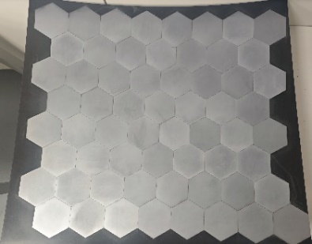
Analyser system. The mechanical assembly station for the analyser panels has been upgraded with the addition of two assembly units (in addition to the existing one) and with the installation of a dedicated lab for the crystal coating. Currently, three panels have been assembled with the hexagonal crystals in the central area (see Figure 2). The process of cutting the crystal at the panel edges is underway. In parallel, the assembly process for the other panels is carried out. The completion date is scheduled for Spring 2026.
The team has developed an integration, verification and validation plan for the analyser system that includes:
Figure 2. Analyzer panel with crystal glued in the central area.
- Verification of relevant dimensions
- Stability of the system under vacuum
Radial collimator. The radial collimator parts were manufactured. The final assembly is waiting for the second layer of Gd2O3 to be applied to the blades. This will be carried out in the dedicated coating lab. The final coating tasks will be carried out before the end of 2025.
Detectors. The MIRACLES detection system (detectors from LND, preamplifiers and digitizer from CAEN) has been delivered to ESS. A verification plan for the MIRACLES detection system is currently under development between the MIRACLES team and the Detector group at ESS.

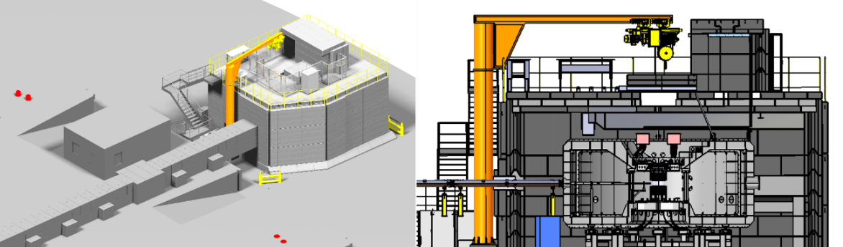
Experimental end station
Figure 3. Design of the experimental end station, including the instrument cave and crane.
Cave. The cave (including sliding slab) passed the SubTG3 review (CDR) this summer and it is in the manufacturing phase. The production of all the concrete blocks will take 6 months, and a pre-build is expected by Spring 2026. On the other hand, the electrical design of the slab will be tendered (including the safety components, like switches, fence, handrails and interfaces with PSS). A detailed design is expected for Q1-2026.
Crane. The crane is in the specifications phase. The technical specification document for the tender is under review by ESS (CTV, Call for Tender Verification review).
Infrastructure (utilities, electrical, etc.). MIRACLES is now part of the ESS Infrastructure Common Projects (agreement signed for Common Utilities Project and Common Electrical Project, and to be signed for the Common Motion Control Project). The integration of MIRACLES infrastructure has been started with the support of NSS Technical Group at ESS. In particular, the review of items including:
- Electrical routing
- Racks layout
- Feedthroughs
- Positions of vacuum pipes, gas lines, etc.
has been initialized. However, the planning has been currently paused due to prioritization of Tranche 1 instruments.
Sample environment. The MIRACLES team has started discussing with the ESS Sample Environment (SE) group the development of dedicated SE for low/high temperature control (CCR, cryofurnace). The requirements considered for the SE include:
- Background optimization
- Integration with polarization system
- Implementation of motorization (e.g. along z axis for the linear sample exchanger designed by ESS Bilbao)
Polarization analysis system
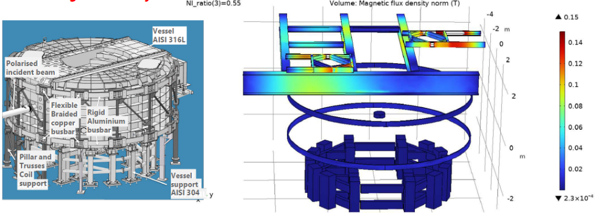
The preliminary design of the MIRACLES polarization analysis system has been issued from the Technical Project Group at ESS. The team has focused on the design of the two coils required to maintain polarization of the scattered beam inside the scattering vessel, as well as the design of the mechanical support structure for the coils (see Figure 4 below). The team has opted for a busbar coil design due to the better heat dissipation compared to classical cable coils. Simulations have been performed and have shown that the design can provide the required magnetic field uniformity below 5 ⋅ 10⁻⁴/cm.
Figure 4. Preliminary design of the polarization analysis coils and mechanical support.
Beam monitors
MIRACLES is part of the Common Beam Monitors Project. The instrument is expected to be equipped with 3 beam monitors (BMs), for which the following technologies are respectively foreseen:
- in-bunker BM at 8.8 m, after the PWD-PS chopper module (ionization chamber)
- BM at 55 m, after the FO chopper (ionization chamber/bGEM)
- BM at 162.2 m, before sample (multi-wire proportional counter).
An additional BM after the sample has been initially envisioned for e.g. absolute calibration. However, the only strategy that is currently foreseen for an after-sample BM is that of using e.g. a neutron camera in the sample area.

MIRACLES team: B. P. Rosi, J.E.M. Pereira, A. Conde, I. Aranda, I. Mazkiaran, E. Céspedes, O. González del Moral, R. Martínez, A. Zugazaga, A. Simelio, H.N. Bordallo, F. J. Villacorta

