MIRACLES: STAP Spectroscopy report (Oct 2025 – Apr 2026)
Benedetta Rosi, José Pereira, Félix J. Villacorta, on behalf of the MIRACLES team
Installed
- NBOA(2021)  - BBGOA (2024)  - In-bunker guide (2024)  - In-bunker guide supports (2024)  - BWI (2024)  - Control room (2024)  - D03 out-of-bunker guide supports (2024) | - Scattering vessel (2024)  - D03 out-of-bunker guide (2025)  - Shutter (2025)  - E02 out-of-bunker guides supports and guides (partially, 2025; to be installed again in 2026)  - FO chopper (2025)  - PWD-PS chopper module (2026)
Manufactured (FAT ongoing or approved) | Manufacturing
- Detectors  - Detectors electronics (front end)  - Vessel shielding  - Get-lost tube/Beam stop | - Analyzer  - Radial collimator  - Cave  - Sample loading area equipment: hatch (sliding slab), sample flange, slit, stick holder)  - Polarization coils
Detailed design | Preliminary design / Specs
- Crane | - Infrastructure (utilities, electrical, …)  - Beam monitors

Guide system: issues and action taken. As described in the previous report, during the installation of the out-of-bunker guides an instability of the E02 section (downstream after the FO chopper pit) has been encountered that would lead to excessive deviations in the guides positioning and alignment. After having discussed different possibilities, the final adopted strategy was to change the design of the guide supports to provide more stiffness to the guide section. The new design has been validated by simulations and discussed in collaboration between Swissneutronics, ESS Bilbao and ESS. The supports will be installed at the end of April, subsequently the guides housing will be placed on the new supports and the tests for stability and alignment will be repeated.
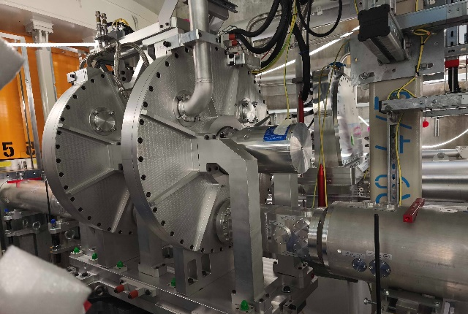
Installation of in-bunker chopper module. After the manufacturer (Aernnova) has found a solution to bring the leak rate of the in-bunker PWD-PS chopper module below the accepted value of something, the module has passed the final Factory Acceptance Test and has been installed in the bunker in January (the leak rate test has been repeated and successfully passed at ESS), Figure 1. The chopper module consists of 3 disks in 2 housings, and has been integrated with the corresponding in-bunker guide section (3 segments) by Swissneutronics.

Figure 1: PWD-PS chopper module after installation in the bunker
Analyser system. With three stations fully operative, the assembly of analyser panels is now rapidly advancing. Currently 8 out of 12 panels have been fully assembled. The completed panels have been successfully tested for vacuum stability. The delivery and installation are planned by June 2026.
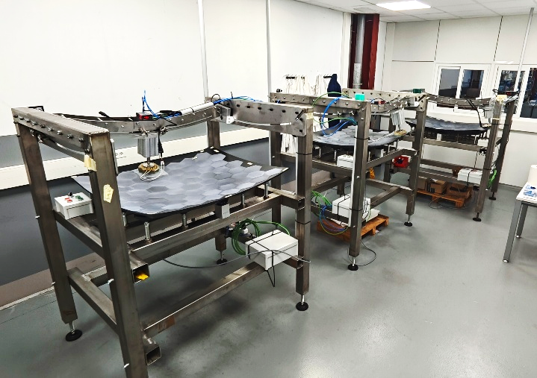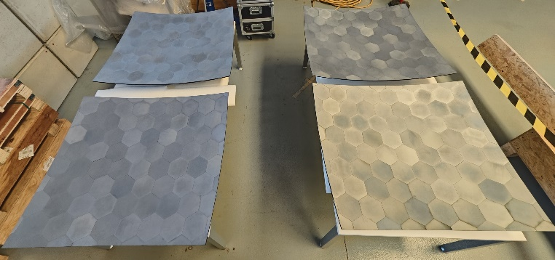
Figure 2: left, assembly stations. Right: fully assembled analyser panels.

Testing of detectors. Testing of the MIRACLES detection system (3He doublets, preamplifiers and front-end acquisition electronics, Figure 2a) has been carried out by the detector group at ESS. The tests have started in the end of 2025 and are currently ongoing. The system has been tested by using an Am/Be source to check parameters including position sensitivity and dynamic range (Figure 2b).
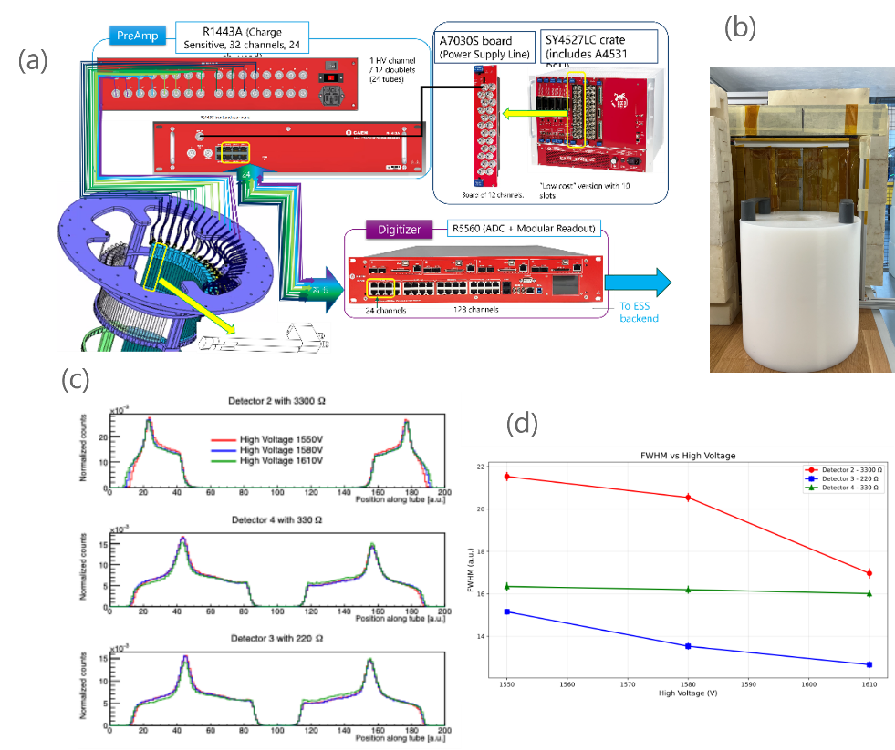
The 48 3He doublets (LND, active length for tube: 152.4 mm) have been provided by the company with a reported position sensitivity between 5 and 10 mm. The tests have been repeated by ESS detector group by using a Cd mask of width 1 mm. A position sensitivity of ~20 mm has been measured. After discussions between ESS, ESS Bilbao and the provider, the instrument team has decided to accept the discrepancy considering that this will not affect the instrument performances.
Another parameter that has been considered is the doublet dynamic range as a function of separating resistor (Figure 2c,d). The current setup consists of two resistor tubes (R_{tube} = 1.2 kΩ) separated by R_{gap} = 3.3 kΩ. The resistance seemed unnecessarily large to provide good separation between the tubes, and smaller separating resistances (330 Ω, 220 Ω) have been tested. The results seem to indicate that a good separation can be achieved even with resistances one order of magnitude smaller, while essentially keeping the same position sensitivity and gaining a larger dynamic range. Therefore, the team is considering substituting the separating resistance with a value of R_{gap} = 330 Ω. Tests are currently ongoing to determine position sensitivity at the edges of the tubes. Further tests to check stability under vacuum are planned in the next future.
Figure 2: a. MIRACLES detector system (only the top part is shown). b. setup for testing the detectors, with the Am/Be source positioned in front of the tubes when using a Cd mask with vertical slit. c. dynamic range as a function of separating resistor. d. variation of position sensitivity (FWHM) as a function of separating resistor and operating voltage.

Shielding
In-vessel shielding. The in-vessel shielding will be installed in the next months. The shielding consists of B4C and Cadmium slabs. Once the detectors will be installed, additional shielding will be inserted between the detectors and sample area.
Polyethylene shielding. A preliminary design has been made of the polyethylene (PE) shielding that is foreseen to be installed around the MIRACLES vessel (Figure 3). The design foresees the use of individually shaped PE blocks in combination with PE beads with some areas on the vessel roof and lateral surface. Efforts are made to speed the installation up and reduce the impact on the installation of the polarization coils and cave.
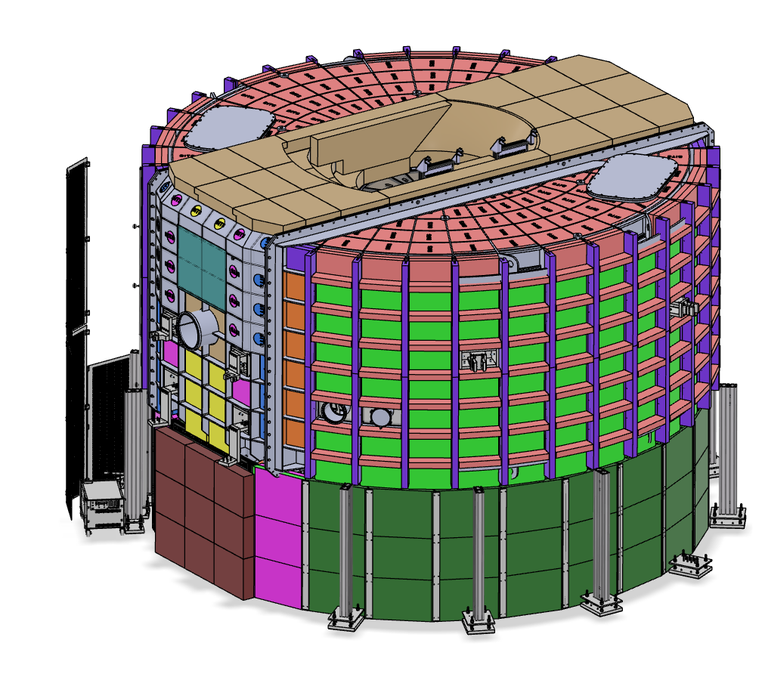
Experimental end station progress (cave, crane, utilities)
The cave is currently in the manufacturing phase. A pre-build at the provider’s premises is planned for June.
The mechanical design of the hatch has passed the SubTG3, along with some components beneath the hatch at the sample loading area (flanges, stick holder, slit).
The preliminary design of the crane has evolved and we are now securing the provider. It will have its SubTG3 in May.
With respect to the sample positioning, MIRACLES plans to have rotation and z-axis motions for hot commissioning (at least the rotation). We consider a good strategy to follow the standardization proposed by the ESS sample environment group. However, delays in the configuration of the specifications and provision leave other alternatives open.
Figure 3: preliminary design for the PE shielding around the MIRACLES vessel.
Infrastructure (utilities, electrical, etc.). The preliminary design review document for MIRACLES electrical design and utilities has been approved.
Polarization analysis.The polarization analysis coils are ready for installation; however, the action is currently paused due to the dependence on installation of PE shielding around the detector tank.
Beam monitors. The procurement of the in-bunker MIRACLES beam monitor (ionization chamber) has been approved. The team is discussing the possibility of testing the monitor performance by external beamtime in summer. The design of the other beam monitors is ongoing.
Data reduction. A first version of the data reduction routines for standard data reduction for MIRACLES has been implemented in Scipp. For this purpose, McStas simulations have been performed to obtain event mode like data. An analysis of the reduced S(q,ω) agrees with the initially used parameters for the McStas simulations. Different chopper settings have been probed to investigate possible operation modes and to obtain their characteristic parameters such as energy transfer range, resolution and flux.

MIRACLES team: B. P. Rosi, J.E.M. Pereira, A. Conde, C. Beck, I. Aranda, I. Mazkiaran, E. Céspedes, O. González del Moral, R. Martínez, A. Zugazaga, A. Simelio, H.N. Bordallo, F. J. Villacorta

