ICD-R Target Helium Cooling_RWH

 | Name | Title
Owner | Jens Harborn | Work unit leader - Target Cooling
Reviewer | Per Persson
Approver | Ulf Oden
Table of Contents
1. Introduction 3
2. INTERFACE agreement 3
2.1 Filter media cartridges waste 4
2.2 Liquid waste 4
References 4
List of Abbreviations 5
Document Revision history 5

Introduction
This document is referred to from document ICD RMH - Target Station [3] in accordance with [1].
Two types of filter units with radioactive particles and oil traces, and lubricants in liquid form is to be handled by the Radioactive Waste Handling System. Disposable filter units demensions and numbers/year and total amount of liquids/year is described as interfaces in this document.

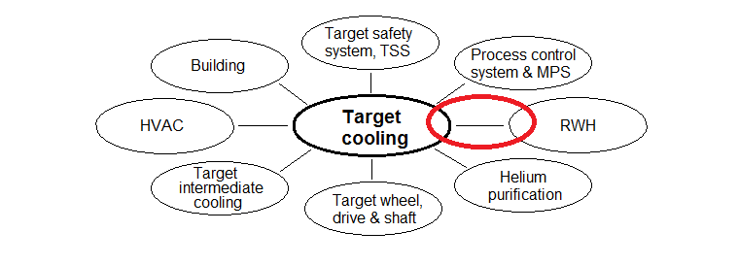
Figure 1 Interfaces included in this document marked in red

2. INTERFACE agreement
Description | Reference
Filter media cartridges waste dimensions and total amount per year of operation | Section 2.1
Liquid waste total amount per year of operation | Section 2.2

2.1 Filter media cartridges waste
ID | PCool-801 | Filter media waste
Requirement | Maximum 15 pcs of filter elements of ceramic material; ᴓ0.2m x 2.2m, and 200 pcs of filter elements of ceramic material; ᴓ0.1m x 1.2m needs to be handled as low radiation waste per 5000h of operation
Rationale/Reference | Proposal from a supplier using off disposable Coaleser filter elements for oil/particle capture from the cold helium stream and standard ceramic off filter elements for particle capture from the warm helium stream, refer to [2].  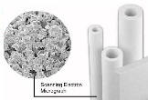  Standard ceramic filter Coaleser ceramic filter elements  elements

2.2 Liquid waste
ID | PCool-802 | Liquid waste
Requirement | Maximum 40 kg of oil/lubricants/cleaning agents per 5000h of operation needs to be handled as low radiation waste
Rationale/Reference | Oil/lubricants 25kg: External oil leakage according to proposal from Aerzener maschinenfabrik GmbH; two industrial blowers (GM11.2cz) in parallel and improved internal axis sealing foreseen compared to the standard machine.  Cleaning agents 15kg/year: General equipment cleaning and maintenance.

References
- ESS-0002917 Interface Management Plan
- ESS-0012527 SDD-sol. Target Helium Cooling
- ESS-0005742 ICD Radioactive Waste Handling Systems - Target Station

List of Abbreviations
Abbreviation | Definition

Document Revision history
Version | Reason for revision | Date
1.0 | New document (using new template) | 2015-04-16

