ICD-R PrC-Fluids supply&process(FS)

 | Name | Title
Owner | Jens Harborn | Work unit leader - Target Cooling
Reviewer | Olof Persson
Approver | Ulf Oden  Håkan Carlsson
Table of Contents
1. Introduction 3
2. Interface agreement 3
2.1. Target Helium Primary Cooling pressure control – Fluids supply & process systems 3
3. References 4
List of Abbreviations 4
Document Revision history 4

Introduction
This document is referred to from document ESS-0005826 ICD Fluid Systems - Target Systems [2] in accordance with [1].
Interfaces between Target helium cooling and Fluids supply & process systems (within Fluid systems, FS) is described in this document. Interface descriptions included in this document are marked red in figure 1 below.
Note that Target helium cooling consists of several sub systems, i.e. PCool, PrC, HeSto, HeRel and HeInj.
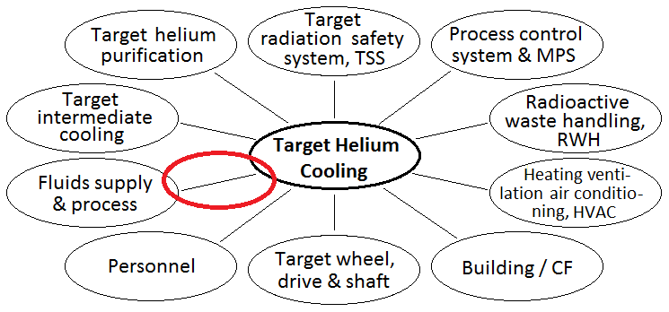
Figure 1. Interfaces included in this document marked in red

Interface agreement

Target Helium Primary Cooling pressure control – Fluids supply & process systems
ID | PCool-901 | Helium supply
Requirement | Pristine helium supply; purity at least 99.95%, flow range 0 – 60 g/s, total available amount without interruption and time delays 100kg, pipe connection DN25.
Rationale/Reference | Purity level to reach a pure enough helium atmosphere in the systems. Flow range upper value to limit the total time to fill the systems. Total available amount in e.g. a buffer to secure at least one complete evacuation and final filling without interruption and time delays.

ID | PCool-902 | Nitrogen supply
Requirement | Nitrogen supply; purity at least 99 %, flow range 0 – 200 g/s, total available amount without interruption and time delays 20kg, pipe connection DN25.
Rationale/Reference | Purity level to reach a pure enough nitrogen atmosphere in the systems. Flow range upper value to limit the total time to fill the systems. Total amount in e.g. a buffer to secure at least one complete evacuation and final filling.

References
- ESS-0002917 Interface Management Plan
- ESS-0005826 ICD Fluid Systems - Target Systems

Document Revision history
Version | Reason for revision | Date
1.0 | New document (using new template) | 2015-04-14

