ICD-R PCool-TSS

 | Name | Title
Owner | Jens Harborn | Work unit leader - Target Cooling
Reviewer | Mikael Olsson
Approver | Ulf Oden  Linda Coney
Table of Contents
1. Introduction 3
2. Interface agreement 4
2.1. Physical measurement points imposed on PCool by TSS 4
3. References 4
List of Abbreviations 5
Document Revision history 5

List of APPENDICES
N/A

Introduction
This document is referred to from the ICD-document Target Safety System - Target Systems [2] in accordance with [1].
Interfaces between Target cooling systems i.e. sub-system Target primary cooling (PCool) and Target Safety System (TSS) is described in this document. Interface descriptions included in this document are marked in red in figure 1 below and in red arrows, i.e. the flanges in figure 2 below.
For more information about Target helium cooling systems refer to [3] and [4].
Note: Signals are only physical process values, e.g. temperature and flow in measurement points. The measurement points are pipe parts for mounting of safety classified instruments. Both the instruments and the pipe parts are owned by TSS, red parts in figure 2.
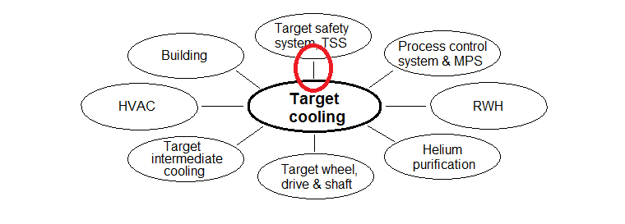
Figure 1. Interfaces included in this document marked red. Target cooling consists of several sub-systems and only sub system PCool has interfaces to TSS.

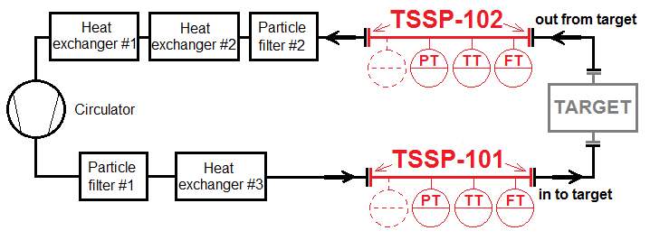
Figure 2 Flange interfaces marked with red arrows. RED=TSS parts, BLACK=PCool, GREY=Target. Refer to the interface requirement id-number (TSSP-) in the tables below.

Interface agreement

Physical connection points imposed on PCool by TSS
ID | TSSP-101 | Pipe flanges for TSS instruments, INLET to target
Requirement | 2 pieces of aligned pipe flanges in stainless steel* DN250, PN16, max temp 150°C, operational pressure 1.00 MPa, Flow rate max 3.0 kg/s. Maximum leakage rate 10mg/h. Distance between flanges sealing surfaces 1.000m.
Rationale/Reference | Connections for pipe part with safety classified instruments owned by TSS

ID | TSSP-102 | Pipe flanges for TSS instruments, OUTLET from target
Requirement | 2 pieces of aligned pipe flanges in stainless steel* DN300, PN16, max temp 300°C, operational pressure 1.00 MPa, Flow rate max 3.0 kg/s. Maximum leakage rate 10mg/h. Distance between flanges sealing surfaces 1.000m.
Rationale/Reference | Connections for pipe part with safety classified instruments owned by TSS

(*) Steel quality normal stainless austenitic; general requirement for all pipe parts and fittings

References
- ESS-0002917 Interface Management Plan
- ICD Target Safety System - Target Systems
- ESS-0012524 SDD-req. Requirements and functions Target Cooling
- ESS-0012527 SDD-sol. Solutions and layout Target Cooling

List of Abbreviations
Abbreviation | Definition

Document Revision history
Version | Reason for revision | Date
1.0 | New document (using new template) | 2015-04-14

