ICD PCool_Target

 | Name | Title
Owner | Jens Harborn | Work unit leader - Target Cooling
Reviewer | Kristoffer Sjögreen | Work unit leader - Target Wheel, drive and shaft
Approver | Ulf oden
Table of Contents
1. Introduction 3
2. INTERFACE agreement 3
2.1 Signal interfaces 4
2.2 Physical connection interfaces 4
2.3 Requirements put on target wheel 4
2.4 General process values and parameters 5
References 6
List of Abbreviations 7
Document Revision history 7

Introduction
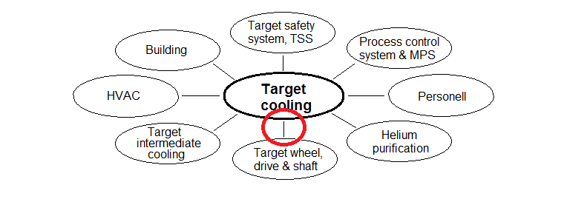
Figure 1. Interfaces included in this document marked in red

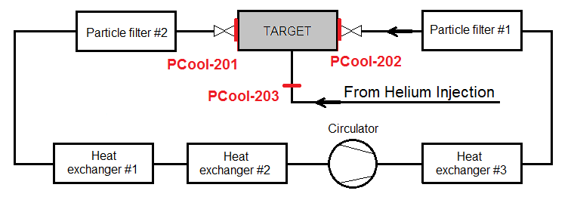
Figure 2. Flange interfaces id numbers and locations

2. INTERFACE agreement
Description | Reference
Signal interfaces  Note that the signals does not go directly between the two systems but via the Process Control system | Section 2.1
Physical connection interfaces | Section 2.2
Requirements put on target wheel | Section 2.3
General process values and parameters | Section 2.4
Cooling media purity requirements (particles < 5 µm, chemical and radiological purity) | ESS-0030664

2.1 Signal interfaces
ID | PCool-200 | Cooling power order
Requirement | An order signal from Target wheel to PCool to set a fixed cooling helium flow
Rationale/Reference | When e.g. the proton beam it shut off an increased cooling may be needed to remove the decay heat from the tungsten blocks

Physical connection interfaces
ID | PCool-201 | Pipe flange with flow to target
Requirement | Stainless steel* DN200, PN16, max temp 150°C**, operational pressure 1.00 MPa, Flow rate max 3.0 kg/s. Maximum leakage rate 10mg/h***.
Rationale/Reference | To fulfil basic functions

ID | PCool-202 | Pipe flange with flow from target
Requirement | Stainless steel* DN250, PN16, max temp 250°C**, operational pressure 1.00 MPa. Maximum leakage rate 10mg/h***.
Rationale/Reference | To fulfil basic functions

ID | PCool-203 | Pipe flange with seal flow to/from target
Requirement | Stainless steel* DN20, PN16, max temp 50°C, operational pressure 1.00 MPa. Maximum leakage rate 5mg/h***.
Rationale/Reference | To fulfil basic functions.

(*) Steel quality normal stainless austenitic; general requirement for all pipe parts and fittings
(**) To secure tightness even if abnormal situation
(***) To comply with the over-all maximum leakage rate for Target cooling systems [2]

Requirements put on target wheel
ID | PCool-204 | Maximum amount of particles formed
Requirement | Maximum amount of particles formed during 5000h of normal operation is 3.5kg
Rationale/Reference | To put an upper limit for the total amount of particles to be handled by the filters

ID | PCool-205 | Maximum pressure drop over Target
Requirement | Total pressure drop from target inlet flange to target outlet flange shall be maximum 90 kPa at nominal helium flow of 3kg/s and 40 °C inlet to target
Rationale/Reference | To put an upper limit of 150 kPa; 90(target wheel and shaft) + 60(PCool circuit) for the circulators to achieve

2.4 General process values and parameters
ID | Wheel-200 | Heat removal power
Requirement | Continuous heat removal of minimum 3.0 MW
Rationale/Reference | Based on top level target design decision and proton beam power decision. Machine safety, basic function.

ID | Wheel-201 | Cooling media
Requirement | Helium as cooling media
Rationale/Reference | Based on ESS top level decision, according to TDR page 225

ID | Wheel-202 | Cooling media maximum normal flow
Requirement | Helium maximum normal flow rate is 3.0 kg/s
Rationale/Reference | Based on reliability and costs, limited creep and thermal loads on systems, including thermal dilatation of the Target Wheel during operation; if lower flow the outlet temperature will be higher or the inlet temperature must be lower to fulfil requirement Wheel-200, also refer to requirement Wheel-203.

ID | Wheel-203 | Cooling media temperature values
Requirement | Lowest allowed temperature of helium in to target 20°C. Maximum temperature of helium in to target 55°C. Maximum temperature of helium out from the target 250°C.
Rationale/Reference | Based on ESS top level decision according to TDR page 225. Basic functions. Above stated limits the inlet temperature to not lower than 20°C but lowest possible is limited by the cooling water temperature in system Target Intermediate cooling. The requirement maximum temperature of helium out from the target is limiting the helium flow not below approximately 3.0 kg/s at full proton beam power.

ID | Wheel-204 | Maximum operational pressure
Requirement | Maximum allowed operational pressure 1.1MPa (11 bar)
Rationale/Reference | Based on engineering judgment by the target division [1], [3]. Basic functions, cost, safety.

ID | Wheel-205 | Minimum operational pressure
Requirement | Minimum operational pressure 0.7 MPa (7 bar)
Rationale/Reference | Based on engineering judgment by the target division [1]. Basic functions, cost.

ID | Wheel-206 | Pipe connections adapted for plug removal
Requirement | The pipe connections to / from the target wheel shall have pipe parts to be disassembled to enable target plug removal
Rationale/Reference | (discussed at the interface meeting Francois, Ulf, Kristoffer 14-11-04)

ID | Wheel-207 | Seal gas mass flow
Requirement | Seal buffer gas mass flow shall be in the range of 5 – 100 mg/s
Rationale/Reference | Depends on the final target rotational seal solution. The pressure in the seal gas pipe needs to be adopted for a certain flow.

ID | Wheel-208 | Seal gas maximum temperature
Requirement | Seal buffer gas temperature shall be maximum 50 °C
Rationale/Reference | Depends on the final target rotational seal solution

ID | Wheel-209 | Concentration of particulates
Requirement | Cooling media maximum concentration of particulates >= 5 µm shall be 1 ppb
Rationale/Reference | To limit the erosion effects on the target

References
- TDR (ESS Technical Design Report)
- ESS-0012524 SDD-req. Target Helium Cooling
- ESS-0012362 Decision basis for the pressure in the Target Helium Cooling System

List of Abbreviations
Abbreviation | Definition

Document Revision history
Version | Reason for revision | Date
1.0 | New document (using new template) | 2015-04-16

