ICD-R PCool_Target Intermediate Cooling

 | Name | Title
Owner | Jens Harborn | Work unit leader - Target Cooling
Reviewer | Allan Lundgren
Approver | Ulf Oden  Håkan Carlsson
Table of Contents
1. Introduction 3
2. INTERFACE agreement 4
2.1 Signal interfaces 4
2.2 Physical connection interfaces, water pipe flanges 5
References 6
List of Abbreviations 7
Document Revision history 7

Introduction
This document is referred to from document ESS-0005826 ICD Fluid Systems - Target Systems [2] in accordance with [1].
Three heat exchangers are included in system 1010. A temperature sensor and 3 water circulation pumps are included in Target Intermediate cooling system thus signals and water flanges are interfaces described.

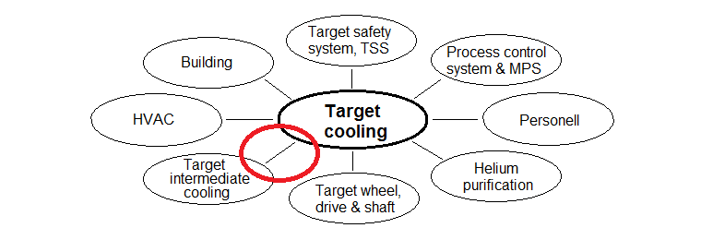
Figure 1 Interfaces included in this document marked in red

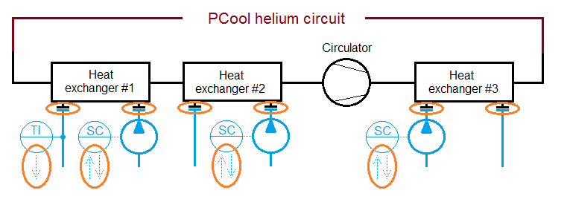
Figure 2 Heat exchangers secondary side flanges interfaces and signal interfaces.
Red= interfaces, Black = 1010, Blue = Intermediate cooling

2. INTERFACE agreement
Description | Reference
Signal interfaces  Note that the signals does not go directly between the two systems but via the Process Control system | Section 2.1
Physical connection interfaces | Section 2.2

2.1 Signal interfaces
ID | 1010-400 | Intermediate systems status
Requirement | A status signal (ready for operation) from Target Intermediate cooling system to Target helium cooling systems
Rationale/Reference | This signal is needed for Target helium cooling systems to secure that the Target Intermediate cooling system is ready to receive the cooling power, and for early alert in case of failure

ID | 1010-401 | Temperature in the return water
Requirement | Process value; temperature in the return water from heat exchanger W01
Rationale/Reference | To fulfil basic functions

ID | 1010-402 | Water flow control set point W001
Requirement | Water flow control set point through heat exchanger W01
Rationale/Reference | To fulfil basic functions

ID | 1010-403 | Water flow control set point, W002
Requirement | Water flow control set point through heat exchanger W02
Rationale/Reference | To fulfil basic functions

ID | 1010-404 | Water flow control set point, W003
Requirement | Water flow control set point through heat exchanger W03
Rationale/Reference | To fulfil basic functions

Physical connection interfaces, water pipe flanges
ID | 1010-451 | Pipe flange water inlet W001
Requirement | Inlet 55±2°C, max 2.5 MPa*, Max normal flow 10 kg/s, Flange; Steel quality normal stainless austenitic, DN80, PN32
Rationale/Reference | To fulfil basic functions

ID | 1010-452 | Pipe flange water outlet W001
Requirement | Outlet max 120°C, max 0.2MPa, Max normal flow 10 kg/s, Flange; Steel quality normal stainless austenitic, DN80, PN16
Rationale/Reference | To fulfil basic functions

ID | 1010-453 | Pipe flange water inlet W002
Requirement | Inlet 55±2°C, max 0.2MPa. Max normal flow 7 kg/s, Flange; Steel quality normal stainless austenitic, DN80, PN16
Rationale/Reference | To fulfil basic functions

ID | 1010-454 | Pipe flange water outlet W002
Requirement | Outlet max 120°C, max 0.2MPa, Max normal flow 7 kg/s, Flange; Steel quality normal stainless austenitic, DN80, PN16
Rationale/Reference | To fulfil basic functions

ID | 1010-455 | Pipe flange water inlet W003
Requirement | Inlet 35±2°C, max 0.2MPa. Max normal flow 5 kg/s, Flange, Steel quality normal stainless austenitic, DN80, PN16
Rationale/Reference | To fulfil basic functions

ID | 1010-456 | Pipe flange water outlet W003
Requirement | Outlet max 120°C**, max 0.2MPa, Max normal flow 5 kg/s, Flange; Steel quality normal stainless austenitic, DN80, PN16
Rationale/Reference | To fulfil basic functions

ID | 1010-457 | Heat power normal maximum W001
Requirement | Transferred normal maximum heat power 1500kW
Rationale/Reference | To fulfil basic functions

ID | 1010-458 | Heat power normal maximum W002
Requirement | Transferred normal maximum heat power 1000kW
Rationale/Reference | To fulfil basic functions0

ID | 1010-459 | Heat power normal maximum W003
Requirement | Transferred normal maximum heat power 750kW
Rationale/Reference | To fulfil basic functions

ID | 1046-100 | Heat exchangers barrier resistance to tritium diffusion
Requirement | The heat exchangers barrier, between primary and secondary side, resistance to limit the diffusion of tritium to maximum XXX mol/m2*s
Rationale/Reference | Requirement for allowance to discharge water from the target intermediate water cooling to the city sewage system, and internal ESS requirement that this water shall be clean enough to discharge to the city sewage system at least twice/year not exceeding the total limit for ESS by a certain percentage.  Since tritium is present in Target Primary cooling loop, a certain diffusion flux of tritium will pass the barrier in the heat exchangers to the water side. With a 0.5mm thick barrier, the flux is 1.0E-13 mol/m2*s [5], and resulting amount tritium after one year of operation is ≈1.7 mg/y with a radiation of 413 GBq/m3.

(*) If heat exchanger 1 is configured as concurrent the inlet water will meet the surface at up to 250°C.
(**) During normal operation the temperatures are below 100°C.

References
[1] ESS-0002917 Interface Management Plan
[2] ESS-0012524 SDD-req. Target Helium Cooling
[3] ESS-0012527 SDD-sol. Target Helium Cooling
[4] TDR (Technical Design Report)
[5] ESS-0054291; One dimensional permeation of tritium through a thin stainless steel plate. Y. Lee, March 29, 2016

List of Abbreviations
Abbreviation | Definition

Document Revision history
Version | Reason for revision | Date
1.0 | New document (using new template) | 2015-04-16

