Interface TargetCooling_Building

 | Name | Title
Owner | Jens Harborn | Work unit leader - Target Cooling
Reviewer | Håkan Carlsson
Approver | Ulf Oden  Fredrik Bergstedt
Table of Contents
1. Introduction 3
2. Interface agreement 3
2.1. Target Cooling – CF 3
2.2. Electric power and lighting interface requirements imposed on CF by Target cooling systems 4
2.3. Building related interface requirements imposed on CF by Target cooling systems 4
3. References 7
List of Abbreviations 7
Document Revision history 7

Introduction
This document is referred to from document ESS-0005745 Site Infrastructure and Target Station Interface Control Document [2] in accordance with [1].
Interfaces between Target cooling and the Conventional facilities (CF) is described in this document. Interface descriptions included in this document are marked red in figure 1 below, CF parts included are Site infrastructure such as electric power & lighting, and Building such as space requirements, doors/openings, wall/floor openings for process pipes/cables and physical support structures incl. weight load requirements.
Note that Target cooling consists of several sub systems, i.e. PCool, PrC, HeSto, HeRel and HeInj.
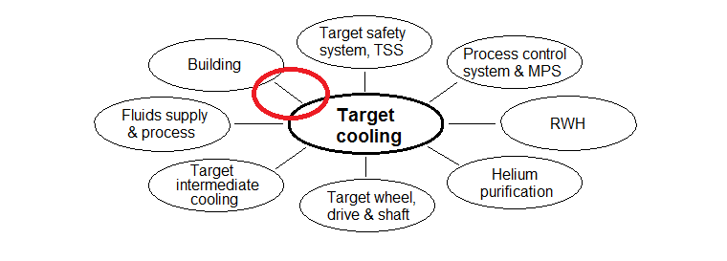
Figure 1. Interfaces included in this document marked in red

Interface agreement

Target Cooling – CF
Reference ID | Description | Value or Reference
 | Electric power, Illuminance, back-up power, signal and control system interfaces between Target cooling and CF | Section 2.2
 | Building Interfaces between Target cooling and CF | Section 2.3

Electric power and lighting interface requirements imposed on CF by Target cooling systems
ID | PCool-551 | Electric power; Switchgear
Requirement | Total installed power 600kW.
Rationale/Reference | Main circulators has a power demand of 300-550kW at maximum flow depending on the total pressure drop. A number of smaller motors has 1.5 – 3 kW each.

ID | PCool-552 | Grounding
Requirement | Protective earth connections, total number and capacity according to [8]
Rationale/Reference

ID | PCool-553 | Electric power; Sockets
Requirement | Total power 10kW
Rationale/Reference | Sockets for tools during e.g. maintenance.

ID | PCool-554 | Lighting illuminance
Requirement | Illuminance 200-500 lux in all open spaces
Rationale/Reference | Normal office illuminance is 320-500 lux

ID | PCool-155 | Back-up power capacity
Requirement | Back-up power system to control system parts; 3kW during 5 minutes
Rationale/Reference | To enable full data access and recording in case of power loss

Building related interface requirements imposed on CF by Target cooling systems
Room numbers in the tables below according to figures 2 and 3. [7] describes wall and floor penetrations in detail.
ID | PCool-501 | Space requirements room 2, level 110
Requirement | Additional free space in room 2, level 110 approximately 50m2 during installation
Rationale/Reference | Area marked bright yellow in figure 1 below.

ID | PCool-502 | Space requirements room 4, level 110
Requirement | Additional free space in room 4 approximately 50m2 during installation
Rationale/Reference | Area marked bright yellow in figure 1 below.

ID | PCool-503 | Roof hatch size
Requirement | Opening for big equipment intake between room 2 and 5
Rationale/Reference | Refer to [6] and [7]. Opening marked bright yellow in figure 1 below.

ID | PCool-504 | Door size and location
Requirement | Between rooms 2 and 4 level 110; Door size, location and orientation, i.e. opening outwards/inwards
Rationale/Reference | Refer to [6] and [7].

ID | PCool-505 | Door size and location
Requirement | Between rooms 2 and 6 level 110; Door size, location and orientation, i.e. opening outwards/inwards
Rationale/Reference | Refer to [6] and [7]

ID | PCool-506 | Space requirements, room 2 level 100
Requirement | Additional free space in room 2, level 100 approximately 50m2 during installation
Rationale/Reference | Area marked bright yellow in figure 2 below, also refer to [5].

ID | PCool-507 | Weight load for main circulator, room 2 level 110
Requirement | Weight load is maximum 25 tonnes concentrated to an area of minimum 2 x 5 m
Rationale/Reference | Refer to [7]. Final weight load distribution will be specified in the end of 2016.

ID | PCool-509 | Floor openings for pipes
Requirement | Floor openings for process pipes between level 110 and level 100, room 2. Dimensions and positions according to [7].
Rationale/Reference

ID | PCool-510 | Wall and floor openings for process pipes and electric installations
Requirement | Wall and floor openings for process pipes dimensions and positions according to [7].
Rationale/Reference | File [7] is a complete 3D-model for the whole Target station building used by CF. It is updated once a week with information from planned installations.

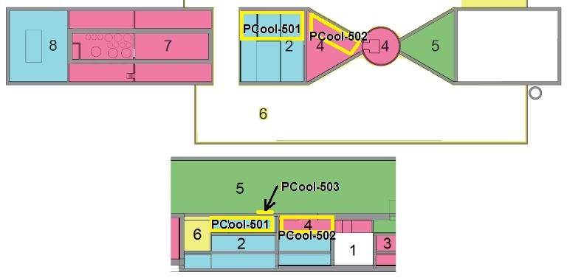
Figure 2 Target cooling rooms overview in the target station. Top: aerial view showing level 110. Bottom: side view (From TDR, page 156).

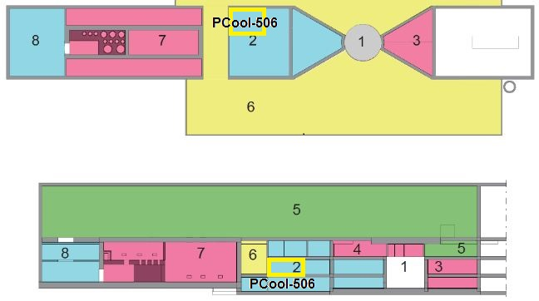
Figure 3 Target cooling rooms overview in the target station. Top: aerial view showing level 100, same as e.g. floor level of room [6]. Bottom: side view. (From TDR, page 153).

References
- ESS-0002917 Interface Management Plan
- ESS-0005745 Site Infrastructure and Target Station Interface Control Document
- ESS-0012524 SDD-req. Requirements and functions Target Cooling
- ESS-0012527 SDD-sol. Solutions and layout Target Cooling
- ESS-0001479 High bay space allocations, target station floor load ratings
- ESS-0011043 Target Station Logistics
- ESS-0026363 Building and installation 3D-model (NAVIS FILE)
- ESS-0017984 Grounding system requirements specification, standards

List of Abbreviations
Abbreviation | Definition

Document Revision history
Version | Reason for revision | Date
1.0 | New document (using new template) | 2015-04-14

