ICD-R TargetCooling_ProcessControl-MPS
(ESS-0019347)

 | Name | Title
Owner | Jens Harborn | Work Unit leader Target helium cooling systems
Reviewer | Linda Coney  Mikael Olsson
Approver | Ulf Oden
Table of Contents
1. Introduction 3
2. Interface agreement 3
2.1. Target Cooling – ICS 3
3. References 4
List of Abbreviations 4
Document Revision history 4

List of APPENDICES
N/A

Introduction
This document is referred to from document ESS-0005738 Integrated control system - Target Systems [2] in accordance with [1].
Interfaces between Target helium cooling systems and the Process control/MPS is described in this document. There are no interface with PSS. Interface descriptions included in this document are marked red in figure 1 below.
Target helium cooling systems consists of several sub systems, i.e. Target preliminary cooling circuit (PCool), Pressure control of PCool (PrC), Helium Storage (HeSto), Helium Relief (HeRel) and Helium Injection (HeInj).
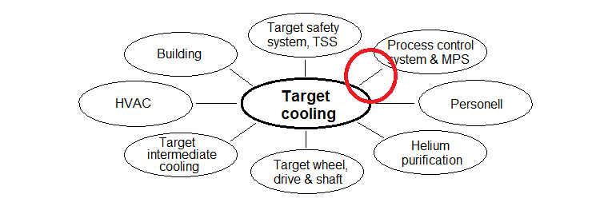
Interfaces included in this document marked in red

Interface agreement

Object signal interfaces summary Target Cooling – Process control
Each line in Appendix 1 represents a signal or a control object with defined signal exchange between Target cooling and Process control/MPS. I.e. process values shall be transmitted to the central process monitoring system together with alarm signals if applicable. Also configuration signals and order signals to be exchanged are defined.
Reference ID | Description | Value or Reference
N/A | Object signal interfaces | Appendix 1

Functional interfaces Target Cooling – Process control
Control objects with more complex functions is also included in Appendix 1. This kind of objects has the functionality defined since it is standard object types, e.g. a controller. Also configuration signals and order signals to be exchanged are defined in the same way as for simple objects.
The table below defines a general interface requirement imposed on Target helium cooling system by MPS.
ID | MPS-201 | Machine protection process values
Requirement | A set of machine protection process values defined in Appendix 1 shall be available for the MPS system. Included signal are marked “MPS”, column “Description” in Appendix 1.
Rationale/Reference | To enable functions to be executed by MPS, e.g. action logic that uses helium temperature value out from target AND pressure value out from target to perform a certain machine protective action. Proposed signals are marked MPS:xx, exactly which signals defined in Appendix 1 to be included in this requirement is to be defined by MPS! E.g. MPS:HighHigh alarm.

The tables below defines Functional interface requirements that are not covered by Appendix 1.
ID | PCool-301 | GUI main process picture
Requirement | The main graphical user interface for Target Cooling shall include all surrounding systems represented in a simplified way. Systems to be included: PCool, PrC, HeSto, HeRel, HeInj, Pristine Helium and Helium purification.
Rationale/Reference | To fulfil reliability-, ergonomics- and basic functions.

ID | PCool-302 | GUI detailed process pictures
Requirement | When selecting a sub system in the main process picture for Target Cooling a more detailed process picture of the sub system shall be shown on top of the main picture for easy access to both pictures
Rationale/Reference | To fulfil reliability-, ergonomics- and basic functions

References
- ESS-0002917 Interface Management Plan
- ESS-0005738 Integrated control system - Target Systems

List of Abbreviations
Abbreviation | Definition
TSS | Target Safety System
MPS | Machine Protection System
PSS | Personal Safety System

Document Revision history
Version | Reason for revision | Date
1.0 | New document (using new template) | 2015-03-26

