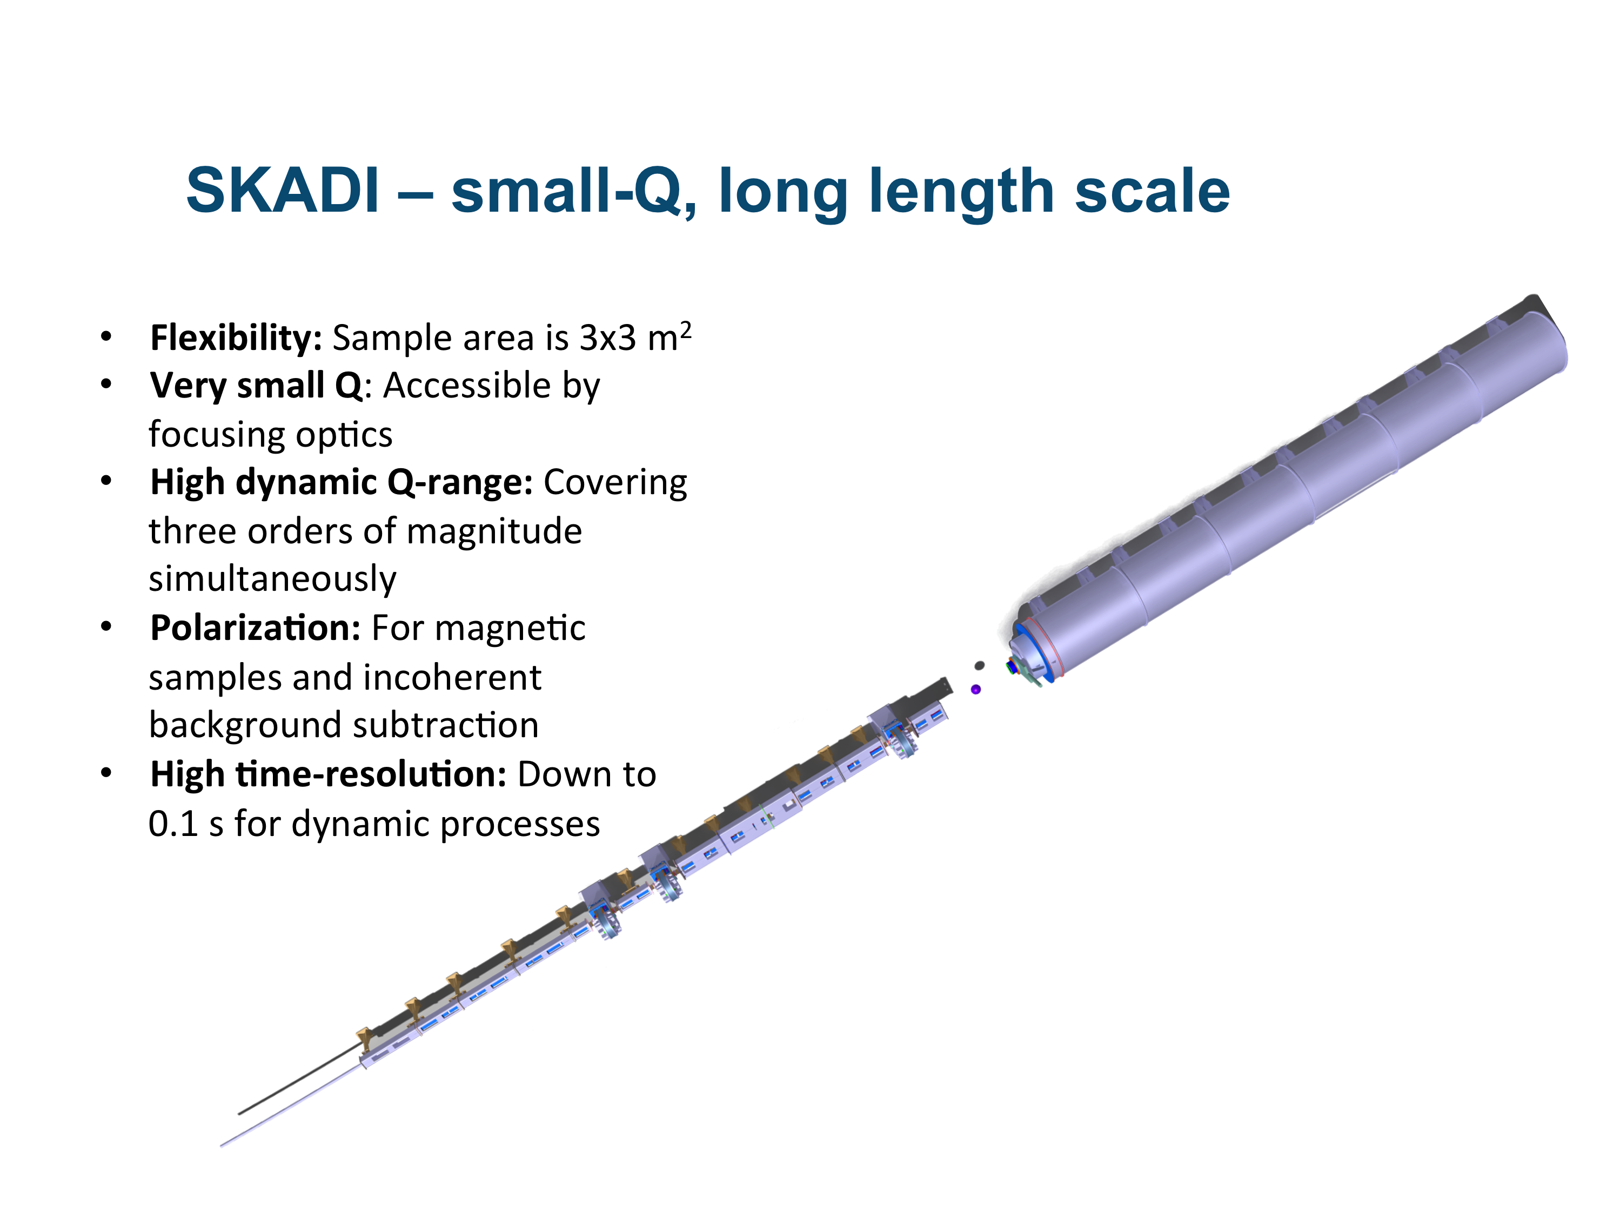Small-K Adavanced DIffractometer - SKADI

The **S**mall-**K** **A**dvanced **DI**ffractometer SKADI is a versatile SANS instrument, which enables scientists to perform a wide range of investigations on topics requiring small Q-values to access long length scales. The scientific areas targeted by SKADI include investigations of smart materials, biological and medical research, magnetic materials and materials for energy storage, as well as experiments on nanomaterials and nanocomposites or colloidal systems. To maximize the applicability of these studies SKADI is designed to accommodate in-situ measurements with custom made sample environments to provide "real-world" conditions.

To achieve all these goals SKADI will feature the following general design properties:

* **Flexibility** (sample area is approx. 3x3 m2, and versatile collimation)
* **Very small Q** accessible through VSANS (using focusing collimation elements)
* **Polarization** for magnetic samples and incoherent background subtraction
* **Good wavelength resolution**, being the longest SANS instrument at the ESS
* **High dynamic Q-range** (covering three orders of magnitude simultaneously)
* **High Q resolution** to achieve high quality data over the whole Q-range

## Budget Options

This is a short description of the possible configurations prepared for the scope setting meeting of SKADI.

There are three options:

1. **Within Cost Category.** Reduced requirements in order to meet the assigned budget. Total Cost: 10.15 M€
2. **Minimal Scope.** Meeting the requirements of the budget, not taking into account later improvements.  
   Total Cost: 13.08 M€
3. **Full Scope.** Meeting the requirements and taking into account the improvements as found until now.  
   Total Cost: 14.59 M€

The limitations of the three options are

1. **Within Cost Category:**
   1. No polarization / polarization analysis
   2. No detector (only high angle bank)
   3. Limited simultaneous Q
   4. Worse resolution
   5. Virtually no sample environment
   6. Worse time resolution / counting efficiency
   7. No possibility for speedy sample change
2. **Minimal Scope:**
   1. One detector not fully equipped
   2. Limited simultaneous Q
   3. Resolution could be better (at the detector)
   4. Medium Range sample environment (1 high priced item: DLS)
   5. No possibility for speedy sample change
3. **Full Scope:**
   1. No limitations

Upgrading Option 1 to Option 2 is nearly impossible without a complete refit of the instrument. A polarizer needs to be included, setup for a proper detector is needed and the sample cave needs to be completely remodelled. Upgrading from Option 2 to option 3 is possible, however extremely costly. One example: At the moment a single photomultiplier tube is ca. 5000 €. Buying 800 of these for a complete setup of SKADI would push the price down to ca. 3000 €, perhaps even less as this was only the first estimate by the supplier. Assuming that a single photomultipliers will cost on average 1000 € more if they are bought in two batches, increases the instrument cost by 800 k€. This is true also for many other components.

These budgets do not take into account SoNDe as requested by the ESS.