Scope Setting Report
Instrument : SKADI versatile SANS

Summary
The purpose of this document is to describe the possible baseline options for the SKADI instrument and how the instrument performance may be upgraded over time after the construction project to get from the day one scope to the full scope as envisaged in the instrument proposal.
Three possible baseline options are presented. Additionally, a discussion about the SoNDe detector project is included, as this is the anticipated detector technology for SKADI.
SKADI has been assigned to cost category B (12M€) including the SoNDe detector. The conclusion from analysing the costs is that it is not possible to deliver SKADI within this cost category in a manner that delivers adequate day one performance and a reasonable, affordable path to world leading performance.

Table of Content Page
Summary 2
1. OVerview 4
1.1. Science Case 4
1.2. Requirements 5
1.3. Configuration options 5
2. Option 1 : Scope within Cost Category A (9M€) 6
2.1. Scope 6
2.2. Costing 7
2.3. Upgrade/Staging plan 7
2.4. Risk 7
3. Option 2 : world class Scope meeting requirements 9
3.1. Scope 9
3.2. Costing 9
3.3. Upgrade/Staging plan 10
3.4. Risk 10
4. Option 3 : Full Scope 12
4.1. Scope 12
4.2. Costing 13
4.3. Risk 13
5. References 14

OVerview

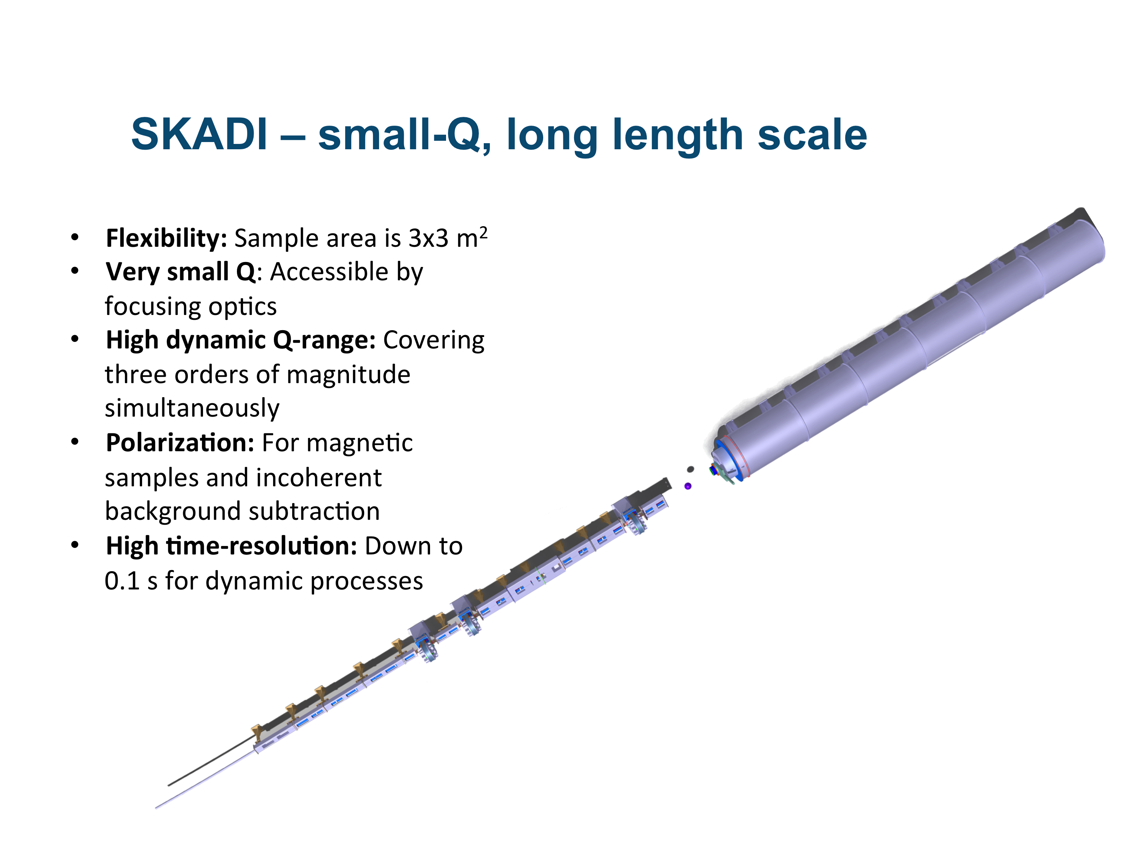
Science Case

The Small-K Advanced DIffractometer SKADI is a versatile SANS instrument, which enables scientists to perform a wide range of investigations on topics requiring small Q-values to access long length scales. The scientific areas targeted by SKADI include investigations of smart materials, biological and medical research, magnetic materials and materials for energy storage, as well as experiments on nanomaterials and nanocomposites or colloidal systems. To maximize the applicability of these studies SKADI is designed to accommodate in-situ measurements with custom made sample environments to provide "real-world" conditions.
To achieve all these goals SKADI will feature the following general design properties:
- Flexibility (sample area is approx. 3x3 m², and versatile collimation)
- Very small Q accessible through VSANS (using focusing collimation elements)
- Polarization for magnetic samples and incoherent background subtraction
- Good wavelength resolution, being the longest SANS instrument at the ESS
- High dynamic Q-range (covering three orders of magnitude simultaneously)
The first four of these features expands the science case into areas not covered by the LoKI. SKADI is envisaged as a vital part of the world leading SANS instrument suite for ESS, particularly in providing access to longer length scales and to polarized neutron measurements.
The 55 m long instrument provides for simple access to bulky sample environment such as high field magnets or polarization analysis units, and also for large presses, load frames or other large deformation tools in the large sample area. This large sample area also facilitates the inclusion of custom-made sample environments. Additional in-situ setups for soft matter and biological investigations such as light scattering for an expansion of Q-space, rheometers, setups for strong electric or magnetic fields or shearing setups for directed self-assembly can be accommodated.
To be able to access the micrometer range in real space, as is needed for example in samples that exhibit a wide range of structural length scales, such as colloidal systems (colloidal aggregates and/or composites), it is necessary to be able to measure at very small Q-values. The versatile collimation allows for collimating elements that enlarge the achievable Q-range (VSANS option). This option will easily allow reaching 10⁻⁴ Å⁻¹, while we aim to reach a 5x10⁻⁵ Å⁻¹.
To be able to monitor this large Q-range in one measurement removes the need to repeat the measurement at another detector distance in the case of kinetic measurements. Even in the standard setup, without the VSANS option, SKADI covers a high dynamic Q-range of three orders of magnitude (typically from 10⁻³ to 1-2 Å⁻¹) and thus is excellently suited for such experiments. These include, but are not limited to, kinetic measurements on phase transitions in soft matter or biologic samples, which have gained increasing attention recently. This possibility to cover a wide Q-range in one measurement is also desirable where in-situ measurements cannot be properly replicated under the exact same conditions, for example increasing stress up to the breaking point of a sample.

Polarization of the incoming beam and polarization analysis after the sample enable full four-channel analysis of the magnetic structure. In this way, all magnetic structures can be identified clearly, opening up the opportunity for detailed analyses of magnetic materials with SKADI. Skyrmions are complex magnetic structures of much interest today, and SKADI is foreseen to analyze even more complicated magnetic structures and topologies. Another topic is magnetic nanoparticles, which are controlled by an external magnetic field. Here the possibility for polarization analysis together with the huge sample area to set up a magnetic field sample environment allow for a wide range of experiments.
While all SANS proposals make excellent use of the high brilliance of the ESS source, SKADI will make an ideal addition to the ESS SANS instrument suite because of its versatility allowing the investigation of a broad variety of samples under well-defined conditions. With the high flux available at the ESS, SKADI allows for the investigation of fast kinetics (even for low scattering contrasts, where nowadays often model systems have to be used) and low concentrations of additives (or even traces). We expect that a time range of several tens of milliseconds will be achievable. Additionally, the long collimation allows for a very high Q-resolution. The wavelength band used on SKADI will be ideally suited for using polarizers, which generally only have a limited wavelength band in which they are feasible, thus no excessive intensity loss is expected for polarized scattering.
These features will allow SKADI to cater for the needs of a wide range of scientists, making it an ideal choice for a first day instrument. This is especially true in the light of the early success strategy by ESS, as SANS instruments have an excellent record of fast publication.

Requirements
The top level requirements for SKADI define the target scope for the instrument construction project. They have been formulated to capture the key aspects of the instrument proposal science case and are:
- SKADI shall allow data collection down to a Q_{min}<8×10⁻⁴ Å⁻¹
- SKADI shall allow data collection up to a Q_{max}>1 Å⁻¹
- SKADI shall allow data to be collected simultaneously over a dynamic Q-range of Q_{max}/Q_{min} >1000.
- SKADI shall allow time resolved studies with a single shot time resolution below 200 ms.
- SKADI shall match the size of the neutron beam to the size of the sample.
- SKADI shall allow the Q resolution to be optimized for the experiment
- SKADI shall provide polarized neutron scattering
- SKADI shall provide polarization analysis of the scattered neutrons in x and y direction (where z is the flight direction of the neutrons).
- SKADI shall provide a Q resolution of <10% dQ/Q between Q=1×10⁻³ Å⁻¹ and Q_{max}
- SKADI shall allow for custom sample environments of at least 1.5×1.5×2 m³ with masses of at least 2000 kg.
- SKADI should optimize the signal to noise ratio of the small angle scattering.

Configuration options
Three configuration options are presented:
- A configuration that is within cost category B (12M€ - 1.85 M€ for SoNDe). The aim was to meet the cost category. Cost: 10.15 M€
- A configuration that manages to meet scientific requirements at reasonable performance. The aim was a world-class instrument. Cost: 13.08 M€
- A configuration that is the full technical scope. This is a refinement of the scope presented in the proposal, taking into account changes in ESS design during Phase 1 and advice from the SANS STAP. Cost: 14.59 M€

Option 1 : Scope within Cost Category A (9M€)

Scope
- 2x line of sight benders
- Sample position at 36 m
- Collimation lengths of 8, 14, 20 m selectable.
- Bandwidth and frame overlap choppers
  - Single Disk at 15.5 m
  - Single Disk at 22.85 m
  - Single Disk at 26.6 m
- High-angle detector bank.
- 1.6m diameter vacuum vessel for above
- Sample environment : Temperature controlled (0 C to 100 C) sample changer for quartz cuvettes
- All necessary associated infrastructure (shielding, cabling, cabins etc.)
This scope does not meet the top-level requirements for:
- Limited simultaneous Q (#3)
- Q resolution over complete wavelength band (#9)
- Time resolution (#4)
- Polarization (#7)
- Polarization analysis (#8)
- Limited custom sample environments (#10)

It is not upgradeable to one that does without complete replacement of major parts of SKADI (sample area, cabling, polarizer, detector).
The science case for SKADI is based on being versatile wide simultaneous Q-range SANS enabling fast kinetic measurements on hierarchical systems. Scattering on multiscale samples requires a comparable statistic and resolution over the whole Q range, using as much of the spectrum as possible. Polarization and polarization analysis is needed to offer analyses of magnetic samples.
The absence of and sample environment beyond a simple water/glycol-thermostatted sample changer severely restricts the experiments that can be performed. In-site measurements, which are a vital part of the science case of SKADI become virtually impossible. Also not using a sample system that allow the fast change between setups inhibits the productive use of beamtime.
Thus, this scope does not fulfil the science case for SKADI.

Costing
The costing is based on bottom-up calculation of the procurement costs and manpower required for the tasks needed to deliver the higher level PBS items. Vacuum equipment is not included in the cost as this is expected to be delivered from outside the SKADI budget. The same is true for DAQ and analysis.
Table 1 Costing for SKADI in Cost Category A
 | 01 Phase 1 | 02 Project Management & Integration | 03 Design | 04 Procurement & Fabrication | 05 Installation | 06 Cold Commissioning | Total
01 Shielding | € 0 |  |  |  |  |  | € 4,080,000
02 Neutron Optics | € 0 |  |  |  |  |  | € 1,000,000
03 Choppers | € 0 |  |  |  |  |  | € 540,000
04 Sample Environment | € 0 |  |  |  |  |  | 62688
05 Detector and Beam Monitors | € 0 |  |  |  |  |  | € 900,000
06 Data Acquisition and Analysis | € 0 |  |  |  |  |  | € 0
07 Motion Control and Automation | € 0 |  |  |  |  |  | € 425,000
08 Instrument Specific Technical Equipment | € 492,200 | € 830,000 |  |  |  |  | € 1,322,200
09 Instrument Infrastructure | € 0 |  |  |  |  |  | € 510,000
10 Vacuum |  |  |  |  |  |  | € 0
11 PSS | € 0 |  |  |  |  |  | € 114,640
12 Contingency |  |  |  |  |  |  | € 1,200,000
Total | € 492,200 |  |  |  |  |  | € 10,154,528
Labour included in above (Person-Years) |  |  |  |  |  |  | 21.4

Upgrade/Staging plan
The staging plan for this option would consist of replacing the sample area and using a detector instead of a high-angle detector bank. Including a polarizer is virtually impossible. Major upgrades in the detector tube would be necessary to include the second detector. Including an additional chopper for a higher resolution setup is not prepared and therefore extremely costly.

Risk
The main risk with this configuration is the failure to deliver the science case that was presented to the SAC. This presents a clear reputational risk to ESS if it is not possible to perform new experiments beyond that which is possible now. This configuration would even be a step backwards from the time-of-flight instruments which exist today.
Below are top 5 risks rated high using ESS risk measures (impact x likelihood).
Table 2 Top 5 risks for Option 1
Risk level | RISK | TREATMENT NAME | Treatment | CATEGORY | TREATMENT PLAN
High 5x5 | Failure to deliver proposed scientific performance | Lower expectations | Mitigate | Budget, quality and function | Communicate with stakeholders the lowered performance expectations. Begin planning for upgrade and seek funding. Responsible: SKADI Team, ESS management
High 4x4 | Conventional Facilities Delay | CF LEVEL ESS-0019533 | Observe | Schedule, budget, quality and function | Access to neutron guide hall is necessary for SKADI schedule. SKADI team Responsible: CF
 |  | External areas like labs and workshops | Mitigate |  | External areas will give the opportunity to start pre-installations Responsible: CF
High 3x5 | Proper design according to instrument requirements and Delay in monolith insert design | Schedule for external milestone | Observe | Schedule, budget, Quality and function | Follow the progress of the design and project schedule. SKADI Team  Responsible: target
 |  | TARGET LEVEL ESS-0019533 | Observe |  | Focus on Safety, feasibility and requirements  Responsible: target
High 3x5 | Late delivery of key components | Schedule | Mitigate | Schedule, budget | Properly assess the delivery time and transportation, also the time that is required for installation and arriving at site. Define the critical path for every component. Responsible: SKADI Team
High 3x3 | SoNDe does not deliver | Detectors Action plan (buy conventional detector) | Mitigate | Schedule, budget, quality and function | Buy readily available detector technique, e.g. ³He detector

Option 2 : world class Scope meeting requirements

Scope
- 2x line of sight benders
- Sample position at 36 m
- Collimation lengths of 8, 14, 20 m selectable.
- Single polarizer+analysis
- Bandwidth and frame overlap choppers
  - Single Disk at 15.5 m
  - Single Disk at 22.85 m
  - Single Disk at 23.3 m
  - Single Disk at 26.6 m
- High-angle front detector, not fully equipped or otherwise limited.
- 1.6m diameter vacuum vessel for above
- Sample environment :
  - Temperature controlled (0 C to 100 C) sample changer for quartz cuvettes
  - In-situ light scattering.

All necessary associated infrastructure (shielding, cabling, cabins etc.)
This scope meets all the high level requirements and is upgradeable to a configuration that provides the full scope.
The science case will mostly be met by this configuration. The absence of a full suite of sample environment directly limits any experiments that need SE such as rheometers, electromagnets, shear cells, stopped-flow etc. The in-situ study of real life systems is a key part of the SKADI science case and this configuration would not provide that on day one. Additionally the fast and simple change of setup is not foreseen here. The detector with a reduced active area inhibits experiments that require a high time resolution.

Costing
The costing is based on bottom-up calculation of the procurement costs and manpower required for the tasks needed to deliver the higher level PBS items. Vacuum equipment is not included in the cost as this is expected to be delivered from outside the SKADI budget. The same is true for DAQ and analysis.

Table 3 Costing for SKADI Option 2
 | 01 Phase 1 | 02 Project Management & Integration | 03 Design | 04 Procurement & Fabrication | 05 Installation | 06 Cold Commissioning | Total
01 Shielding | € 0 |  |  |  |  |  | € 4,080,000
02 Neutron Optics | € 0 |  |  |  |  |  | € 1,480,000
03 Choppers | € 0 |  |  |  |  |  | € 720,000
04 Sample Environment | € 0 |  |  |  |  |  | € 250,000
05 Detector and Beam Monitors | € 0 |  |  |  |  |  | € 2,750,000
06 Data Acquisition and Analysis | € 0 |  |  |  |  |  | € 0
07 Motion Control and Automation | € 0 |  |  |  |  |  | € 545,200
08 Instrument Specific Technical Equipment | € 492,200 | € 830,000 |  |  |  |  | € 1,322,200
09 Instrument Infrastructure | € 0 |  |  |  |  |  | € 510,000
10 Vacuum |  |  |  |  |  |  | € 0
11 PSS | € 0 |  |  |  |  |  | € 114,640
12 Contingency |  |  |  |  |  |  | € 1,308,004.44
Total | € 492,200 |  |  |  |  |  | € 13,080,044
Labour included in above (Person-Years) |  |  |  |  |  |  | 27.5

Upgrade/Staging plan
The additional fit out of the remaining detector coverage, as foreseen in the full scope, would cost approximately 1.3 M€ knowing the single modules will be far more expensive not bought in huge batches.
Adding the full sample environment suite would cost around 250 k€ and is something that we could envisage obtaining from external funding. This does however not include the possibility for fast and simple exchange of the sample setup or custom made sample setups. For this the sample area would need a refit, which is assumed to cost around 100 k.

Risk
The main risks for this configuration are delays in delivery of various ESS systems and SKADI components. The need for development of detectors is a risk that is not unique to SKADI, but must be mitigated through schedule and planning for a backup solution.
Below are top 5 risks rated high using ESS risk measures (impact x likelihood).

Table 4 : Top 5 risks for Option 2
Risk level | RISK | TREATMENT NAME | Treatment | CATEGORY | TREATMENT PLAN
High 4x4 | Conventional Facilities Delay | CF LEVEL ESS-0019533 | Observe | Schedule, budget, quality and function | Access to the neutron guide hall is necessary for SKADI schedule. SKADI team Responsible: CF
 |  | External areas like labs and workshops | Mitigate |  | External areas will give the opportunity to start pre-installations Responsible: CF
High 3x5 | Proper design according to instrument requirements and Delay in monolith insert design | Schedule for external milestone | Observe | Schedule, budget, Quality and function | Follow the progress of the design and project schedule. SKADI Team  Responsible: target
 |  | TARGET LEVEL ESS-0019533 | Observe |  | Focus on Safety, feasibility and requirements  Responsible: target
High 3x5 | Late delivery of key components | SKADI schedule | Mitigate | Schedule, budget | Properly assess the delivery time and transportation, also the time that is required for installation and arriving at site. Define the critical path for every component. Responsible: SKADI Team
High 3x3 | SoNDe does not deliver | Detectors Action plan (buy conventional detector) | Mitigate | Schedule, budget, quality and function | Buy readily available detector technique, e.g. ³He detector
High 2x5 | Weak integration process | Integration plan, Hall EPL  (Included in SKADI planning), Checklist of activities, work package documentation, interface control document | Mitigate | Schedule, budget, quality and function | Integration plan is consider in work package documentation, detail description of interfaces, schedule and a detail list of activities  Responsible: SKADI team

Option 3 : Full Scope

Scope
The full instrument scope consists of:
- 2x line of sight benders
- Sample position at 36 m
- Collimation lengths of 8, 14, 20 m selectable.
- Single polarizer+analysis
- Bandwidth and frame overlap choppers
  - Single Disk at 15.5 m
  - Single Disk at 22.85 m
  - Single Disk at 23.3 m
  - Single Disk at 26.6 m
- High-angle front detector , plus rear detector. Resolution 6x6 mm² except for 20x20 cm² center: 3x3 mm²
- 1.6m diameter vacuum vessel for above
- Sample environment :
  - Temperature controlled (0 C to 100 C) sample changer for quartz cuvettes
  - In-situ light scattering.
  - Rheometer
  - Stop Flow
  - Possibility for fast and simple sample change
  - Preparation for custom sample environment

This scope meets all the high level requirements and fulfils the science case.

Costing
The costing is based on bottom-up calculation of the procurement costs and manpower required for the tasks needed to deliver the higher level PBS items. Vacuum equipment is not included in the cost as this is expected to be delivered from outside the SKADI budget. The same is true for DAQ and analysis.
Table 5 Costing for SKADI Full Scope
 | 01 Phase 1 | 02 Project Management & Integration | 03 Design | 04 Procurement & Fabrication | 05 Installation | 06 Cold Commissioning | Total
01 Shielding | € 0 |  |  |  |  |  | € 4,080,000
02 Neutron Optics | € 0 |  |  |  |  |  | € 1,480,000
03 Choppers | € 0 |  |  |  |  |  | € 720,000
04 Sample Environment | € 0 |  |  |  |  |  | € 500,000
05 Detector and Beam Monitors | € 0 |  |  |  |  |  | € 3,860,000
06 Data Acquisition and Analysis | € 0 |  |  |  |  |  | € 0
07 Motion Control and Automation | € 0 |  |  |  |  |  | € 545,200
08 Instrument Specific Technical Equipment | € 492,200 |  |  | € 830,000 |  |  | € 1,322,200
09 Instrument Infrastructure | € 0 |  |  |  |  |  | € 510,000
10 Vacuum |  |  |  |  |  |  | € 0
11 PSS | € 0 |  |  |  |  |  | € 114,640
12 Contingency |  |  |  |  |  |  | € 1,459,115.56
Total | € 492,200 |  |  |  |  | € 0 | € 14,591,156
Labour included in above (Person-Years) |  |  |  |  |  |  | 30.71

Risk
The main risks for this configuration are delays in delivery of various ESS systems and SKADI components. The need for development of detectors is a risk that is not unique to SKADI, but must be mitigated through schedule and planning for a backup solution. This option has a higher detector coverage and thus the likelihood of a delay in detector delivery is greater.
Below are the top risks rated high using ESS risk measures (impact x likelihood).

Table 6 : Risks for Option 3
Risk level | RISK | TREATMENT NAME | Treatment | CATEGORY | TREATMENT PLAN
High 4x4 | Conventional Facilities Delay | CF LEVEL ESS-0019533 | Observe | Schedule, budget, quality and function | Access to the neutron guide hall is necessary for SKADI schedule. SKADI team Responsible: CF
 |  | External areas like labs and workshops | Mitigate |  | External areas will give the opportunity to start pre-installations Responsible: CF
High 3x5 | Proper design according to instrument requirements and Delay in monolith insert design | Schedule for external milestone | Observe | Schedule, budget, Quality and function | Follow the progress of the design and project schedule. SKADI Team  Responsible: target
 |  | TARGET LEVEL ESS-0019533 | Observe |  | Focus on Safety, feasibility and requirements  Responsible: target
High 3x5 | Late delivery of key components | SKADI schedule | Mitigate | Schedule, budget | Properly assess the delivery time and transportation, also the time that is required for installation and arriving at site. Define the critical path for every component. Responsible: SKADI Team
High 2x5 | Weak integration process | Integration plan, Hall EPL  (Included in SKADI planning), Checklist of activities, work package documentation, interface control document | Mitigate | Schedule, budget, quality and function | Integration plan is consider in work package documentation, detail description of interfaces, schedule and a detail list of activities  Responsible: SKADI team

Considerations on the inclusions of SoNDe
The result (physical detector prototype) and the respective benefit should be shared between the partners. Details for this argument will follow later.

