Accelerator and Target Station
Interface Control Document

Table of content
Table of content 2
1. Introduction 3
1.1 Purpose of the document 3
1.2 Definitions, acronyms and abbreviations 3
1.3 References 3
2. characteristics of the Systems 3
2.1 Accelerator system purpose 3
2.2 Accelerator system overview 3
2.3 Target Station purpose 4
2.4 Target Station overview 4
3. Characteristics related to the safety 4
4. Interfaces specification 5
4.1 Mechanical 5
4.2 Radiations 5
4.3 Vacuum 5

Introduction

Purpose of the document
The Interface Control Document (ICD) between the Accelerator system and the Target Station system exhaustively collects and describes all the interfaces between these systems. It is an agreed specification of the interface between the parties.
This document supports the execution of the Interface Management Plan [1] as an A2B ICD. It is subject to the facility preliminary design review. Once approved, it is hereafter edited according to the configuration management plan [2].

Definitions, acronyms and abbreviations
Abbreviation | Explanation of abbreviation
ICD | Interface Control Document
PBW | Proton Beam Window

References
[1] Interface Management Plan, ESS-0002917.
[2] Configuration Management Plan, ESS-0003688.

characteristics of the Systems

Accelerator system purpose
ESS is an accelerator-driven neutron spallation source. The linear accelerator, or linac, is thus a critical component. The role of the accelerator is to create protons, accelerates them to an appropriate energy, and steers them onto the Target Station to create neutrons via the spallation process for use by a suite of research instruments.

Accelerator system overview
The general layout of the ESS linac is shown in the figure below. The beam from the electron cyclotron resonance source (ECR) is transported through a low energy beam transport (LEBT) section to the radio-frequency quadrupole (RFQ) for bunching and acceleration. The beam is transported from the RFQ and matched to the normal conducting drift tube linac (DTL) through a medium energy beam transport (MEBT) section. Leaving the DTL, the beam enters the superconducting portion of the linac using liquid helium at a nominal temperature of 2 K. From the superconducting portion of the linac, the beam is transported via the high-energy beam transport (HEBT) section to the target.
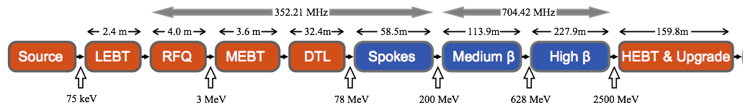
Figure 1: Accelerator layout.

Target Station purpose
The main function of the Target Station is to convert the high-energy proton beam from the accelerator into low-energy neutron beams with the greatest possible efficiency.

Target Station overview
Key Target Station subsystems deliver this main functionality. A first group consists of the Target monolith and the components it houses. It includes the proton beam window, the rotating Target wheel system, the moderator-reflector assembly and the beam extraction system. A second group is made up of fluid systems, including the closed cooling circuits and the radioactive gaseous effluents and confinement (RGEC) system.
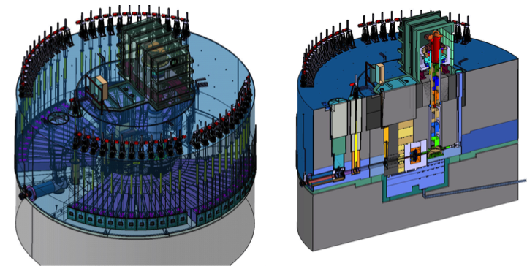
Figure 2: Monolith general layout. Left: 3D perspective view. Right: Side view along the vertical plane of the incident proton beam.

Characteristics related to the safety
ESS.SyR-313 Target Station shall protect the accelerator from contamination by its by-products.
The accelerator vacuum shall not be impaired by intrusion of the Target monolith atmosphere.

Interfaces specification

Mechanical
ESS.SyR-192 Target Station shall receive proton beam from accelerator.

Accelerator shall supply proton beam to Target Station.

Radiations
ESS.SyR-410 At the completion of the milestone ‘5MW’ of the ESS Construction Phase, the accelerator shall be designed and constructed to be capable of delivering to the Target Station a time averaged proton beam power of 5 mega-Watts.
ESS.SyR-420 At the completion of the milestone ‘First protons to target’ of the ESS Construction Phase, the accelerator shall be designed and constructed to be capable of delivering to the Target Station a time averaged proton beam power of 1 mega-Watts
ESS.SyR-430 The nominal operational repetition rate of accelerator acceleration cycles shall be 14 Hertz.
ESS.SyR-450 The nominal operational beam pulse length shall be 2.86 milli- Seconds.
ESS.SyR-460 The nominal peak beam power delivered to Target Station averaged over a period of 200 micro-Seconds shall not vary more than 5 percent from the peak beam power delivered to Target Station averaged over the nominal macro pulse length.
ESS.SyR-463 The time averaged beam power delivered to the Target Station shall not vary more than 5 percent pulse to pulse.
ESS.SyR-465 The time averaged beam power delivered to the Target Station shall be able to be varied in steps to its nominal value of 5 mega- Watts with a maximum step size of 500 kilo-Watts and with a precision of 125 kilo-Watts.

Target shall receive proton beam from accelerator in accordance to beam parameters described in the table below.

Parameter | Minimum | Nominal | Maximum
Time averaged beam power (MW) | 0 | 5 | 5.25
Beam energy (GeV) | 0.55 | 2 | 2.5
Average beam current during the pulse (mA) | 0 |  | 62.5
Pulse length (ms) | 19.8/7 | 20/7 | 20.2/7
Time averaged pulse length (ms) | 19.98/7 | 20/7 | 20.02/7
Beam energy per pulse (kJ) | 0 | 357.1 | 375
Beam footprint on interface (PBW) enclosing > 97,5% beam fraction (mm²) | - | - | 160 H x 60 V
Beam footprint on interface (PBW) enclosing > 99,9% beam fraction (mm²) | - | - | 180 H x 62 V
Pulse repetition rate (Hz) |  | 14 | 14
Maximum displacement of footprint (mm) | -5 H ; -2 V | 0 ; 0 | +5 H ; +2 V

Accelerator shall limit its irradiation of Target Station.

ESS.SyR-312 Target Station shall limit its backscattering of particles to the accelerator.
ESS.SyR-313 Target Station shall protect the accelerator from contamination by its by-products.

Vacuum
The accelerator vacuum shall not be impaired by intrusion of the Target Station monolith atmosphere.
ESS.SyR-314 The Target Station monolith atmosphere shall be prevented from entering into the accelerator beam pipe so that the accelerator vacuum is preserved.

