Scope Setting Report
Instrument: SKADI versatile SANS

Summary
The purpose of this document is to describe the agreed day one scope for the SKADI instrument and how the instrument performance may be upgraded over time after the construction project to get from the day one scope to the full scope as envisaged in the instrument proposal and also meet the subsequently extended requirements as found during the planning phase of SKADI.
SKADI has been assigned to cost category B (12M€) including the SoNDe detector.
Table of Content Page
Summary 2
1. OVerview 4
1.1. Science Case 4
1.2. Requirements 6
2. Scope as from the SCOPE Setting meeting 6
2.1. Scope 6
2.2. Costing 7
2.3. Upgrade/Staging plan 8
2.4. Risk 9
3. Considerations on the inclusions of SoNDe 10

OVerview

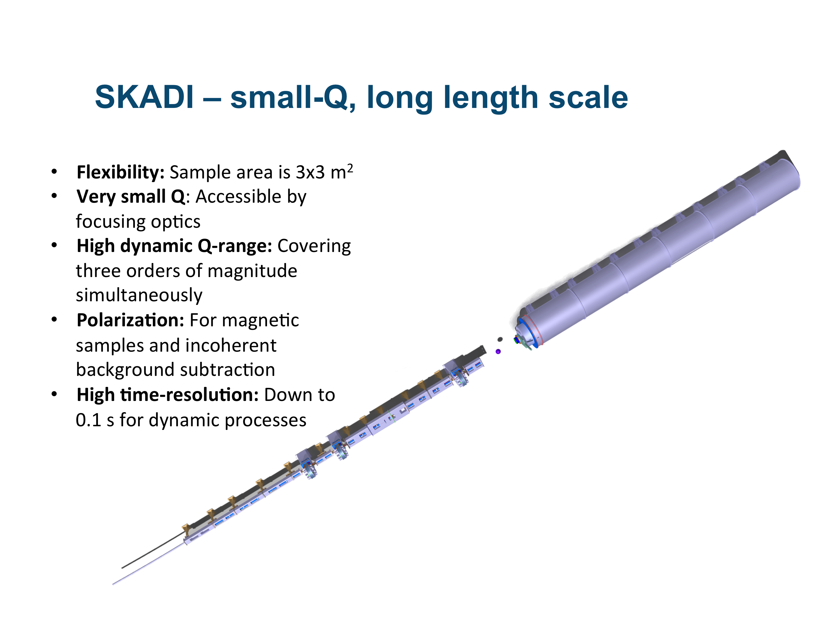
Science Case

The Small-K Advanced DIffractometer SKADI is a versatile SANS instrument, which enables scientists to perform a wide range of investigations on topics requiring small Q-values to access long length scales. The scientific areas targeted by SKADI include investigations of smart materials, biological and medical research, magnetic materials and materials for energy storage, as well as experiments on nanomaterials and nanocomposites or colloidal systems. To maximize the applicability of these studies SKADI is designed to accommodate in-situ measurements with custom made sample environments to provide "real-world" conditions.
To achieve all these goals SKADI will feature the following general design properties:
- Flexibility (sample area is approx. 3x3 m², and versatile collimation)
- Very small Q accessible through VSANS (using focusing collimation elements)
- Polarization for magnetic samples and incoherent background subtraction
- Good wavelength resolution, being the longest SANS instrument at the ESS
- High dynamic Q-range (covering three orders of magnitude simultaneously)
- High Q resolution to achieve high quality data over the whole Q-range
The first four of these features expands the science case into areas not covered by the LoKI. SKADI is envisaged as a vital part of the world leading SANS instrument suite for ESS, particularly in providing access to longer length scales and to polarized neutron measurements.
The 55 m long instrument provides for simple access to bulky sample environment such as high field magnets or polarization analysis units, and also for large presses, load frames or other large deformation tools in the large sample area. This large sample area also facilitates the inclusion of custom-made sample environments. Additional in-situ setups for soft matter and biological investigations such as light scattering for an expansion of Q-space, rheometers, setups for strong electric or magnetic fields or shearing setups for directed self-assembly can be accommodated and will strengthen the scientific performance of SKADI.
To be able to access the micrometer range in real space, as is needed for example in samples that exhibit a wide range of structural length scales, such as colloidal systems (colloidal aggregates and/or composites), it is necessary to be able to measure at very small Q-values. The versatile collimation allows for collimating elements that enlarge the achievable Q-range (VSANS option). This option will easily allow reaching 10⁻⁴ Å⁻¹, while we aim to reach a 5x10⁻⁵ Å⁻¹.
To be able to monitor this large Q-range in one measurement removes the need to repeat the measurement at another detector distance in the case of kinetic measurements. Even in the standard setup, without the VSANS option, SKADI covers a high dynamic Q-range of three orders of magnitude (typically from 10⁻³ to 1-2 Å⁻¹) and thus is excellently suited for such experiments. These include, but are not limited to, kinetic measurements on phase transitions in soft matter or biologic samples, which have gained increasing attention recently. This possibility to cover a wide Q-range in one measurement is also desirable where in-situ measurements are hard to be replicated under the exact same conditions, for example increasing stress up to the breaking point of a sample.
Polarization of the incoming beam and polarization analysis after the sample enable full four-channel analysis of the magnetic structure. In this way, all magnetic structures can be identified clearly, opening up the opportunity for detailed analyses of magnetic materials with SKADI. Skyrmions are complex magnetic structures of much interest today, and SKADI is foreseen to analyze even more complicated magnetic structures and topologies. Another topic is magnetic nanoparticles, which are controlled by an external magnetic field. Here the possibility for polarization analysis together with the huge sample area to set up a magnetic field sample environment allow for a wide range of experiments.
While all SANS proposals make excellent use of the high brilliance of the ESS source, SKADI will make an ideal addition to the ESS SANS instrument suite because of its versatility allowing the investigation of a broad variety of samples under well-defined conditions. With the high flux available at the ESS, SKADI allows for the investigation of fast kinetics (even for low scattering contrasts, where nowadays often model systems have to be used) and low concentrations of additives (or even traces). We expect that a time range of several tens of milliseconds will be achievable. Additionally, the long collimation allows for a very high Q-resolution. The wavelength band used on SKADI will be ideally suited for using polarizers, which generally only have a limited wavelength band in which they are feasible, thus no excessive intensity loss is expected for polarized scattering.
These features will allow SKADI to cater for the needs of a wide range of scientists, making it an ideal choice for a first day instrument. This is especially true in the light of the early success strategy by ESS, as SANS instruments have an excellent record of fast publication.

Requirements
The top-level requirements for SKADI define the target scope for the instrument construction project. These top-level requirements have been formulated to capture the key aspects of the instrument proposal science case. They also include subsequent recommendations from the STAP following the original proposal:
- SKADI shall allow data collection down to a Q_{min}<8×10⁻⁴ Å⁻¹
- SKADI shall allow data collection up to a Q_{max}>1 Å⁻¹
- SKADI shall allow data to be collected simultaneously over a dynamic Q-range of Q_{max}/Q_{min} >1000.
- SKADI shall allow time resolved studies with a single shot time resolution below 200 ms.
- SKADI shall match the size of the neutron beam to the size of the sample.
- SKADI shall allow the Q resolution to be optimized for the experiment
- SKADI shall provide polarized neutron scattering
- SKADI shall provide polarization analysis of the scattered neutrons in x and y direction (where z is the flight direction of the neutrons).
- SKADI shall provide a Q resolution of <10% dQ/Q between Q=1×10⁻³ Å⁻¹ and Q_{max}
- SKADI shall allow for custom sample environments of at least 1.5×1.5×2 m³ with masses of at least 2000 kg.
- SKADI should optimize the signal to noise ratio of the small angle scattering.

Scope as from the SCOPE Setting meeting
This scope comprises the technical decisions needed to achieve the top-level requirements. Decisions or technical details stated here mirror one or several of the top-level requirements mentioned above.

Scope
- 2x line of sight benders
- Sample position at 36 m
- Collimation lengths of 8, 14, 20 m selectable.
- Polarizer, no polarization analysis
- Four single disk choppers for high flux and high resolution settings
- 1 m² of detector area
- 2 m inner diameter vacuum vessel for above, detectors movable
- Cold commissioning
- Sample environment: Selection of sample environment using the sample environment pool as a basis
- All necessary associated infrastructure (shielding, cabling, cabins etc.)
- Upgradeable to full scope

This scope delivers a world-class instrument. The performance, being measured in flux-on-sample, is a factor of five over the best of today’s instruments. Regarding the limitations as compared to the instruments proposal the following limitations are imposed by the agreed scope.
- Limited simultaneous Q (#3)

- Time resolution (#4)
- Polarization analysis (#8)
- Custom sample environments (#10)

Thus all major top-level requirements are met. Moreover, any of these limitations can be overcome by a detailed upgrade plan during the operations phase, so that SKADI ensures early success by delivering world-class science while keeping the potential for future improvements.

Costing
The costing is based on bottom-up calculation of the procurement costs and manpower required for the tasks needed to deliver the higher level PBS items. Vacuum equipment is not included in the cost as this is expected to be delivered from outside the SKADI budget. The same is true for DAQ and analysis.
Table 1 Costing for SKADI
 | 01 Phase 1 | 02 Project Management & Integration | 03 Design | 04 Procurement & Fabrication | 05 Installation | 06 Cold Commissioning | Total
01 Shielding |  |  |  |  |  |  | € 1,999,000
02 Neutron Optics |  |  |  |  |  |  | € 3,415,200
03 Choppers |  |  |  |  |  |  | € 767,480
04 Sample Environment | € 0 |  |  |  |  |  | € 402,500
05 Detector and Beam Monitors | € 0 |  |  |  |  |  | € 2,674,200
06 Data Acquisition and Analysis | € 0 |  |  |  |  |  | ESS
07 Motion Control and Automation | € 0 |  |  |  |  |  | € 334,000
08 Instrument Specific Technical Equipment |  |  |  |  |  |  | € 836,000
09 Instrument Infrastructure | € 0 |  |  |  |  |  | € 381,000
10 Vacuum |  |  |  |  |  |  | ESS
11 PSS | € 0 |  |  |  |  |  | € 114,640
12 Contingency |  |  |  |  |  |  | € 1,213,780.00
Total | € 492,000 |  |  |  |  |  | € 12,629,800.0
Labour included in above (Person-Years) |  |  |  |  |  |  | 34

Upgrade/Staging plan
The staging plan is designed to upgrade SKADI to the full scientific scope as laid out in the instrument proposal and additional improvements through the STAP that have been included later. This comprises the inclusion of the PA, higher detector coverage and a wider range of sample environments.
All these upgrades immediately translate in additional experiments that can be performed at SKADI and thus into scientific performance.
- Upgrading the detector coverage:
  - Affects top level requirements about simultaneous Q and time resolution
(#s 3 and 4).
  - Using this upgrade, which may even be possible incrementally, will immediately impact all users on SKADI. The increased instrument performance will reflect both in shorter beam times and higher quality of data.
  - The modularity of the proposed SoNDe detector makes an incremental upgrade possible. Moreover, if other instruments were to share the technology, a sharing for spare parts for the detectors should be considered.
- Upgrading the sample environments:
  - In order to perform world-class science at SKADI, a wide and adapted range of sample environments is required. While every single sample environment will not impact the whole user community, a prioritized list of sample environments may decisively influence the experiments being performed on SKADI.
  - As SKADI will be able to share its sample environment for a huge part at least with Loki, possibly also with other large scale structure instruments, most upgrades concerning the sample environments will also benefit other instruments.
- Including PA:
  - This will impact all users depending on polarized scattering, being one of the main differentiating properties for neutron scattering when compared to other scattering techniques. Using the appropriate system for that, this upgrade could also be shared with other instruments.

Risk
The main risk with this configuration is the failure to deliver the science case that was presented to the SAC. This presents a clear reputational risk to ESS if it is not possible to perform new experiments beyond that which is possible now.
Below are top 5 risks rated high using ESS risk measures (impact x likelihood).
Table 2 Top 5 risks for Option 1
Risk level | RISK | TREATMENT NAME | Treatment | CATEGORY | TREATMENT PLAN
High 5x3 | Failure to deliver proposed scientific performance | Lower expectations | Mitigate | Budget, quality and function | Communicate with stakeholders the lowered performance expectations. Begin planning for upgrade and seek funding. Responsible: SKADI Team, ESS management
High 4x4 | Conventional Facilities Delay | CF LEVEL ESS-0019533 | Observe | Schedule, budget, quality and function | Access to neutron guide hall is necessary for SKADI schedule. SKADI team Responsible: CF
 |  | External areas like labs and workshops | Mitigate |  | External areas will give the opportunity to start pre-installations Responsible: CF
High 3x5 | Proper design according to instrument requirements and Delay in monolith insert design | Schedule for external milestone (2019) | Observe | Schedule, budget, Quality and function | Follow the progress of the design and project schedule. SKADI Team  Responsible: target
 |  | TARGET LEVEL ESS-0019533 | Observe |  | Focus on Safety, feasibility and requirements  Responsible: target
High 3x5 | Late delivery of key components | Schedule | Mitigate | Schedule, budget | Properly assess the delivery time and transportation, also the time that is required for installation and arriving at site. Define the critical path for every component. Responsible: SKADI Team
Medium 3x3 | SoNDe does not deliver | Detectors Action plan (buy conventional detector) | Mitigate | Schedule, budget, quality and function | Buy readily available detector technique, e.g. ³He detector

Considerations on the inclusions of SoNDe
The SoNDe detector project is a H2020 funded project for the development of a new detector technology for high flux neutron detection. Partners in this project are LLB, ESS, Lund University, IDEAS and JCNS, where JCNS is the coordinator.
Having the opportunity available to develop a dedicated neutron detection technique leaves SKADI in an outstanding position as the detailed design of the detector can be tailor made to suit the instrument.
Using this detector technology SKADI in its final staging will be able to use the higher flux of the world’s brightest neutron source ESS to capacity and translate the capabilities of that facility into scientific performance.
SoNDe as a project will be able to deliver half of the required detector area, making SKADI a world class instrument at a competitive budget.

