Accelerator tunnel cooling skids CWS01 & CWS02 functional description

 | Name | Role/Title
Owner | Anton Lundmark | Cooling system engineer
Reviewer | Akif Coku | WP16 project engineer
Reviewer | Piero Valente | Plant and process section coordinator
Approver | Anton Lundmark | Cooling system engineer

Table of content | Page
1. <<Heading 1>> 3
1.1. <<Heading 2>> 3
1.1.1. <<Heading 3>> 3
2. Glossary 4
3. references 4
Document Revision history 4

list of tables
Table 1 Design data for CWL-CWS01 4
Table 2 Design data for CWM-CWS02 4
Table 3 Description of main components 6

list of Figures
Figure 1. Layout of the ESS accelerator. The blue parts indicate the superconducting part of the linac whereas the other colours indicate room temperature elements. 3
Figure 2 Layout of conceptual cooling system 6

Introduction
The ESS accelerator is a long pulsed superconducting linac that accelerates a 62.5 mA proton beam current to the energy of 2 GeV. Peak beam power to the target will be 125 MW. The layout of the accelerator is shown in Figure 1.

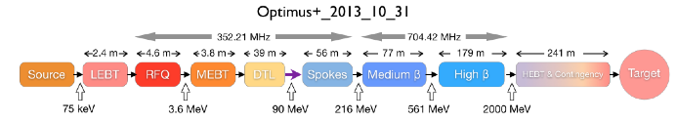
Figure 1. Layout of the ESS accelerator. The blue parts indicate the superconducting part of the linac whereas the other colours indicate room temperature elements.
The accelerator comprise of a number of different subsystems, primarily divided into a warm section (room temperature) and a superconducting section. The last part of the accelerator consists of quadrapole magnets and beam instrumentation that guides the proton beam to the target station (HEBT). The HEBT section may also be used as future upgrade space.
The warm section consists of ion source, Low Energy Beam Transport (LEBT), Radio Frequency Quadrapole (RFQ), Medium Energy Beam Transport (MEBT), and Drift Tube Linac (DTL).
The superconducting section Spokes, Medium Beta, and High Beta. The acceleration in this section is performed via 2 K helium cooled niobium cavitites.
A number of components located in the accelerator tunnel require water-cooling in order to maintain a stable operating temperature.
The cooling of equipment in the tunnel is divided into four separate systems:
- RFQ cooling/tuning system
- DTL cooling/tuning system
- CWL-CWS01 – Cooling system for IS, LEBT, MEBT and DTL Farady cups
- CWM-CWS02 – Cooling system for RF couplers (SPK, MBL, HBL), LWUs (SPK, MBL, HBL), and HEBT/A2T magnets
This system description only concern the CWL-CWS01 and CWM-CWS02. The first part of the naming refers to the conventional facilities cooling systems, CWL (8 °C) and CWM (25 °C) two latter.

System Data

Design data
Table 1 Design data for CWL-CWS01
Parameter | Value | Comment
Nominal flow rate | 14.5 m3/h
Nominal heat load | 85 kW
Nominal pressure drop | 6 bar | The maximum pressure drop of any load is 5 bar
Nominal system volume | TBD
Design temperature | 50 °C
Operating temperature range | 15 – 40 °C | Minimum supply temperature to loads - maximum outlet temperature from loads
Nominal operating temperature | 20 °C | Operator shall be able to change the set point at least +/- 5 °C.  Stability during steady state heat loads shall be better than 1 °C.
Primary side water temperature | 8 °C
Primary side supply pressure | 7 bar(g)
Primary side maximum allowed pressure drop | 3 bar
Primary side water quality | Low conductivity water  Conductivity: 1 μS/cm | Conservative assumption. The 8 °C water may be “clean water” instead of low conductivity.
Nominal flow rate | 14.5 m3/h

Table 2 Design data for CWM-CWS02
Parameter | Value | Comment
Nominal flow rate | 85 m³/h
Nominal heat load | 500 kW
Nominal pressure drop | 6.5 bar | The maximum pressure drop of the loads is 5 bar
Nominal system volume | TBD
Design temperature | 50 °C
Operating temperature range | 30 – 45 °C | Minimum supply temperature to loads - maximum outlet temperature from loads
Nominal operating temperature | 30 °C | Operator shall be able to change the set point at least +/- 5 °C.  Stability during steady state heat loads shall be better than 1 °C.
Primary side water temperature | 25 °C
Primary side supply pressure | 7 bar(g)
Primary side maximum allowed pressure drop | 3 bar
Primary side water quality | Low conductivity water  Conductivity: 1 μS/cm
Nominal flow rate | 85 m³/h

Location
The cooling skids are located in G02 level 100, front-end building.

Applicable standards and norms
- Pressure Equipment Directive (2014/68/EU)
- Low Voltage Directive (2006/95/EC)
- EMC directive (2004/108/EC)
- ISO and EU standards; primarily EN 13480, EN 60204 and its normative references

Control & Monitoring
Component references are according to Figure 1.
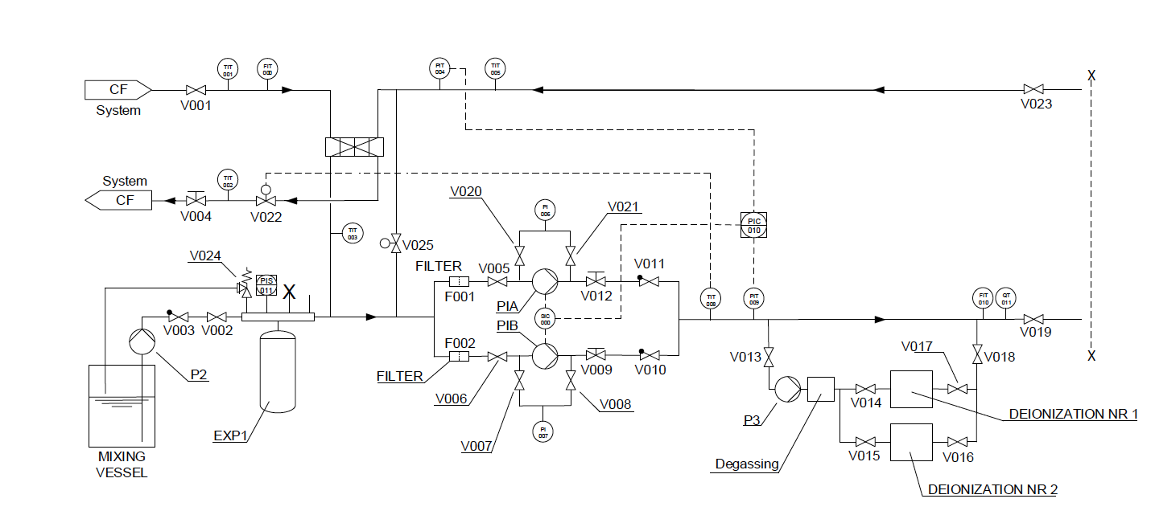
Figure 2 Layout of conceptual cooling system

Table 3 Description of main components
Component | Purpose
FIT010 | Measure full flow
QT011 | Conductivity meter
TIT005 | Measure temperature of return flow
PIT004/PIT005 | Differential pressure measurement for control of pump
TIT001/TIT002 | Primary side temperatures
FIT000 | Primary flow
V022 | Main temperature control valve
V025 | Bypass control valve (in case of low heat load)
V010/V011 | Non-return valves

Main functionality
Both CWS01 and CWS02 have the same control layout, they only differ in supply temperature and cooling capacity.
The primary purpose of the cooling system is to deliver cooled low conductivity water to the components in the tunnel. The system is equipped with a degassing unit in order to maintain low oxygen content, which inhibits corrosion (primarily copper corrosion).
The cooling system is equipped with frequency driven pumps, which controls the differential pressure.
The pumps automatically interchange from operation to cold stand-by monthly. The switching operation is controlled not to disrupt cooling to loads.
It is possible to operate the pumps manually, i.e. the PLC has a manual control mode.
In case of pump failure (motor protection trip) or erroneous flow control, the stand-by pump will start automatically and the other is stopped.
In case of low heat load the control system can make use of a bypass line, see V025 in Figure 1.

Degassing, filtering and deionization
The cooling skids are equipped with the following water treatment features:
- Deionization unit, capable of maintaining a conductivity of at least 0.1 μS/cm
- Degassing system, able to maintain oxygen content < 15 ppb
- Filtering unit, 100 μm, operating with a bypass flow of up to 10% of the nominal flow

Trips and alarms
The cooling skids have the following alarms and interlocks.
Alarms:
- PLC error
- high conductivity
- high temp
- low flow
- low pressure in exp vessel
- pump error
- control valve error
- instrument error
- filter replacement
Trips:
- high high temperature
- low flow for sustained time
- low low level in exp tank
- high high conductivity
- PLC error

Glossary
Term | Definition
CWL | Cooling Water Low, 8 °C
CWM | Cooling Water Medium, 25 °C
CWS | Cooling Water System
LEBT | Low Energy Beam Transport
MEBT | Medium Energy Beam Transport
HEBT | High Energy Beam Transport
A2T | Accelerator to Target (last part of accelerator before target station)

references
- -

Document Revision history
Revision | Reason for and description of change | Author | Date
1 | First issue | Anton Lundmark | 2016-10-11

