13/07/2017

**VESPA Neutron optics and shielding**

1. **Beamline Orientation:**  ISCS definition
2. **Feeder:** geometry and reflectivity, ask confirmation for procurement process of NBOA
3. **Guide system:** 2 options, elliptic and straight tapered (3 tested reflectivity) SNAG feedback
4. **Substrate:** metallic Al, Cu for the first 20 m from TCS
5. **Cost estimation:** SNAG + support and mechanics

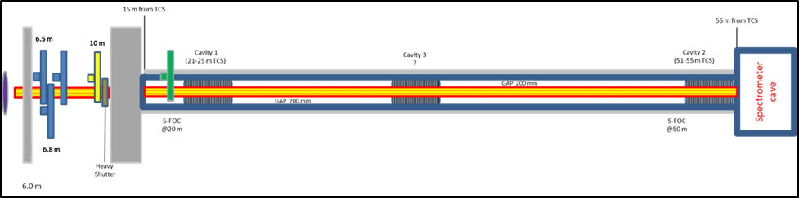

Figure 1 – VESPA beamline scheme, guide is evidenced in yellow.

**Beamline Orientation:**

ISCS definition

The definitions of the ESS Coordinate Systems (CS) are reported in “Main Coordinate System at the ESS”, ESS-0035090, and the following definitions are used:

* ISCS, Instrument Source Coordinate System. The ISCS is determined in this document.

TCS Target Coordinate System

* Origin in the center of the monolith, defined as the intersection of the proton beam with common vertical axis of the two moderators;
* X axis pointing upstream the proton beam;
* Z axis collinear to gravity in the opposite direction;
* Y axis is defined following the right hand rule.

FP Focal Point (East sector, beamport E7):

* Origin at (54, -89, 137) mm in the TCS;
* XFP axis at a 66’ angle with the TCS X axis;
* ZFP axis collinear to gravity in the opposite direction;
* YFP axis is defined following the right hand rule.

**ISCS**

The origin of the ISCS is the point on the moderator considered as the neutron source for a given instrument.

The ISCS is specific for every instrument and its position and orientation are driven by the needs of the instrument.

The direction of the axes is defined as follows:

- X is pointing downstream the neutron beam.

- Z is perpendicular to X and shall belong to the plane containing X and the gravity, and opposite to gravity

- Y is defined following the right hand rule

The goal is to get the highest thermal flux possible for VESPA without cutting too much of the cold neutrons. As thermal flux we describe neutrons 100meV and above.

In order to collect a higher flux of neutrons in the desired range of energy for VESPA, a shift of the beamline along the direction of the y’ axis keeping it parallel to the beamport axis is required;

This shift brings to the definition of the Instrument Source Coordinate System (ISCS) .

**VESPA ISCS** origin respect to the TCS is (40,-95,137)

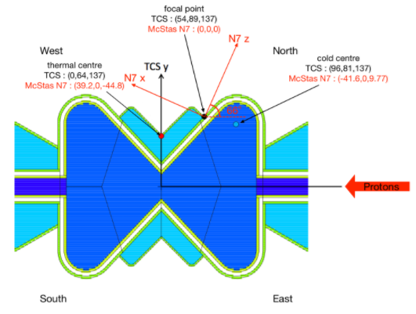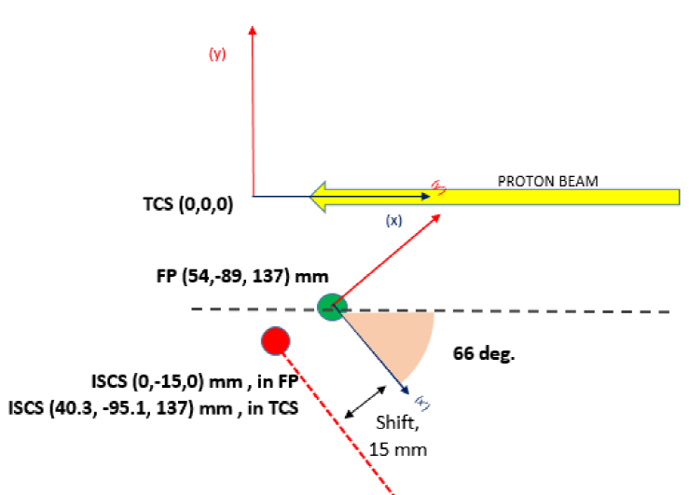

Figure 2 – Identification of CS.

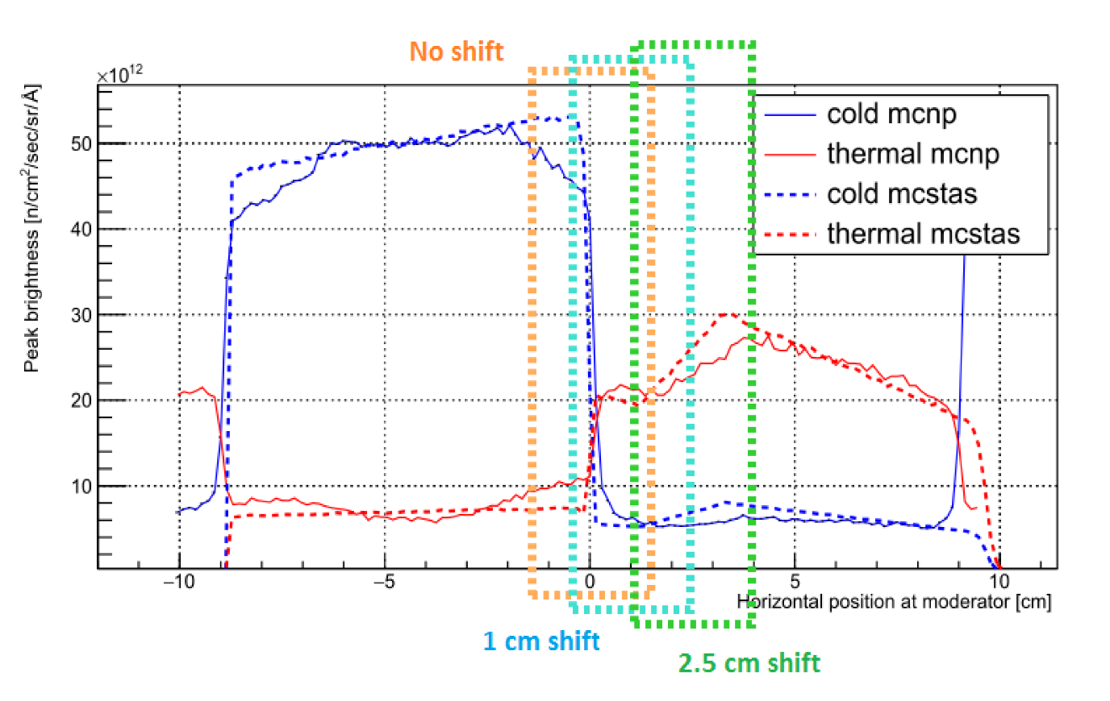

Figure 2 – Sample direct view, direct neutrons (ESS-0068256). Cold < 20 meV < Thermal < 100 meV.

**Feeder** **/NBOA**

NBOA stands for the**N**eutron **B**eam **O**ptics**A**ssembly. It is a small part of the NSS projects (thus instruments) installed within the Target monolith shielding.

NBOA will have an overall nominal length of about 3.5m, though some units on beam-ports close to the proton beam axis will be a little shorter . To ease construction and installation it is envisaged to construct NBOA in 3 sections 1.0m / 1.0m / 1.5m each separated by a short gap.

As indicated by the name the device is an optical component whose principal function of the device is to efficiently transport selected neutrons from the neutrons from the moderator out to surface of the monolith.

The NBOA comprises;

* Optical components (reflective or not)
* Mobile shielding components (the thick substrate backing)
* All alignment and features, both mobile and static. (adjustment screws and plates)
* Mobile additional fluid cooling features as required.

All components are required to work closely together and will be tailored to the specific requirements of the instrument in question, thus it is proposed that all are designed and procured as part of the same assembly.

**Instrument project scope - clarification**

NBOA are part of the instrument construction work package. The design, specification, procurement and integration of these devices are the responsibility of the instrument concerned.

The engineering integration with monolith systems (i.e. the current NBOA team activities), the post-delivery physical integration and alignment into the insert plug (NBEX), the installation of plugs into the monolith and alignment survey of completed units will be conducted under the responsibility of the ESS and overseen by the optics group.

**VESPA feeder/NBOA design**

Three geometry options have been simulated to verify the best performance in extracting neutron from the moderator view:

1. Straight tapered opening geometry
2. Straight tapered focusing geometry
3. Elliptical focusing geometry

The feeder geometry options were tested with different downstream guide system geometries;

**Brief summary on NBOA geometry tested**

1. Elliptical guide insert only gives gain for cold neutrons. Performance for thermal neutrons is the same as with a focusing tapered guide insert. No matter which guide is used at the rest of the beamline, the elliptical insert gives only gains for neutrons in the range of 5 to 100 meV (e.g. 20% gain at the chopper position. Elliptical guide with tapered opening insert shows better performance than elliptical guide with elliptical insert for thermal neutrons but performance is a bit worse for cold.
2. Tapered closing insert shows a significant gain for thermal neutrons provided the m-value of the supermirror coating is high enough. This entails higher costs. The insert can be used effectively with a subsequent tapered or elliptical guide.
3. Following (2), the option of leaving the monolith insert “empty” with a few collimation pieces was considered as a fall-back option, since it has the advantages of less risks of radiation damage to the supermirror surfaces within the monolith. This might actually be a good performing, cost saving option that will only reduce the amount of cold neutrons in the beamline, without reducing the delivery of thermal ones with respect to other focusing insert options.
4. The tapered insert opening up gives a significant gain for thermal neutrons.

The divergent (or opening) linear tapered optic resulted to be the best option for the instrument. The dimensions of the beam cross section are defined as 35x35 mm2 at 2 m from TCS and 40x40 mm2 at 5.5 m from TCS.

This may over illuminate the beam-section at the choppers. A simply straight feeder might be used as well, but will be less performing when second order effects (such as neutrons coming from the pre-moderators) are taken into account.

For improved clarity, a sketch is here reported:

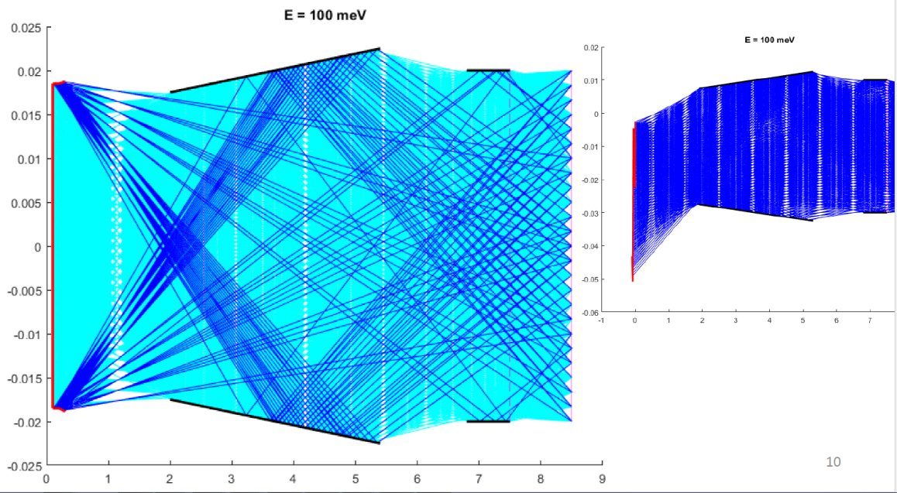

Figure 3 - opening geometry NBOA. Moderator in red, supermirrors in black, chopper section in lilla. Where two colours for the neutron trajectories are present, the darker one shows neutrons coming from the pre-moderators.

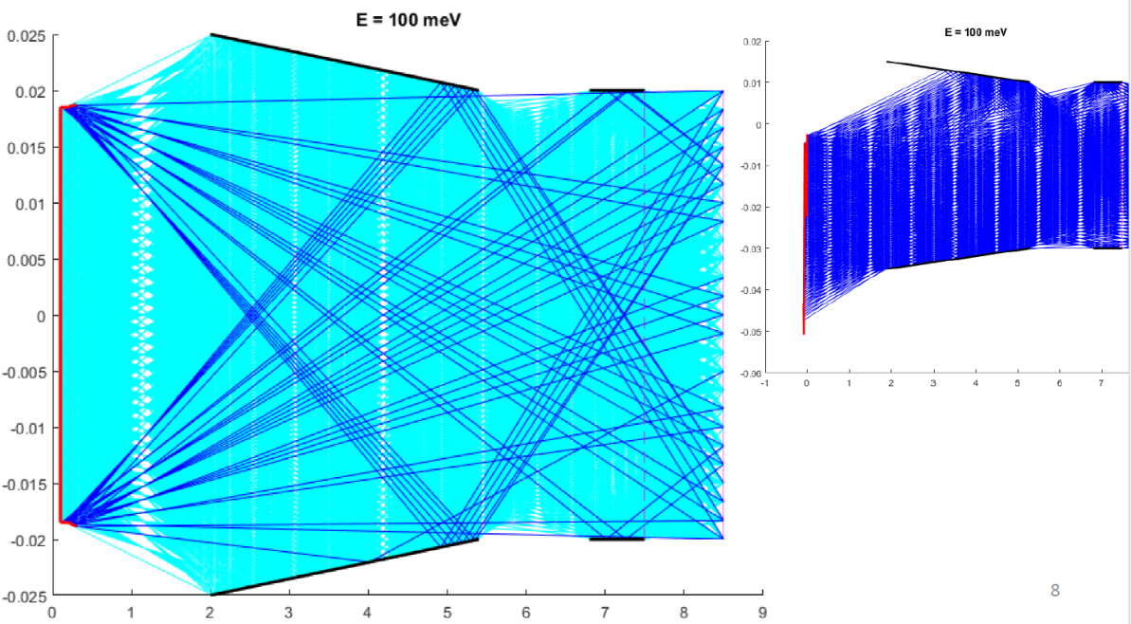

**Figure 4 - closing geometry NBOA. Moderator in red, supermirrors in black, chopper section in lilla. Where two colours for the neutron trajectories are present, the darker one shows neutrons coming from the pre-moderators.**

**NBOA Reflectivity value**

Different values of reflectivity (m) were tested to assess the performance of the NBOA, and the risks associated to the degradation of the coating with m value>6 due to high irradiation level brought to a first choice of m=5;

Following NBEX note of May 15th 2017 where a cap on the reflectivity value for the NBOA of m=4 was communicated the m-value of the insert optics has been reduced accordingly. An assessment of the effect that such a constraint could determine was done considering the downstream guide system (after 5.5 m from TCS), for the two options of guide system geometry considered (elliptical E2, or straight tapered T2, see next paragraphs for details). The comparison of neutron delivery performance is reported in the following figure, and the change to m=4 affects moderately and equally both options. The effect on neutrons which could come from the pre-moderators was not assessed, but we expect a slight reduction.

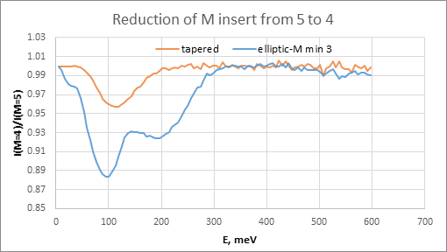

Figure 5 - effect of reduction of the m value of the feeder from 5 to 4.

**NBOA VESPA specifications**

On April 2017 the specification for the NBOA as requested by ESS were communicated, and the ESS-0105565 was released; confirmation of the design after the ESS proposed modification due to the m value cap and the clashes detected with the thicker windows choice were accepted;

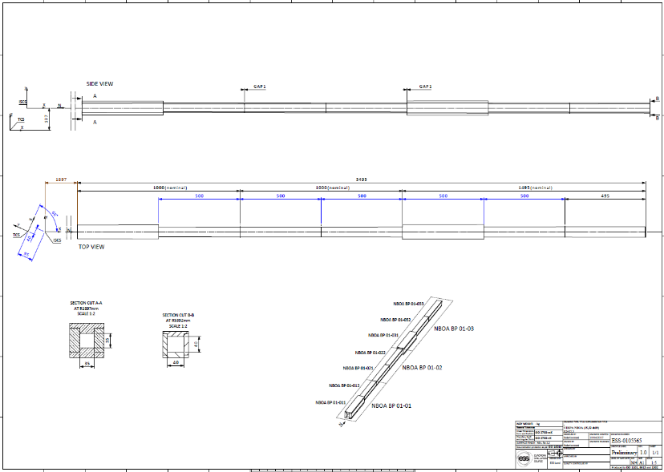

Figure 6 – VESPA NBOA drawing ESS-0105565.

**Guide System**

At the end of the feeder/NBOA section (~5.5 m from TCS) the VESPA guide system starts to deliver the collected neutrons up to the sample position at 59 m. Tt is assumed that a mirrored guide section will be enclosed in the LSS (Light Shutter System) between 5.5m and 6.0 m from TCS).

For the downstream beamline, two geometry options have been considered: straight tapered and elliptical, with different cross section sizes.

The best performing profiles for each geometry are reported in the following figure, where the half-cross section is plotted on the y axis, while the x axis reports the distance in metres from the moderator; both the options have a squared cross section, so the horizontal and the side view have the same profile. The profiles are compared with the former guide design, which was discarded after the scope-setting meeting.

Ideal m-values for the two guides are reported as well. The cap on the maximum m-value is not reported and should be taken into account by the reader. We expect that an optimization of the m-profile for the straight guide in order to reduce the average m-value can be performed if necessary.

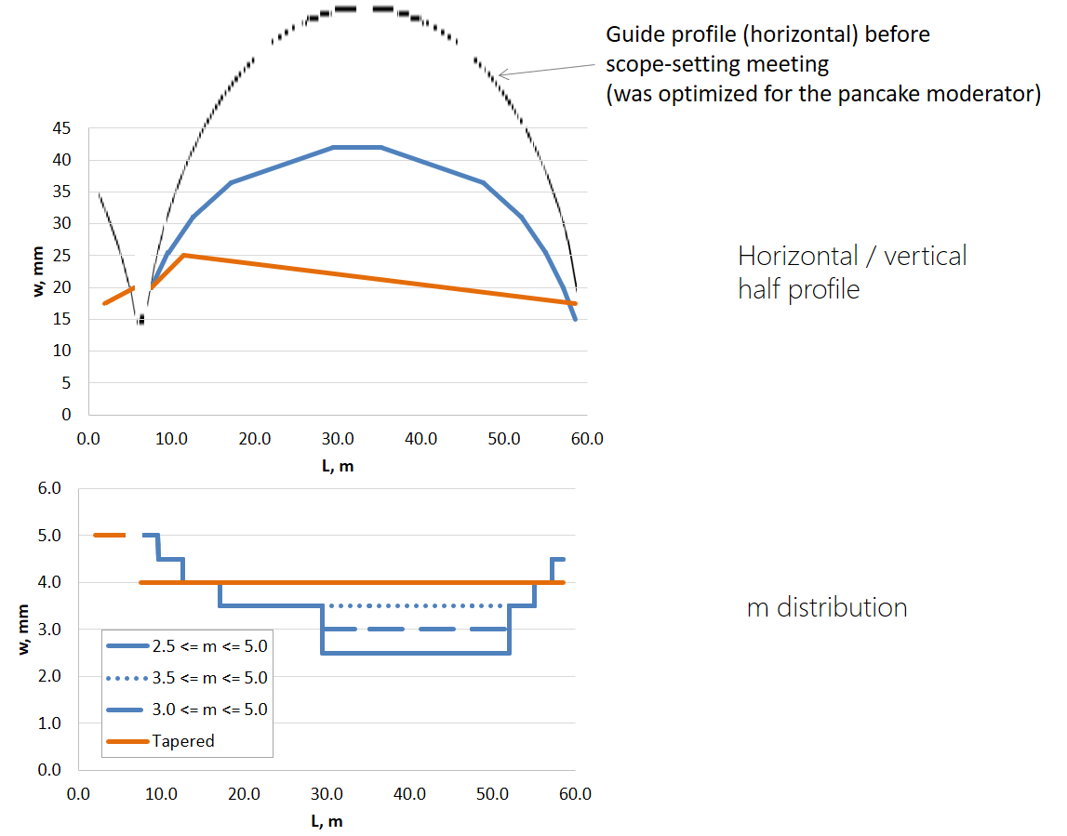

Figure 7 – VESPA beamline guide profiles.

The performance of the two geometries were assessed by neutronics simulations (McStas) and the differences resulted neither ground-breaking nor negligible, as described in Figure 8. The straight tapered guides shows a more homogeneous beam profile at the sample and has slightly better divergence figures. Nevertheless, both the guides are within the divergence requirements.

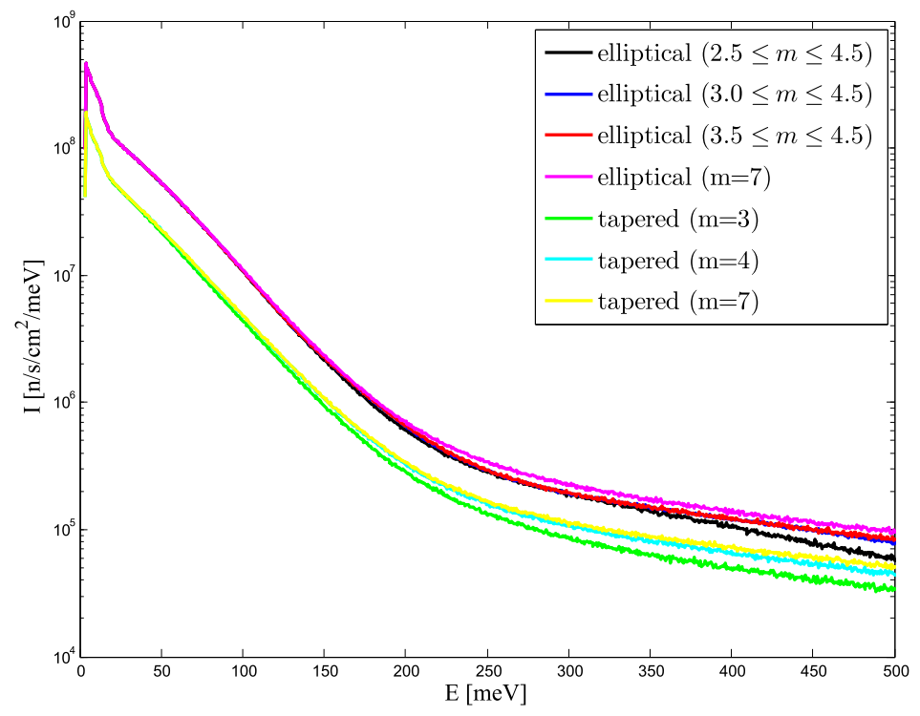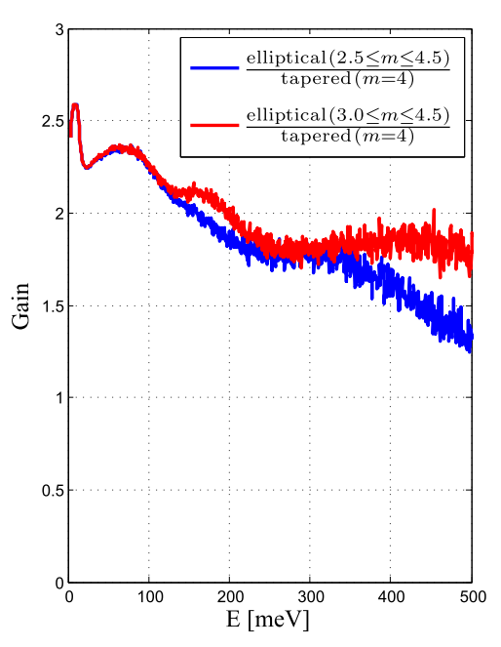

Figure 8 – Comparison of the neutron delivery at sample position, different guides and m-values.

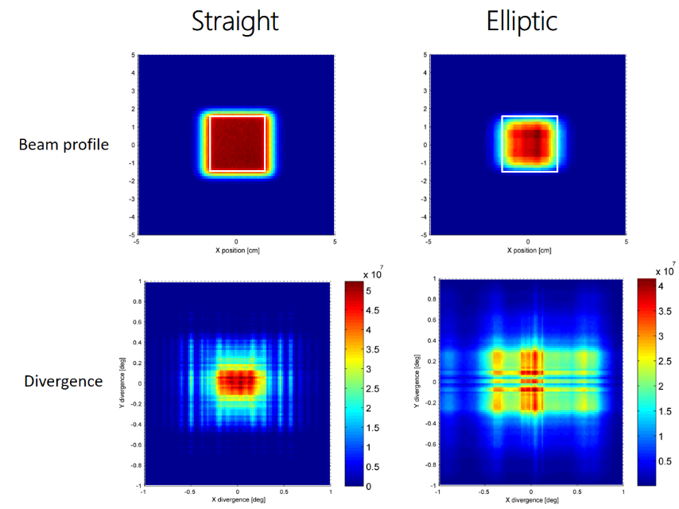

Figure 9 – Beam profile and total divergence at sample position. White borders identify sample dimensions.

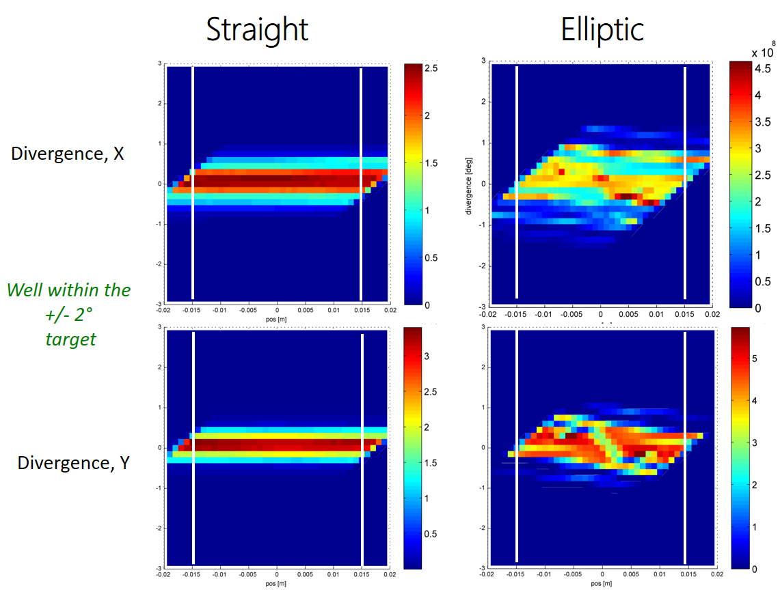

Figure 10 – Divergence at sample as a function of the position. White borders identify sample dimensions.

Given pro & cons of the two options, in order to have additional elements to address the choice of the geometry and carry on further optimization on a selected geometry, the supplier Swiss Neutronics (SNAG) was asked for a preliminary quotation for guide systems with the following specifications:

1. Straight tapered profile m=3 (T1)
2. Straight tapered profile m=4 (T2)
3. Straight tapered profile m=5 (T3)
4. Elliptical profile distributed m range 2.5 – 5 (E1)
5. Elliptical profile distributed m range 3.0 – 5 (E2)
6. Elliptical profile distributed m range 3.5 – 5 (E3)

SNAG provides a cost estimates that include

* Substrates: borkron glass throughout.
* Coatings: Ni/Ti, specifications as given on the web page of SNAG: <http://www.swissneutronics.ch/index.php?id=24>
* Assembly of the guide with either linear or elliptic tapering.

T1: tapered, m = 3:          CHF     907'300  
T2: tapered, m = 4:          CHF  1'267'400  
T3: tapered, m = 5:          CHF  3'396'200  
  
E1: tapered, m = 2.5/5:    CHF  1'400'900  
E2: tapered, m = 3.0/5:    CHF  1'538'900  
E3: tapered, m = 3.5/5:    CHF  1'716'500

The options T2 and E2 have been then kept as reference for addressing the choice of the shape having similar performance in terms of neutrons delivery (TBC);

**T2: tapered**, m = 4:          CHF  1'267'400 = **1140 k€**

**E2: tapered**, m = 3.0/5:    CHF  1'538'900 = **1406 k€**

A further consideration about the cost difference between these last two options concerns the metallic substrate, that is not an option at least in the first 20 metres of beamline; in fact Al-based substrates are lasting longer but are €30 000/m2 more expensive than the N-BK 7 glass based one.

Considering the guide surface of the 2 options E2 is 16/9 larger than T2;

Considering the surface from 2 m to 22 m from TCS we have the following surface of mirrored guide and the amount of substrate for the 2 options bring to the following additional cost:

**T2 surface** (2-22 m from TCS): ~ 1.6 m2 => 1.6*30 = **47.69 k€**

**E2 surface** (2-22 m from TCS): ~ 4.64 m2 => 4.64*30 = **139.29 k€**

TOTAL COST for the guide system with metal substrate from 2 to 22 m is:

**T2 tapered** ~ **1207 k€**

**E2 tapered** ~ **1545 k€**

At this point of the project the VESPA team agreed to further develop the instrument having the T2 geometry as a baseline configuration, according to a cost/benefit consideration evaluating the target value of flux at the sample required by the instrument, and the increase of neutron flux vs the increase of costs of the two options; so the T2 profile is being optimized now with the introduction of details in the beamline such as air gap, and neutron windows along the neutron path;

later on, a refinement of the E2 is possible and a review of the choice can be made.

For this purpose it was crucial to adopt a feeder design that can pair evenly with both guide geometry profile.

**VESPA Shielding**

The shielding of the beamline in the instrument hall is under definition;

The design options include a conventional design with reference to the concepts proposed by ESS, with the additional implementation of cavities with discs of steel and tungsten along the beamline to reduce the neutron streaming and the related background noise at the detectors;

The definition of the thicknesses of the shielding component along the beamline rely on the neutronics calculation in progress at the present time; shielding performance need to be evaluated for the chopper pit of the s-FOC at 20 m from ISCS, for the beamline shielding in the instrument hall, and for the shielding of the experimental cave and the experimental hutch on top of the spectrometer.

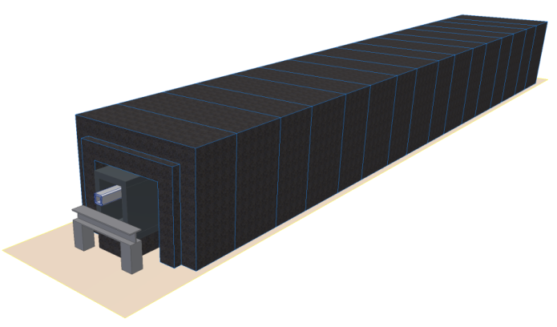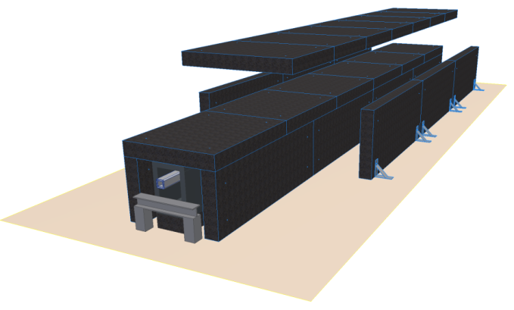

Figure 11: ESS suggested shielding concepts

The shielding of the beamline scales with the size of guide; the space between guide housing and shielding should be at least 20 cm;

Assuming that a cross section of 3 cm x 3 cm should require at least 40 cm of concrete, and 20 cm steel tickness, and a cross section of 8 cm x 8 cm requires a minimum of 50 cm of concrete, and 30 cm of steel, VESPA team is evaluating the effectivness of the shielding for the baseline guide system with geometry T2;

A concept of the shielding layout is sketched in the figure below

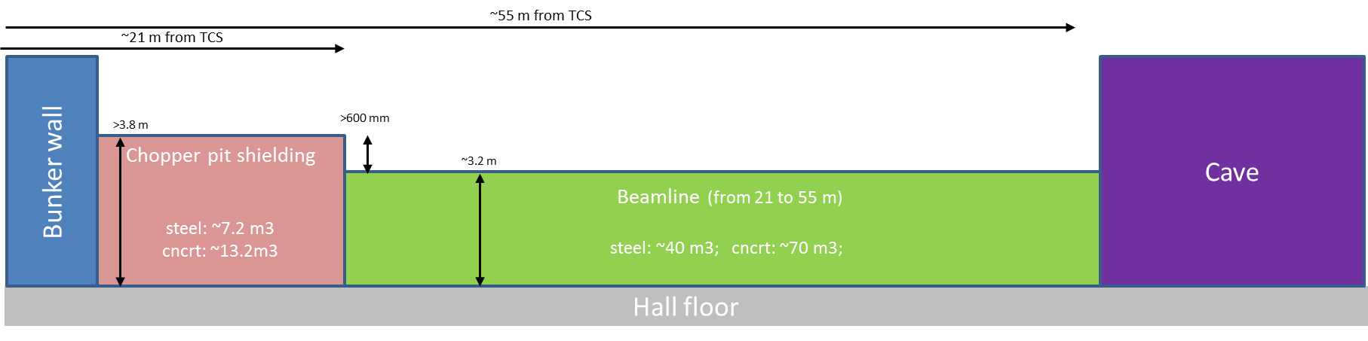

Figure 11 VESPA shielding layout

To improve the shielding of background noise at the experimental cave, the introduction of cavities along the beamline is under evaluation, following the design sketched in the figure below

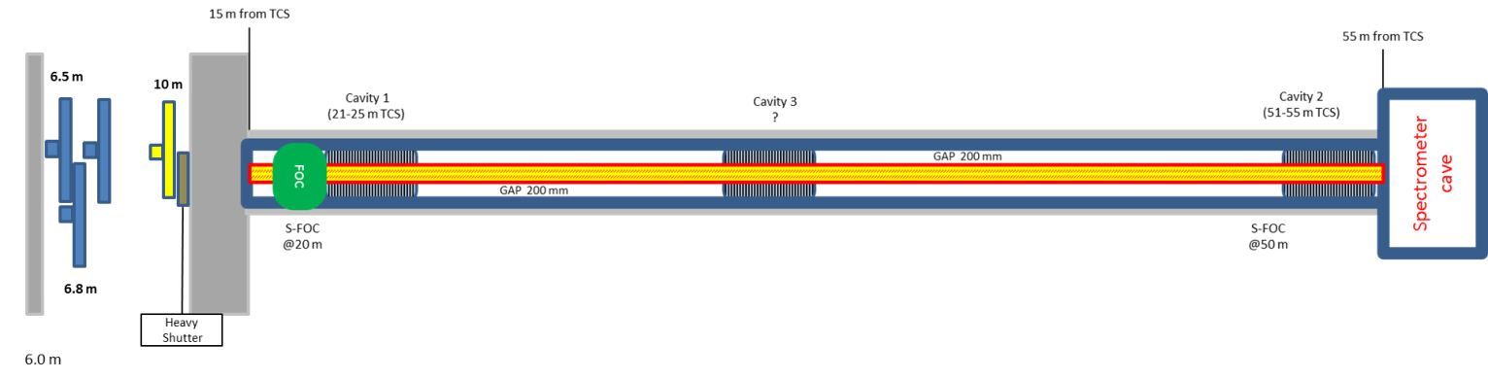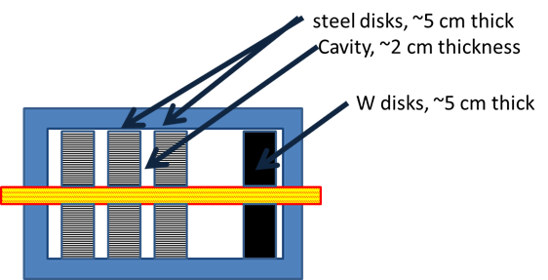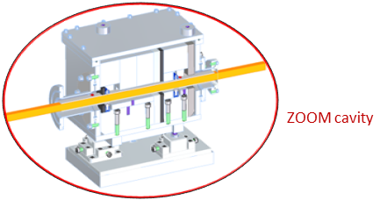

Figure 12: VESPA shielding concept with ZOOM-like cavities

An alternative design will be tested with neutronic simulation to asses the effectivness of an even improved reduction of the background noise, adopting a X-mas tree profile of the shielding walls along the beamline: a preliminary design of this option is showed in the picture below.

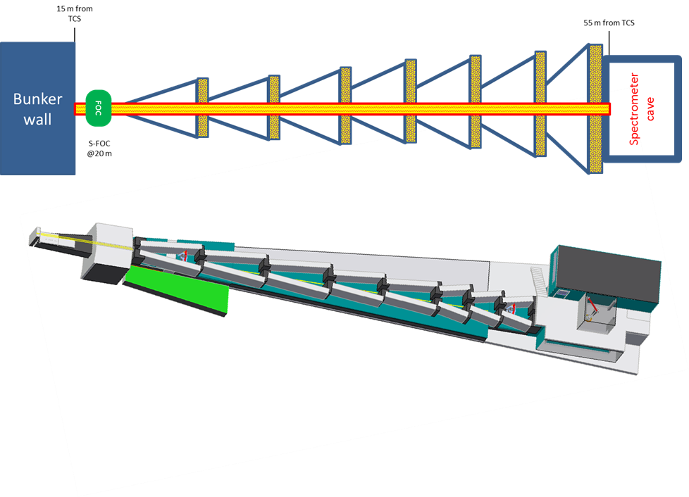

Figure 1 VESPA X-mas tree concept shielding

The results of the neutronic calculations will be then evaluating together with the complexity and cost of the design options to provide an optimal solution for the instrument shielding.