14/07/2017

**Chopper System**

The chopper system of VESPA counts 5 choppers plus a Prompt Pulse Suppression chopper at the full scope stage of the instrument;

in the figure 1 it is shown the location of each chopper along the beamline, for each one it is indicated the distance from the ISCS in meters.

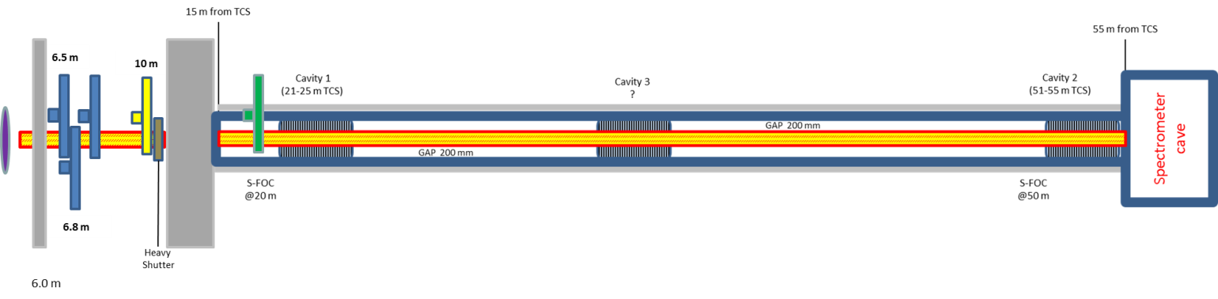

*Figure 1 VESPA layout: the guide system is made of 3 section of supermirror m=4 with a straight tapered profile except a straight section crossing the triple WFM chopper system from 6.5 to 7.5 m distance from moderator*

VESPA needs three Wavelength Frame Multiplication Pulse Shaping Chopper (WFM-PSC) enabling the instrument to vary the resolution between two settings: low (∆*t/t =* 1.4%), and high resolution (∆*t/t =* 0.4%), depending on the choppers in use (only two choppers at a time will be used, the other leaved in an open position).

In addition to the WFM Pulse-Shaping Chopper (PSC), a Frame-Overlap Chopper (FOC) and a sub-Frame Overlap Chopper (s-FOC) are needed to keep the three bands well separated in time.

Table 1 reports details on disc diameter, rotation speed and cross section of the beamline (straight tapered baseline option); the choppers are double-disc counter-rotating chopper pairs except the FOC at 10 m from the ISCS that has a single disc;

*Table 1 VESPA Choppers system*

|  |  |  |  |  |  |  |
| --- | --- | --- | --- | --- | --- | --- |
|  | dist from mod [m] | Disc diam. [mm] | Freq [Hz] | Beam Size [mm^2] | Cut direction | Abs material |
| WFM PSC 1 | 6.5 | 700 | 154 | 40x40 | Opposite | B10 |
| WFM PSC 2 | 6.8 | 700 | 154 | 40x40 | Opposite | B10 |
| WFM PSC 3 | 7.44 | 700 | 154 | 40x40 | Opposite | B10 |
| FOC | 10 | 700 | 28 | 46.3x46.3 |  | B4C |
| **PPSC** | **TBD** |  |  | 47X47 |  |  |
| s-FOC | 20 | 700 | 42 | 47.3x47.3 | Opposite | B4C |

The choppers system is made of pretty standards components in term of disc diameters and rotation speed and the current available technology can provide the requested performance of the system;

the ESS environment needs special care in the design of the components operating inside the bunker in term of installation and servicing, for this reason special frame and tool for remote handling were taking into account estimating the cost of the system;

**WFM PSC sub-system**

The triplet of chopper enabling the variation of the resolution of the instrument needs a very compact design having the three double-disc choppers within 6.5 and 7.5 m of distance from the ISCS;

Operating in-bunker needs remote handling features and an “extracting operation” plan;

The proposed solution considers to have the three DD choppers units sharing a common vacuum box, the box also acts as a support structure for the spindle units;

for reason of space constraints, the discs of each chopper are mounted in an over/under configuration, with one of the disc of the pair mounted with the axis above the beam, and the other one with the axis mounted below the neutron beam; the vacuum box and the three choppers makes a unique block that is moved as a single unit for the remote handling operations and servicing;

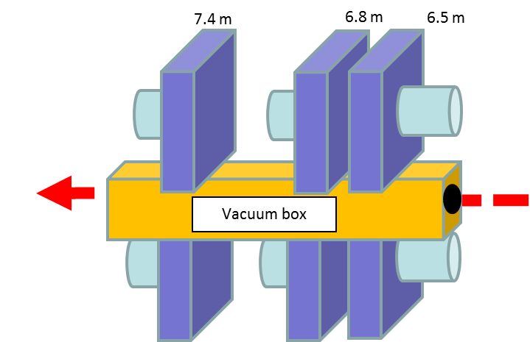

Figure 2 WFM assembly concept: vacuum box supporting discs and spindle units

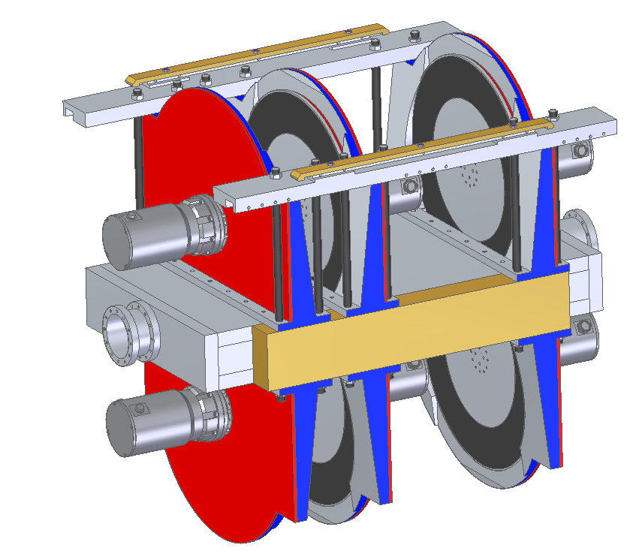

Neutron beam

*Figure 3: WFM-PSC triplet design concept*

*Figure 4: in-bunker frame and choppers assembly concept*

**WFM PSC CHIM**

A dedicate frame fixed to the baseplate in the bunker floor integrates the remote handling and precise positioning features to allow the WFM assembly to be craned in place inside the bunker; (the ESS-0041194 variant can be considered an option?)

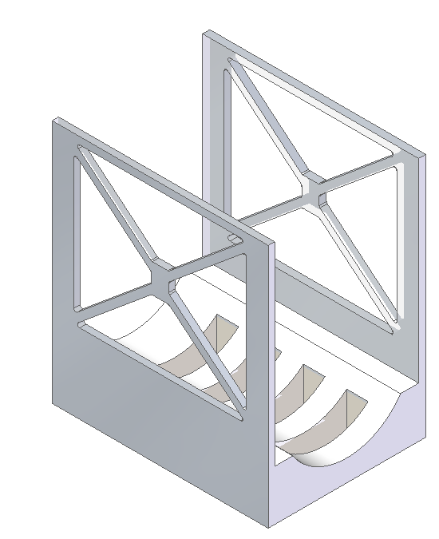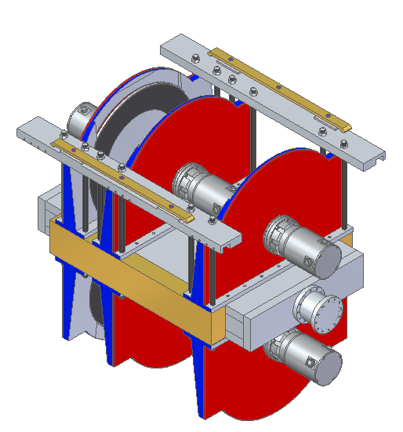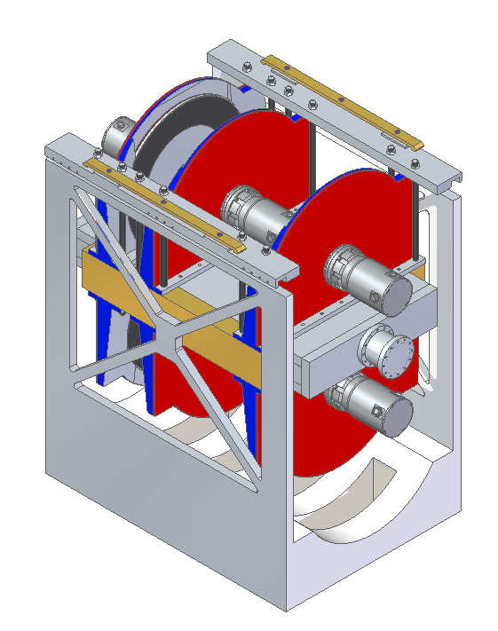

*Figure 4: WFM-PSC assembly and dedicated CHIM design concept*

The special needs of compactness of the WFM arrangement brought to the design of a specific CHIM; the detailed design is still in progress, and some development task is needed and planned to be done to deliver the system;

in the following a list of the features included in the CHIM and WFM assembly:

* Vacuum box, choppers, CHIM will be integrated with features to limit any vibrational transmission from a module to the other (magnetic bearings spindle unit), avoiding critical resonance effects, and mechanical stress, precise alignment of the spindle units (avoid gyroscopic effect stress/bent);
* The CHIM integrates features for the precise positioning of the chopper assembly, and remote handling and extraction (repeatability ±0.25 mm according to ESS-0041170)
* CHIM integrates holder for two beam monitors (normalization and diagnostic) after the last chopper of the assembly at 7.44 m from ISCS
* CHIM integrates a connection plate where the umbilical connects the required services and utilities cables (ESS-0041170)
* A pit head box fixed close to the CHIM will provide the connection point with the umbilical
* Utilities to the WFM assembly are: vacuum, gas for monitor(? ESS-0041175)
* a package of cables for the SKF G5 system and monitoring sensors will be connected to the chopper system via the umbilical
* the common vacuum box of the WFM will be separated from the adjacent component (LSS @ 6.0 from TCS, beam line guide @~7.8 m from TCS) by two neutron windows (Al, 1mm thk?) and a gap min. 8 mm to allow the remote handling
* total weight of the “extractable” assembly <2000kg

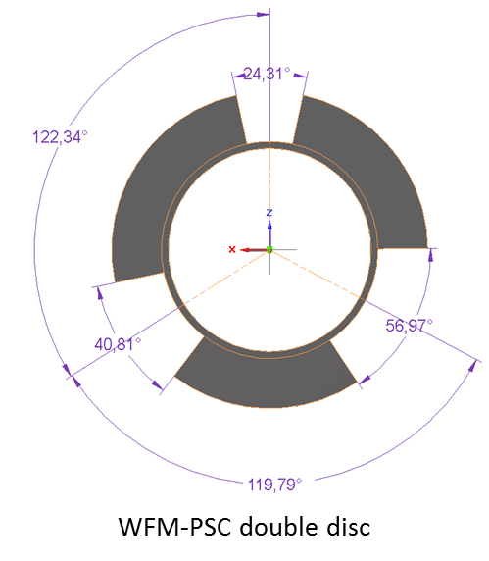

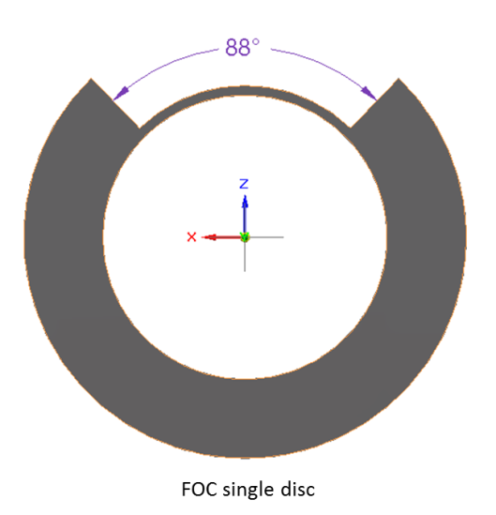

FOC slits pattern

WFM-PSC slits pattern

**Frame Overlap Chopper**

The FOC is a single disc chopper at ~10.1 m from TCS with a small rotor (700 mm diam) that can be fit in to the Pillar DC-SR variant or the horizontal-split DC-SR variant CHIM; this component includes all the required features for the in-bunker installation, and it will be separated from the adjacent components by two windows (Al, 1mm thk?) and a minimum gap of 8 mm.

**Sub-Frame Overlap Choppers**

The s-FOC is placed at 20 m far from the ISCS, is a double disc chopper and the proposed configuration is the over/under one, with the spindle units above and below the beam; also a face to face discs configuration may be possible;

The enclosure integrated DC-SR CHIM can be the preferred solution for this chopper, which diameter is <700 mm, and speed is 42Hz.

Being a standard unit, it follows the design proposed by ESS for all the related features for handling and interface with the utilities coming form the instrument hall;

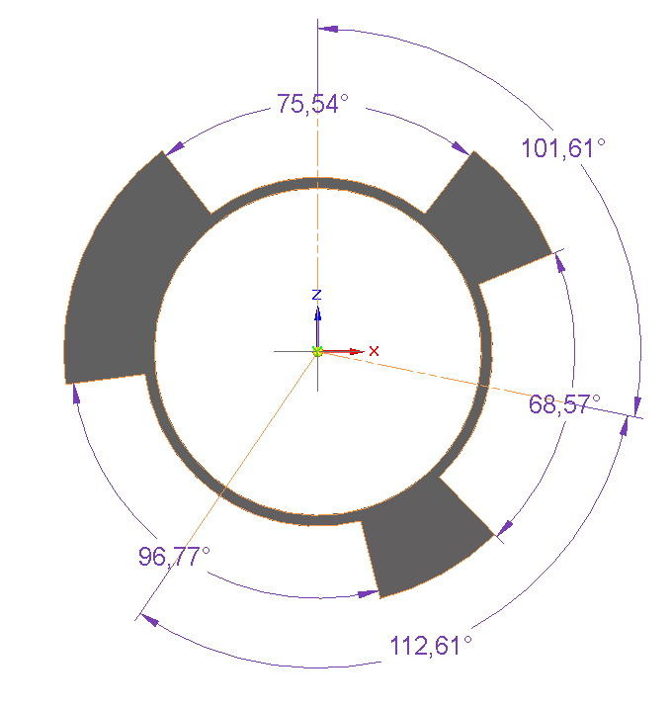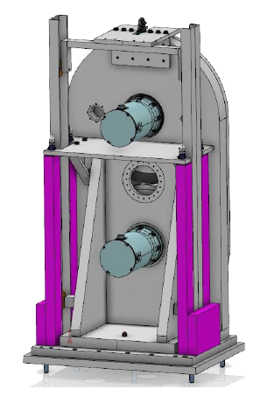

s-FOC slits pattern

*Figure 5 The ESS enclosure integrated DC-SR CHIM*

**Prompt Pulse Suppression Chopper**

This component is considered as the first upgrade stage of the instrument; in order to meet the budget for its class (12 M€) VESPA can be operated without such a component in day one, although it can surely benefit of such improvement in the next future;

The PPSC, whose design details still are missing, will be mounted as close to the bunker wall as possible; the present design of the instrument considers the PPSC installed between 15.5 and 18 m far from the moderator, right before the s-FOC; the beam shielding just off the bunker wall is designed to make possible the installation of the PPSC in the instrument without the need of major modification.

**In bunker chopper system details**

A brief description of the in bunker area (6.0-11.5 m from TCS) is reported in the following to illustrate the arrangement of the 4 choppers unit in that space and the remote handling strategy considered

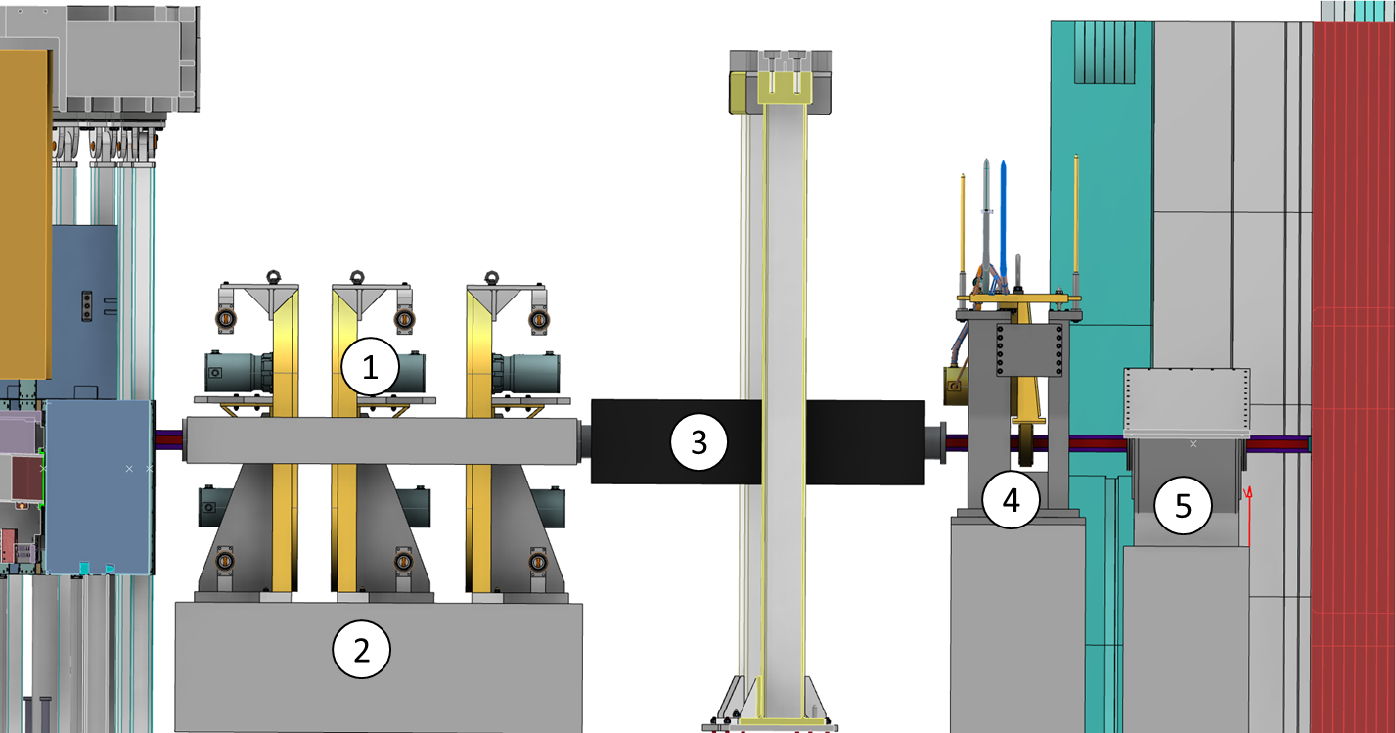

*Figure 6: VESPA in bunker components*

With reference to the above picture 6 the items placed in the bunker area are:

1. WFM-PSC chopper assembly
2. WFM-PSC support frame fixed to the bunker floor baseplate
3. Mirrored guide section (7.8-9.7 m from ISCS)
4. FOC single disc assembly
5. Heavy shutter

Each of the above blocks (1 and 2 considered together) are separated by windows and an air gap of 8 mm, to allow the remote handling avoiding interference during the extraction operation from the bunker rroof;

The strategy for the access to one of the components in the bunker is to crane them up vertically;

Doing this it is necessary to consider the roof slab over the LSS that interfere with the WFM assembly which first chopper is at 6.6 m from TCS;

This requires a horizontal translation towards the beam direction, in order to avoid any clash with the roof slab;

Also the supporting beam of the bunker roof at ~8 m from TCS is a constraint for the remote handling operations;

This beam can be removed but if the removal operations results time demanding alternative solutions are possible;

In the following a scheme for the remote handling extraction of the in bunker area is proposed for two options.

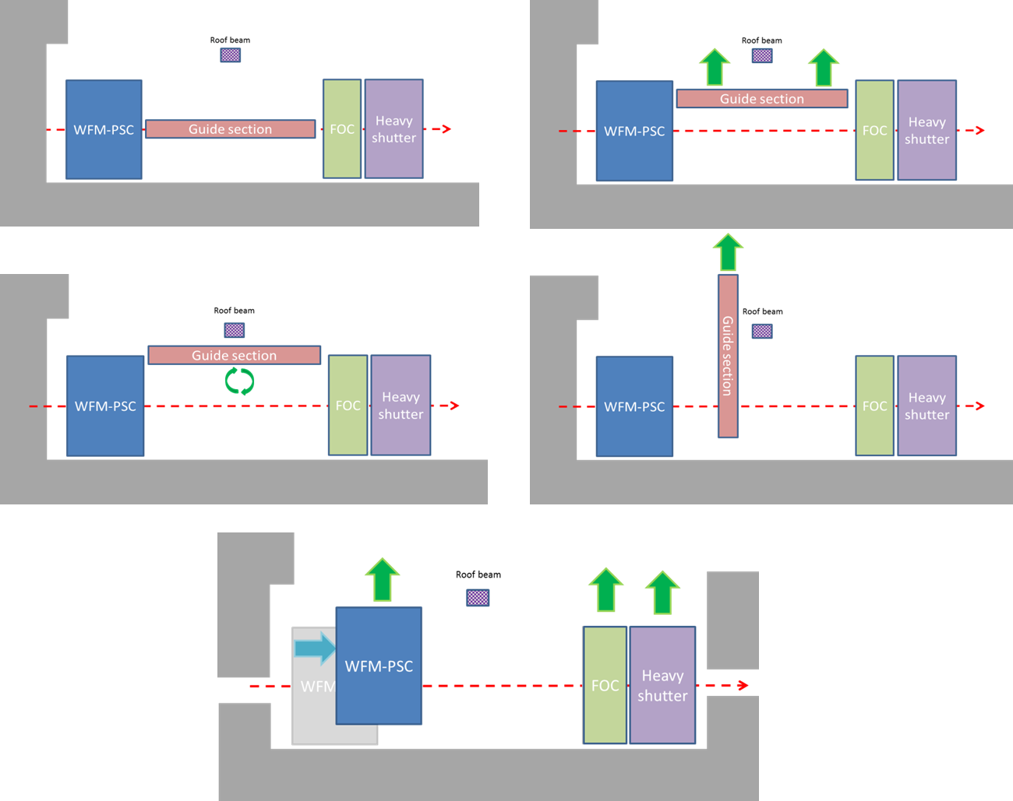

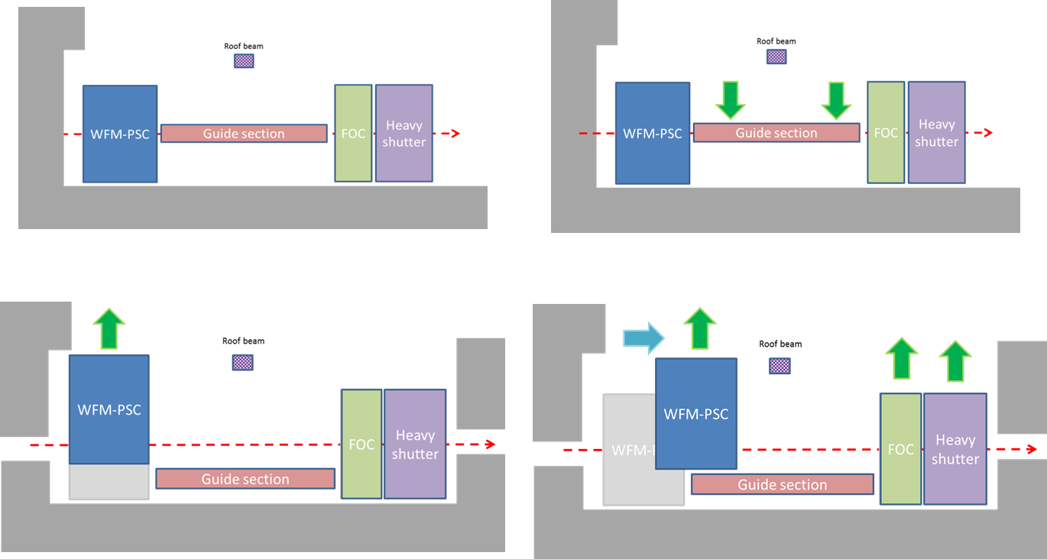

**Cost estimation**

The estimation of the cost for the chopper system is based on the ESS guidelines (ESS-0060400 Neutron Chopper Systems Costing Estimate) and the ISIS database of recent projects.

The two approaches brought to a similar estimate of costs and the details are shown in the following tables, considered that the ISIS cost estimation includes equipment only.

|  |  |  |  |  |
| --- | --- | --- | --- | --- |
|  | **ISIS approach estimation** | | |  |
|  | WFM PSC double-disc Choppers 700mm dia @ 154Hz (3-OFF) | FOC single-disc chopper 750mm dia @ 28Hz (1-OFF) | sFOC double-disc Chopper 750mm dia @ 28Hz (2-OFF) |  |
|  |  |
|  | 3 CHOPPERS (€K) | 1 CHOPPER (€K) | 1 CHOPPER (€K) |  |
| DISC | 141.60 | 9.44 | 16.52 |  |
| HOUSING | 88.50 | 17.7 | 29.5 |  |
| SPINDLE UNIT | 247.80 | 36 | 73.8 |  |
| CABLES | 53.10 | 11.8 | 17.7 |  |
| BEAM BOX | 53.10 | 11.8 | 17.7 |  |
| ALIGNMENT SYSTEM | 42.48 | 14.16 | 14.16 |  |
| HANDLING/SERVICES | 42.48 | 11.8 | 14.16 |  |
| CONTROL SYSTEM | 141.60 | 23.6 | 47.2 |  |
| SUPPORT | 7.08 | 2.36 | 2.36 |  |
| CONDITION MONITORING | 10.62 | 3.54 | 3.54 | TOTAL[k€] |
|  | **828.36** | **135.7** | **221.84** | **1207.20** |

|  |  |  |  |  |  |  |
| --- | --- | --- | --- | --- | --- | --- |
| **ESS guidelines Neutron Chopper Systems Costing Estimate** | | | | | | |
|  |  |  |  |  |  | [k€] |
| Chopper assembly | Double disc | overunder assy | in bunker | x 3 | 700 mm 150Hz | 594 |
| Double Disc | overunder assy | instr hall | x 1 | 700 mm 28 Hz | 139 |
| Single Disc |  | in bunker | x 1 | 700 mm 14 Hz | 132 |
| CHIM | PSC CHIM | for 3 dd chopper | shared vacuum | IMAT like |  | 140 |
| FOC CHIM |  |  |  |  | 38.5 |
| s-FOC CHIM |  |  |  |  | 50 |
| Chopper cntrl system | Master rack | 4 drives +1 slave |  |  |  | 30.6 |
| Slave rack | up to 8 drives |  |  |  | 11.8 |
| Drives | x 9 axis |  |  |  | 145.8 |
| Power | x 9 chopper axis |  |  |  | 16.9 |
| Support system | Vacuum | x 3 CHIM |  |  |  | 6.5 |
|  |  |  |  |  | **TOTAL** | **1305.1** |

**Chopper system time scale estimate**

According to the experience of ISIS chopper group a possible timescale for the delivery of the system is the following:

|  |  |  |
| --- | --- | --- |
|  | WFM | FOC, s-FOC |
|  | [days] | [days] |
| Concept design and review: | 120 | 30 |
| Detailed design and review: | 50 | 15 |
| OJEU tendering (possible): | 90 | |
| Procurement: | 60 | |
| Manufacturing and testing: | 40 | 15 |