|  |
| --- |
|  |
|  |
|  |
|  |
|  |
|  |
|  |
| BPM Electronics test report  European Spallation Source ESS ERIC |
|  |
|  |

April 4th, 2017

|  |  |  |  |
| --- | --- | --- | --- |
| **Date** | **Revision** | **Description** | **Authors** |
| 04 - April - 2017 | 0.1 | Initial draft.- Preliminary report | Rafael A. Baron, |
|  |  |  |  |
|  |  |  |  |
|  |  |  |  |

1. **BPM electronics performance results**

Beam phase resolution, position accuracy error and beam position resolution are presented as function of the input power of the electronics. The analysis is presented as function of the RF input power, in units of dBm, instead of as function of beam current due to the many different BPMs and beams conditions at ESS[1].

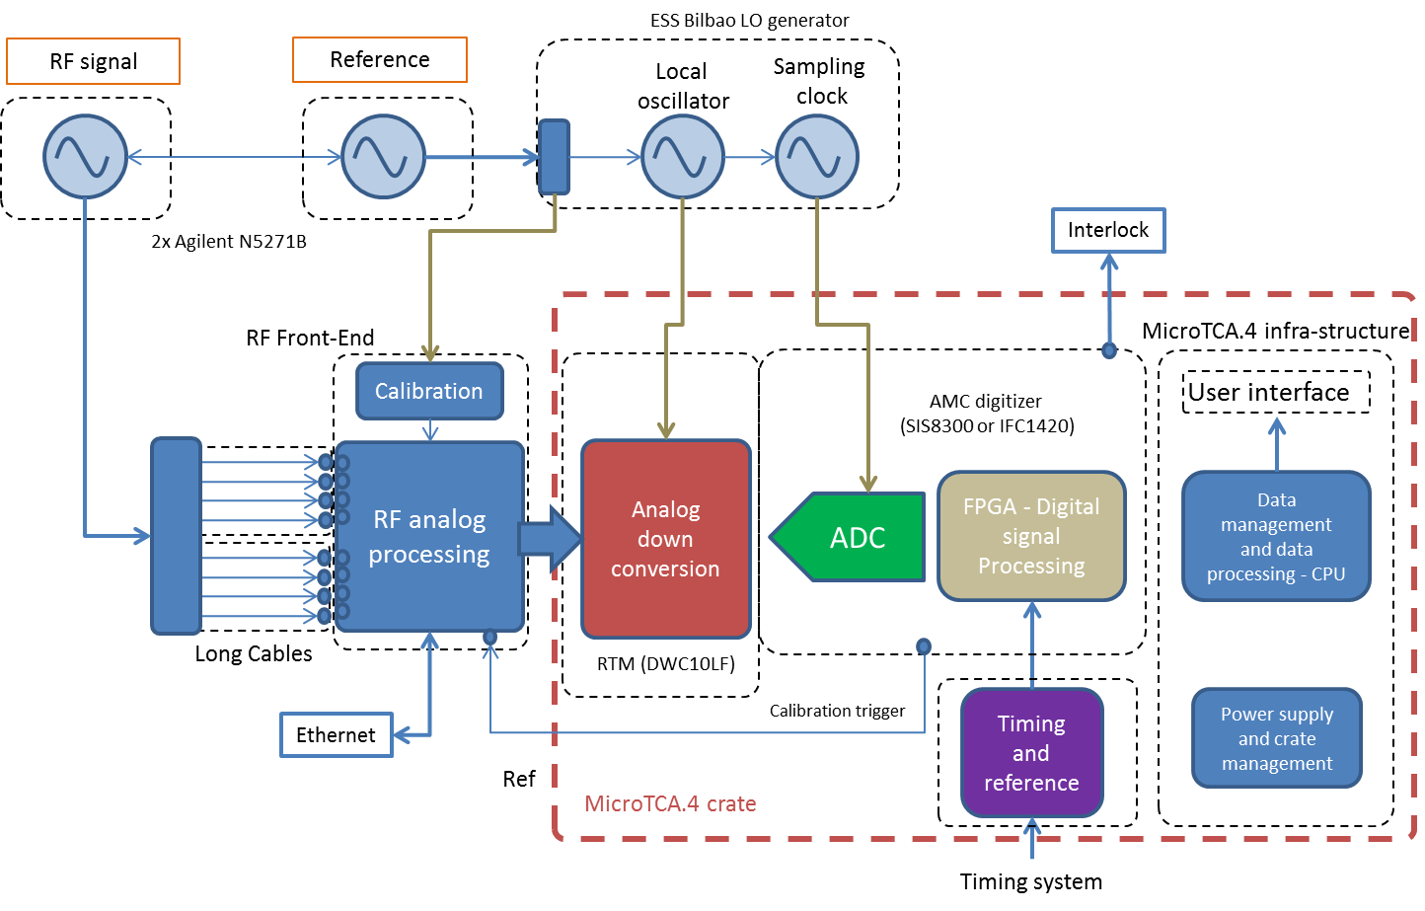

Figure: Test bench setup for the BPM electronics evaluation.SIS8300-KU is used as AMC digitizer board. No Front-end electronics used for this evaluation.

|  |  |  |  |
| --- | --- | --- | --- |
| **RF (MHz)** | **CLK (MHz)** | **LO (MHz)** | **IF (MHz)** |
| 352 | 44 | IF+RF | 4/15*CLK |

BPM electronics input power as function of the beam current for a typical LWU BPM response:



Figure: Typical BPM response for an LWU BPM

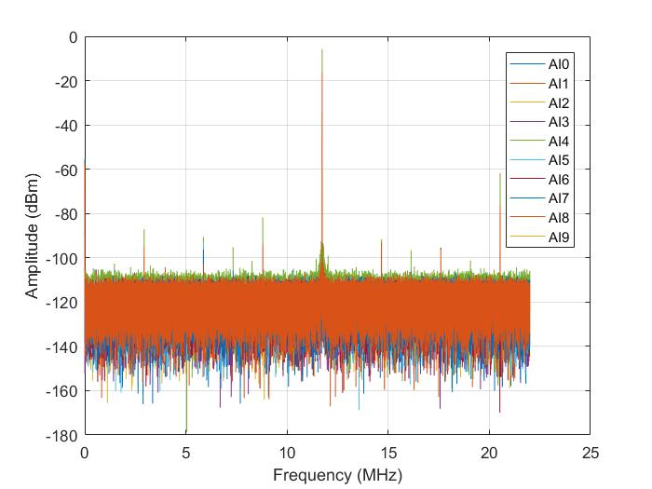

Figure: FFT of the ADC raw data for IF = 4/15*44 MHz, RF = 352 MHz and sampling frequency = 44 MHz.

Figure: BPM electronics position resolution as function of the RF input power, measured performance. The beam current dependence is also shown since it provides the information about the position accuracy error expected from the BPM electronics as function of the beam current. The calibration factor used for the position calculations is *kx = ky = 10 mm*. The RMS position resolution is measured for a FPGA DSP with 1 MHz bandwidth.

* The integrated RMS noise provides the useful information about how the noise contribution to the position resolution is distributed over frequency.



Figure: Phase measurements in time domain for BPM1 and BPM2



Figure: Phase measurements FFT for BPM1 and BPM2



Figure: Phases integrated RMS noise



Figure: BPM Positions time domain.

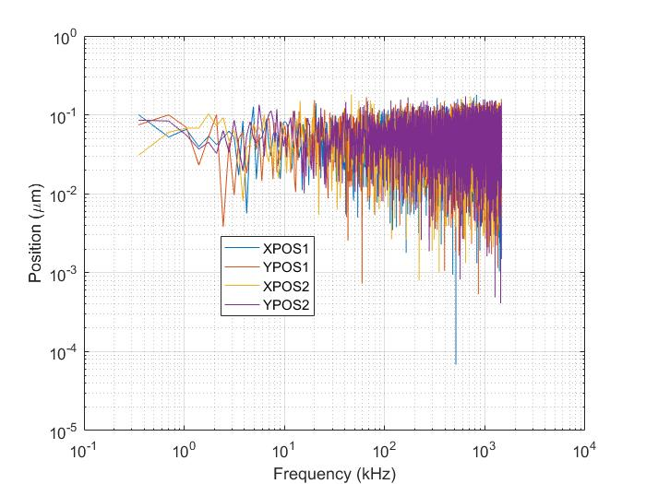

Figure: BPM Positions in frequency domain

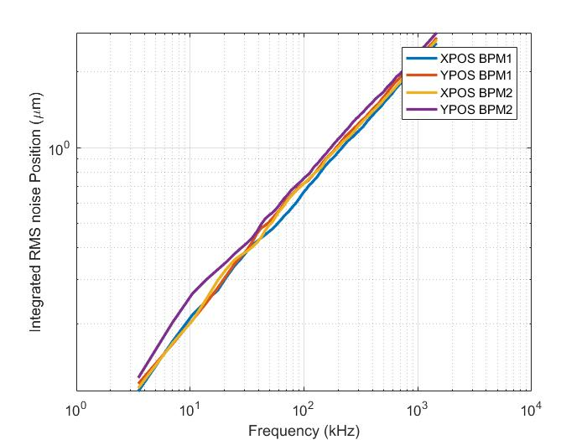

Figure: BPM Positions integrated RMS

1. The RF signal power at the BPM sensor depends on many different parameters such as the BPM sensor type, beam energy, bunch length and beam current. The relation between the beam current and input power were discussed in the previous simulations.