|  |
| --- |
|  |
|  |
|  |
|  |
|  |
|  |
|  |
|  |
| ESS LWU Beam Position Monitor Project Quality Plan |
|  |
|  |

|  | Name | Title |
| --- | --- | --- |
| **Author** | Rafael A. Baron | Beam Diagnostics Engineer |
| **Reviewer** | Fabio Ravelli | Vacuum System Engineer |
| **Owner** |  |  |
| **Approver** |  |  |

|  |  |
| --- | --- |
| Table of content | Page |

1. Scope 5

2. Input to this quality plan 5

3. Quality goals 5

4. management responsibilities within this quality plan 5

5. documentation and storage of data 6

6. Control of records within this QUality plan 6

7. Resources 7

7.1. Materials 7

7.2. Human resources 7

7.3. Infrastructure and work environment 7

8. Requirements 8

9. Customer communication 8

10. Design and development Process 8

10.1. Control of Design and Development changes 9

11. Purchasing 9

12. Production and service provision 9

12.1. Installation and post-delivery activities 10

13. Identification and traceability 10

14. Preservation of product 11

15. Control of nonconforming product 11

16. Monitoring and measurement 12

17. Audits 12

18. Implementation and revision of the quality plan 12

18.1. Review and acceptance of the quality plan 12

18.2. Implementation of the quality plan 12

18.3. Revision of the quality plan 12

19. Glossary 13

20. references 13

Document Revision history 13

<<List of APPENDICES>>

<<Appendix 1 Name of Appendix>>

<<Appendix 2 Name of Appendix>>

**SUMMARY**

A description of the quality procedures to be followed during the manufacturing process of the LINAC Warm Units (LWUs) Beam Position Monitor (BPMs) feedthroughs is presented in this document. Production quality control, documentation, production data files format, production test results and general manufacturing procedures are described.

The Project Quality Plan is described in order to assure that all the specifications will be met by the DESY feedthroughs.

# Scope

The BPMs are composed of two main parts, the electromagnetic sensor (feedthrough) and the BPM housing. The feedthroughs design and production were subcontracted by ESS Lund to DESY. DESY will delivery manufactured and tested feedthroughs to STFC Daresbury Laboratory in accordance to the procedures described in this document and the dates specified in the contract with DESY.

This Project Quality Plan is intended to describe the quality checks and approvals for the feedthroughs manufacturing, tests, delivery and assembly into the BPM housings. The quality checks include aspects such as vacuum tests, Radio-Frequency (RF) tests, data storage and shipping.

# Input to this quality plan

The following steps will be applied for the BPMs feedthroughs manufacturing:

* The BPMs feedthroughs electromagnetic and mechanical design will be done by DESY.
* The feedthroughs manufacturing will be managed by DESY and manufactured by a third-party company.
* The feedthroughs will be tested and paired at DESY.
* DESY will upload and share the manufacturing test measurements and reports.
* The tests results and measurements will be approved by ESS and STFC Daresbury.
* The feedthroughs will be shipped to STFC Daresbury.

# Quality goals

A list of procedures needs to be followed to assure that the specifications of the manufactured feedthroughs are in accordance to the ones specified by ESS. The following parameters need to be followed:

* Visual check
* Mass check
* Mechanical dimensions check
* Serial number engraving
* UHV cleaning, see ESS Vacuum Handbook Part 3, ESS-0012896
* Vacuum leak check, see ESS Vacuum Handbook Part 4, ESS-0012897
* RF parameters tests
* Test results data storage
* Feedthroughs pairing according to RF S-Parameters
* Packaging and shipping to Daresbury, see ESS Vacuum Handbook Part 3, ESS-0012896

# management responsibilities within this quality plan

Responsibilities and task regarding the Project Quality Plan:

* Responsible person for checking the implementation of the Quality Plan: Rafael A. Baron - ESS Lund.
* Responsible person for the feedthroughs purchase and tests: Silke Vilcins-Czvitkovits - DESY
* Review and analyse manufactured data: Rafael A. Baron, Thomas Shea – ESS Lund, Paul Aden – STFC Daresbury Laboratory.
* Authorize deviations from the management system or from the quality plan: Rafael A. Baron, Paul Aden.

# documentation and storage of data

The documentation and data from the manufacturing tests shall be reported to ESS and STFC Daresbury Laboratory containing the information described on this document.

Responsible persons to approve the manufactured BPMs:

* BPM RF characteristics:
  + ESS: Rafael A. Baron
  + ESS: Thomas Shea
* Vacuum characteristics and mechanical characteristics
  + ESS: Marcelo Juni Ferreira
  + STFC / Daresbury Laboratory: Paul Aden

The feedthroughs data results shall be send to ESS and checked for shipping approval. The data shall be in accordance to the specified on this document.

The delivered feedthroughs to Daresbury shall be checked and inspected by Daresbury Laboratory before welding them into the BPM housing.

# Control of records within this QUality plan

The production data results shall be provided to ESS and stored at the partner during the retention period, as mentioned above.

|  |  |  |
| --- | --- | --- |
| Record No | Place for archive | Retention period |
| Visual inspection, Mechanical tests and vacuum checks | ESS Digital Document management system, DESY storage system and redundant physical memory storage devices ( flash drives or other solid state storage devices) | 20 years |
| Radio Frequency S-parameters measurements | ESS Digital Document management system, DESY storage system and redundant physical memory storage devices ( flash drives or other solid state storage devices) | 20 years |
|  |  |  |

# Resources

The BPMs manufacturing and production tests shall have enough resources to perform the mechanical, vacuum and RF tests needed to assure the specification of all the manufactured pieces.

## Materials

The BPM RF feedthroughs shall be in accordance to the standard ESS standard materials.

The materials facing vacuum shall be selected with reference to ESS Vacuum Handbook Part 3, ESS-0012896

The RF feedthroughs manufacturing process shall follow some materials:

* Equipment for testing vacuum leak, UHV cleaning and mechanical tolerances checks.
* Materials and equipment for the RF tests:
  + - Network Analyser from 1 MHz to 9 GHz bandwidth
    - RF test bench and matrix of RF switches
* Log system for reporting the data

## Human resources

The competences needed to successfully manufacture, test and assure the Beam Position Monitors quality are:

* RF test engineer for performing the RF S-parameters measurements and pairing feedthroughs with similar RF characteristics
* Mechanical engineer/technician for performing the measurement checks, vacuum leak tests and quality inspections.

## Infrastructure and work environment

For the feedthroughs manufacturing, the following infrastructure is needed:

* Vacuum leak tests
* Mechanical measurements, permanent serial number engraving.
* RF tests based on network analyser from 1 MHz to 9 GHz bandwidth for the feedthroughs
* Mass checks

# Requirements

Technical requirements are defined on the table below

|  |  |  |
| --- | --- | --- |
| Parameter | Value | Comments / description |
| RF feedthroughs S11 parameter – reflection coefficient | <-20 dB | Measured over <100 MHz to 2 GHz bandwidth |
| Feedthrough mechanical tolerances | 0.1 mm |  |
| Total leak rate (vacuum) | < 10-9 mbar l s-1 | Ref. ESS Vacuum Handbook Part 4, ESS-0012897 |
| Outgassing rate (vacuum) | < 10-10 mbar l s-1 cm-2 | Ref. ESS Vacuum Handbook Part 4, ESS-0012897 |
| Mass measurements tolerance | 0.01 kg |  |
| Serial number | - | Visual inspection. Shall be clear for checking and reading |
|  |  |  |

# 

# Customer communication

DESY is responsible for managing the manufacturing process, including production and production tests. Reports on status of the manufacturing process shall be done regularly to ESS ERIC and STFC Daresbury in a weekly basis.

* Silke Vilcins-Czvitkovits is the responsible person at DESY for the feedthroughs manufacturing and mechanical drawings.
* Dirk Lipka is the responsible person for the electromagnetic performance of the feedthroughs.

# Design and development Process

The electromagnetic design of the feedthroughs are described on the contract between ESS and DESY. The manufacturing of the feedthroughs and the manufacturing test procedures shall be designed to follow the following parameters

* The feedthroughs material shall be Stainless steel 316LN.
* The RF measurements shall be automated to avoid human interference to the data results
* The test bench configuration shall be informed to ESS for approval after the test bench design phase
* The data files format shall be informed to ESS before starting the series production tests
* The test configuration shall be reported and documented during the tests design phase.

## Control of Design and Development changes

Design modifications needed during or before the manufacturing process shall be communicated to all the parties and actions to be taken shall be discussed.

* A design change can be requested by ESS ERIC, STFC Daresbury Laboratory and DESY.
* Design changes shall be approved by all the parties.
* Design files shall be all distributed to ESS.
* Design modifications might affect the schedule and procedures. Any modification or change shall be notified and agreed.

# Purchasing

The BPM feedthroughs are the active electromagnetic part and will be designed and manufactured by DESY.

The BPM sensor is mainly composed of two parts, the feedthrough and the BPM housing. The feedthroughs are the active electromagnetic part and will be designed and manufactured by DESY.

* Feedthroughs will be purchased by DESY.
* The test equipment for vacuum tests, mechanical measurements, UHV cleaning will be purchased by DESY.
* The RF test equipment will be purchased by DESY.
* All the items not described on this document and that are related to the feedthroughs production and test will be purchased by DESY.

# Production and service provision

The BPM feedthroughs production processes are related to each other as described on the following process map.

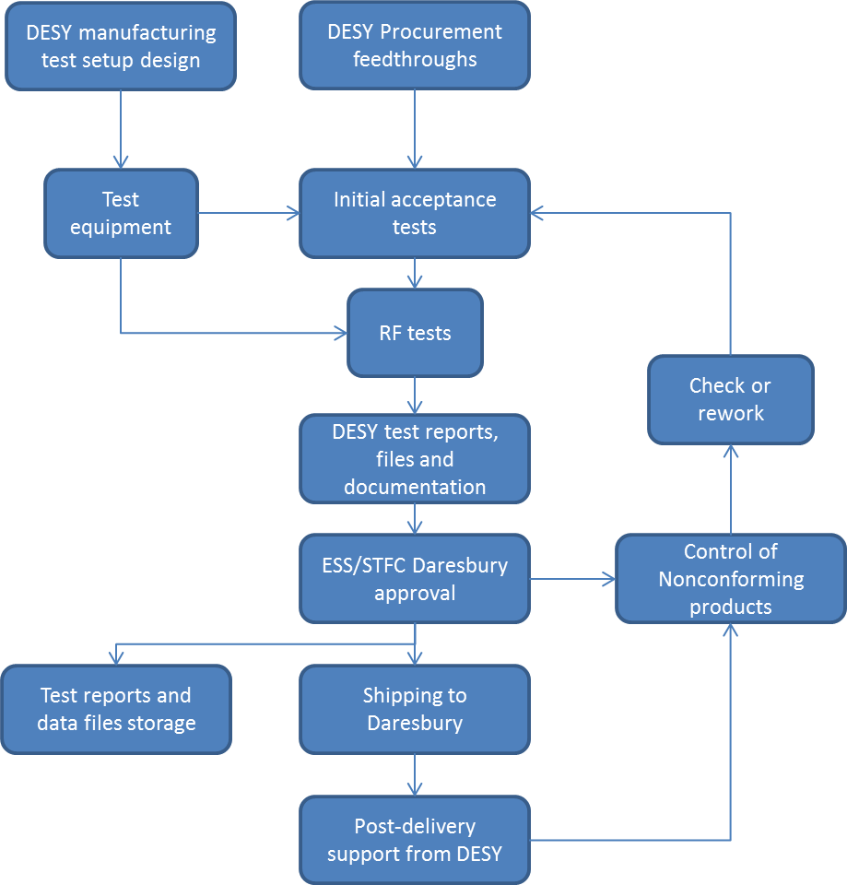

## Installation and post-delivery activities

Support during the installation phase is necessary from DESY. The parts that fail during the assembly at Daresbury shall be tested and send back to DESY to evaluate if is it possible to rework in case it is identified that a problem with the vacuum glass-ceramics insulation or the mechanical pieces of the feedthroughs has happened.

In case of need, DESY shall provide technical support and training for the installation, tests, and integration analysis.

The training and technical support, if needed, can be requested by STFC Daresbury.

# Identification and traceability

All the manufactured feedthroughs, and complete assembled Beam Position Monitors shall have a permanent identification number (serial number) engraved on its mechanical parts in order to identify each unique piece.

The Radio-Frequency (RF) test results and all the related manufacturing measurements shall be provided relative to each serial number and documented. Data format shall be some script readable format, like ASCII, space or tab separated values (text files). All the files shall have a header describing at least the following test parameters:

* Serial number
* Date of manufacturing
* Manufacturer
* Test date
* Test checks (passed, rework or failed) for visual inspection, mechanical dimensions, vacuum leak and UHV cleaning.
* Responsible person for the tests
* Test results of the feedthroughs RF parameters:
  + S-parameters: RF reflection measurements S11 parameter of each sensor. One file for each feedthrough, containing the header with the serial number and the previous description.

Notes:

* PDF files, images or plots won’t be accepted if not delivered together with the data files (ASCII) that were used to generate the plots.
* Files shall be named with the serial number of the part number tested separated to the file name by an underline: “serialnumber_filedescription.txt”
* The identification of all the manufactured physical devices (feedthroughs and BPM housings) shall be permanent / engraved.

# Preservation of product

With reference to ESS Vacuum Handbook Part 3, ESS-0012896 the feedthroughs packaging shall be in accordance to:

* Particle cleaning before shipping.
* Vacuum sealed package.
* Particle contamination control.
* Humidity and temperature control shall be applied if needed to preserve the electrical and mechanical characteristics of the feedthroughs and its components.

In case of damage during the transportation, DESY is responsible for providing new pieces.

# Control of nonconforming product

Nonconforming feedthroughs shall be send back to DESY for rework. Nonconformities can be related to the following problems, but not exclusively:

* Mechanical dimensions not in accordance to tolerances or specifications.
* Vacuum leak not in accordance to the specifications.
* Serial number engraving with problems or with defects on the identification.
* RF parameters not in accordance to specifications.
* STFC Daresbury will inspect the received feedthroughs. In case the specifications are not in accordance to specified, the pieces will be returned to DESY for inspection and rework.

If rework procedures are applied to some of the pieces, all the test procedures shall be repeated and the results shall be approved by all the parties. The information that a specific serial number was reworked shall be described on the data files.

# Monitoring and measurement

In order to provide objective evidence of conformity define:

* Feedthroughs RF tests shall follows the following procedures:
  + Monitoring and measurements activities of processes and product that will be applied and specify in which stages.
  + RF tests shall be performed without human interference: permittivity, temperature, noise, vibration, shall not affect the measurements.
  + The standard torque and specialized tools shall be used to the N-type connectors to assure repeatability and accuracy of the measurement process.

# Audits

The ESS Lund team will audit the feedthroughs production and tests during the manufacturing process.

* ESS will be involved on the manufacturing tests if requested by DESY or ESS.
* ESS will monitor and verify the manufactured parts by the manufacturing test data results.
* DESY is responsible for analysing the manufactured pieces in case ESS reports problem on the manufactured data results.
* ESS and STFC Daresbury can perform audits and verify the feedthroughs manufacturing tests.

# Implementation and revision of the quality plan

## Review and acceptance of the quality plan

The Project Quality Plan will be reviewed by ESS Lund and its partners in order to check the manufacturing procedures and if they are in accordance to the manufacturing standards and requirements needed for the manufacturing process.

## Implementation of the quality plan

The quality plan will be followed during the manufacturing process of the feedthroughs and its implementation will be checked by all the parties.

The implementation will be followed by reports and notifications from DESY about the manufacturing procedure. A weekly basis updates shall be made to all the parties, reporting the manufacturing status.

A weekly-basis report on the status shall be made to ESS and STFC Daresbury.

## Revision of the quality plan

Revision of the quality plan shall be requested by ESS Lund, DESY or STFC Daresbury. The parties can be informed by direct communication.

A revision of quality plan shall be approved by ESS Lund.

# Glossary

| Term | Definition |
| --- | --- |
| BPM | Beam Position Monitor |
| Feedthrough | BPM sensor with the connector interface tot eh RF cables |
| RF | Radio-Frequency |
| UHV | Ultra High Vacuum |
| LWU | LINAC Warm Units |
|  |  |
|  |  |
| ESS | European Spallation Source ERIC |
| STFC | Science and Technology Facilities Council |
|  |  |
|  |  |
|  |  |
|  |  |

# references

1. <<Sample reference to internal/external document: Document (document Number)>>

Document Revision history

| Revision | Reason for and description of change | Author | Date |
| --- | --- | --- | --- |
| 0 | Release version | Rafael A. Baron | 2016-09-05 |
|  |  |  |  |
|  |  |  |  |