|  |
| --- |
|  |
|  |
|  |
|  |
|  |
|  |
|  |
|  |
| Machine Protection Requirements on Beam Current Monitors |
|  |
|  |

|  | Name | **Role/Title** |
| --- | --- | --- |
| **Owner** | Annika Nordt | ICS Group Leader - Protection Systems |
| **Reviewer** | Martin Rejzek |  |
| **Reviewer** | Matthias Werner |  |
| **Reviewer** | Hooman Hassanzadegan | Beam Diagnostics Engineer |
| **Approver** | Annika Nordt | ICS Group Leader - Protection Systems |
| **Approver** | Timo Korhonen | ICS Chief Engineer |
| **Approver** | Andreas Jansson | Group leader Beam instrumentation |

|  |  |
| --- | --- |
| Table of content | Page |

1. Issuing Organisation 3

2. Scope 3

3. Context 6

4. Requirements 6

4.1. Beam Presence Function Requirements 6

4.2. Beam Charge Function Requirements 7

4.3. Beam Loss Function Requirements 7

4.4. General Machine Protection Requirements Applied for BCMs 8

5. Summary 10

6. Glossary 11

7. References 11

Document Revision history 12

# Issuing Organisation

Integrated Control Systems - Machine Protection and Personnel Safety Systems Group

# Scope

The scope of this document is to define the requirements imposed on the Beam Current Monitor (BCM) System by Machine Protection. The requirements are needed in order to implement Protection Functions depending on Beam Current Measurements [1], [2].

When referring to the BCM System we are referring to all the ACCTs, the ACCT front-end electronics, the digital processing board and the ACCT crates, see Figure 1. All requirements below refer to the BCM System, the latency refers to the detection by the BCM System until the output of the signals from the processing board that is connected to the Beam Interlock System (BIS), see Figure 1 and Figure 2 below, where the red line represents the interface [3].

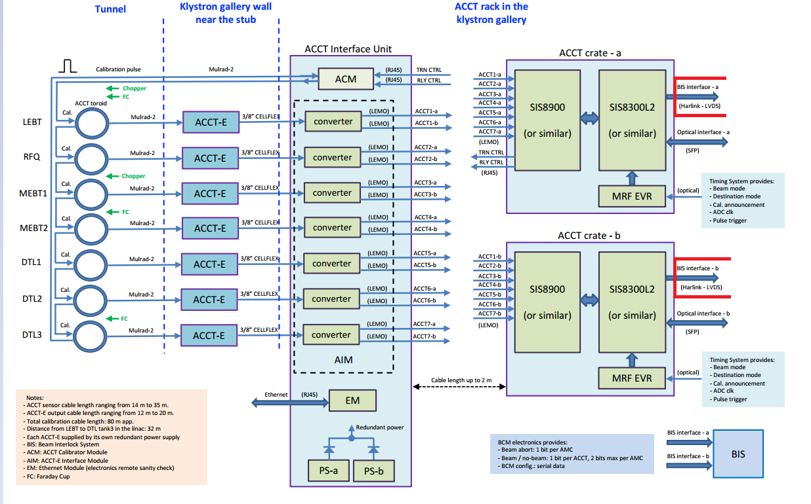

Figure 1: Schematics of the BCM System (LEBT-DTL3)

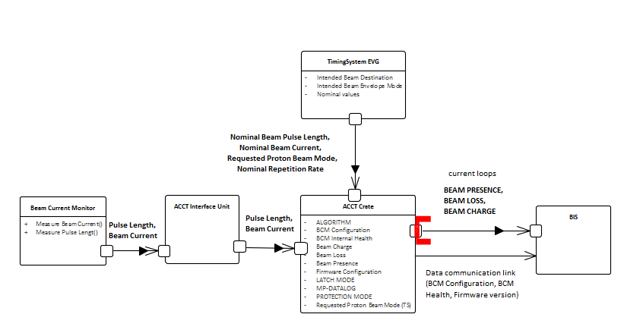

Figure 2: Simplified overview of the functions and signals

# Context

To reach the ESS Machine Protection goals, Protection Functions with certain requirements have to be implemented [4]. To achieve the desired protection the involved systems have to fullfill part of the requirements.

Three main protection functions where BCMs are involved have been identified. The Beam Presence Function detects if beam is present or not present, the Beam Charge function monitors if the beam is within the specified parameters (beam current, pulse length and repetition rate) and the Beam Loss function detects Losses (reduction of current).

# Requirements

## Beam Presence Function Requirements

| Id | Text |
| --- | --- |
| MP-BCM-REQ-1 | Each BCM shall be able to monitor if any beam is present |
| Resolution | The BCMs shall be able to detect probe beam (6 mA). The smallest detected beam current shall be 2-3 times higher than the BCM resolution. |
| Interface | The BCM System shall provide the BEAM PRESENCE status to BIS. The status shall be transmitted through a hardwired current loop interface. [5] |
| Signal | The BEAM PRESENCE signal shall switch to “0” as soon as beam is detected, and switch to “1” as soon as no beam is detected (using the above-mentioned threshold). “1” corresponds to current and “0” corresponds to no current in the current loop. |
| Latency | BEAM PRESENCE signal latency shall be less than 1-2 μs (detection, ACCT analog front-end and digital processing). This is in order to allow for a total reaction time of no more than 3 μs in the warm linac and 5 μs in the cold linac for the complete function, including the sensors (BCMs), cables, logic (BCM Processing Board, the Beam Interlock System), and actuator systems. |
| PIL | The function shall comply with Protection Integrity Level (PIL) 2 requirements. |

## Beam Charge Function Requirements

The BEAM CHARGE shall be detected and the signal delay due to the electronics (excluding cable delays between the BCM System and BIS) shall be within 1-2 μs. The function shall comply with PIL 2 requirements.

| Id | Text |
| --- | --- |
| MP-BCM-REQ-2 | Each BCM shall monitor the BEAM CHARGE. |
| Resolution | BCMs shall detect BEAM CURRENT with a resolution of XX.  BCMS shall detect PULSE LENGTH with a resolution of XX.  BCMs shall detect REPETITION RATE with a resolution of XX. |
| Interface | The BCM System shall provide the BEAM CHARGE status for each BCM to BIS. The status shall be transmitted through a hardwired current loop interface. [5] |
| Signal | The BEAM CHARGE signal from a BCM shall switch to “0” if that BCM detects that any of the below values are exceeded, and switch to “1” if none of the below values are exceeded (using the above-mentioned thresholds). “1” corresponds to current and “0” corresponds to no current in the current loop.   * Each BCM shall be able to detect if the maximum pulse length, defined by the selected proton beam mode, is exceeded or not. * Each BCM shall be able to detect if the maximum beam current, defined by the selected proton beam mode, is exceeded or not. * Each BCM shall be able to detect if the maximum repetition rate, defined by the selected proton beam mode, is exceeded or not. |
| Latency | BEAM CHARGE signal latency shall be less than 1-2 μs (detection, ACCT analog front-end and digital processing). This is in order to allow for a total reaction time of no more than 3 μs in the warm linac and 5 μs in the cold linac for the complete function, including the sensors (BCMs), cables, logic (BCM Processing Board, the Beam Interlock System), and actuator systems. |
| PIL | The function shall comply with Protection Integrity Level (PIL) 2 requirements. |

## Beam Loss Function Requirements

The BEAM LOSS shall be detected within 1-2 μs and the function shall comply with PIL 2 requirements.

| Id | Text |
| --- | --- |
| MP-BCM-REQ-3 | The BCM system shall be able to detect beam losses in all sectors of the linac. |
| Resolution | Beam Losses shall be detected with a resolution of XX. |
| Interface | The BCM System shall provide the BEAM LOSS status for each ACCT to BIS. The status shall be transmitted through a hardwired current loop interface. [5] |
| Signal | If the detected loss is greater than the allowed value the Beam Loss shall be set to “0”. If detected loss is smaller than the allowed value the Beam Loss shall be set to “1”. |
| Latency | BEAM LOSS signal latency shall be less than 1-2 μs (detection, ACCT analog front-end and digital processing). This is in order to allow for a total reaction time of no more than 3 μs in the warm linac and 5 μs in the cold linac for the complete function, including the sensors (BCMs), cables, logic (BCM Processing Board, the Beam Interlock System), and actuator systems. |
| PIL | The function shall comply with Protection Integrity Level (PIL) 2 requirements. |

## General Machine Protection Requirements Applied for BCMs

| Id | Text |
| --- | --- |
| MP-BCM-REQ-4 | The BCM System shall implement configurable off nominal state detection ALGORITHMs. The ALGORITHMs shall be readable and writeable by external systems. |
| Resolution | - |
| Interface | EPICS may be used |
| Signal | Setting thresholds, read thresholds… |
| Latency | - |
| PIL | - |
| Off nominal | a state that can lead to damage or activation of the machine |
| ALGORITHM | the logic used to detect off nominal states |
| example | It shall be possible to change beam loss thresholds and which BCM pairs to use for differential beam loss measurements. Can be done through EPICS. |

| Id | Text |
| --- | --- |
| MP-BCM-REQ-5 | The BCM System shall be able to allow configuration of the status of signals sent to BIS (BEAM CHARGE, BEAM LOSS and BEAM PRESENCE) by changing the PROTECTION MODE.  Example: during operation with probe beam we might want to mask the BEAM LOSS function because this mode requires less protection integrity than full beam power mode. |
| Resolution | - |
| Interface | EPICS may be used |
| Signal | It shall be possible to set the BEAM CHARGE signal status according to ALG, OK or NOK. Where ALG corresponds to the off nominal state detection ALGORITHM, OK to “1” and NOK to “0”. This will be used for testing of the BIS, masking for commissioning or degraded states. |
| Latency | - |
| PIL | - |

| Id | Text | |
| --- | --- | --- |
| MP-BCM-REQ-6 | | The BCM System shall have a MP-DATALOG readable by external systems. The time and reason for all off nominal state transitions shall be stored in the MP-DATALOG. | |
| Resolution | | - | |
| Interface | | EPICS may be used | |
| Signal | | The time and reason for all transitions to BEAM CHARGE: NOK and BEAM LOSS: NOK shall be logged. (Archiving) | |
| Latency | | - | |
| PIL | | - | |

| Id | Text |
| --- | --- |
| MP-BCM-REQ-7  LATCH | The BCM System shall implement a configurable LATCH MODE for the signals sent to BIS (BEAM CHARGE, BEAM LOSS and BEAM PRESENCE). |

If the LATCH MODE is YES, BEAM CHARGE, BEAM LOSS and BEAM PRESENCE shall stay in the NOK state until a RESET command is received.

If the LATCH MODE is NO, BEAM CHARGE, BEAM LOSS and BEAM PRESENCE shall automatically transition from the NOK state to the OK state when no off nominal states are detected.

| Id | Text |
| --- | --- |
| MP-BCM-REQ-8  MODE | The BCM System shall be able to provide its current configuration to BIS through a data communication link. Signal latency shall be less than 100-200 μs. The configuration information shall include proton beam mode and proton beam destination. |

Assumption: In case the Timing System is broadcasting an updated proton beam mode or proton beam destination, the BCM configuration shall update accordingly and send this information to BIS for its mode consistency check.

| Id | Text |
| --- | --- |
| MP-BCM-REQ-9  FIRMWARE | The BCM System shall be able to provide its current firmware version to BIS through a data communication link. Signal latency shall be less than 100-200 μs. |

The firmware version is needed to be able to detect changes and possible function changes that are relevant for protection integrity.

| Id | Text |
| --- | --- |
| MP-BCM-REQ-10  HEALTH | The BCM Systems shall provide its HEALTH status to BIS through a data communication link. Signal latency shall be less than 100-200 μs. |

Assumption: The BCM electronics have some kind of self-diagnosis function. If an internal error is detected by the BCM system (BCMs, BCM Processing Board, cabling aso) the Beam Interlock System shall be informed.

# Summary

The functional and signal requirements on Beam Current Monitors related to Machine Protection have been defined in this document (MP-BCM-REQ-1 to MP-BCM-REQ-10), see summary below. A visual representation of the signals and functions described in this document can be seen in Figure 2. The interfaces through which the required information will be transmitted are described in [5].

# Glossary

| Term | Definition |
| --- | --- |
| BCM | Beam Current Monitor |
| BIS | Beam Interlock System |
| PIL | Protection Integrity Level |
| PF | Protection Function |
| OPF | Overall Protection Function |
|  |  |

# References

1. Machine Protection Risk Management Process (ESS-0086476)
2. Protection Functions for BCMs (ESS-00XXXXX)
3. Beam Current Monitor Design Overview Document (ESS-0041438)
4. Machine Protection - Systems requirements and architectural framework (ESS-0057251)
5. Beam Current Monitors and Machine Protection Interface Control Document
6. I. Dolenc Kittelmann, T. Shea, 2016. SIMULATIONS AND DETECTOR TECHNOLOGIES FOR THE BEAM LOSS MONITORING SYSTEM AT THE ESS LINAC. Proceedings of HB2016, THAM6Y01, Malmö, Sweden

Document Revision history

| Revision | Reason for and description of change | Author | Date |
| --- | --- | --- | --- |
| 1 | First issue | Szandra Kövecses | 2017-04-10 |
|  |  |  |  |
|  |  |  |  |

| Id | Text |
| --- | --- |
| MP-BCM-REQ-1 | Each BCM shall be able to monitor if beam is present (within the possible resolution of the BCM). |
| MP-BCM-REQ-2 | Each BCM shall monitor the BEAM CHARGE. |
| MP-BCM-REQ-3 | The BCM system shall be able to measure beam losses in all sectors of the linac. |
| MP-BCM-REQ-4 | The BCM System shall implement configurable off nominal state detection ALGORITHMs. The ALGORITHMs shall be readable and writeable by external systems. |
| MP-BCM-REQ-5 | The BCM System shall be able to allow configuration of the status of signals sent to BIS (BEAM CHARGE, BEAM LOSS and BEAM PRESENCE) by changing the PROTECTION MODE. |
| MP-BCM-REQ-6  MP-DATALOG | The BCM System shall have a MP-DATALOG readable by external systems. The time and reason for all off nominal state transitions shall be stored in the MP-DATALOG. |
| MP-BCM-REQ-7  LATCH | The BCM System shall implement a configurable LATCH MODE for the signals sent to BIS (BEAM CHARGE, BEAM LOSS and BEAM PRESENCE). |
| MP-BCM-REQ-8  CONFIG | The BCM System shall be able to provide its current configuration to the Beam Interlock System through a data communication link. |
| MP-BCM-REQ-9  FIRMWARE | The BCM System shall be able to provide its current firmware version to the Beam Interlock System through a data communication link |
| MP-BCM-REQ-10  HEALTH | The BCM Systems shall provide its HEALTH status to the Beam Interlock System through a data communication link |