Approval Matrix

Review  Role Name Date  Author Hooman Hassanzadegan (ESS, BI section) 2017-02-24  Reviewer Matthias Werner (DESY)  Reviewer Hinko Kocevar (ESS, BI section)  Reviewer Klemen Erjavec (Cosylab)?  Reviewer Annika Nordt (ESS, MPS group)  Reviewer Timo Korhonen (ESS, ICS)  Reviewer Mohammad Eshraqi (ESS, Beam Physics section)  Reviewer Rejzek Martin (ZHAW)  Approver Thomas Shea (ESS, BI section) | Stake Holder  System Name Date  BPOD group head Andreas Jansson  BI section head Thomas Shea  ACCT custom firmware Matthias Werner (DESY)  ACCT integration firmware Klemen Erjavec (Cosylab)?  Software, MRF timing, GUI Hinko Kocevar  EPICS integration ICS???  BCM system lead, ACCT analogue electronics Hooman Hassanzadegan

Versions Summary
Version | Date | Modifications since last version
1.0 | 2017-02-24 | Hooman Hassanzadegan created the document.
2.0 | 2017-03-17 | Modified after discussing with M. Werner on March 16th 2017

Background

Background

This document is an upgrade to the ‘LEBT ACCT “Pre-version” firmware and software requirements’ that was used earlier for the design and development of the LEBT ACCT firmware and software. The current document extends the firmware and software functionality to the ACCTs in the warm linac down to the DTL end. The added functionality includes ex. special FW blocks for the MEBT and RFQ protection, differential current measurements as well as ACCT calibration.

The ESS ACCT toroids will be Bergoz type. The ACCT size and type (i.e. ‘in-air’ or ‘in-flange’) will be chosen based on the mechanical requirements on the ACCT integrations. The ACCT front-end electronics will be of Bergoz ACCT-E type with a full-scale current range of +/- 80 mA and default bandwidth of 3 Hz – 1 MHz.

The ACCT readout electronics will be based on the uTCA.4 standard. It is planned to use a Struck SIS8900 RTM in combination with a Struck SIS8300-L2D AMC for the early installations.

A custom ACCT Interface Unit is planned for the interconnection of the ACCT toroid, the uTCA electronics and the Beam Interlock System (BIS).

The ACCT firmware will consist of two parts being: 1) A custom firmware including algorithms relevant to the ACCT signal processing such as baseline level correction, droop compensation and interlock signal generation for machine protection. 2) An integration firmware based on the original SIS8300-L2D firmware and tailored to the ESS BCM requirements in terms of clock multiplexing, register and memory maps, data decimation, optical fiber interface and the timing interface.

The readout electronics need to be integrated into EPICS. Display of the ACCT output data and control of the settings will be done through a dedicated user interface.
Purpose of the document:

- Functional description of the ACCT system
- Definition of ACCT FW/SW requirements based on the BCM L-4 requirements and the discussions with the other groups
- BCM planning
- Project coordination with other groups and external partners

Concept:

The ESS BCM system will be based on the Bergoz ACCT toroid and uTCA.4 electronics. The toroid will include a calibration winding that will be used for the compensation of signal drifts due to temperature variations. The ACCT output signal will be transferred to the Bergoz front-end module (i.e. ACCT-E) using a radiation-hard cable. The length of this cable varies from less than 20 m to 80 m or even more depending on the ACCT location in the linac. The analogue bandwidth of the system will largely depend on the sensor cable length and the resultant differences in the response times need to be compensated in the BCM firmware. In order to minimize the sensor cable length and protect the ACCT-E from harmful radiation, the ACCT-E module should be installed at the head of the stub in the klystron gallery. The output of the ACCT-E module is then transferred by a coaxial cable to a custom ACCT Interface Unit that will be installed in the same rack as the uTCA readout electronics. The AIU will, among other things, match the voltage level and the impedance of the ACCT-E output to those of the RTM input. The ACCT signal will be sampled at 88.0525 MHz and then FPGA processed on the AMC for droop compensation, baseline level correction, machine protection etc. For the early installations, it is planned to use the Struck SIS8900 RTM in combination with the SIS8300-L2D AMC. An MRF EVR module will transfer ADC clock and pulse trigger to the AMC through the crate backplane. The ADC clock will be locked to the RF frequency and the trigger will be configured in the EVR so that it always arrives at a fixed time interval before the beam pulse. A “check shape” block in the ACCT firmware will measure the amplitude, width and frequency of the beam pulse for machine protection and consistency check. The readout electronics will be integrated into EPICS. The beam pulse information as well as alarm signals will be shown on a user screen. Control of the BCM and machine-protection settings will be done through password protected panels.

Scope:

The current document covers the ACCT firmware functionality (both custom and integration parts), software as well as hardware requirements.

Acceptance tests:

The BCM system needs to successfully pass acceptance tests against the current requirements before an official delivery of the FW takes place.

The foreseen methods for check and verification are described below:

- Inspection: carefully checking the system thus making sure that it fulfils a certain requirement.
- Test: verification by making tests. When applicable, this will be done using a test bench specific to the test as well as some lab. equipment.
- Measurement: verification by measuring a physical quantity
- Simulation: verification by simulating the code functionality

The foreseen verification method for each requirement item is mentioned in the following requirements table.

As the firmware/software developer will have in-depth knowledge about these parts, the intent should that he delivers a bug-free, tested and verified piece of firmware/software thus avoiding potential delays. Therefore, the acceptance tests that are foreseen within this document are not intended to verify that all the FW/SW blocks work as expected (these tests should have already been done by the developers ex. through simulations before delivery), but rather to focus on the system performance and an in-depth verification of the functionality as described in this document. The FW/SW developer shall still provide support to fix any bugs that may be detected later on such as those not captured during the acceptance tests.

Glossary:

ACCT: AC Current Transformer
ACM: ACCT Calibrator Module
AIM: ACCT-E Interface Module
AIU: ACCT Interface Unit
AMC: Advanced Mezzanine Card
BCM: Beam Current Monitor
BI: Beam Instrumentation
BIM: BIS Interface Module
BIS: Beam Interlock System
EM: Ethernet Module
EVR: Event Receiver
FE: Front End
FW: Firmware
GUI: Graphical User Interface
I2C: Inter Integrated Circuit
LU: LEBT Upgrade
MEBT: Medium Energy Beam Transport
MPS: Machine Protection System
MRF: Micro Research Finland
PRDM: Power Redundancy and Distribution Module
RFQ: Radio Frequency Quadrupole
SW: Software
uTCA micro Telecommunication Computing Architecture

ID | Title | Description | Author | Date | Stake Holder | Approval  Status
LU-BCM -spec--- | Measurement type | The ACCT system will be used to measure the beam current including pulse and no-pulse periods. The beam current data will be processed in FW for machine protection purposes including pulse width, amplitude and frequency measurements as well as differential current measurement using several ACCT pairs.  Verification method: inspection | HH | 7/3/2017 | MW
LU-BCM -spec--- | Measurement range | The ACCT system needs to satisfy the requirements that are described in this document with the beam current ranging from 1 mA to 90 mA, pulse width ranging from 5 us to 6 ms and pulse repetition rate ranging from 1/30 Hz to 14 Hz.  Verification method: test using the ACCT toroid and an emulated beam from a waveform generator. The pulse parameters will be changed to cover the foreseen ranges. | HH | 7/3/2017 | MW
LU-BCM -spec--- | Data display | The information on the user screen shall include (but not necessarily be limited to):  - Graphical display of the measured pulse: the pulse display window shall as minimum start shortly before the rising edge of the pulse, and end after the falling edge.  - Numerical display of the average current over the pulse flat-top (compliant with LU-BCM-spec--- and LU-BCM-spec---)  - Numerical display of the per-pulse charge (compliant with LU-BCM-spec---)  - Numerical display of the cumulative charge from the time of a manual reset on the ooperator screen (compliant with LU-BCM-spec---)  - Numerical display of the pulse width (compliant with LU-BCM-spec---)  - Numerical display of the external trigger frequency (compliant with LU-BCM-spec--- and LU-BCM-spec---)  - Control of BCM and machine-protection settings through password-protected panels  Verification method: inspection | HH | 7/3/2017 | HK
LU-BCM -spec--- | Mode of operation | The ACCT system shall work in pulsed mode.  Verification method: inspection | HH | 7/3/2017 | MW
LU-BCM -spec--- | Screen update rate | The ACCT data on the user screen shall be updated at a rate not lower than 1 Hz.  Verification method: measurement | HH | 7/3/2017 | HK
LU-BCM -spec--- | Custom firmware time resolution | The ACCT custom firmware shall output the ACCT raw data at the ADC clock rate.  Verification method: inspection | HH | 7/3/2017 | MW
LU-BCM -spec--- | Integration firmware time resolution | The ACCT integration firmware shall decimate the custom firmware output data at 8-to-1 rate. This data shall then be sent to software for post-processing and display on the user screen.  Verification method: inspection | HH | 7/3/2017 | KE
LU-BCM -spec--- | Display data time resolution | The pulse data on the user screen shall include:  - Raw ADC data with the custom firmware time resolution (i.e. LU-BCM-spec---)  - processed data with the integration firmware time resolution (i.e. LU-BCM-spec---)  Verification method: inspection | HH | 7/3/2017 | HK
LU-BCM -spec--- | ACCT number | The FW/SW shall be able to read and process data from up to 10 ACCTs connected simultaneously to a single RTM/AMC pair.  It shall be possible to use the FW/SW for all the ACCTs in the ESS warm linac.  Verification method: inspection | HH | 10/3/2017 | HH
LU-BCM -spec--- | ADC clock source | The FW/SW shall work successfully with any of the following clock sources:  - External 88.0525 MHz clock from the MRF timing receiver module through the crate backplane (default option)  - External clock through the SMA or the Harlink connector on the AMC front-panel  - Free-running AMC clock  Clock multiplexing shall be done in the integration firmware. The custom firmware shall get only one clock. All inputs and outputs shall be in the clock domain of this clock.  Verification method: inspection | HH | 7/3/2017 | KE
LU-BCM -spec--- | External trigger specifications | An external trigger that is synched with the beam pulse shall be provided by the MRF timing receiver module. The width and repetition rate of the trigger shall be the same as those of the beam pulse downstream of the MEBT chopper.  - The rising edge of the external trigger shall be received by the AMC at minimum 99 us and at maximum 101 us before the rising edge of the beam pulse.  - The falling edge of the external trigger shall be received by the AMC at minimum 99 us and at maximum 101 us before the falling edge of the beam pulse.  Note: Upstream of the MEBT chopper, due to space charge neutralization, the rising edge of the beam pulse happens 20 us (max) earlier than the pulse downstream of the MEBT chopper, while differences in the falling edge can be safely ignored. Nevertheless, the ACCTs upstream of the MEBT chopper shall use a trigger with the same width as the ACCTs downstream of the MEBT chopper thus eliminating the need for another trigger from the EVR. The differences in the start of the beam pulse shall then be compensated by the FW (compliant with ----)  Verification method: measurement | HH | 7/3/2017 | HK
LU-BCM -spec--- | External trigger source | The FW/SW shall work successfully with any of the following trigger sources:  - External trigger from the MRF timing receiver module through the crate backplane  - External trigger through the Harlink connector on the AMC front-panel  Trigger multiplexing shall be done in the integration firmware. The custom firmware shall only have one trigger input.  Verification method: inspection | HH | 7/3/2017 | KE
LU-BCM -spec--- | Interlock on external trigger | An interlock signal shall be sent out if the beam pulse does not arrive 100 +/- 1 us after the external trigger (compliant with the LU-BCM-spec---). The generation of this interlock shall be consistent with the timing specifications in LU-BCM-spec---.  Verification method: test with waveform generators | HH | 7/3/2017 | MW
LU-BCM -spec--- | Toroid type | The ACCT toroid will be of Bergoz wideband type with a default bandwidth of 3 Hz to 1 MHz.  Verification method: inspection | HH | 7/3/2017 | HH
LU-BCM -spec--- | ACCT front-end electronics | The ACCT front-end electronics shall be of Bergoz ACCT-E type. The output voltage range of the ACCT-E shall be +/- 10 V for a full-scale current range of +/- 80 mA.  Verification method: inspection | HH | 7/3/2017 | HH
LU-BCM -spec--- | RTM type | The readout electronics shall use Struck SIS8900 RTM.  Verification method: inspection | HH | 7/3/2017 | HH
LU-BCM -spec--- | ACCT Interface Unit | A custom AIU shall be used for the interconnection of the uTCA electronics, ACCT-E module, ACCT calibration winding and the BIS. The AIU may include some or all of the following modules:  - A custom ACCT-E Interface Module (AIM) may be used to match the ACCT-E output voltage and impedance to those of the RTM input (the other alternative will be to use a modified SIS8900 RTM with input impedance and voltage range already matching those of the ACCT-E output):  - Both the input and the output of the AIM will be single-ended.  - The AIM shall have high-impedance input (that will be seen by the ACCT-E output) and 50 Ohm output (that will be seen by the RTM input).  - The AIM shall have two identical output ports per ACCT-E so that the ACCT-E signal can be measured simultaneously by two sets of readout electronics.  - The AIM shall have a gain of 0.1 thus giving an output voltage of -1 V to +1V with the input voltage ranging from -10 V to +10 V (corresponding to an ACCT current of -80 mA to +80 mA).  - The AIM shall optionally add a small offset of 40 mV (TBC) to the outputs. The offset shall then be used for remote sanity check of the AIU internal power supply.  - A custom ACCT Calibrator Module (ACM) to generate a current pulse for the ACCT calibration:  - The calibration pulse shall be enabled/disabled using two LVDS signals on the RJ-45 DATA port on the SIS8900. The LVDS signals shall be used to control a transistor and a relay on the ACM.  - The amplitude of the calibration pulse shall be fixed to 50 mA.  - An Ethernet Module (EM) with I2C adapter for Serial Number as well as remote sanity check (i.e. temperature, voltage) of the AIU  - A BIS Interface Module (BIM) to provide hardware interface between the BCM RTM/AMC and the BIS  - A Power Redundancy and Distribution Module (PRDM) providing redundant power to the modules in the AIU  Design of the AIU and its connection to external units shall be consistent with the following layout (subject to small changes):  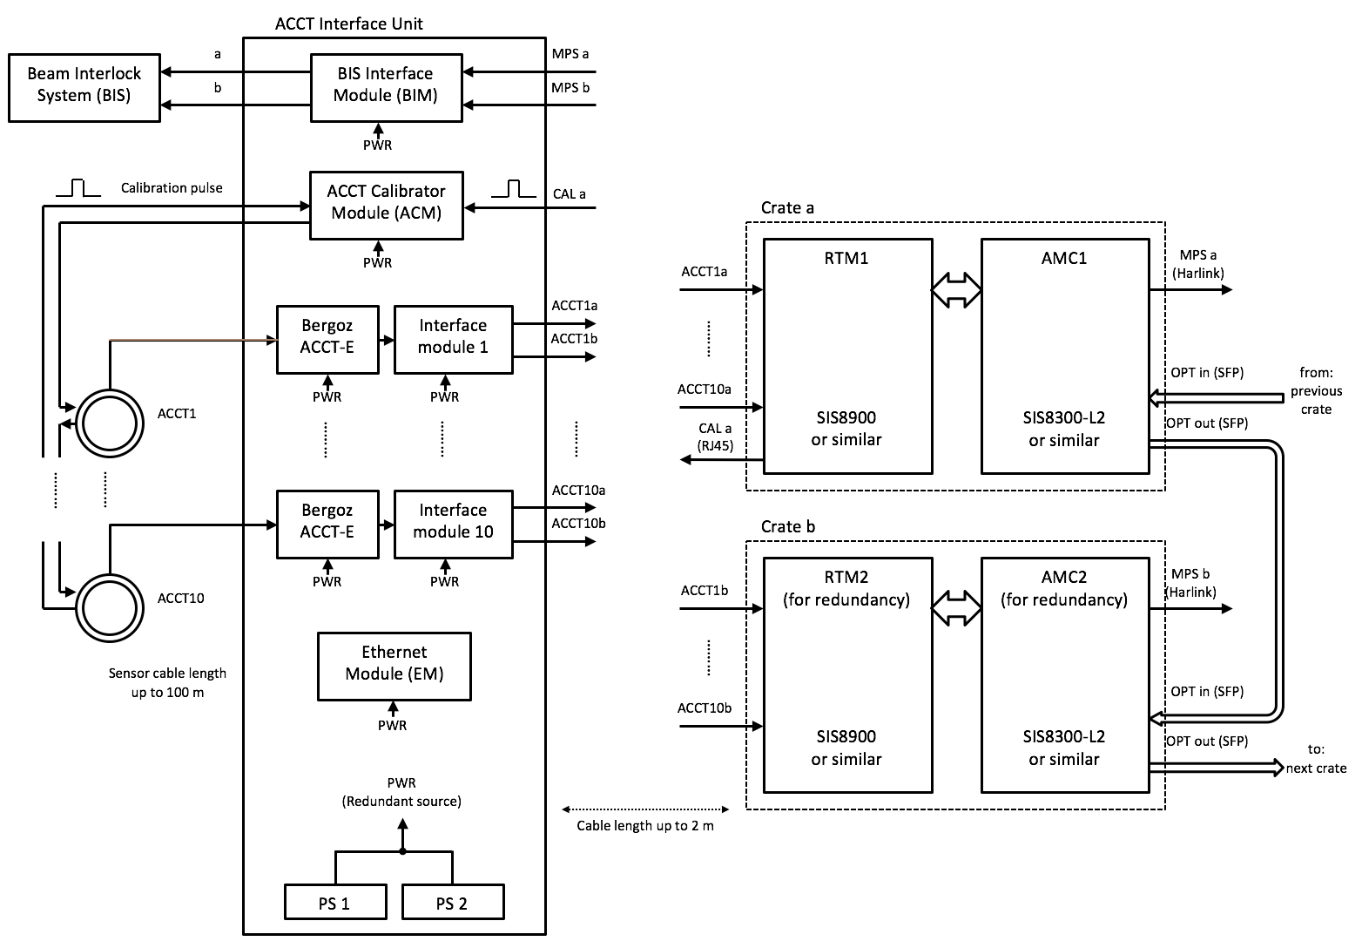  Note 1: For ACCTs with long sensor cables and depending on ACCT location in the linac, the ACCT-E may be installed in a separate enclosure (at shorter cable distance to the sensor) and supplied by a redundant power supply.  Note 2: Full crate redundancy is only foreseen for the warm linac where BLMs cannot be used for beam loss measurements. In the downstream sections, only one crate is foreseen per AIU and redundancy will be provided by the BLMs.  Verification method: inspection | HH | 7/3/2017 | HH
LU-BCM -spec--- | AMC type | The readout electronics shall use the Struck SIS8300-L2D or alternatively the Struck SIS8300 Kintex Ultrascale (KU) AMC  Verification method: inspection | HH | 8/3/2017 | HH
LU-BCM -spec--- | uTCA chassis and infrastructure | The uTCA crate and the infrastructure modules shall consist of the following items:  - Schroff MicroTCA.4 system cube 5U-42HP with 6-slots. Compact 3U crate  - NAT MCH-PHYS front module: NAT-MCH-M4-Base12-GbE, SSCH + TCTCXO, PCIEx48 and FP1D. 128Gb 2.5” SSDNAT MCH-COMex  - NAT Rear Module configured with: i7 COMex processor module, 1,7 GHz System Clock & 4Gb RAM  - NAT MicroTCA 600W Power Module. AC-DC Double Width Full Size (6 HP).  - MRF event-receiver timing module  Verification method: inspection | HH | 8/3/2017 | HH
LU-BCM -spec--- | ACCT custom firmware functionality | The custom FW functionality shall include:  - Baseline level correction: when enabled, shifts the baseline level of the ACCT signal to zero Volt.  - Droop compensation: when enabled, compensates the droop to better than +/- 0.1% of the pulse current for the maximum pulse width and within the full current range.  Verification method: inspection  - Interlocks on pulse amplitude: when enabled, checks pulse current and generates an interlock if the current goes above an upper_MPS_threshold or below a lower_MPS_threshold. The upper_MPS_threshold check shall be done continuously. The time window for the lower_MPS_threshold shall start 103 us after the rising edge of the external trigger, and end 99 us after the falling edge of the external trigger.  - Interlock on errant beam detection: when enabled, generates an interlock if an errant beam is detected during the no-pulse period. The time window for the errant beam detection starts 104 us after the falling edge of the external trigger, and ends 98 us after the rising edge of the external trigger (next pulse). An MPS threshold shall be used for the errant beam detection. Downstream of the MEBT chopper, the lower, upper and errant thresholds shall be activated according to the following timing diagram:  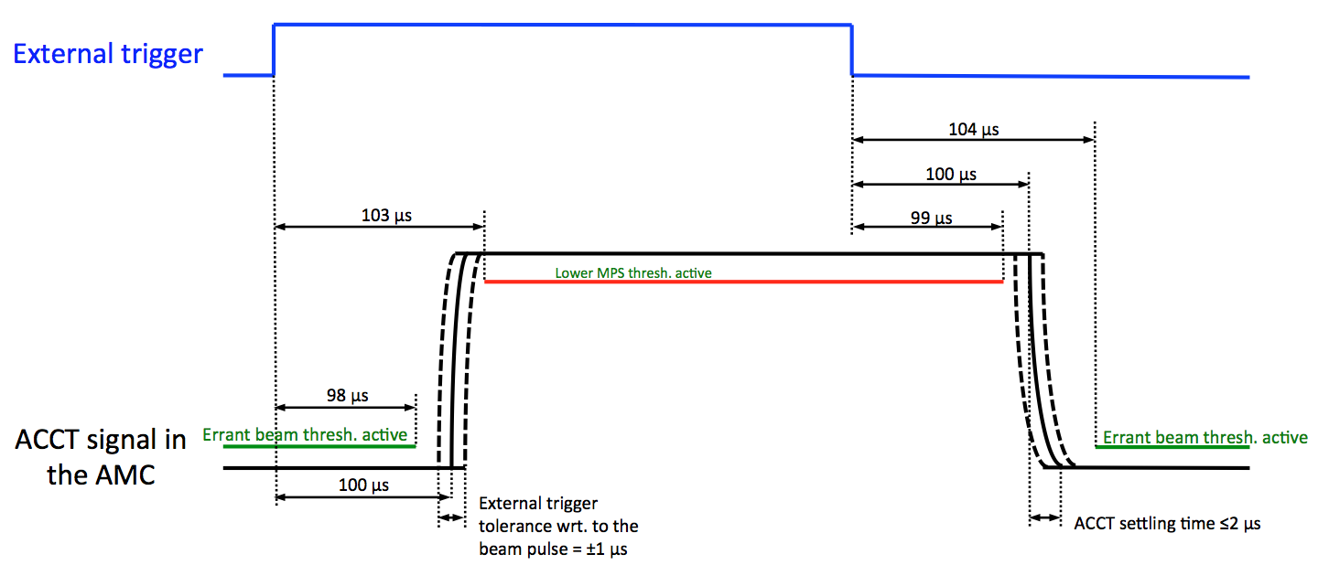  - Upstream of the MEBT chopper, the rising edge of the beam pulse can happen 20 us (max) earlier, and consequently the time window for the errant beam detection with these ACCTs shall end 78 us after the rising edge of the external trigger instead (compliant with the LU-BCM-spec---).  - It shall be possible to define a differential pair using any two ACCTs in the linac. The custom FW shall send out a beam_abort signal if the differential current exceeds a threshold that can be configured for each differential pair individually. If the two ACCTs in the differential pair are not both connected to the same RTM/AMC, an optical fiber link shall be used for the ACCT data transmission to the AMC in the down-stream crate. The custom FW shall include ports for importing data from the optical link with the same format?? as the other (i.e. connected to the same RTM/AMC) ACCTs. The custom FW shall also provide a fine delay mechanism to align the of two ACCTs in the differential pair.  - It shall be possible to enable/disable each of the above-mentioned interlock signals individually for each ACCT and each differential pair.  - The custom FW shall send out both the FIRST (i.e. first alarms that happened after a manual BCM alarm reset and latched until next reset) as well as CURRENT (i.e. most up-to-date) alarm (compliant with LU-BCM-spec---).  Verification method: inspection and test  - A moving average filter shall be applied to the ACCT data. The time constant of this filter (assuming a step change at the input and 88.0525 MHz clk) shall be about 100 ns. When enabled, the filtered data shall be used for the pulse shape display as well as the absolute and differential interlock signals mentioned above.  Verification method: inspection and test  - ACCT calibration: the ACCT shall be calibrated in MANUAL and AUTO modes (compliant with LU-BCM-spec---). A calibration current pulse shall be sent to the calibration winding of the ACCT during the no-pulse period. The custom firmware shall automatically correct the baseline level, the scale factor and the ACCT droop-rate using 3 samples of the calibration pulse. In the MANUAL mode, calibration shall be done during the next no-pulse period after pressing a button on the operator panel. In AUTO mode, calibration shall be done repeatedly and the calibrator pulse frequency shall be set by the operator. The timing of the calibrator output pulse shall be consistent with the following diagram:  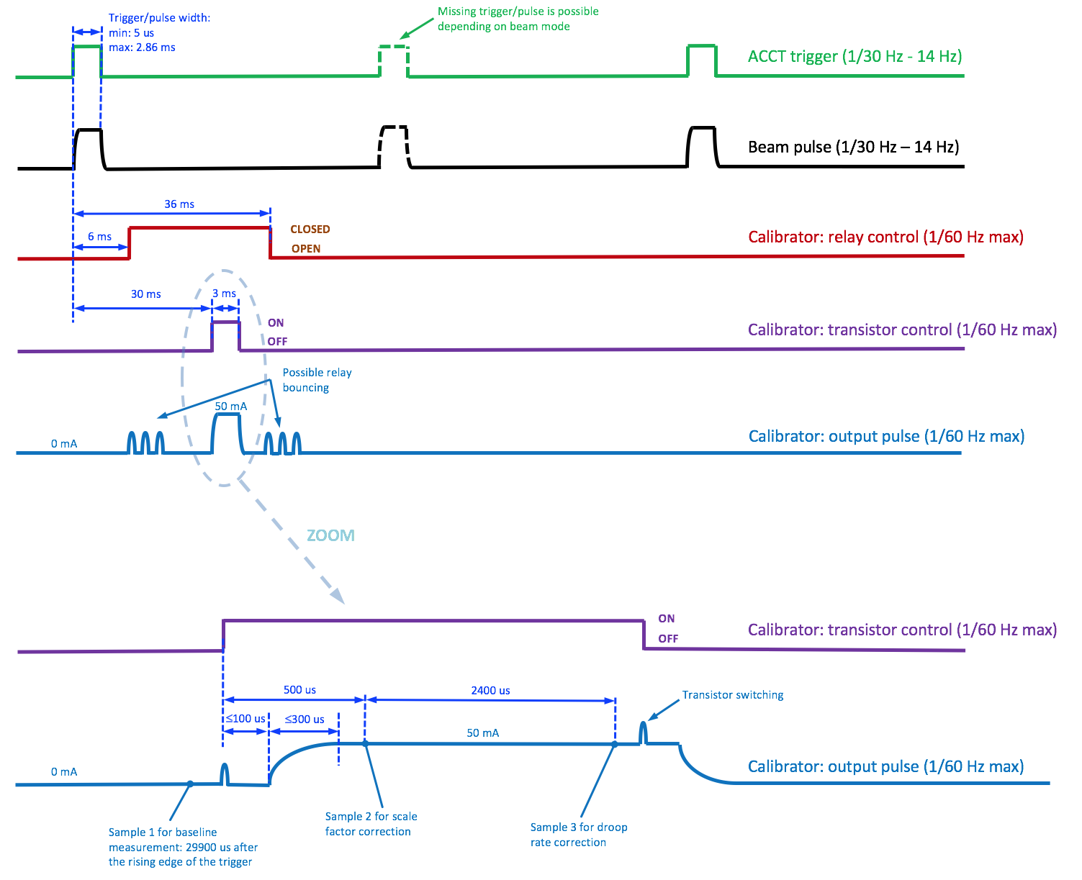  - Pulse width measurement: measures the total time within one pulse that the beam current is above a fixed level of 3 mA. This measurement shall be done within a time period that is complementary to that of the errant beam detection  - Trigger frequency measurement: measures the repetition period of the external trigger with a time resolution of not more than 1 us (this number shall then be reversed in the software to give trigger frequency, compliant with LU-BCM-spec---).  - Pulse charge measurement: pulse current shall be integrated, thus giving per-pulse charge including rising and falling edges (compliant with: LEBT-BCMpre-FD-003).  - Average beam current measurement over the pulse flat top: the custom firmware shall integrate the pulse current from 104 us after the rising edge of the external trigger to 99 us after the falling edge of the external trigger. The integrated charge and the integration period shall then be sent to the software to calculate the average current by diving these two numbers (compliant with LU-BCM-spec--- and LU-BCM-spec---).  - Common enable/disable input for the baseline-level correction and droop compensation  Verification method: test | HH | 8/3/2017 | MW
LU-BCM -spec--- | MEBT protection feature | The custom FW shall include a special feature that accounts for the extra width of the beam pulse before the MEBT chopper, and consequently the normal beam losses due to the operation of the chopper. This includes absolute current measurement with an ACCT upstream of the MEBT chopper as well as differential current measurement with one ACCT being upstream and the other downstream of the MEBT chopper. Any additional delay needed for the MEBT protection feature shall be generated by the BCM custom code itself without a need for another external trigger from the MRF EVR module. The timing of the MEBT protection feature shall be consistent with the following diagram:  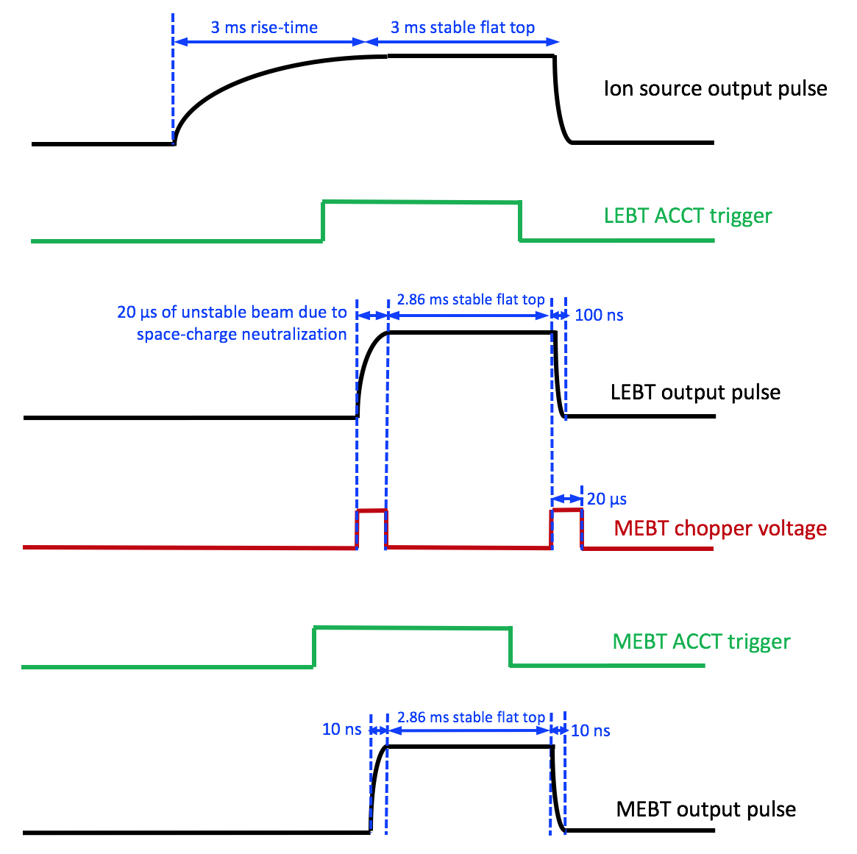  The 20 us (max) of unstable beam at the rising edge of the beam pulse upstream of the MEBT chopper shall be ignored by the MEBT protection feature in absolute as well as differential measurements.  Verification method: test | HH | 10/3/2017 | MW
LU-BCM -spec--- | RFQ protection feature | The custom FW shall include a special feature for the protection of the RFQ where significant part of the beam current will be normally lost. This includes absolute current measurement with an ACCT upstream of the RFQ as well as differential current measurement with one ACCT being upstream and the other downstream of the RFQ. An operator-defined threshold shall determine the maximum beam current that can be lost in the RFQ without generating a beam-abort signal.  Verification method: test | HH | 10/3/2017 | MW
LU-BCM -spec--- | Interfacing to the timing system | The BCM custom FW shall receive beam-envelope and destination mode information from the ESS global timing system. The format and exact type of data that will be transferred through the timing system remains TBD. The BCM electronics shall automatically re-configure itself upon receiving new beam-envelope or destination mode information from the timing system. The reconfiguration shall as minimum include the followings:  - upper_MPS_threshold and lower_MPS_threshold (complient with LU-BCM-spec---) based on new beam envelope mode  - RFQ_loss_threshold (complient with LU-BCM-spec---) based on new beam envelope mode  - Masking/unmasking of the interlocks based on new beam destination mode  The thresholds corresponding to the different beam envelope modes shall be stored in a table that will reside locally in the AMC memory??? The BCM operator shall be able to read the thresholds table, make changes in it and store a new table on the AMC memory from the BCM operator screen.  Verification method: inspection
LU-BCM -spec--- | Interfacing to the BIS | The BCM electronics shall be connected to the BIS using the Harlink out port on the AMC front panel. The following signals shall be transferred through the Harlink out connector (subject to changes):  - Harlink CLK: N/A  - Harlink out 1: ACCT calibrator -> transistor control  - Harlink out 2: ACCT calibrator -> relay control  - Harlink out 3: beam_above_3mA  - Harlink out 4: beam_abort (common to all the ACCTs connected to the AMC)  TBD: Harlink out 3 shall switches from 0 to 1 as soon as the current of a certain ACCT goes above the 3 mA threshold, and similarly switch from 1 to 0 as soon as the current of the ACCT goes below the 3 mA threshold. Alternatively, it can serially transfer 10 bits of data after each pulse where each bit shows whether the corresponding ACCT has measured a beam pulse.  Verification method: test
LU-BCM -spec--- | Latency | Total BCM system latency from the moment that the beam goes through the ACCT toroid until the moment that an interlock signal becomes available on the AMC output pin shall not be more than 2 us. This includes toroid response time, cables, ACCT front-end electronics and digital processing.  Verification method: measurement  Out of the total delay budget mentioned above, the digital processing delay from ADC data in the FPGA to FPGA output alarm pin shall be 400 ns (MAX).  Verification method: simulation | HH | 8/3/2017 | MW, HH
LU-BCM -spec--- | Custom firmware deliverables | The custom ACCT firmware shall be delivered as a collection of files - with a designated top level file which will be the interface to the surrounding code designed by ESS or other parties. Three deliverables are foreseen:  - Signal port list of the VHDL top module  - Complete VHDL code, tested by simulation  - Documentation  Verification method: inspection  Technical details shall be based on discussions (emails, skype meetings etc.) between the DESY and the ESS contact persons. | HH | 8/3/2017 | MW
LU-BCM -spec--- | Custom firmware acceptance tests | The custom firmware performance shall be tested and verified against the requirements described in this document before an official delivery takes place. When applicable, firmware functionality shall be tested on a BCM test bench at ESS.  The ACCT code developer shall be responsible for bug fixings and modifications if the code does not satisfy any of the requirements. | HH | 8/3/2017 | HH
LU-BCM -spec--- | Integration firmware | The ACCT custom firmware shall be integrated into the generic AMC firmware. The integration firmware shall be tailored to the ESS BCM requirements in terms of clock multiplexing, register and memory maps, data decimation etc.  The integration FW shall include ports for receiving data from up to 10??? remote ACCTs over the optical fiber link. The integration FW shall decode the data and send the data to the custom FW with the same format as the other (i.e. directly connected) ACCTs.  Verification method: inspection | HH | 8/3/2017 | KE
LU-BCM -spec--- | ACCT firmware acceptance tests | The integration firmware shall be tested and verified against the requirements described in this document before an official delivery takes place.  The code integrator shall be responsible for bug fixings and modifications if the code does not satisfy any of the requirements that are relevant to the integration of the ACCT custom code into the generic firmware. | HH | 8/3/2017 | HH
LU-BCM -spec--- | Custom firmware milestones and schedule | -  -  - | HH | 8/3/2017 | MW
LU-BCM -spec--- | Integration firmware milestone | ACCT firmware with integrated custom code shall be delivered to ESS not later than ---- | HH | 8/3/2017 | KE
LU-BCM -spec--- | BCM software milestone | ACCT software shall be delivered not later than ---- | HH | 8/3/2017 | HK
LU-BCM -spec--- | Custom-code interface | Parameters relevant to the custom-code interface including bit sizes and data rates shall be provided by the ACCT custom code developer based on the foreseen application that is described in this document.  Verification method: inspection | HH | 8/3/2017 | MW
LU-BCM -spec--- | Firmware-software interface | The code integrator shall use both the LU-BCM-spec--- interface definition and this functional description to define a custom register array memory map for the firmware-software interface. This interface definition shall include register addresses, definition of functions as well as register types and lengths.  Verification method: inspection | HH | 8/3/2017 | KE
LU-BCM -spec--- | Software functionality | The signal processing that will be performed on the ACCT signal in software shall include (but not necessarily be limited to):  - Average current over the pulse flat-top shall be calculated by dividing the integrated charge by the integration period (compliant with LU-BCM-spec--- and LU-BCM-spec---)  - Cumulative beam charge shall be measured by adding up the charge of consecutive pulses. The user shall be able to reset the cumulative charge value by pressing a reset button on the user screen (compliant with LU-BCM-spec---).  - Repetition period of the external trigger shall be reversed to give the trigger frequency (compliant with: LU-BCM-spec--- and LU-BCM-spec---).  The controls on the user screen shall include (but not necessarily be limited to):  - ADC clock source (compliant with LU-BCM-spec---)  - Trigger source (compliant with LU-BCM-spec---)  - MANUAL/AUTO/OFF switch for the ACCT calibration mode as well as numerical input for the calibration frequency  - Upper and lower MPS thresholds for the pulse current (compliant with LU-BCM-spec---)  - MPS threshold for errant beam detection (compliant with LU-BCM-spec---)  - Enable/disable switch for the moving average filter (compliant with LU-BCM-spec---)  - Common enable/disable switch for the baseline level correction and droop compensation (compliant with LU-BCM-spec---)  - Individual enable/disable switch for the interlock signals (compliant with LU-BCM-spec---)  It shall be possible to see all the alarms including those relevant to machine protection on the BCM operator panel (compliant with LU-BCM-spec---). The alarm display shall include both the FIRST and the CURRENT alarms.  Verification method: inspection | HH | 8/3/2017 | HK
LU-BCM -spec--- | EPICS support | The ACCT readout electronics shall be integrated into EPICS. The read-out data and control of settings shall be all available on an operator panel.  Verification method: inspection | HH | 8/3/2017 | HK
LU-BCM -spec--- | ADC coding | The ADC shall be configured to output format “Offset Binary Output Mode” or “Twos Complement Mode” by the framework.  Verification method: inspection | MW | 8/3/2017 | KE

