|  |
| --- |
|  |
|  |
|  |
| Ion source performance at the end of COMMISSIONING Phase 2 |
|  |

|  | Name | Role/Title |
| --- | --- | --- |
| Authors | Øystein Midttun  Lorenzo Neri  Cyrille Thomas |  |

# Introduction

This document summarizes the ion source performance after the Phase 2 of the commissioning at INFN-LNS, Catania. The measurement set-up was the ion source with a cross piece for diagnostics connected to the pumping box, shown in Figure 1.

Available diagnostics:

* Faraday cup
* Emittance measurement unit (horizontal plane)
* Dopper shift monitor
* Beam current transformer (ACCT on high voltage cable)

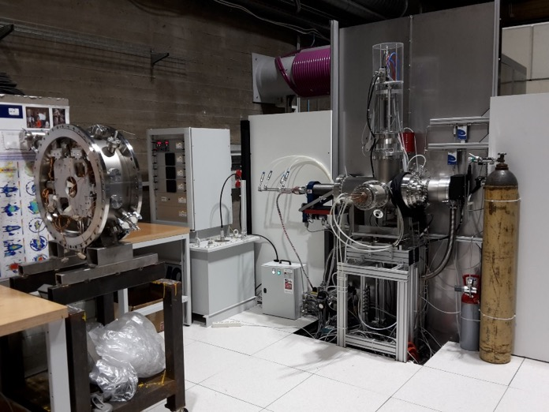

Figure - Measurement set-up with the cross piece connected to the pumping box. The Faraday cup was inserted from the top, and the EMU from the left side. The Doppler shift monitor was connected to the viewport at the bottom.

# Ion source measurements

## Current

The beam current measurement was made 2017-05-25. The ion source was set-up in its nominal configuration:

* Coil 1 108.8 A
* Coil 2 68.6 A
* Coil 3 227.7 A
* H2 gas injection 3 sscm
* Pressure (pumping box) 3x10-5 mbar
* RF power 700 W
* Repeller electrodes voltage -3.5 kV
* Extraction voltage 75 kV
* Pulse length 6 ms
* Flat-top length 3 ms
* Repetition rate 14 Hz

With these settings, the ACCT measured a current of 89.7 mA (Figure 2), and the Faraday Cup measured a current of 50 mA (Figure 3). The discrepancy between the two measurements is due to the beam being larger than the Faraday cup aperture of 80 mm at the Faraday cup and EMU location.

Note that the ACCT has a droop of about 2 % per ms, which means that the current actually increased during the beam pulse. The Faraday cup current decreased during the beam pulse because while the extracted beam current increased, less and less beam current arrived within the acceptance of the cup.

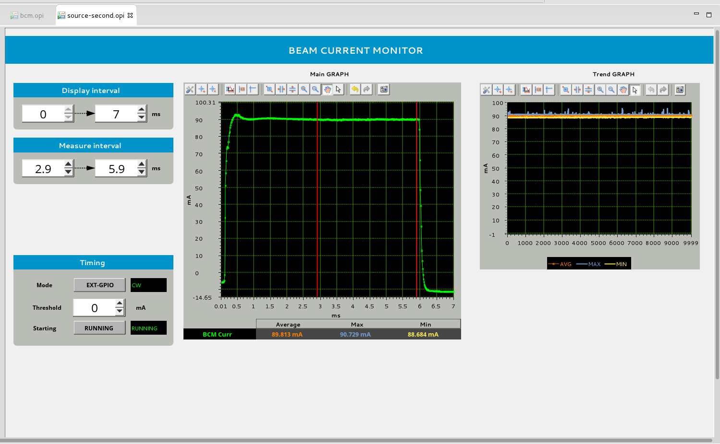

Figure - Screenshot of the signal from the ACCT mounted in the high voltage cable.

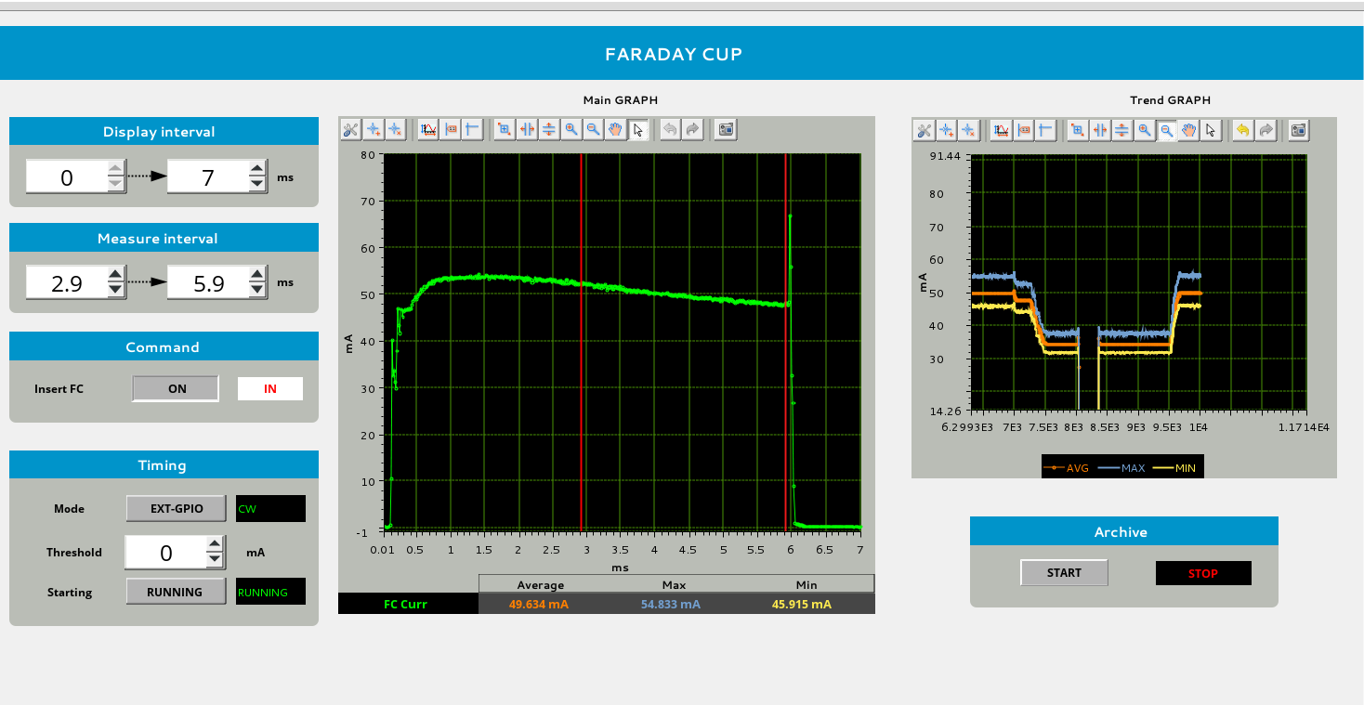

Figure - Screenshot of the signal from the Faraday cup.

## Proton fraction

The ion species fractions were measured with the Doppler shift monitor for the same source configuration as for the beam current, 2017-05-25. The measured fractions were (Figure 4):

* Protons 84.8 %
* H2+ 11.9 %
* H3+ 3.3 %

With this proton fraction, the beam consisted of 76 mA protons.

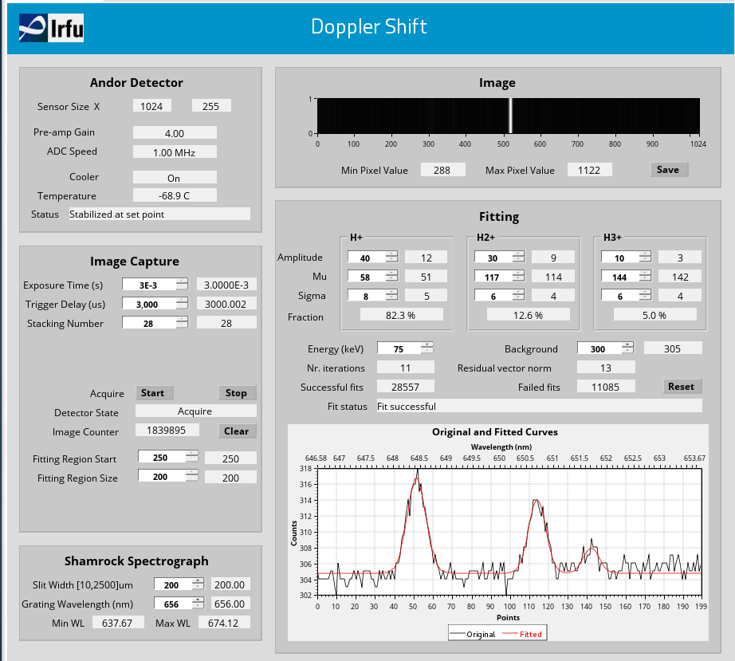

Figure - Screenshot of the Doppler shift measurement user interface.

## Stability

The stability of the beam was measured during the spring 2017, and presented at IPAC’17. The measured stability was ±1.5 % inside the beam flat top, and ±3 % between pulses [1].

## Time structure

The ion source produced the nominal time structure, i.e. 6 ms pulse length, 14 Hz repetition rate. On 2017-09-12, it was demonstrated that the ion source produced beams with pulse lengths ranging from 1 ms to 3 ms, without significant changes to the beam current and quality. The repetition rate was varied from 0.25 Hz up to 28 Hz. This had a small effect on the beam current measured in the commissioning tank after the LEBT, but had no effect on the stability of the ion source.

## Emittance

The emittance was measured in the horizontal plane. Because of the large beam size, the EMU did not capture the whole beam. It means that the emittance is necessary larger than the measured one. The analysis of the measurement was made with 3 different methods [2]. The results converge, and the measured emittance was [2]:

* Normalized rms: 0.4 mm mrad
* Normalized 98 %: 3.8 mm mrad

The beam divergence of the partially cut beam was larger than 80 mrad.

Because of the installation of the LEBT, there were no more chances to improve the result of this measurement.

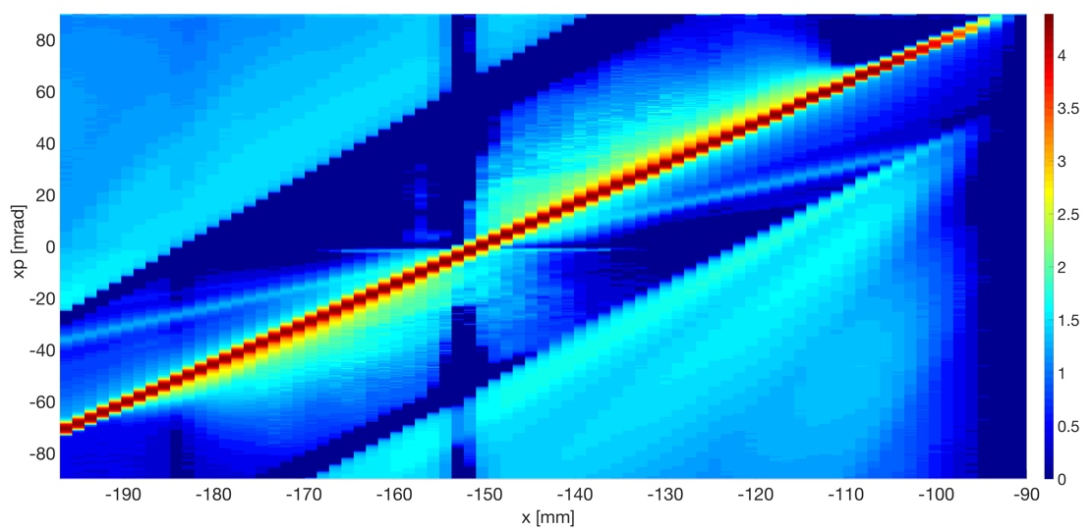

Figure - Reconstructed emittance for the nominal ion source configuration (log. scale) [2].

## Energy

During the measurement on 2017-05-25, the beam energy was changed in a range from 70 keV to 80 keV. The results are shown in Figure 6, and Figure 7.

A voltage divider was installed at a later stage to measure the energy stability of the beam. The stability was measured on 2017-09-12, and the result is shown in Figure 8. The voltage divider had previously been calibrated with the HV power supply and without beam, and the result showed that it underestimated the voltage by 950 V. The set voltage was 75132 V, and the reading therefore started at approximately 74.2 kV. At -3 ms, the plasma was ignited and a beam was extracted from the plasma chamber. The voltage on the platform dropped as the beam current was drawn, and the HV power supply stabilized the voltage during 2-3 ms. The voltage then stabilized at a lower value because of a difference in potential across a resistor in the HV power supply. When the plasma switched off, the HV power supply stabilized the voltage during 5-6 ms.

Figure 9 shows a zoom of the voltage stability during the beam flattop. The stability is within the required value of ±10 V.

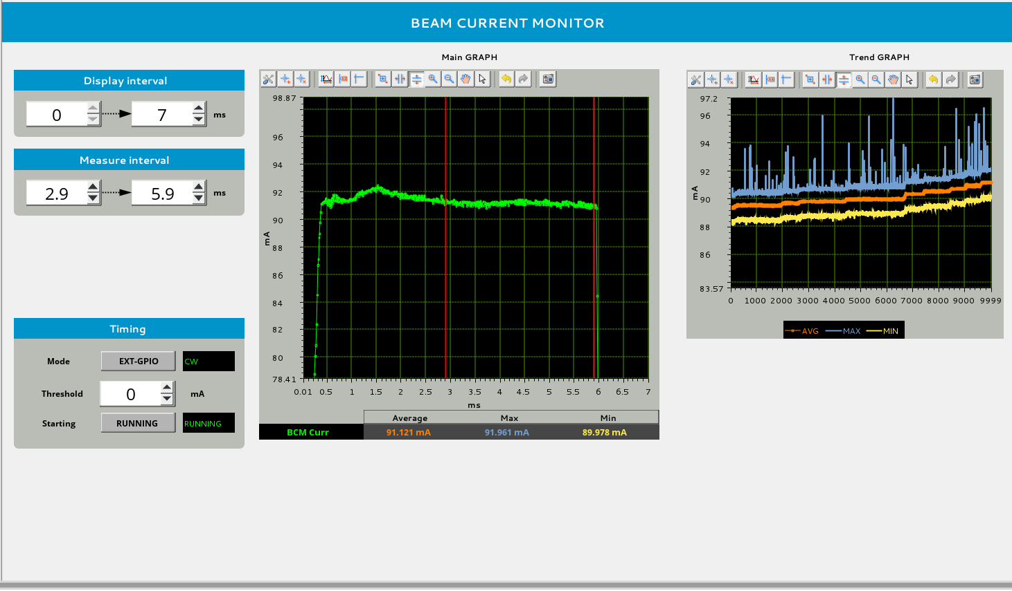

Figure - Screenshot of the signal from the ACCT mounted in the high voltage cable. The image on the right shows the trend of the beam current while increasing the beam energy from 70 keV to 80 keV in steps of 1 kV.

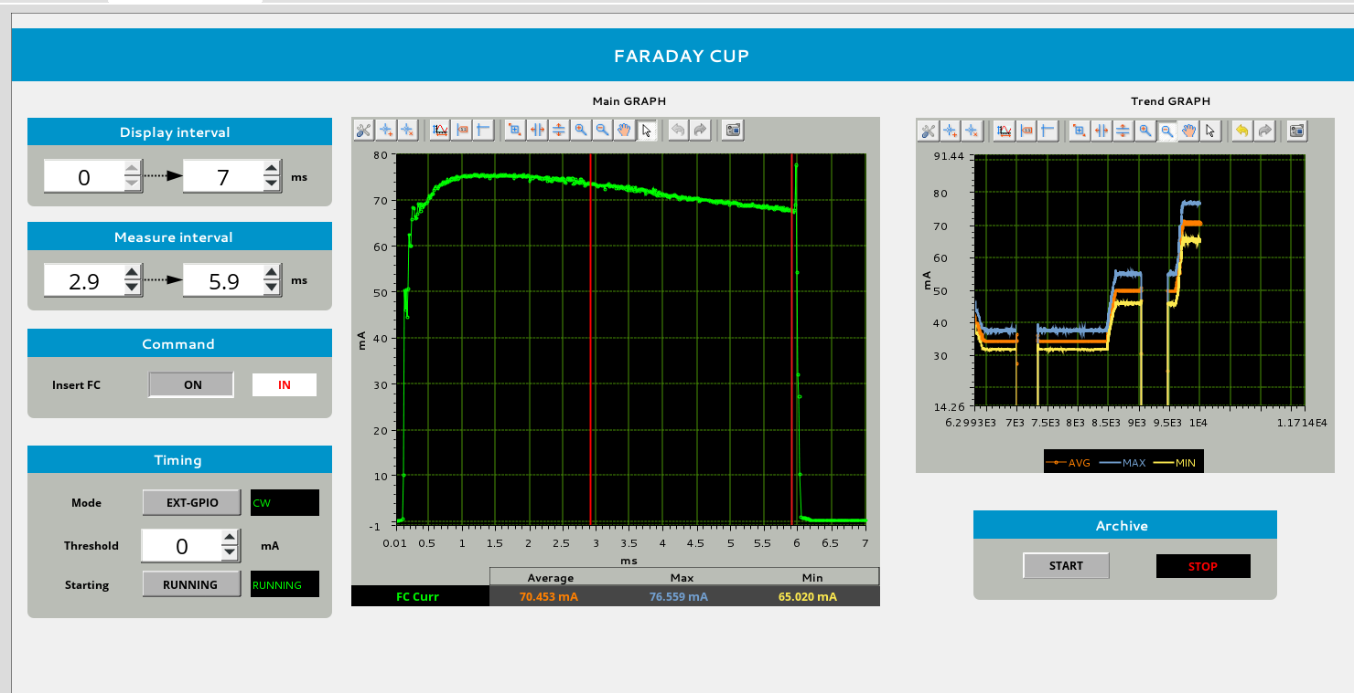

Figure - Screenshot of the signal from the Faraday cup. The image on the right shows the Faraday cup current for beams with energies of 70 keV (35 mA), 75 keV (50 mA), and 80 keV (70 mA).

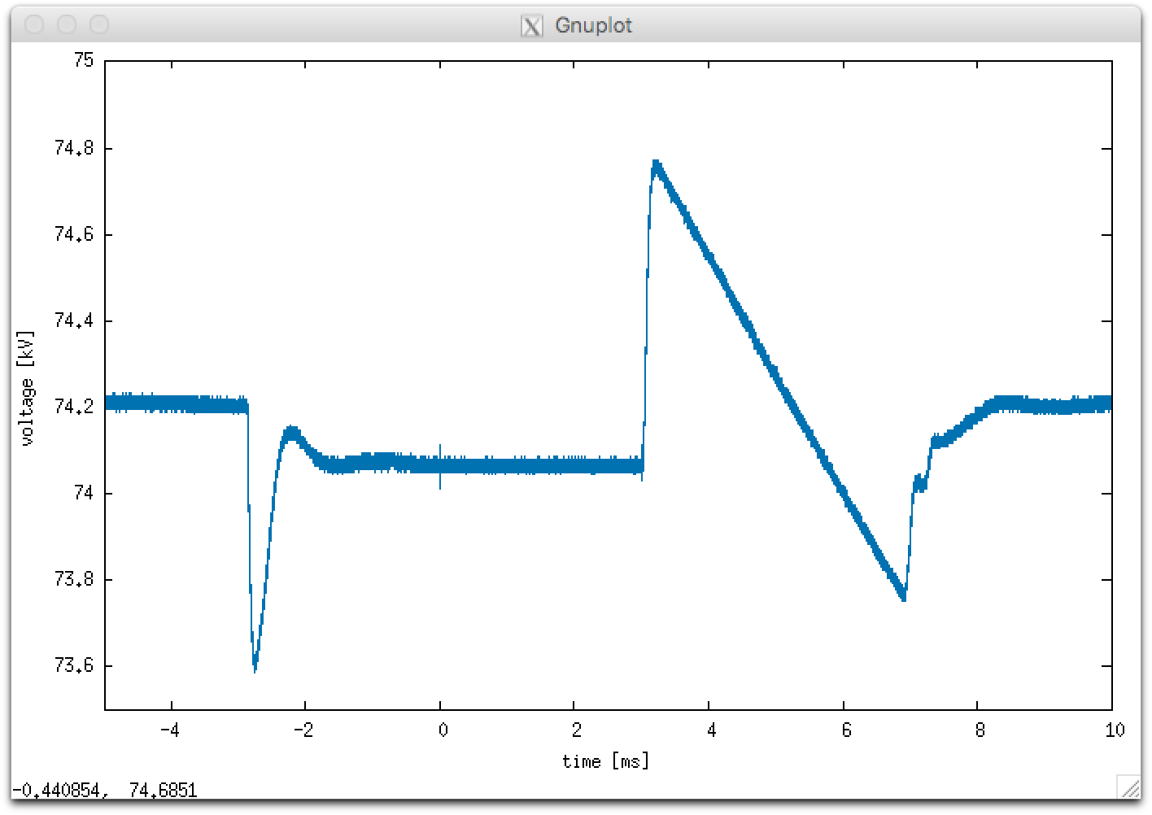

Figure - Voltage on the HV platform as a function of time. The plasma switched on at -3 ms, and the flattop is the part from 0 to 3 ms.

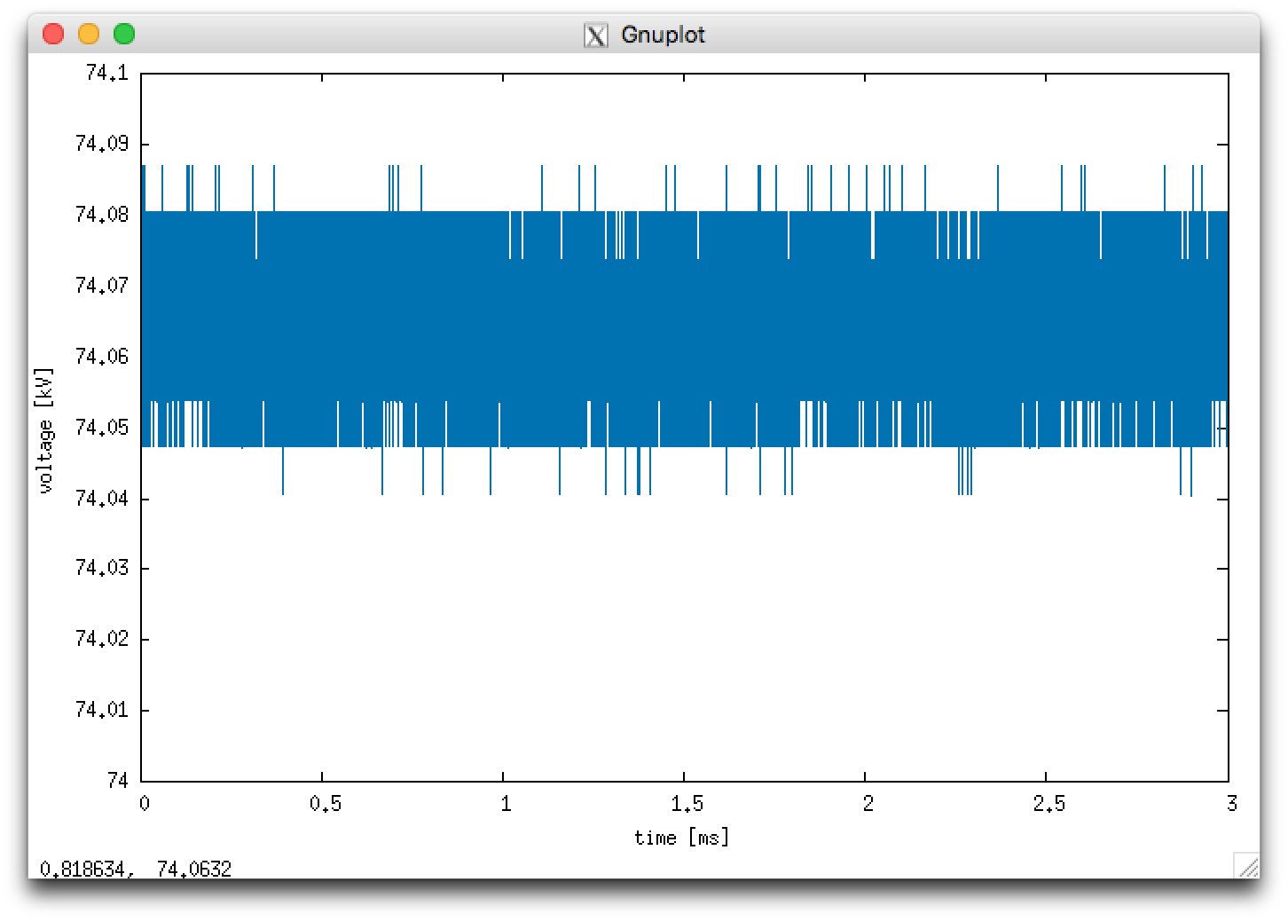

Figure - Zoom of the stability of the HV platform voltage during the beam flattop.

## Restart time

2017-04-27: there was a short circuit on the repeller electrode of the ion source extraction system. A wire was replaced, and to make this change, the vacuum was broken for approximately 24 hours. The vacuum was restarted April 28 at approximately 14:00. A stable beam was reached April 29 at around 12:00. This results in a recovery time after vacuum break of 22 hours.

2017-07-19: Source was off since 17th at approximately 18:00. After ~40 hours without plasma the source produced a stable beam within a few seconds.

2017-09-12: The magnetron was inhibited for 5 seconds and switched on again. Figure 10 shows that the beam was recovered at the first beam pulse after the inhibit time.

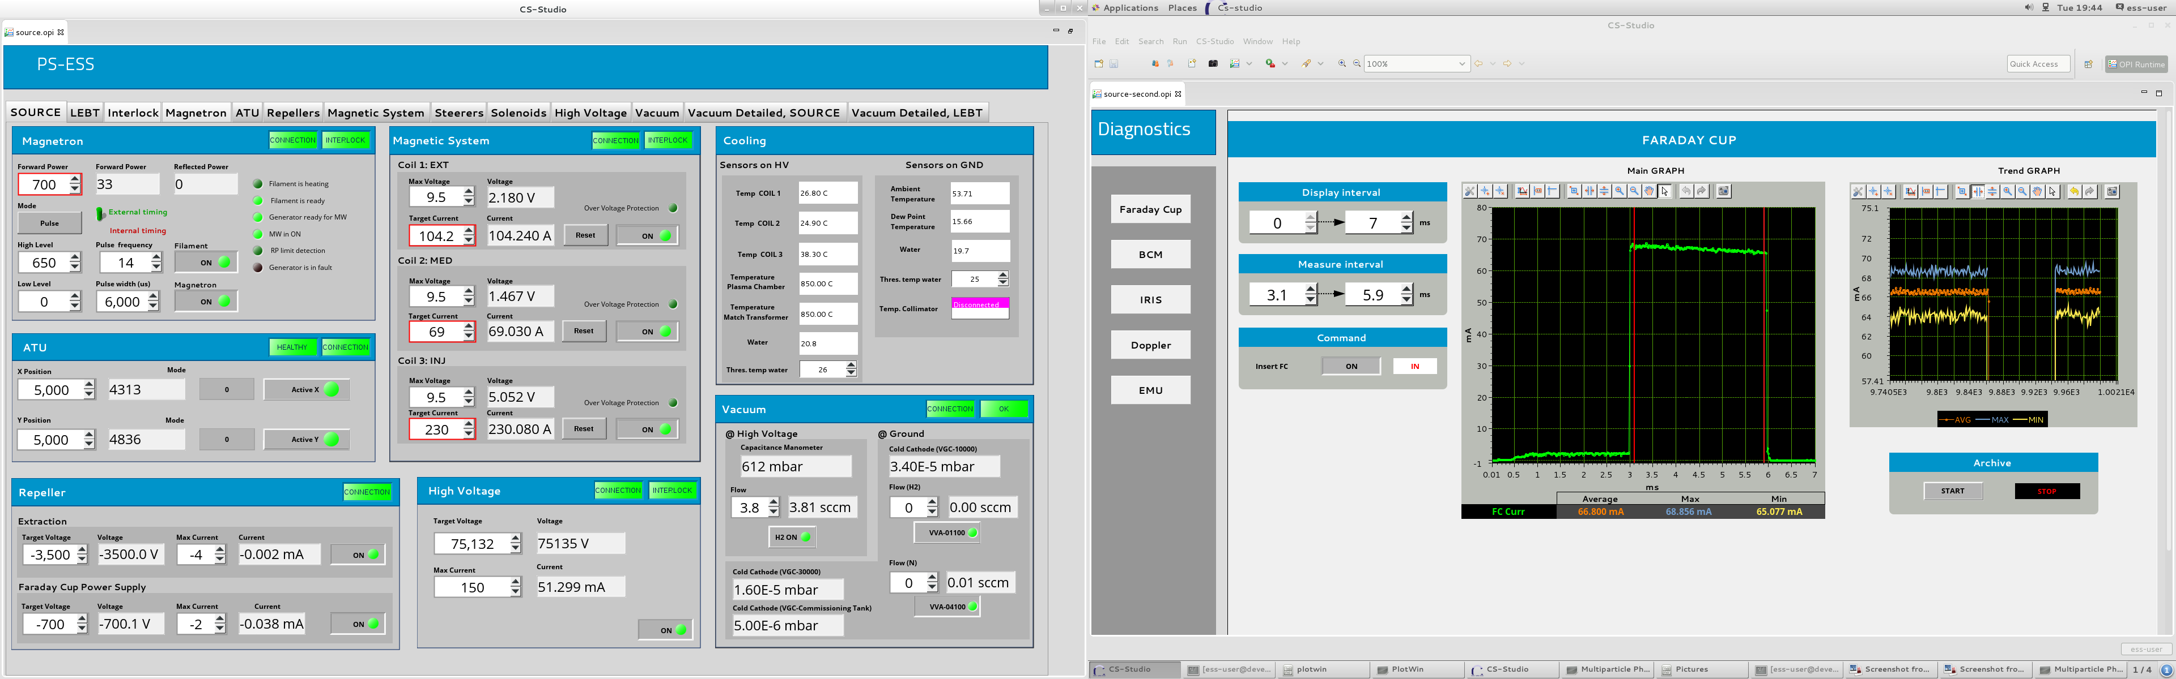

Figure - Faraday cup (in the commissioning tank after the LEBT) current. The plot to the right shows the min, max, and average current for each beam pulse. After a 5 second inhibit time, the beam current recovered in the first beam pulse.

# Summary of ion source measurements

Table 1 summarizes the ion source requirements with the results of the beam commissioning at INFN-LNS. The status symbols signifies the following:

☑ Requirement achieved

☒ Requirement not achieved

☐ Requirement not measured

■ Requirement not possible to verify because of reduced commissioning time or missing beam instrumentation

Table - Ion source requirements.

| Requirement ID | Requirement | Vaule  (ref. Chess) | Measurement device | Status |
| --- | --- | --- | --- | --- |
| ISrc.SyR-12 | Nominal beam current | 74 mA | Faraday cup, ACCT | ☑ |
| ISrc.SyR-10 | Maximum proton beam current | > 90 mA | Faraday cup, ACCT | ☑ |
| ISrc.SyR-13 | Proton beam current range | 67-74 mA | Faraday cup, ACCT | ☑ |
| ISrc.SyR-11 | Proton fraction | > 75 % | Doppler shift monitor | ☑ |
| ISrc.SyR-16 | Pulse length | 3 ms | Faraday cup | ☑ |
| ISrc.SyR-17 | Pulse length maximum | 6 ms | Faraday cup | ☑ |
| ISrc.SyR-18 | Flat top stability | ±2 % | Faraday cup, ACCT | ☑ |
| ISrc.SyR-19 | Pulse to pulse stability | ±3.5 % | Faraday cup, ACCT | ☑ |
| ISrc.SyR-24 | Repetition rate | 14 Hz | User interface, Faraday cup | ☑ |
| ISrc.SyR-35 | Repetition rate range | 1-14 Hz,  1 Hz step | User interface, Faraday cup | ☑ |
| ISrc.SyR-36 | Pulse length range | 1 ms - 3 ms | Faraday cup | ☑ |
| ISrc.SyR-20 | Beam energy | 75 keV | HV power supply | ☑ |
| ISrc.SyR-21 | Beam energy fluctuation | ± 0.01 keV | N/A | ☑ |
| ACC.ACC-SyR125 | Energy adjustment range | ± 5 keV | User interface | ☑ |
| ISrc.SyR-23 | Energy adjustment precision | ± 100 eV | User interface | ☑ |
| ACC.ACC-SyR71 | Transverse emittance (99 %) at IS-LEBT lattice interface | 1.8 μm | EMU (horizontal plane) | ■ |
| ACC.ACC-SyR72 | Beam divergence (99 %) at IS-LEBT lattice interface | 80 mrad | EMU (horizontal plane) | ■ |
| ACC.ACC-SyR123 | Beam center offset at IS-LEBT lattice interface | ±0.1 mm | N/A | ■ |
| ACC.ACC-SyR124 | Beam angle offset at IS-LEBT lattice interface | ±1 mrad | N/A | ■ |
| ISrc.SyR-22 | Matched beam parameters |  | Faraday cup, ACCT, EMU, Doppler, user intaface | ■ |
| ISrc.SyR-32 | Operating vacuum pressure | < 1e-3 mbar | Vacuum gauge | ☑ |
| ISrc.SyR-14 | Start-up time after shut down | 16 hours | Faraday cup, ACCT | ☑ |
| ISrc.SyR-15 | Start-up time after source maintenance | 32 hours | Faraday cup, ACCT | ☑ |
| ISrc.SyR-37 | Recovery after 5 s downtime | 1 pulse | Faraday cup, ACCT | ☑ |

# References

1. L. Neri *et al.*, “Beam Commissioning of the High Intensity Proton Source Developed at INFN-LNS for the European Spallation Source”, in *Proc. Of IPAC’17*, Copenhagen, Denmark, May 2017, paper WEOBB2, pp. 2530-2532.
2. B. Cheymol, C. Thomas, “Emittance anlaysis with nominal source configuration”, ESS-0122222.