|  |
| --- |
|  |
|  |
|  |
| Ion source AND LEBT performance at the end of COMMISSIONING Phase 4 |
|  |

|  | Name | Role/Title |
| --- | --- | --- |
| Authors | Øystein Midttun  Lorenzo Neri |  |

# Introduction

This document summarizes the ion source and LEBT performance after the Phase 4 of the commissioning at INFN-LNS, Catania. The set-up was the ion source and the two-solenoid LEBT with the commissioning tank at the end, as shown in Figure 1.

Available diagnostics:

* Ion source: ACCT on HV cable, voltage divider on HV platform.
* Pumping box: vacuum gauge.
* Permanent tank: Emittance measurement unit (vertical plane), vacuum gauge.
* Chopper: voltage sensor.
* Collimator: ACCT.
* Commissioning tank: EMU vertical plane, Faraday cup.

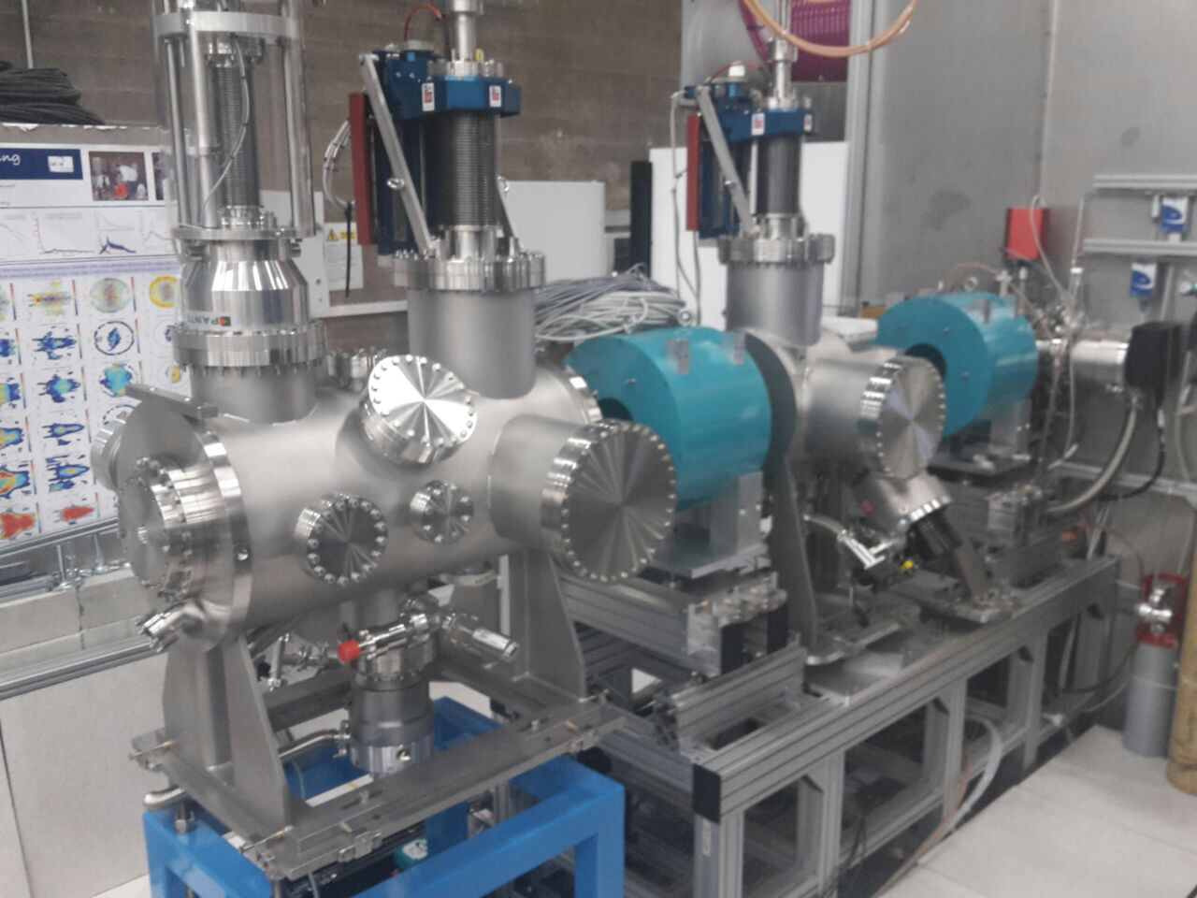

Figure – Ion source to the right behind the metal wall. LEBT with two solenoids (green), one EMU in each diagnostics tank, and the Faraday cup in the commissioning tank to the left.

# LEBT measurements

The measurements described in this documents were performed on 2017-09-12. The ion source was set-up was:

* Coil 1 104.2 A
* Coil 2 69 A
* Coil 3 230 A
* H2 gas injection 3.8 sscm
* Pressure (pumping box) 3.5x10-5 mbar
* Pressure (permanent tank) 1.6x10-5 mbar
* Pressure (commissioning tank) 5.2x10-6 mbar
* RF power 650 W
* Ion source repeller electrode -3.5 kV
* Collimator repeller electrode 0 V (due to a short circuit)
* Extraction voltage 75 kV
* Pulse length 6 ms
* Flat-top length 3 ms
* Repetition rate 14 Hz
* Chopper voltage -11 kV
* Chopper pulse length 3 ms
* Chopper pulse length for EMU 200 µs

## Current

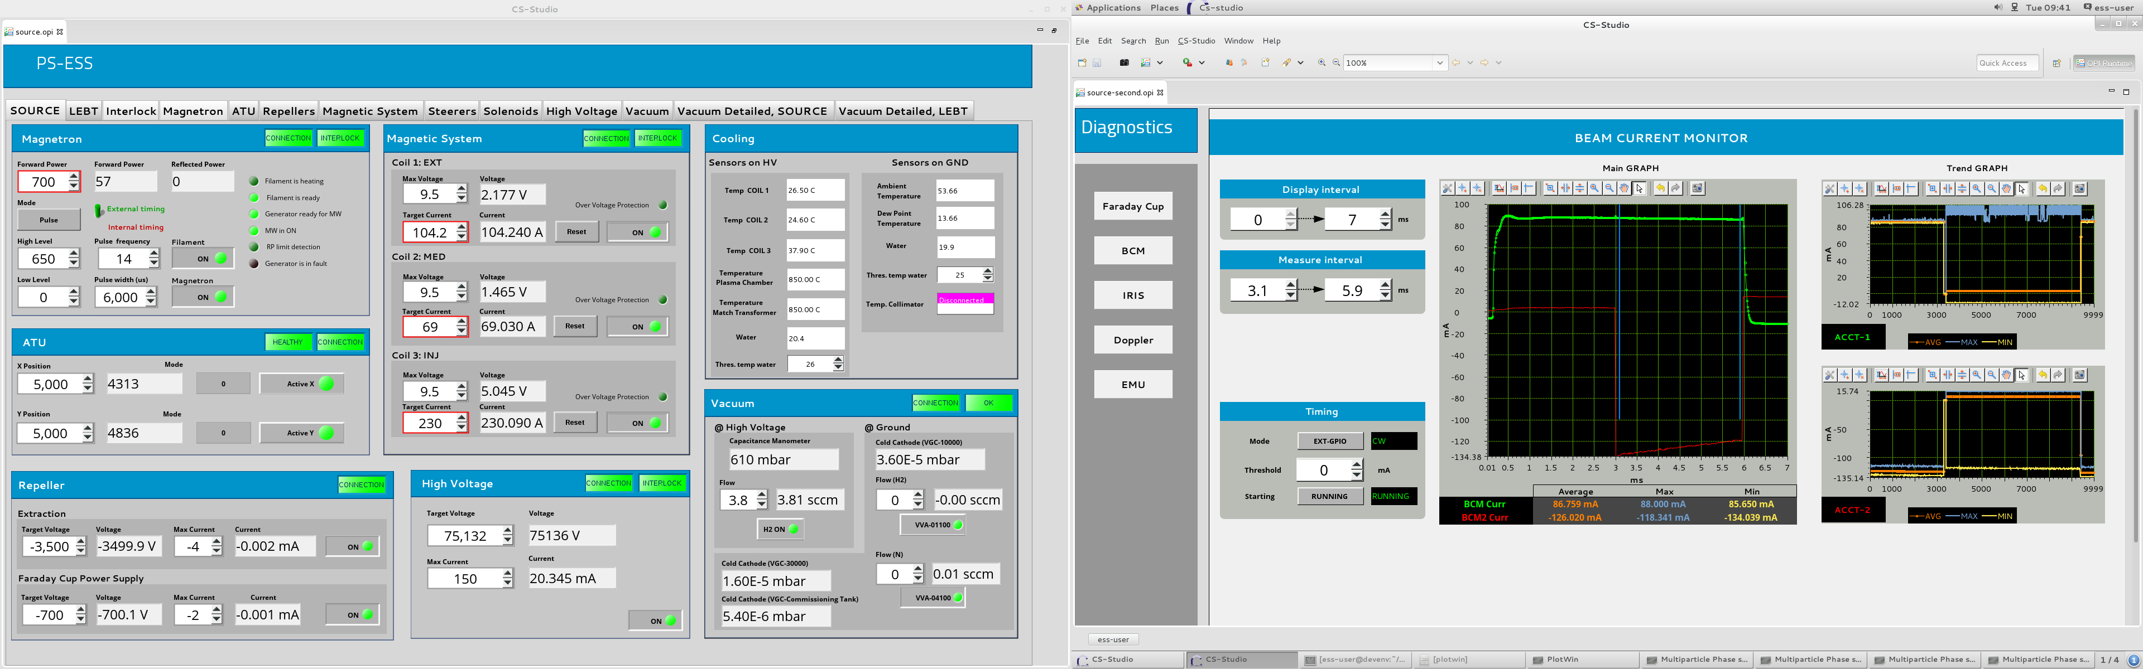

Figure - Screenshot of the signal from the ACCT mounted in the high voltage cable.

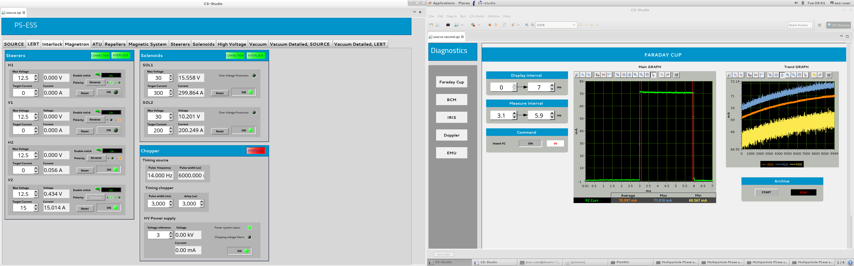

Figure - Screenshot of the signal from the Faraday cup.

## Beam current range

Iris opening diameter, and measured current in the Faraday cup:

3 mm, 0.2 mA

4 mm, 0.35 mA

5 mm, 0.5 mA

6 mm, 0.7 mA

25 mm, 10 mA

45 mm, 29.5 mA

46 mm, 31 mA,

46.5 mm, 31.6 mA

46.7 mm, 31.8 mA

74 mm, 72.25 mA

73 mm, 71.75 mA

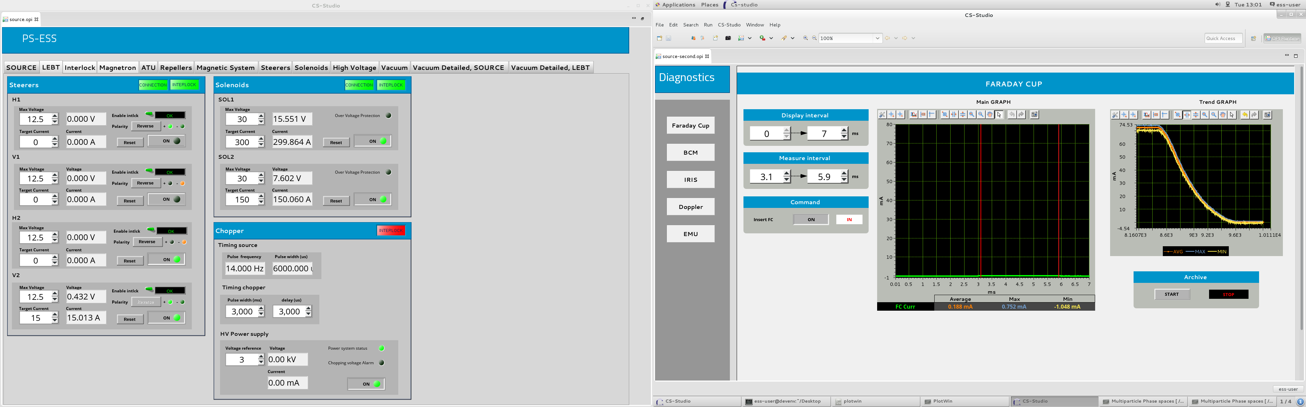

Figure - Screenshot of the trend of the Faraday cup current while closing the iris.

## Time structure

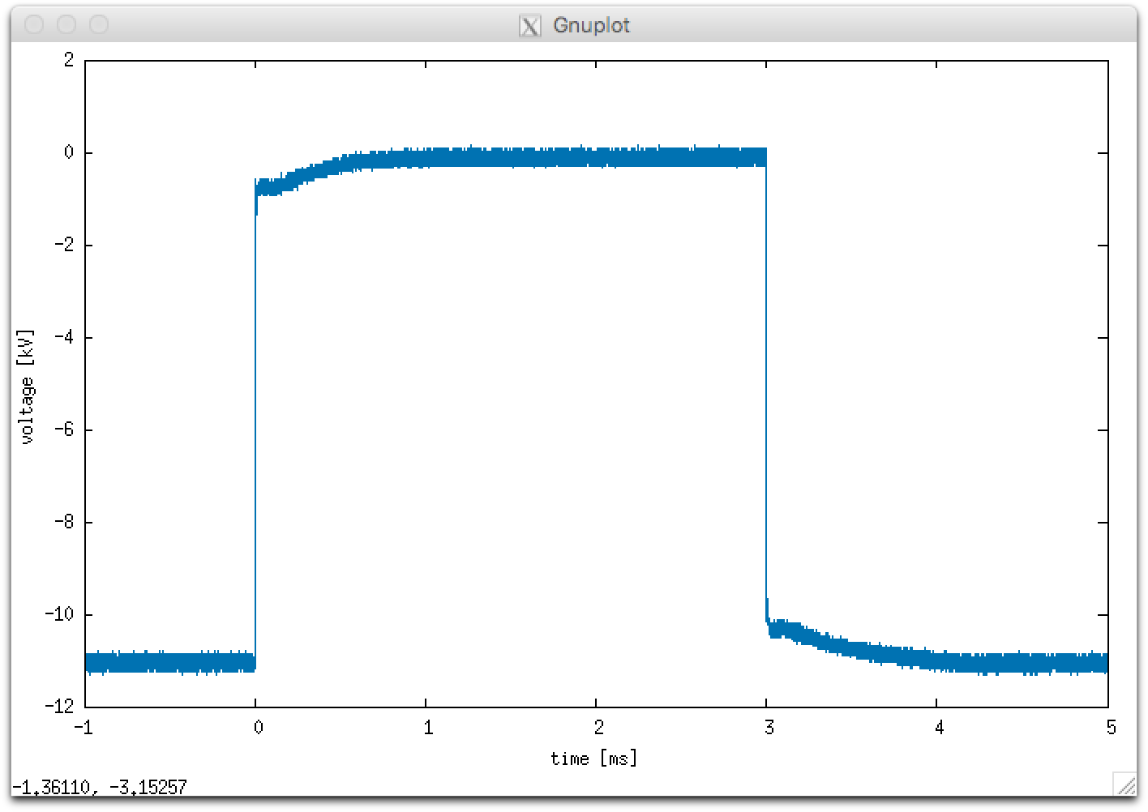

Figure - Chopper voltage

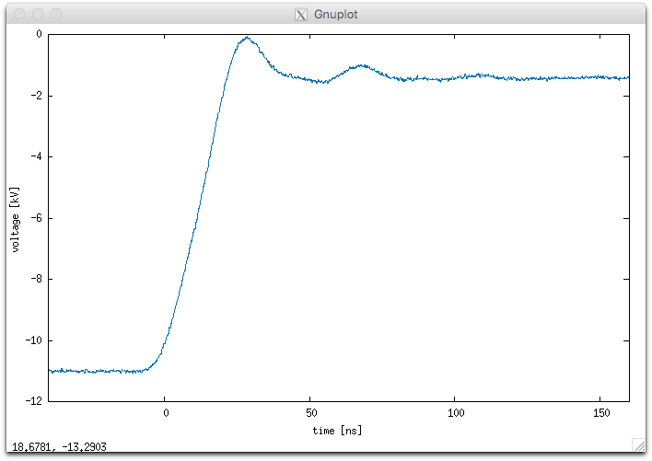

Figure - Chopper fall time.

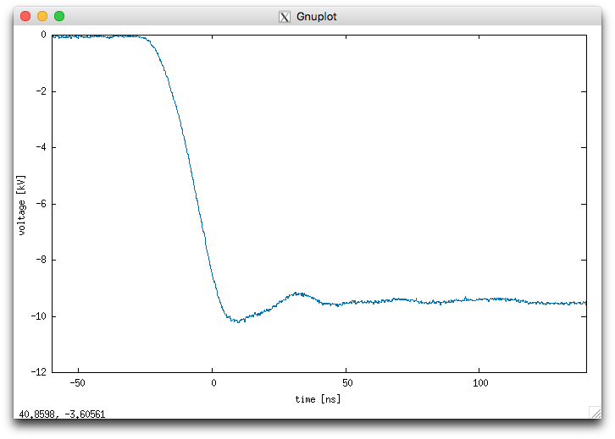

Figure - Chopper rise time.

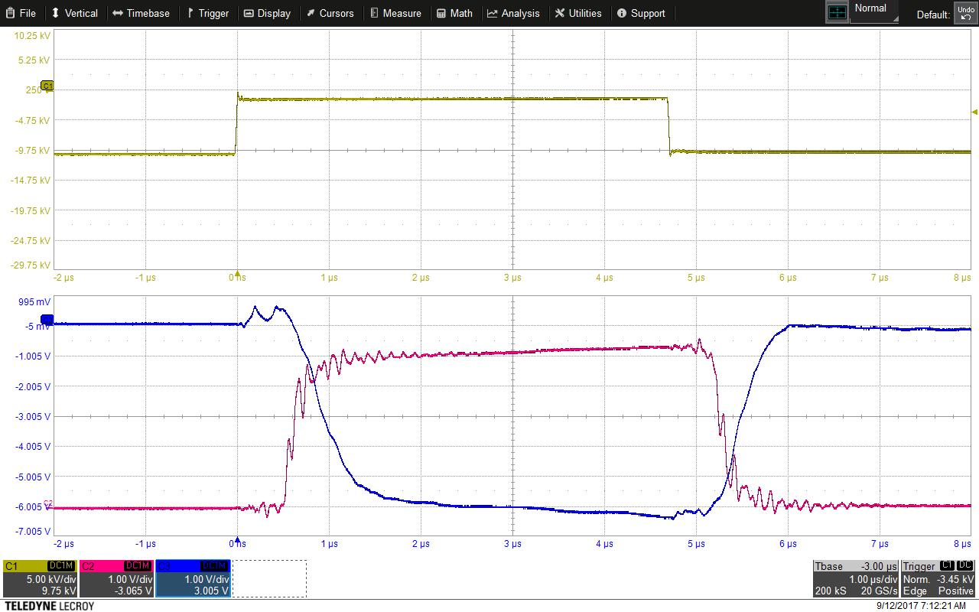

Figure - 5 µs pulse.

## Emittance

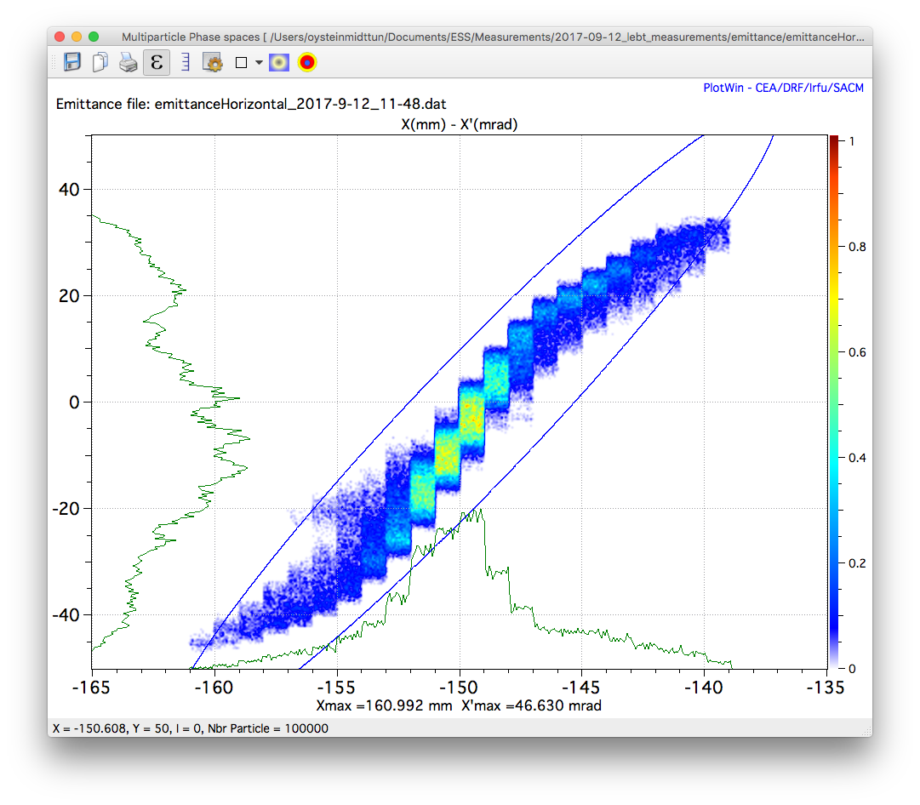

Figure - Phase space plot. I=70mA, Isol1=300A, Isol2=200A.

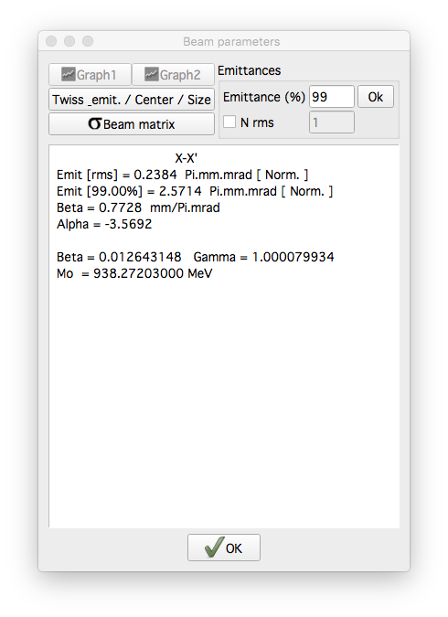

Figure - Emittance and twiss parameters. I=70mA, Isol1=300A, Isol2=200A.

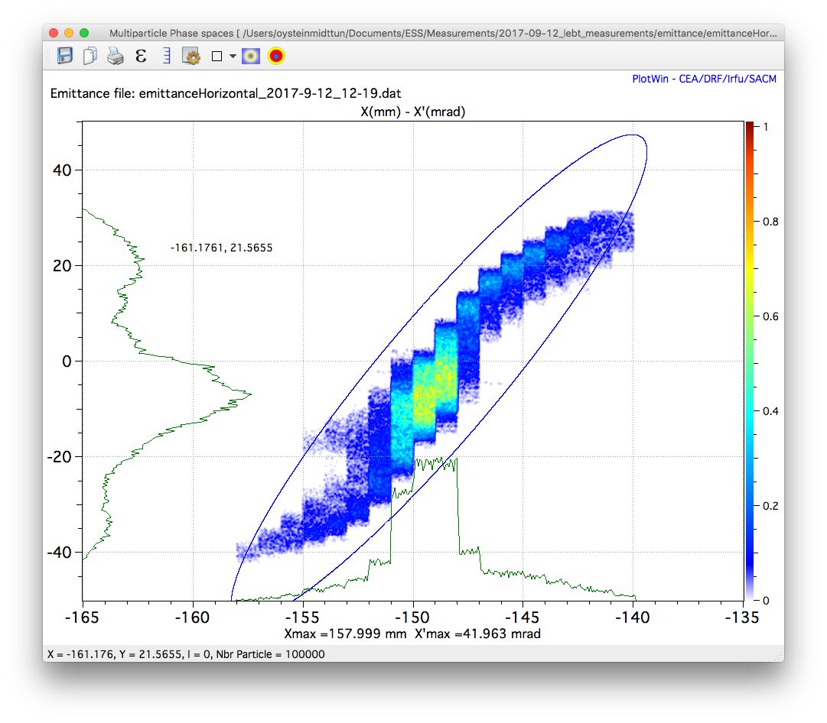

Figure - Phase space plot. I=70mA, Isol1=300A, Isol2=150A.

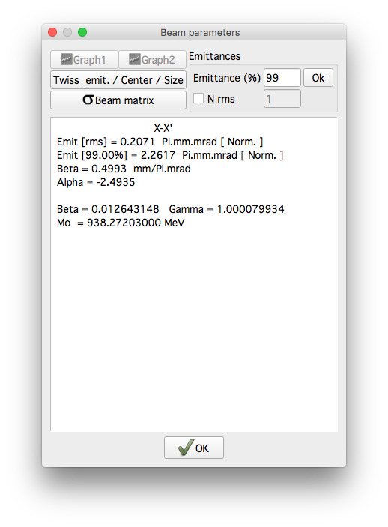

Figure - Emittance and twiss parameters. I=70mA, Isol1=300A, Isol2=150A.

# Summary of LEBT measurements

Table 1 summarizes the LEBT requirements with the results of the beam commissioning at INFN-LNS. The status symbols signifies the following:

☑ Requirement achieved

☒ Requirement not achieved

☐ Requirement not measured

■ Requirement not possible to verify because of reduced commissioning time or missing beam instrumentation

Table - LEBT requirements.

| Requirement ID | Requirement | Vaule  (ref. Chess) | Measurement device | Status |
| --- | --- | --- | --- | --- |
| LEBT.SyR-10 | Nominal beam peak current | 74 mA | ACCT on HV cable | ☑ |
| LEBT.SyR-11 | Transmission | > 95 % | Faraday cup, ACCTs | ☑ |
| LEBT.SyR-12 | Design beam energy | 75 keV | Voltage divider | ☑ |
| LEBT.SyR-13 | Transverse emittance containing 99 % of the nominal current | 2.25 µm | EMU | ☑ |
| LEBT.SyR-14 | Beam alignment | ±0.1 mm | N/A | ■ |
| LEBT.SyR-15 | Beam current range | 0-74 mA | Faraday cup | ☑ |
| LEBT.SyR-16 | Beam current range step size | 2 mA | Faraday cup | ☑ |
| LEBT.SyR-17 | Beam current precision | 1 mA | Faraday cup | ☑ |
| LEBT.SyR-18 | Operating vacuum pressure | < 6e-5 mbar | Vacuum gauges | ☑ |
| LEBT.SyR-19 | Nominal beam pulse flat top length | > 2.86 ms | Faraday cup, ACCTs | ☑ |
| LEBT.SyR-20 | Matched parameters during flat top |  | Faraday cup, voltage divider, EMU, vacuum gauges | ■ |
| LEBT.SyR-26 | Total beam pulse length | < 2.88 ms | Faraday cup, ACCTs | ☑ |
| LEBT.SyR-27 | Matched Tranverse Twiss parameter alpha | 1.02±20 % | EMU | ■ |
| LEBT.SyR-28 | Matched Tranverse Twiss parameter beta | 0.11±10 % | EMU | ■ |
| LEBT.SyR-30 | Proton beam pulse lengths for commissioning and start-up | 0.005-2.86 ms | Faraday cup | ☑ |
| LEBT.SyR-31 | Single pulse production |  | N/A | ■ |
| LEBT.SyR-33 | Orbit control | ±0.5 mm | N/A | ■ |
| LEBT.SyR-35 | Transmission of the transient | < 1 % | Faraday cup | ☑ |
| LEBT.BMD-29 | Chopper rise/fall time | 100 ns | N/A | ■ |
| LEBT.BMD-31 | Chopper efficiency | 99 % | Faraday cup, ACCT, EMU, Doppler, user intaface | ☑ |
| LEBT.BMD-32 | Chopper voltage repetition frequency | 1-14 Hz | Vacuum gauge | ☑ |
| LEBT.BMD-35 | Chopper voltage OFF period | 0.005-2.88 ms | Faraday cup, ACCT | ☑ |
| LEBT.BMD-63 | Chopper Micro-Pulse Voltage Flat-Top fluctuations | ±10 % | Faraday cup, ACCT | ☑ |
| LEBT.BMD-64 | Chopper voltage fall time | 1 µs | Faraday cup, ACCT | ☑ |

# References