|  |
| --- |
|  |
|  |
|  |
|  |
|  |
|  |
|  |
|  |
| Ion source high voltage protection cage |
|  |
|  |

|  | Name | **Role/Title** |
| --- | --- | --- |
| **Owner** | Øystein Midttun | System leader ion source and LEBT |
| **Reviewer** | <<Name>> | <<Role/ Title>> |
| **Approver** | <<Name>> | <<Role/ Title>> |

|  |  |
| --- | --- |
| Table of content | Page |

1. Scope 3

2. Description of the cage 3

3. Procedure of entering the cage 4

4. Summary 6

5. Glossary 6

6. references 6

Document Revision history 7

# Scope

This document describes the protection cage for the high voltage (HV) platform of the ESS ion source. The main function of the cage is to protect against the electrical hazard of the platform, which is biased to 75 kV during operation. In addition the cage has lead shielded walls to reduce the level of x-rays from the ion source, and small openings at the top to allow the hydrogen gas to escape in case of a leak on the gas bottle.

# Description of the cage

The first function of the HV protection cage (Figure 1) is to protect against the electric hazard of the HV platform, which is biased to 75 kV during ion source operation. Grounded floor-to-roof walls surrounds the complete platform to prevent to possibility to touch the platform while it’s biased. The walls attach to the grounded plate between the ion source and LEBT (in black). This wall is the closest to the HV platform with a distance of 18 cm.

The cage is electrically connected to ground mesh of the accelerator tunnel through three grounding points at the centre of tunnel, and two wall mounted grounding points. Three copper sheets run along the floor from the grounding points to one grounding point on the wall. One copper sheets runs along the floor below the LEBT, and connects to the other grounding point on the wall. On the inside of the HV cage there is one grounding bar on the side facing the transport area of the tunnel, and on the LEBT girder there is one grounding bar for connecting the LEBT components.

The lowest 2.5 meters of the HV cage walls are made of 6 mm thick plates of lead sandwiched between aluminium (2 mm alu + 2 mm lead + 2mm alu). Measurements made at INFN-LNS show that the ion source produces x-ray with energies up to 75 keV, and that these are effectively blocked by 2 mm lead [1].

The last meter to the roof has aluminium plates with 2.5 mm diameter holes to let hydrogen gas escape in case of a leak. The design of the cage is then made according to the IP3x standard.

The cooling water to the ion source arrives through a plastic water hose, shown in pink behind the cage wall in Figure 1. To increase the length of the water, the hose is rolled around a cylindrical support. The hose is then routed on the inside of the cage to the water inlet next to the LEBT. Steels pipes penetrate the HV protraction cage at this location in order to have a proper grounding of the water pipes.

The Personal Safety Systems (PSS) group at ESS is responsible for the safety aspects and entering procedures of the HV cage [2].

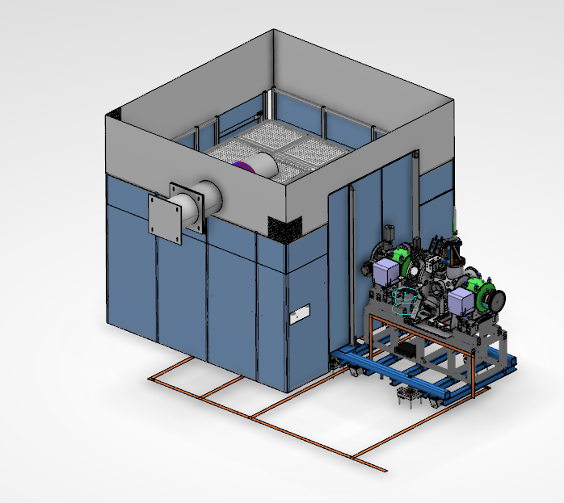

Figure 1 - Illustration of the high voltage protection cage.

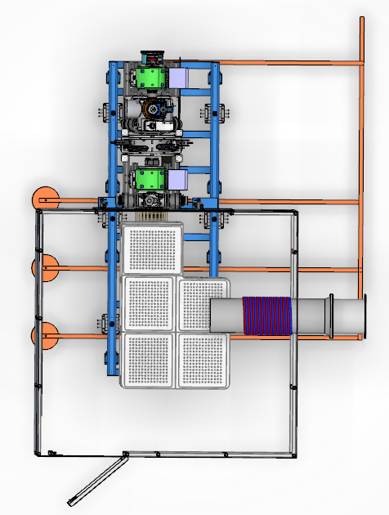

Figure 2 - Top view of the HV protection cage with grounding copper bars along the floor.

# Summary

<< Text >>

# Glossary

| Term | Definition |
| --- | --- |
| <<Sample term>> | <<Sample explanation >> |
|  |  |
|  |  |

# references

1. ESS-0114736
2. Concept of Operations For the Accelerator Personnel Safety System 0 (PSS0)

Document Revision history

| Revision | Reason for and description of change | Author | Date |
| --- | --- | --- | --- |
| 1 | First issue | Øystein Midttun | 2017-09-08 |
|  |  |  |  |