ESS Procedure for Wearing and working in Cleanroom

 | Name | Role/Title
Owner | Christophe Jarrige | Vacuum system technician
Reviewer
Approver

Table of content | Page
1. Definition 4
2. Prohibition before entering 5
3. DRESS PROCEDURE 6
4. Behaviour in the cleanroom 10
5. references 10
6. Document Revision history 10

Definition
A cleanroom is an environment, in our case used in scientific research, which has a low level of environmental pollutants, such as dust, airborne microbes, aerosol particles and chemical vapours. To work in one, we need to take the appropriate steps to avoid introducing of contamination.

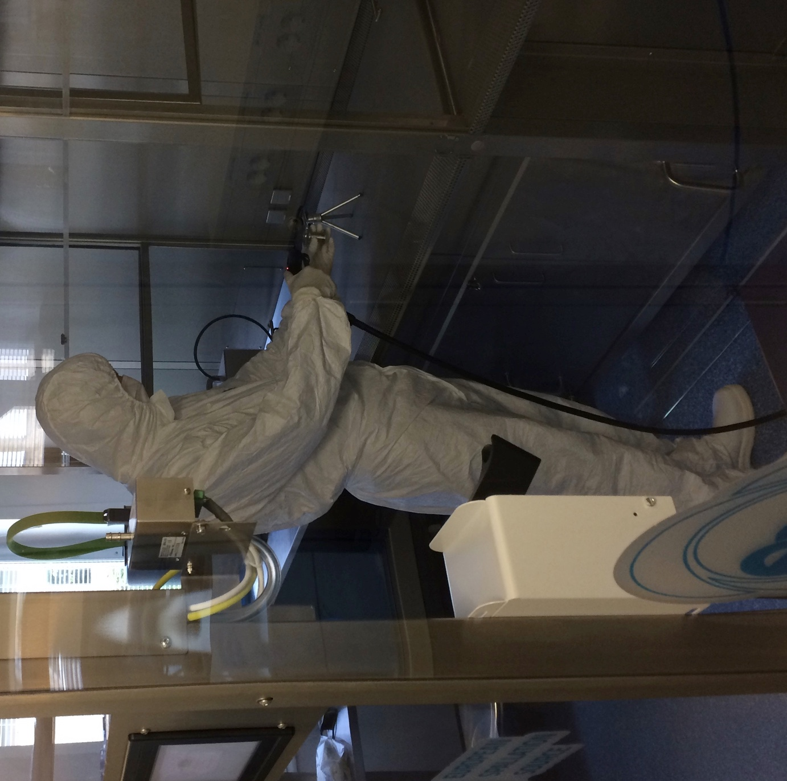

Prohibition before entering
- Not wear cosmetics, hairspray and perfumes
- Don’t smoke within 45 min of entering in the cleanroom
- Discard gum or anything else in your mouth
- Outdoor shoes must stay outside of cleanroom
- Personnel with colds or severe sunburns

DRESS PROCEDURE
The rule to put on the cleanroom gear in the correct order is from Top to Bottom

Step 1: Start putting on under gloves

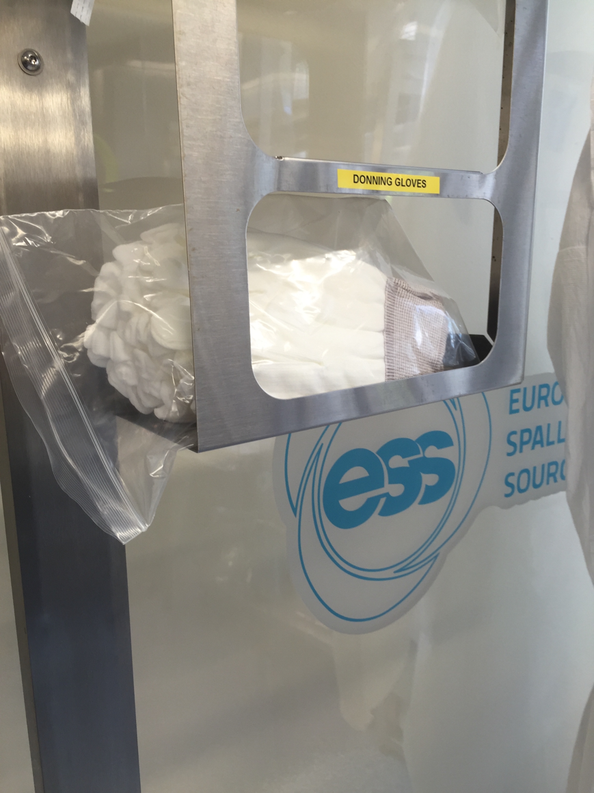

Step 2: Put on Hair net
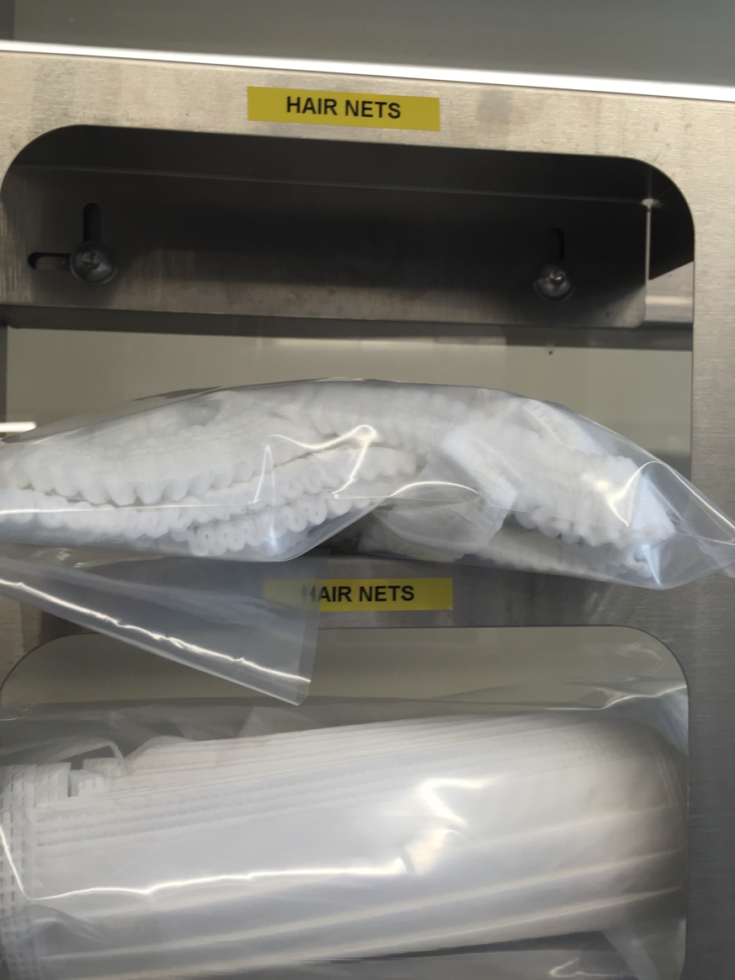

Step 3: Put on Face Masks
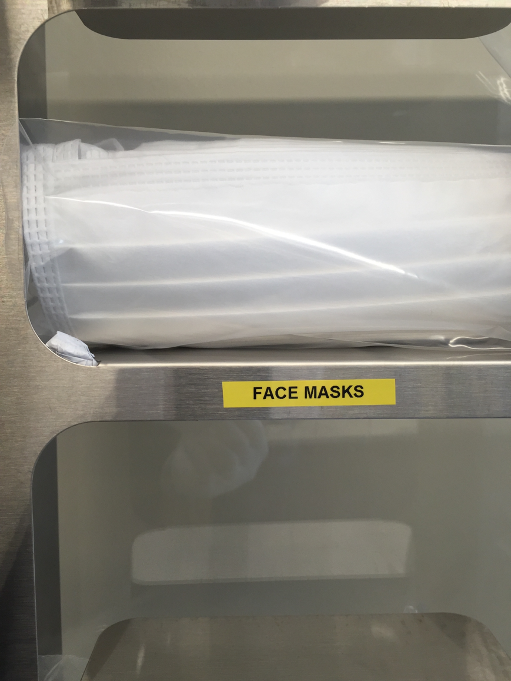

Step 4: Wear Suit
Don’t let the sleeves touch the ground
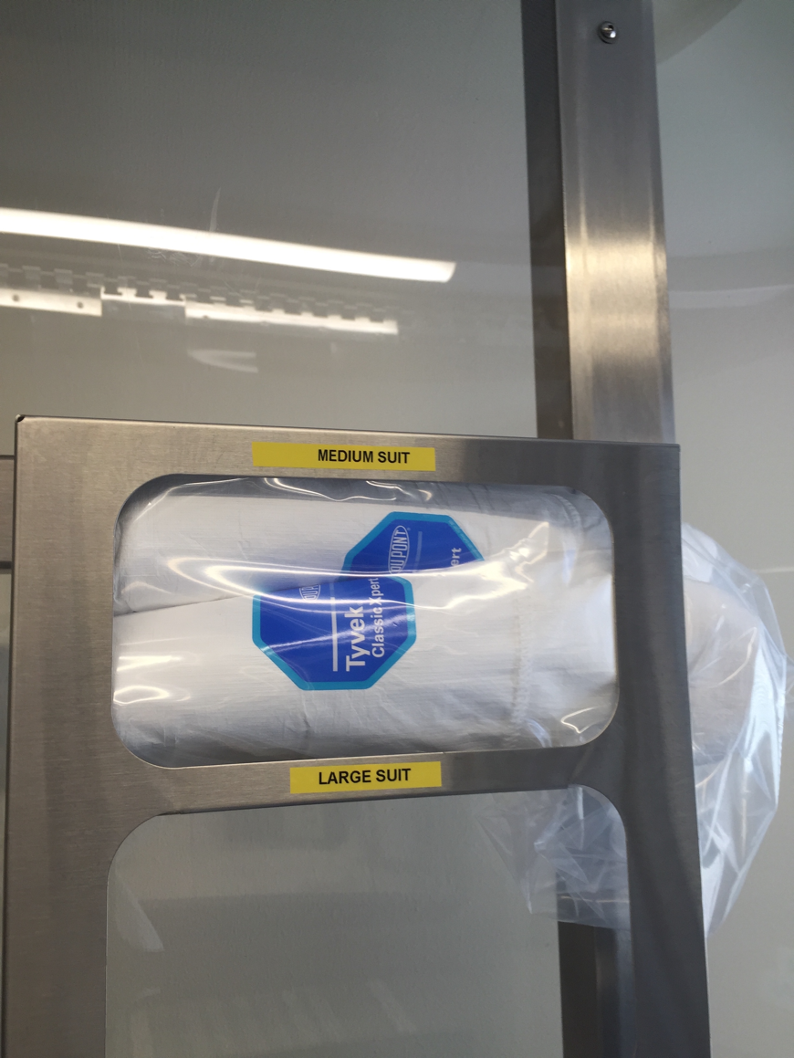

Step 5: Pair of shoes
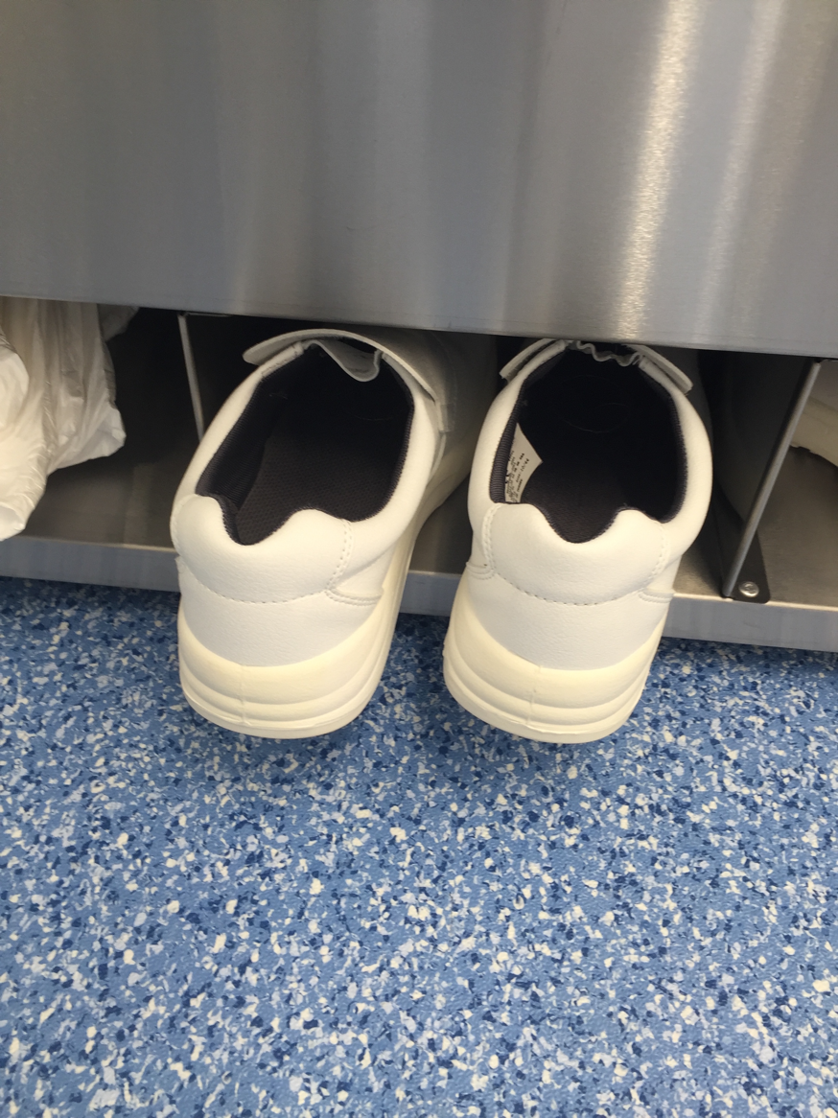

Step 6: get through the curtains
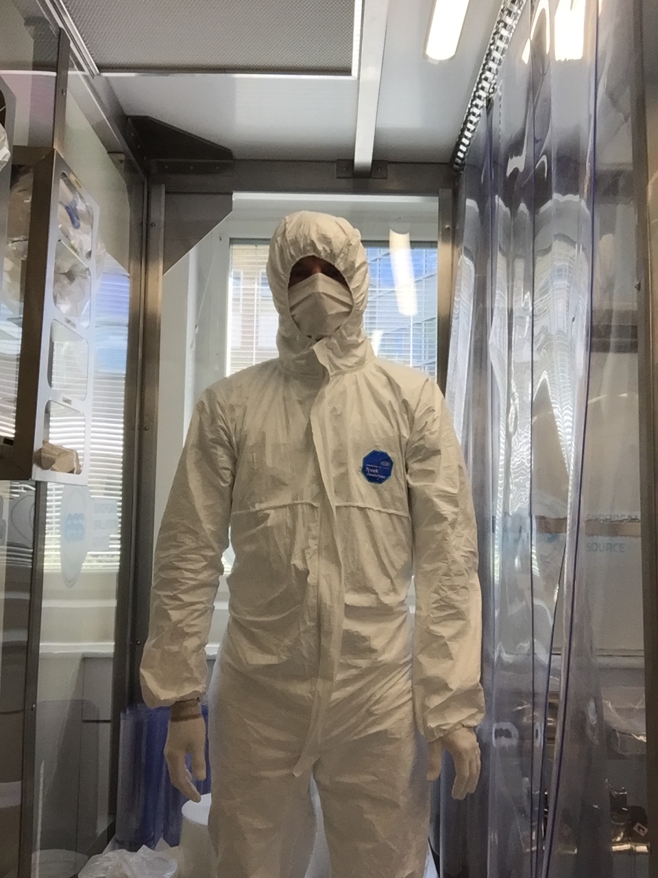

Step 7: Put on nitrile gloves
Be sure to change nitrile gloves before starting a new activity
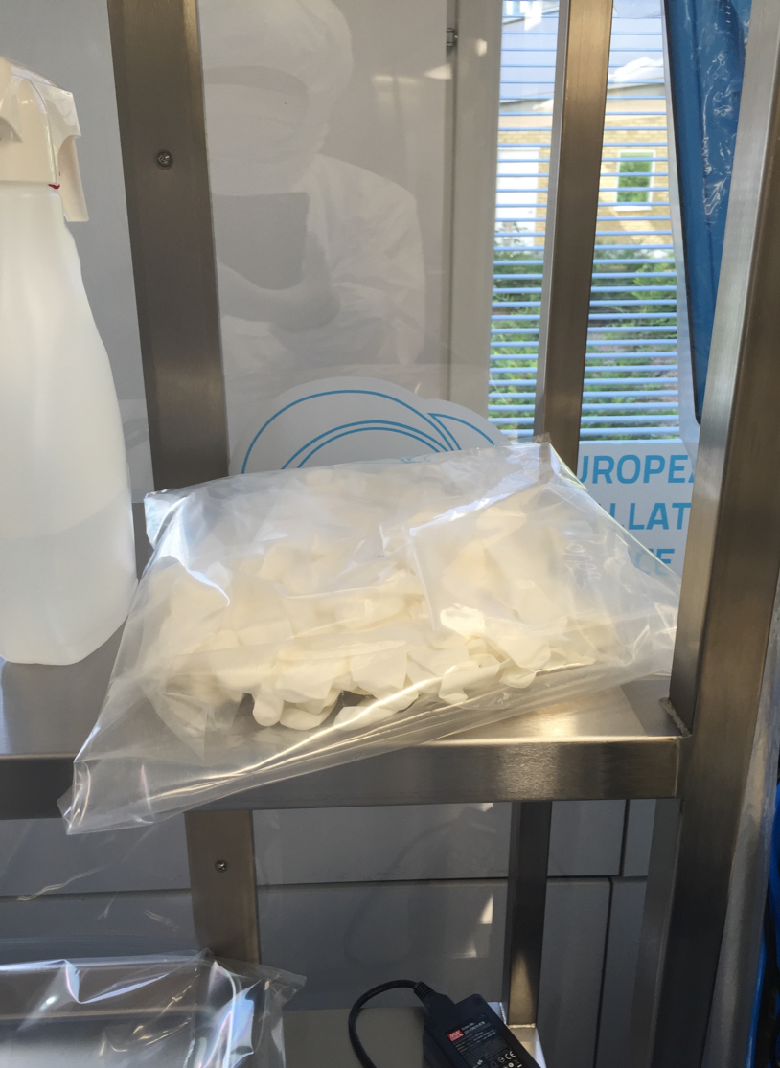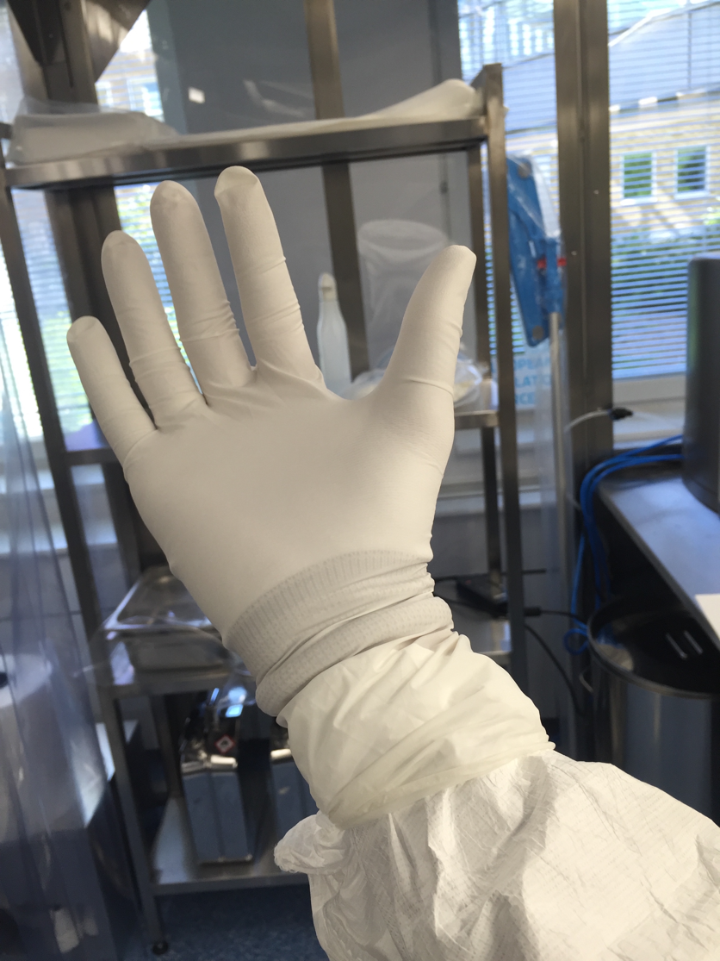

Behaviour in the cleanroom
Walking rapidly or moving unnecessarily is prohibited
All tools or pieces that rest on the surface of table must be placed on a cleanroom wipe.
Before and after using, tools must be cleaned with an IPA wipe.
Any work or tools dropped on the floor shall be considered contaminated and must be cleaned.
Changes nitrile gloves before starting a new activity
All wastes should be taken out from cleanroom at the end of activities

references
- ESS vacuum hand book ESS 012894

Document Revision history
Revision | Reason for and description of change | Author | Date
1 | Adapted to a new template | Christophe Jarrige | 17-11-05
 | <<Keep only full number revisions when approving document>>

