ESS Procedure for Cleaning assembly particle free UHV component

 | Name | Role/Title
Owner | Christophe Jarrige | Vacuum system Technician
Reviewer
Approver

Table of content | Page
1. INTRODUCTION 3
2. SCOPE 3
3. Principle 3
4. cleaning procedure 3
4.1 Rinsing 4
4.2 Wiping 4
4.3 Drying 5
4.4 Controlling 6
4.5 Assembly 7
4.6 Packing 8
5. references 8
6. Document Revision history 9

INTRODUCTION
The European Spallation Source (ESS) is an accelerator-driven neutron spallation source. The linear accelerator (LINAC) of which is a critical component. The role of the accelerator is to create protons at the ion source, accelerates them to an appropriate energy, and steer them onto the target to create neutrons via the spallation process for use by a suite of research instruments.

SCOPE
This document gives a detailed technical specification for cleaning, handling and acceptance tests for UHV-components to be applied in particle free part at ESS Accelerator. This document is a deviation of cleaning procedure for UHV-component at ESS accelerator; Chess document ESS-0123055 Vacuum component degreasing procedure.

Principle
All pieces for particle free applications shall be degreased, rinsed, dried and controlled in particles. In general, various hydrocarbons (oils, lubricants and so on from fabrication process) can be present by contacts and are bad for vacuum and particle contaminations of the surfaces of the cavities for beam acceleration must be avoided to prevent deterioration of the cavity gradient.

cleaning procedure
NB:
- At ESS, cleaning procedure will be done in ISO 6 cleanroom environment. Follow the procedure: Entering and working procedure for Cleanroom
- During the cleaning procedure: as soon as the piece enters the cleanroom it shall be handled with clean lint-free gloves, which shall be changed at each stage of the treatment process.
- In this procedure, all components are considered cleaning for UHV environment. If it’s not the case, to refer to the UHV component cleaning procedure. The state of surfaces in the ultra-high vacuum pieces parts shall be checked, and should be as close as possible to a specular surface. At ESS, It’s impossible to perform any kind of recovery operation such as polishing or etching.

Rinsing
Thorough rinsing in deionized water.
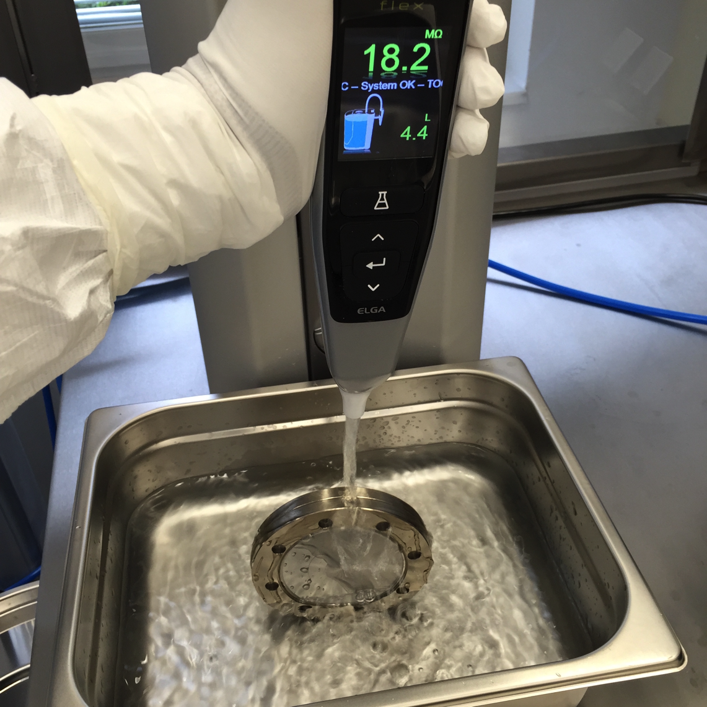
The characteristics of the water shall be:
Resistivity: 18.2MΩ
TOC: 5 PPM

4.2 Wiping
Components have to be placed in a clean room in particle free air flow ISO Class 5 or better.
If rinsing is not possible, the option is to use wet wipe with a sterile Isopropanol and wiping of all component surfaces. If airflow in the cleanroom is vertical from the roof, wiping shall be start from the top-down.
Wiping

4.3 Drying
Components have to be placed in a clean room in particle free air flow ISO Class 5 or better for several hours before assembly.
Pre-drying can be carry out with ionized nitrogen gas blow throughout a topgun.

Pre-drying: blowing with ionized nitrogen gas
Drying under laminar flow class Iso

4.4 Controlling
The absence of particles has to be controlled in a clean room class ISO 5 or better. Therefore, the components will be cleaned with particle free ionized nitrogen. After 1 minute using a gas throughput of 28 l/min at 3 bars, there should be at maximum 10 particles/minute ≥ 0.3, 0.5, 1, 5 μm be detected.
This check can be done triple, if result is still over 10 particles, component shall be cleaned again.
Due to the multitude of components to be analysed and their different geometries there is no standardized test set-up or specification of the procedure. Thus, a suitable positioning of the particle counter and the chosen blow process for the components needs to be approved.
Particle counted
Checking of absence of particles

4.5 Assembly

The assembly of components and the joining of vacuum parts has to be performed in a
environment according to the specified clean room class.
For the assembly in clean rooms only unlubricated, uncoated and electro polished screws with nuts silver coated which can not cold-weld must be used.
Handle clean parts on all vacuum surfaces with clean lint-free gloves only.

Mounting

4.6 Packing
- Fill vacuum vessels with particle-free nitrogen and fit with blank flanges, or seal vessel flanges with antistatic polyethylene plastic film and protect knife edges and sealing surfaces with particle-free covering caps. Wrap flooded vacuum vessels in two layers of antistatic polyethylene plastic foil.
- The use of aluminum foil is not permitted.
- Flexible parts as bellows and rotatable flanges need to be fixed for transport.

references
- ESS Vacuum Handbook Part1 ESS-0012894

Document Revision history
Revision | Reason for and description of change | Author | Date
1 | Adapted to a new template | Christophe Jarrige | 17-11-05
 | <<Keep only full number revisions when approving document>>

