|  |
| --- |
|  |
|  |
|  |
|  |
|  |
|  |
|  |
|  |
| Labels Wall instrument position |
|  |
|  |

|  | Name | **Role/Title** |
| --- | --- | --- |
| **Owner** | Thorbjörn Lindwall | Mechanical Design Engineer |
| **Reviewer** | Sebastian Lyrbo | Mechanical Design Engineer |
| **Approver** | Zvonko Lazic | Bunker Project Leader |
| **Notified** | Iain Sutton  Oliver Kirstein  Ken Andersen  Shane Kennedy | Neutron Scattering Systems Senior Engineer  Head of Instrument Technologies Division  Head of Instruments and Neutron Beams Division  Interim Deputy Science Director and Project Leader |

|  |  |
| --- | --- |
| Table of content | Page |

1. Scope 3

2. Blocks Labeling 3

2.1. Labels requirements 3

3. Blocks installation and uninstalltion 5

4. references 7

5. List of figures 7

Document Revision history 7

# Scope

This document gives instruction how to label wall blocks, as well as it instructs how to perform an installation, or an uninstallation of the Bunker walls.

# Blocks Labeling

Bunker walls are built of nearly 550 blocks and every block has its own, unique destination. Wall blocks are not interchangeable, thus in order to avoid errors during an installation, each block must be labelled - painted numbers on sides and on top of each block.

Blocks should be labelled in accordance with their title, which describes destination of a block. ESS-0122180.1 [1] will be used as an example:

* CAD number of the block: ESS-0122180.1
* Title of the block: W 3.IT.4 WALL BLOCK ASSY.
* Label of the block: **W 3.IT.4**
* W 3.IT.4 label stands for (for more details please refer to Section 3 of this document):
  + **W**est Sector
  + Instrument position **3**
  + **I**nstrument **T**op layer
  + Column **4**

Some blocks are universal for different destinations, thus their titles do not describe the final installation place. Nevertheless, they must be marked with a unique label. ESS-0102745.1 [2] will be used as an example:

* CAD number of the block: ESS-0102745.1
* Title of the block: W X.T.3 WALL BLOCK ASSY.
* Labels of the blocks: from **W 2.T.3** to **W 8.T.3** (8 blocks in total)

Any “X” mark in a block title represent universal block. A spreadsheet with blocks CAD numbers and corresponding labels will be delivered to a manufacturer (reference to be advised).

## Labels requirements

Labels should be easily visible for a crane operator, as well as for people working on the ground. Labels requirements are (details of the font to be advised):

* Bright color, contrasting with a blocks color surface (see *Figure 2*)
* Orange color is forbidden
* Font size equals to at least 50% of a block height
* Label painted on the left side, right side, and on top of the block (see *Figure 1*)

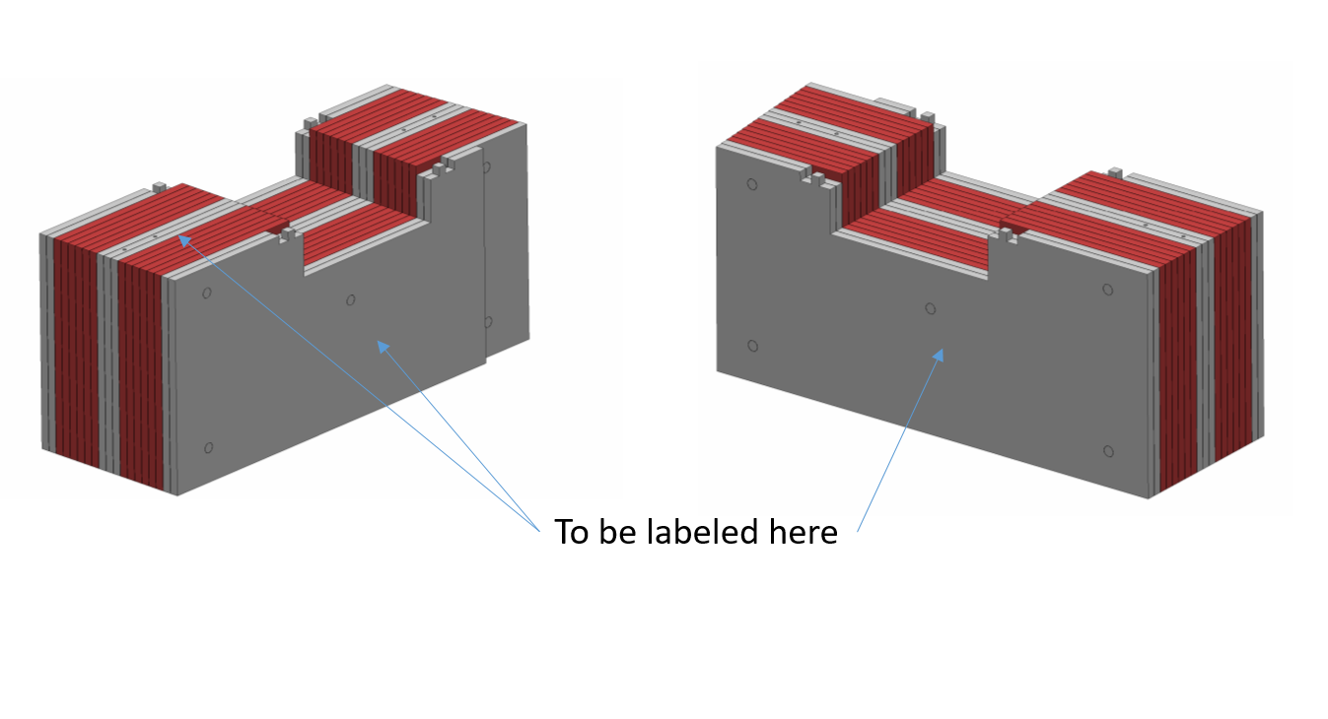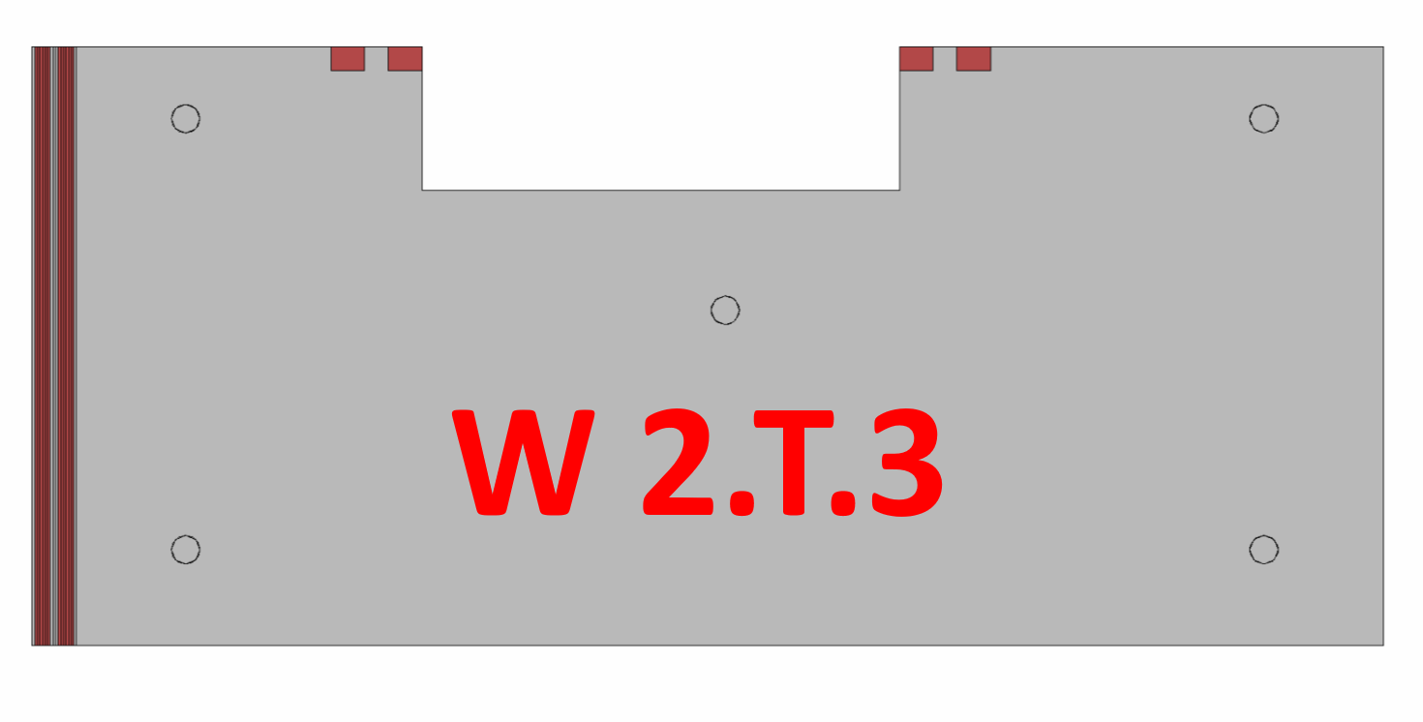

*Figure 2 – An illustrative label*

*Figure 1 - Position of block labels*

# Blocks installation and uninstalltion

The Wall blocks design require a specific sequence. The strategy during an installation is to start with the lower layer and first column. Install all four lower blocks. Next step is to add instrument lower layer then instrument insert. Add wall layer “instrument top” and “Top”. Install the utility feedthrough and add the Utility block.

* Blocks are not interchangeable,
* Blocks have to be installed and uninstalled layer by layer (lower layers have to be installed first - see *Figure 3*)
* Mid Walls and Temporary shielding have a own marking system

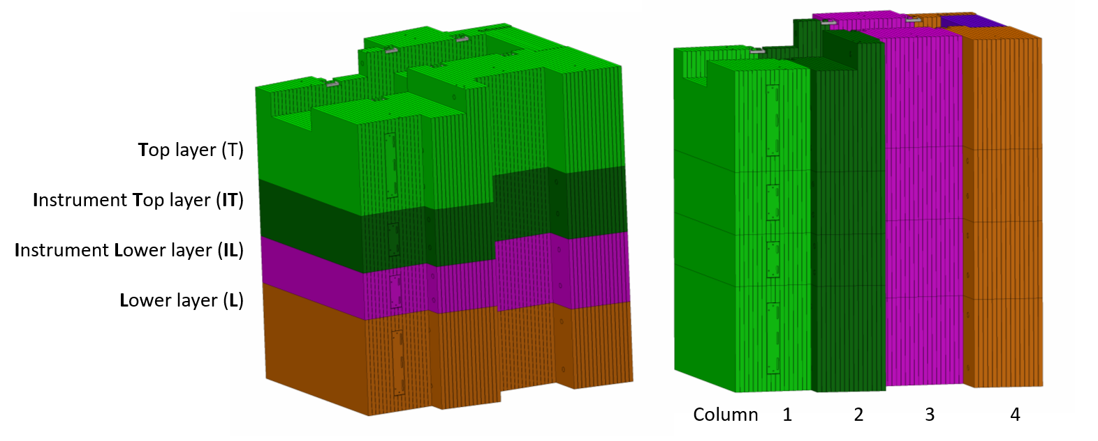

*Figure 3 – Wall composition*

In order to avoid mistakes during an installation, each block will be marked, as described in Section 2 of this document. Every label gives four information about a block position and it is defined as follows:

[sector].[level].[row].[block#]

* [sector] – W (West), S (South), E (East) or N (North)
* [Instrument position] – 1 to 11
* [layer] – L (Lower), IL (Instrument Lower), IT (Instrument Top) or T (Top)
* [Column] – 1 to 4

For the sake of an example, W 2.L.2 label stands for:

* West Sector
* Instrument position 2
* Lower layer
* Second column

Please see *Figure 4* for illustration, ESS-0053441 Wall Top Assem

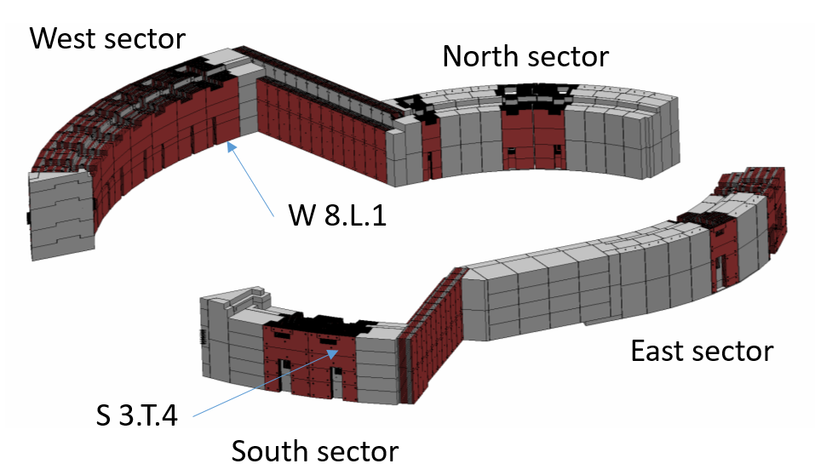

*Figure 4 - Bunker Walls*

# references

|  |  |
| --- | --- |
| [1] | *ESS-0053441.1 - Wall Top Assm.* |
| [2] | *ESS-0103125.1 - Wall Assm East* |
| [3] | *ESS-0103126.1 - Wall Assm North* |
| [4] | *ESS-0192719.1 - Wall Assm South* |
| [5] | *ESS-0103308.1 - Wall Assm South* |

# List of figures

*Figure 1 - Position of block labels* 4

*Figure 2 – An illustrative label* 4

*Figure 3 – Wall composition* 5

*Figure 4 – Bunker Walls* 6

Document Revision history

| Revision | Reason for and description of change | Author | Date |
| --- | --- | --- | --- |
| 1 | First issue | Thorbjörn Lindwall | 2017-11-28 |
|  |  |  |  |