|  |
| --- |
|  |
|  |
|  |
|  |
|  |
|  |
|  |
|  |
| Installation and Labelling-Frame Beams and Pillars |
|  |
|  |

|  | Name | **Role/Title** |
| --- | --- | --- |
| **Owner** | Senad Kudumovic | Mechanical Design Engineer |
| **Reviewer** | Thorbjörn Lindwall | Mechanical Design Engineer |
| **Approver** | Zvonko Lazic | Bunker Project Leader |
| **Notified** | Iain Sutton  Oliver Kirstein  Ken Andersen  Shane Kennedy | Neutron Scattering Systems Senior Engineer  Head of Instrument Technologies Division  Head of Instruments and Neutron Beams Division  Interim Deputy Science Director and Project Leader |

|  |  |
| --- | --- |
| Table of content | Page |

1. Scope 3

2. Beam/Pillars Labeling 3

2.1. Labels requirements 3

3. BEAM/PIllar installation and uninstalltion 5

4. references 6

5. List of figures 6

Document Revision history 6

# Scope

This document gives instruction how to label frame beams and pillars, as well as it instructs how to perform an installation, or an uninstallation of the frame.

# Beams/Pillars Labeling

Bunker frame is built of nearly 200 pillars/beams and every pillar/beam has its own, unique destination. In order to avoid errors during an installation, each beam and pillar must be labelled - painted numbers on sides and on top of each beam and painted number on side of each pillar.

Parts should be labelled in accordance with their title, which describes destination of a part. ESS-0129165 [1] will be used as an example:

* CAD number of the beam: ESS-0129165
* Title of the beam: R9 Beam NW-R9-1
* Label of the block: **NW-R9-1**
* NW-R9-1 label stands for (for more details please refer to Section 3 of this document):
  + North West sector
  + Radial Beam - 9 m radius
  + First beam in row

Some beams and pillars are universal for different destinations, thus their titles do not describe the final installation place. Nevertheless, they must be marked with a unique label. ESS-0124320 [2] will be used as an example:

* CAD number of the beam: ESS-0124320
* Title of the beam: R9 Beam NW-R9-X/SE-R9-X
* Labels of the beam: from **NW-R9-5** to **NW-R9-9** and **SE-R9-4 to SE-R9-9**
* (11 beams in total)

Any “X” mark in a beam/pillar title represent universal part. A spreadsheet with beam CAD numbers and corresponding labels will be delivered to a manufacturer (reference to be advised).

## Labels requirements

Labels should be easily visible for a crane operator, as well as for people working on the ground. Labels requirements are (details of the font to be advised):

* Bright color, contrasting with a beam color surface (see *Figure 2*)
* Orange color is forbidden
* Font size equals to at least 50% of a beam height
* Label painted on the left side, right side, and on top of the beam (see *Figure 1*)

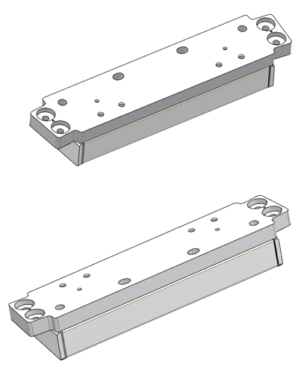

To be labeled here

*Figure 1 - Position of beam labels*

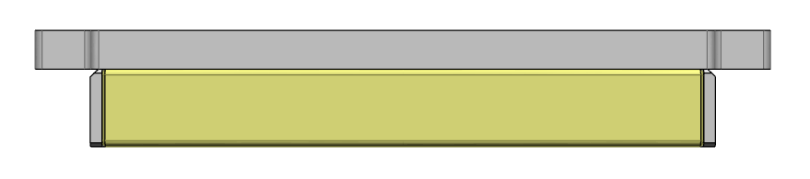

*Figure 2 – An illustrative label*

***NW-R9-1***

# BEAM/Pillar installation and uninstalltion

In order to avoid mistakes during an installation, each beam will be marked, as described in Section 2 of this document. Every label gives tree information about a beam/pillar position and it is defined as follows:

[sector]. [row]. [beam#]

* [sector] – NW (North-West), or SE (South-East)
* [radius] – beam/pillar radius number counted outwards from the TCS
* [beam#] – beam/pillar number counted clock wise in the NW sector, and counter clockwise in the SE sector

For the sake of an example, NW-R9-1 label stands for:

* North-West Sector
* Radial Beam (9 m radius)
* First beam in row

Please see *Figure* 3 for illustration, as well as ESS-0150112.3 [3], ESS-0150301.1 [4], assembly drawings.

NW-R9-1

SE-R9-5

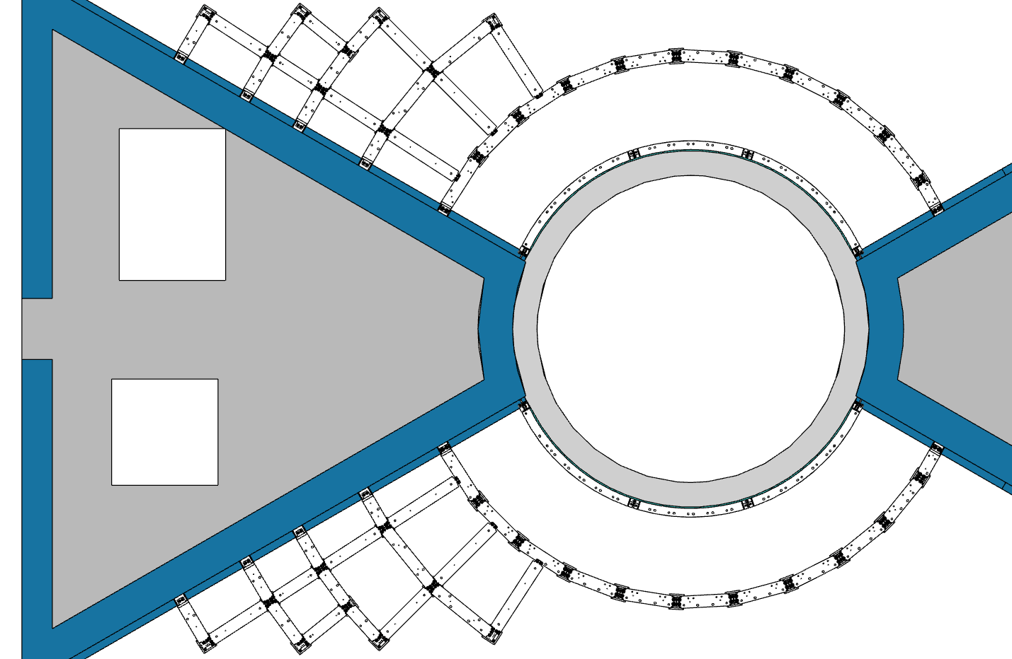

*Figure 3 - Bunker Frame-D02*

Beam Line

TCS

# References

|  |  |
| --- | --- |
| [1] | *ESS-0129165 - R9 Beam NW-R9-1.* |
| [2] | *ESS-0124321 - R9 Beam NW-R9-X/SE-R9-X.* |
| [3] | *ESS-0150112- D02 Assembly.* |
| [4] | *ESS-0150301- D01/D03 Assembly.* |

# List of figures

*Figure 1 - Position of beam labels* 4

*Figure 2 – An illustrative label* 4

*Figure 3 – Bunker Frame-D02* 5

Document Revision history

| Revision | Reason for and description of change | Author | Date |
| --- | --- | --- | --- |
| 1 | First issue | Senad Kudumovic | 2017-11-28 |
|  |  |  |  |