|  |
| --- |
|  |
|  |
|  |
|  |
|  |
|  |
|  |
|  |
| Neutronics considerations on dilatation joints |
|  |
|  |

|  | Name | **Role/Title** |
| --- | --- | --- |
| **Owner** | Esben Klinkby | Scientist |
| **Reviewer** | Luca Zanini | Neutronics Group Leader |
| **Approver** | Peter Jacobsson  Günter Muhrer  Zvonko Lasic | Head of ES&H Division  ESS Shield Design Coordinator  Neutron Scattering Systems Integration Engineer |
| **Distribution list** |  |  |

1.Scope 3

2.CONTRIBUTORS 3

3.Issuing organisation 3

4.Methodology 3

5.Acceptance Criteria 6

6.Open Items 6

7.Assumptions 6

8.Limitations 6

9.Computer Hardware and software 6

10.Calculation Inputs 6

11.calculations 6

12.CONCLUSIONS AND RECOMMENDATIONS 8

13.Glossary 8

14.references 8

Document Revision history 9

# Scope

This report describes radiation transport calculations focusing on neutrons streaming through clearance gabs in the region where the so called *hanging curtain* and the bunker roof meet. The purpose is to ensure that the biological dose-rate meets the requirements on top of the bunker roof.

# CONTRIBUTORS

Günter Muhrer, Stuart Ansell, Valentina Santoro

# Issuing organisation

*European Spallation Source ERIC*

# Methodology

Radiation shielding calculations are performed following the ESS Procedure for designing shielding for safety [1]. Monte Carlo radiation transport calculations are performed using MCNPX [2].

The radiation contributing to the biological dose-rate in the region of the interface between the bunker roof and the hanging curtain has two main components:

1) Neutrons scattered on the T0 choppers, located underneath the dilatation gaps.

2) Bulk penetration of neutrons through the steel of the target monolith.

The simulations reported here, reflect this division and are split into two parts.

*Model1* is based on a Comblayer model, which accurately discribes the region outside the target monolith, including a precise modelling of a T0 chopper – see figure 1.

To enforce conservatism in the calculations, the largest possible guide insert is modelled: 10cm x 12 cm in cross-section. To increase the simulation efficiency, the default proton source is in *Model1* replaced by a tailored surface neutron source, covering the entrance of the guide instert (radius=2m) – the source corresponds to a proton beam power of 5MW and is adapted from [3]. To ensure statistical convergence, neutrons undergo forced collisions at T0 chopper.

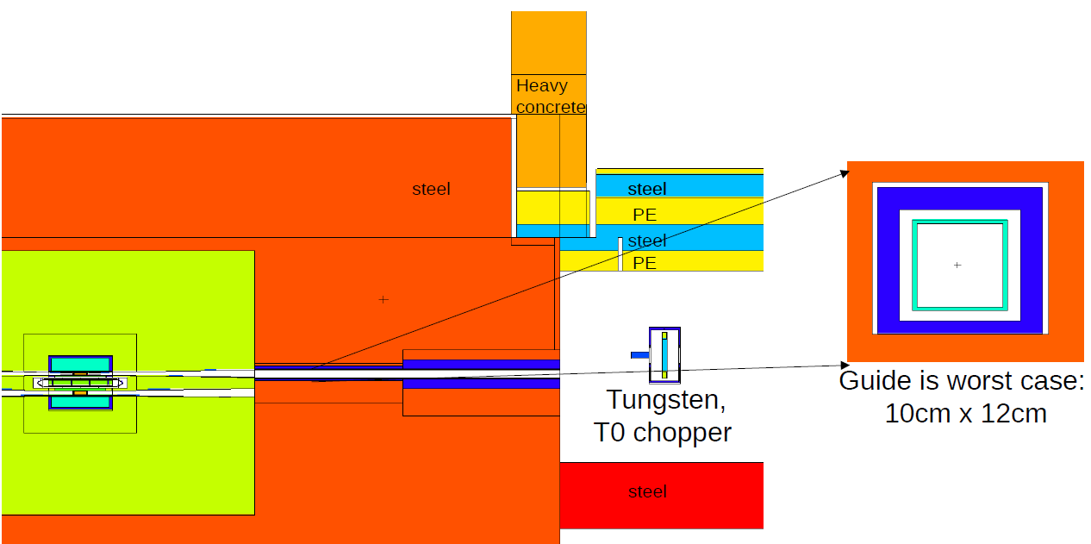

Figure 1: Simulation geometry, Model1 - Comblayer model. As the illustration shows, by scattering in the T0 chopper, neutrons coming from the beam extraction can be diverted toward the region of the curtain-bunker roof interface, encountering only little material along their trajectories, and arrive there with a direction close to that of the vertical clearance gaps.

*Model2:* The second simulation is based on the Mastermodel[7], in which the target building and monolith are accurately described. The model is updated to accurately discribe the bunker roof and clearances between the monolith, hanging curtain and bunker roof, as shown in figure 2. The source used in *Model2* is the default proton source, corresponding to 5MW beam power.

To increase the simulation efficiency, ADVANTG [4] is used to prepare weight windows – see figure3. The weight windows are prepared using the *cadis* method targeting to minimize statistical fluctuations on top of the bunker roof – labelled “tally cell” in figure 2.

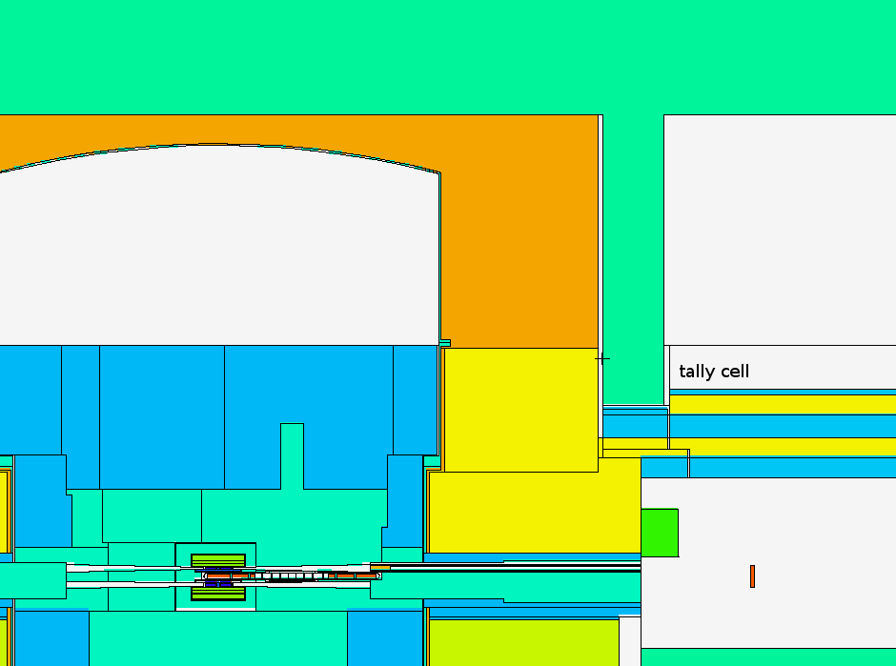  
Figure 2: Simulation geometry, Model1 - Mastermodel.

Figure 3: Weight windows used for Model2 - generated by ADVANTG

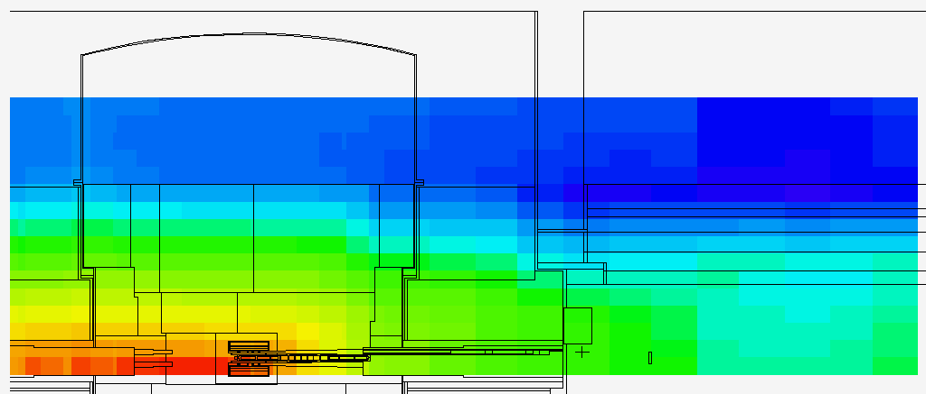

# Acceptance Criteria

In accordance to Ref. [5] the calculated biological dose-rates cannot exceed half the limits allowed for the area in question. From Ref. [6], the limit is: 3 μSv/h on the bunker roof which is classiffied as a supervised area. However, though not documented at this stage, a fence on top of the bunker roof is foreseen, following the circumference of the bunker (radius 15m and 28m respectively). The region inside the fence will be classified as a Highly restricted controlled zone, meaning that the limit relevant to this work is 1.5μSv/h at radius 15m (freely assessable part of the instrument halls). In practice, however, there are several contributions to the biological dose in these areas, so the contribution from neutrons coming through R6 dilatation joint between the bunker roof and the monolith (as modelled here), should be significantly below this limit.

In addition, the High Bay zooning (superwised area) must be respected. Between the R6 dilatation joint region and the High Bay there is 1m of concrete.

# Open Items

None

# Assumptions

The region on top of the bunker roof will be fenced, so that the region inside radius 15m, 26m respectively, is classified as a Highly restricted controlled zone.

# Limitations

None

# Computer Hardware and software

For the calculations the Monte Carlo particle transport code MCNPX 2.7 [2] is used.

# Calculation Inputs

The MCNPX input decks and ADVANTG input can be found attached to this report.

# calculations

Dose-rate maps corresponding Model1 and Model2 as descripted above, and shown in figure 4 and figure 5 respectively.

Figure 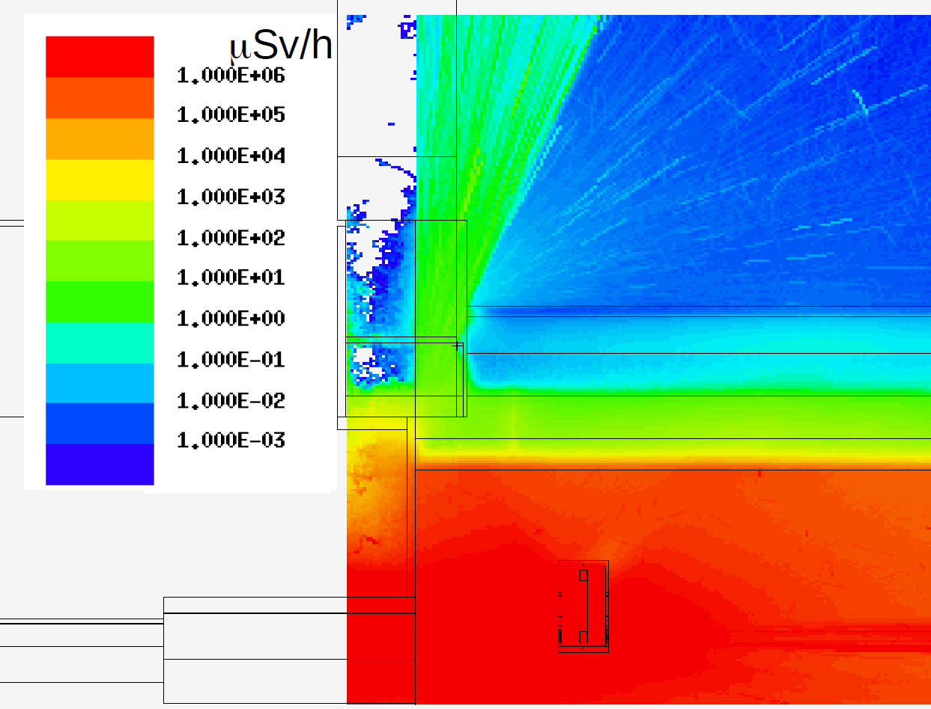4: Figure 4: Biological dose-rate in μSv/h from Model1

Figure 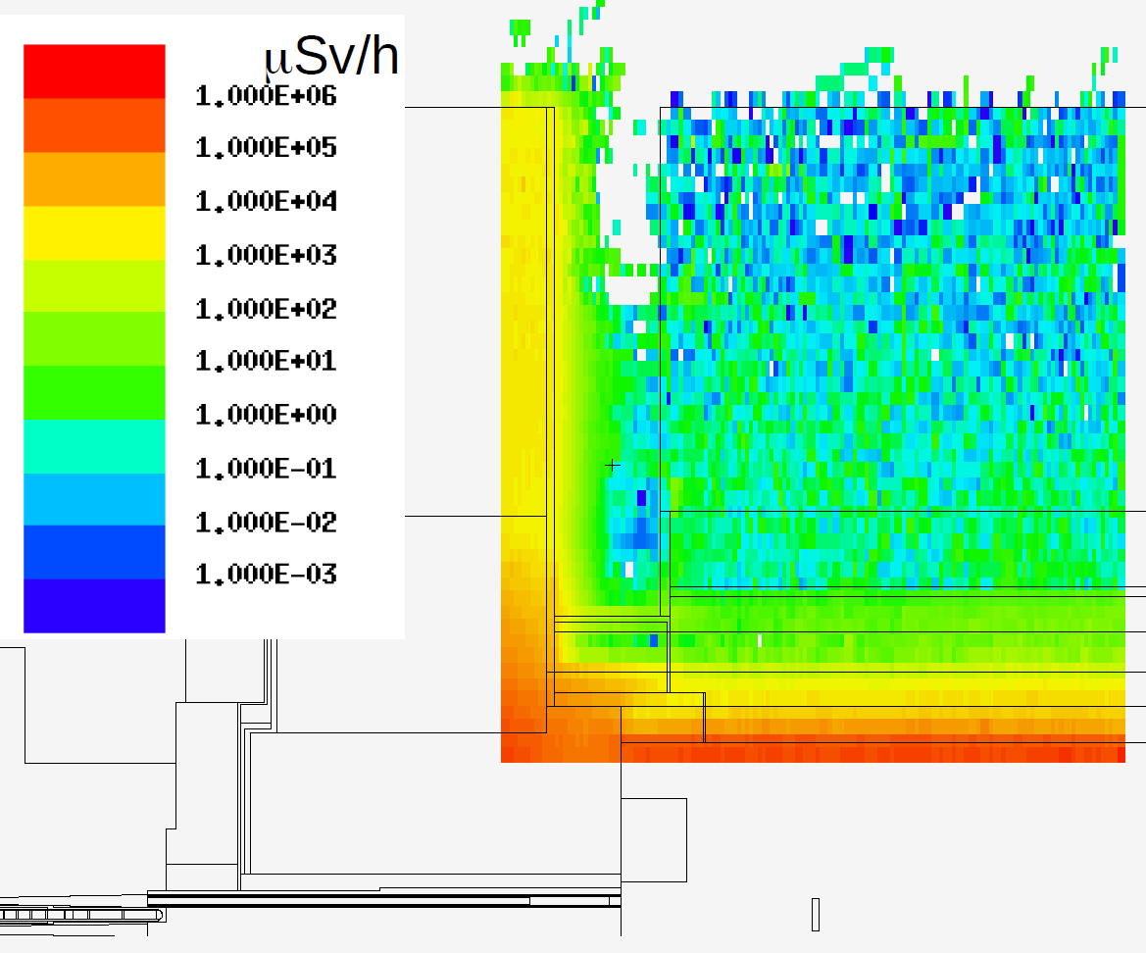5: Biological dose-rate in μSv/h from Model2

# CONCLUSIONS AND RECOMMENDATIONS

The neutron streaming to the dilatation joints has been modelled. The streaming is directed upward and peaks at about 10μSv/h, which is acceptable, given that that region inside the bunker wall will be fenced (Highly restricted controlled area).

Likewise, the bulk penetration of neutrons through the monolith steel is found to be about 1 μSv/h in the interface region between the target building and the bunker. This is acceptable, given the 1m concrete which is situated between this region and the High Bay (superwised area).

# Glossary

| Term | Definition |
| --- | --- |
|  |  |
|  |  |
|  |  |

# references

1. ESS Procedure for designing shielding for safety, ESS-0019931
2. Gregg W. McKinney et al., "MCNPX 2.7.0 - New Features Demonstrated," [LA-UR-12-25775](https://mcnpx.lanl.gov/opendocs/misc/LA-UR-12-25775.pdf).
3. ESS-0087785
4. ADVANTG―An Automated Variance Reduction Parameter Generator, ORNL/TM-2013/416 Rev. 1
5. ESS Procedure for designing shielding for safety, ESS-0019931
6. Summary of requirements for Supervised area, ESS-0001786
7. https://jira.esss.lu.se/browse/TN-28

Document Revision history

| Revision | Reason for and description of change | Author | Date |
| --- | --- | --- | --- |
| 1 | First issue | Esben Klinkby | 2017-12-04 |
|  |  |  |  |
|  |  |  |  |